
KLE Society's

KLE Technological University, Hubballi.

A Senior Design Project Report

on

Image Captioning Using Deep Learning For Visually Impaired

submitted in partial fulfilment of the requirement for the degree of

Bachelor of Engineering

in

Computer Science and Engineering

Submitted by

ROHIT KUMAR

ADITYA MUTAGI

SHASHIDHAR M.

AKASH D.H.

RAGHVENDRA B

01FE18BCS178

01FE18BCS019

01FE18BCS199

01FE18BCS021

01FE18BCS163

Under the guidance of

Dr. S.G. Totad

SCHOOL OF COMPUTER SCIENCE AND ENGINEERING

Hubballi – 580 031

2021 -22


KLE Society's

KLE Technological University, Hubballi.

2021 - 2022

SCHOOL OF COMPUTER SCIENCE AND ENGINEERING

CERTIFICATE

This is to certify that Senior Design Project titled ‘Image Captioning Using Deep Learning For Visually Impaired’ is a bonafied work carried out by the student team comprising of Rohit Kumar (01FE18BCS178), Aditya Mutagi (01FE18BCS019), Shashidhar M (01FE18BCS199), Akash D.H. (01FE18BCS021), Raghvendra B. (01FE18BCS163) for partial fulfilment of completion of seventh semester B.E. in Computer Science and Engineering during the academic year 2021-22.

Guide

Head, SoCSE

Dr. S.G. Totad

Dr. Meena S. M

Viva -Voce:

Name of the Examiners Signature with date

1.

2.

ACKNOWLEDGEMENT

We would like to thank our faculty and management for their professional guidance towards the completion of the project work. We take this opportunity to thank Dr. Ashok Shettar, Vice-Chancellor, Dr. N.H Ayachit, Registrar, and Dr. P.G Tewari, Dean Academics, KLE Technological University, Hubballi, for their vision and support.

We also take this opportunity to thank Dr. Meena S. M, Professor and Head, SoCSE for having provided us direction and facilitated for enhancement of skills and academic growth.

We thank our guide Dr. S.G. Totad, Professor, SoCSE for the constant guidance during interaction and reviews.

We extend our acknowledgement to the reviewers for critical suggestions and inputs. We also thank Project Co-ordinators. and faculty in-charges for their support during the course of completion.

We express gratitude to our beloved parents for constant encouragement and support.

ROHIT KUMAR - 01FE18BCS178

ADITYA MUTAGI - 01FE18BCS019

AKASH D H - 01FE17BCS021

RAGHAVENDRA BURALI - 01FE18BCS163

SHASHIDHAR MUGAD - 01FE17BCS199

3

ABSTRACT

Image captioning seeks to construct a sentence description for an image automatically. Our project model will take an image as input and output an English sentence that describes the image’s contents and its audio description. In recent years, it has gained a lot of study attention in the field of cognitive computing. The challenge is diﬃcult because it combines concepts from both the computer vision and natural language processing fields. We built a functioning model of Image caption generator combining the ideas of a Convolutional Neural Network (CNN) and a Long Short Term Memory (LSTM) model by implementing CNN with LSTM. The CNN acts as an encoder, extracting features from images, and the LSTM acts as a decoder, generating words that describe the image. We use BLEUScores to test the eﬃciency of our model after the caption creation step. As a result, our method assists the user in obtaining a descriptive caption for the input image.

Keywords: Convolutional Neural Network, LSTM, BLEUscores.

I

CONTENTS

ACKNOWLEDGEMENT |  |  |  | 3
ABSTRACT |  |  |  | I
CONTENTS |  |  |  | iii
LIST OF TABLES |  |  |  | iv
LIST OF FIGURES |  |  |  | v
1 | INTRODUCTION |  |  | 1
 | 1.1 | Background Of the Project . . . . . . . . . . . . . . . . . . . . . . . . . . . . . |  | 1
 | 1.2 | Problem Statement . . . . . . . . . . . . . . . . . . . . . . . . . . . . . . . . . |  | 2
 | 1.3 | Objective . . . . . . . . . . . . . . . . . . . . . . . . . . . . . . . . . . . . . . |  | 2
 | 1.4 | Motivation . . . . . . . . . . . . . . . . . . . . . . . . . . . . . . . . . . . . . . |  | 2
 | 1.5 | Data Flow diagram of the project . . . . . . . . . . . . . . . . . . . . . . . . . |  | 3
 | 1.6 | Literature Survey . . . . . . . . . . . . . . . . . . . . . . . . . . . . . . . . . . |  | 4
2 | REQUIREMENT ANALYSIS |  |  | 7
 | 2.1 | Non-Functional Requirements Requirements . . . . . . . . . . . . . . . . . . . |  | 7
 | 2.2 | Hardware requirement and software requirements . . . . . . . . . . . . . . . . |  | 7
 |  | 2.2.1 | Hardware Requirements . . . . . . . . . . . . . . . . . . . . . . . . . . | 7
 |  | 2.2.2 | Software Requirements . . . . . . . . . . . . . . . . . . . . . . . . . . . | 7
3 | METHODOLOGY |  |  | 8
 | 3.1 | DATAPREPROCESSING............................. |  | 8
 |  | 3.1.1 | Preparing the Dataset . . . . . . . . . . . . . . . . . . . . . . . . . . . | 8
 |  | 3.1.2 | Preparing the Dataset . . . . . . . . . . . . . . . . . . . . . . . . . . . | 8
 |  | 3.1.3 | Data Preprocessing - Images . . . . . . . . . . . . . . . . . . . . . . . . | 8
 |  | 3.1.4 | Data Preprocessing - Caption . . . . . . . . . . . . . . . . . . . . . . . | 9
 |  | 3.1.5 | Word Embeddings . . . . . . . . . . . . . . . . . . . . . . . . . . . . . | 9
 | 3.2 | Methodology of Image Captioning . . . . . . . . . . . . . . . . . . . . . . . . . |  | 9
 |  | 3.2.1 | CONVOLUTIONNETWORK ...................... | 9
 |  | 3.2.2 | Long Term Short Memory . . . . . . . . . . . . . . . . . . . . . . . . . | 10
 | 3.3 | Architecture Diagram . . . . . . . . . . . . . . . . . . . . . . . . . . . . . . . . |  | 10
 |  | 3.3.1 | Image Feature Encoder . . . . . . . . . . . . . . . . . . . . . . . . . . . | 11

ii
 | 3.3.2 Sequence Decoder . . . . . . . . . . . . . . . . . . . . . . . . . . . . . . | 12
 | 3.3.3 Sentence Generator . . . . . . . . . . . . . . . . . . . . . . . . . . . . . | 13
3.4 | Low level design . . . . . . . . . . . . . . . . . . . . . . . . . . . . . . . . . . . | 14
4 RESULT AND DISCUSSION |  | 15
4.1 | Result . . . . . . . . . . . . . . . . . . . . . . . . . . . . . . . . . . . . . . . . | 15
5 CONCLUSION AND FUTURE SCOPE OF THE WORK |  | 18
REFERENCES |  | 21

LIST OF FIGURES

1.1 | Data Flow Diagram of the project . . . . . . . . . . . . . . . . . . . . . . . . . | 3
3.1 | Isolated simulated approach. . . . . . . . . . . . . . . . . . . . . . . . . . . . . | 9
3.2 | low level design 1. . . . . . . . . . . . . . . . . . . . . . . . . . . . . . . . . . . | 14
3.3 | low level design 2. . . . . . . . . . . . . . . . . . . . . . . . . . . . . . . . . . . | 14
4.1 | Epoch vs Test Loss . . . . . . . . . . . . . . . . . . . . . . . . . . . . . . . . . | 15
4.2 | Image Result-1
4.3 | Image Result-2

v

Image Captioning Using Deep Learning For Visually Impaired

Chapter 1

INTRODUCTION

1.1 Background of the Project

Using natural language to automatically describe the content of photographs is a fundamental and diﬃcult task. Building models that can create captions [13] for an image has become viable thanks to advances in computational power and the availability of large datasets. Humans, on the other hand, can easily explain the situations they are in. It’s natural for someone to describe an enormous quantity of information about a picture in a single glance. Although much progress has been made in computer vision, tasks such as object recognition, action classification, image classification, attribute classification, and scene recognition are now possible, allowing a computer to describe an image in the form of a human-like sentence is still a relatively new task. The goal of this project is to create an application that allows visually impaired persons to understand and interpret images to a reasonable degree, thereby improving their internet experience and participation.The semantics of images should be captured here and expressed in the desired form of natural languages for this objective of image captioning. It has a significant impact in the real world, for example, by assisting visually challenged persons in better comprehending the content of web images. As a result, we’ll combine CNN and RNN architectures to create our picture caption generator model. CNN is used to extract features from photos. We utilised the Exception pre-trained model. LSTM [16] uses the information collected by CNN to generate a description of the image.

The many applications of of the text to audio converter have an ultimate goal of enhancing the experience of the visually impaired by describing the information in the images on the internet or social media. The following are the examples where this solution could be used

- Social Media

- CCTV cameras

- Search engine optimization

School of Computer Science & Engineering, KLE Technological University, Hubballi - 31 1

Image Captioning Using Deep Learning For Visually Impaired

1.2 Problem Statement

Using deep learning frameworks such as CNN and LSTM deep neural networks, we hope to create an application that can analyse photographs and provide comprehensible text about the image.

1.3 Objective

- Recognize the objects in image using CNN and prepare a feature vector.

- Convert the caption sentence to speech for better reach.

- Generate a brief sentence using the feature vector.

- Provide a user interface for ease of access.

1.4 Motivation

The bulk of the population now has internet connection. For the sight challenged, interpreting visuals is a diﬃcult undertaking. Their inability to perceive graphics detracts from their overall internet browsing experience. Many successful models for text-to-speech have been developed, but none for describing visuals. Text-to-speech APIs are used to construct standard screen readers for visually impaired users.

They will not oﬀer any interpretations for photos in web documents. As a result, a person who relies on these tools may lose context because photos cannot be read aloud. There is a need to bridge the gap between visuals and text-to-speech screen readers in terms of context.

School of Computer Science & Engineering, KLE Technological University, Hubballi - 31. 2

Image Captioning Using Deep Learning For Visually Impaired

1.5 Data Flow diagram of the project

Data Flow diagram of the project represents the overview of the project steps that is being carried out in implementation of the project. It gives an overview of the works being carried out for the analysis of Image captioning and converting that into audio.
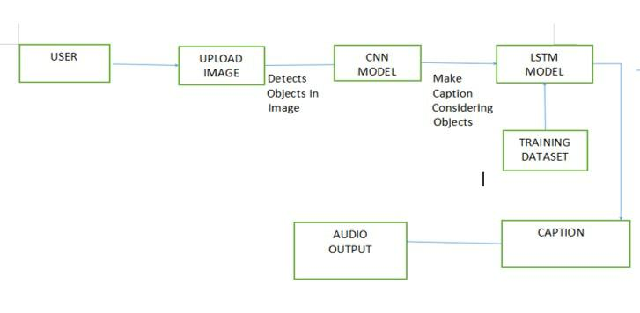

Figure 1.1: Data Flow Diagram of the project

- The image is uploaded and the object detection is done.

- After the object is detected its fed to a CNN model.

- Further captioning is done in a LSTM model with the help of a training dataset.

- The caption with highest probability will come out as an output.

- Finally, the caption is converted to audio output.

School of Computer Science & Engineering, KLE Technological University, Hubballi - 31. 3

Image Captioning Using Deep Learning For Visually Impaired

1.6 Literature Survey

Literature survey

Serial | Paper |  |  | Publication |  | Inferences
No.
1. | Image | Caption- |  | 2018 1st Inter-
 | ing for Ambient |  |  | national | Con- | 1. The design and imple-
 | Awareness |  | on | ference on Data |  | mentation of a system
 | a Sidewalk’ by |  |  | Intelligence |  | embedded in an RPi3
 | Faruk | Ahmed, |  | and | Security | is part of the experi-
 | Md Sultan Mah- |  |  | (ICDIS) |  | ment.
 | mud, |  | Rakib |  |  | 2. They have considered
 | Al-Fahad,
 |  |  |  |  |  | two | types of inputs:
 | Shahinur |  | Alam, |  |  | two
 |  |  | Alam, |  |  | voice | command and
 | and Mohammed |  |  |  |  | voice
 |  |  |  |  |  | button press. |  | A user
 | Yeasin [1] |  |  |  |  |  |  | A user
 |  |  |  |  |  | can | choose | to have
 |  |  |  |  |  | spoken feedback, hap-
 |  |  |  |  |  | tic feedback, or a cer-
 |  |  |  |  |  | tain tone for obstacles

- Image Caption- Mullachery,

ing’ by Vikram | V.,Motwani, V. | 1. They | used | three
Mullachery, | (2018). Image | diﬀerent datasets to
Vishal Motwani. | Captioning. | train | and | evaluate
 |  | their | data | models
 |  | MSCOCO, Flickr30k
 |  | and Flickr 8k.

2. They used the base-

line model designed

by A.Karpathy and

improve upon that

model by increasing

the RNN layers and

using ResNet in lieu of

VGGNet.

School of Computer Science & Engineering, KLE Technological University, Hubballi - 31. 4

Image Captioning Using Deep Learning For Visually Impaired

3.

Image |  |  | Cap- | Article |  | Pub-
tioning |  |  | using | lished | in | In-
Deep | Learning: |  |  | ternational
A | Systematic |  |  | Journal |  | of
Literature |  |  | Re- | Advanced |  | Com-
view’ | by |  | Murk | puter | Science
Chohan, |  |  | Adil | and | Applica-
Khan, |  | Muham- |  | tions(IJACSA),
mad |  | Saleem |  | Volume 11 Issue
Mahar, |  |  | Saif | 5, 2020
Hassan, |  |  | Ab-
dul |  | Ghafoor,
Mehmood Khan

- In this study they have found that CNN is used to understand image contents and find out objects in an image while RNN or LSTM is used for language generationIt was also found that LSTM with CNN has outperformed RNN with CNN.

- The purpose of this Systematic Literature Review is to study all newest Articles from 2017 to 2019 to find diﬀerent methods to achieve auto image captioning in diﬀerent domains. what diﬀer-ent datasets are used to achieve the task In which diﬀerent practi-cal domains this task is used. which tech-nique Outperforms others and finally attains to describe

the technicalities behind diﬀerent net-works, methods and evaluation matrices

School of Computer Science & Engineering, KLE Technological University, Hubballi - 31. 5

Image Captioning Using Deep Learning For Visually Impaired

4.

Image Cap- (IJAST)Vol.29 tion Generator NO.3s(2020).

Using Deep

Learning by

B.Krishnakumar,

K.Kous alya,

S.Gokul

- Proposed Model suc-cessfully trained to generate captions of images using CNN

technique, model

is depends on data

and used small data

set.The model gen-

erate caption by

using Keras Frame-

work used in Jupyter

notebook and also

conclude keras has

strong support for

multiple GPU’

School of Computer Science & Engineering, KLE Technological University, Hubballi - 31. 6

Image Captioning Using Deep Learning For Visually Impaired

Chapter 2

REQUIREMENT ANALYSIS

2.1 Non-Functional Requirements Requirements

1.The website must be simple, minimalistic, and easy to use.

2.User interaction with the images must be as minimal as possible to access the caption service.

3.There must be no drastic changes in the interface to maintain consistency.

4.The results must be generated within a reasonable amount of time.

2.2 Hardware requirement and software requirements

Hardware requirements and software requirements are the requirements which are needed for the implementation of the project. In this all the hardware and software requirement were explored which will be needed by the existing prototype.

2.2.1 Hardware Requirements

Hardware requirements include;

1.Processor - Quad-core Intel i7 Skylake or higher(Dual-core is manageable)

2.RAM - Minimum of 4 GB RAM is required.

3.Storage - 500 GB of Hard disk (SSD is preferred, for backend)

2.2.2 Software Requirements

Software requirement includes software and applications needed for the project. The software requirements needed are:

1.Language - Python 3

2.Operating System - Windows 10 (64 bit) or Linux OS for backend. No specific OS for frontend.

3.Environments - Google colab, Anaconda Jupyter notebook.

School of Computer Science & Engineering, KLE Technological University, Hubballi - 31 7

Image Captioning Using Deep Learning For Visually Impaired

Chapter 3

METHODOLOGY

This Sections talks about the methodology that is used in the simulation and the analysis of the protocols.

3.1 DATA PREPROCESSING

3.1.1 Preparing the Dataset

Flicker 30k dataset has been used for training the model has 31000 images with 5 captions for each image in a .csv format. We create a dictionary named “descriptions” which contains the name of the image (without the .jpg extension) as keys and a list of the 5 captions for the corresponding image as values.

3.1.2 Data Cleaning

Some basic cleaning like lower-casing all the words (otherwise “hello” and “Hello” will be regarded as two separate words), removing special tokens (like ‘Create a vocabulary of all the unique words present across all the 31000*5 (i.e., 155000) image captions (corpus) in the data set.

3.1.3 Data Pre-processing - Images

1.Every image must be converted into a fixed sized vector which can then be fed as input to the neural network. For this purpose, we opt for transfer learning by using the InceptionV3 model (Convolutional Neural Network) created by Google Research.

2.This model was trained on ImageNet dataset to perform image classification on 1000 diﬀerent classes of images. The purpose here is not to classify the image but just get a fixed-length informative vector for each image. This process is called automatic feature engineering.

3.Hence, the last SoftMax layer will be removed from the model and extract a 2048 length vector

School of Computer Science & Engineering, KLE Technological University, Hubballi - 31 8

Image Captioning Using Deep Learning For Visually Impaired

4.Save all the

bottleneck train features in a Python dictionary and save it on the disk using Pickle file, namely

“encoded_{t}rain_{i}mages:pkl whosekeysareimagenamesandvaluesarecorresponding2048lengthfeaturevect

3.1.4 Data Pre-processing - Caption

Represent every unique word in the vocabulary by an integer (index). As seen above, we had 5192 unique words in the corpus and thus each word had represented by an integer index between 1 to 5192.These two Python dictionaries can be used as follows: wordtoix[‘abc’] -> returns index of the word ‘abc’ixtoword[k] -> returns the word whose index is ‘k’
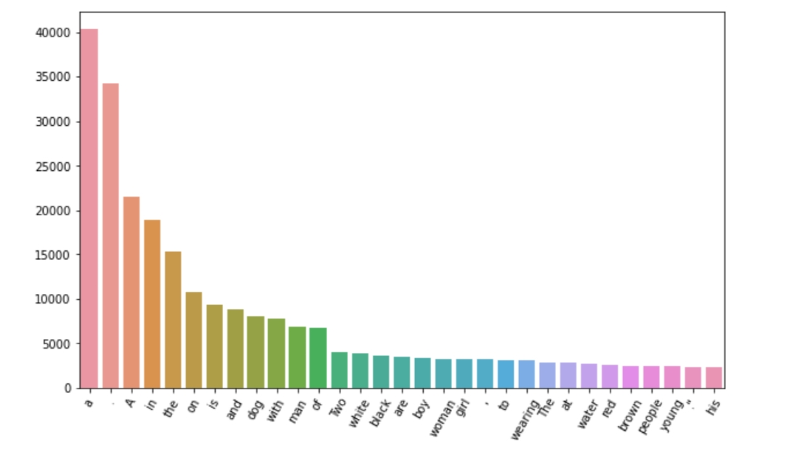
Fig. 3.1
3.1.5 Word Embeddings

We had mapped every word (index) to a 200-long vector and for this purpose, we used to use a pre-trained GLOVE Model. Now, for all the unique words in our vocabulary, we created an embedding matrix which will be loaded into the model before training. the -0.071549 0.13139 -0.0088767 0.33617 . . . . . . . 0.030591 0.25577

The embedding matrix will be of dimensions [ vocabulary X 200 ]

3.2 Methodology of Image Captioning

Deep learning is expanding and explored topics of study that is infiltrating all aspect of our life. It’s a branch of machine learning that deals with algorithms and is inspired by the brain’s structure and function. In our project, we combined Convolutional Neural Networks and a LSTM using Deep Learning Techniques for image captioning.

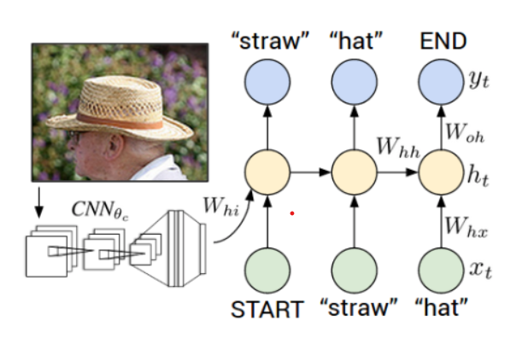

Fig.3.2.CNN
3.2.1 CONVOLUTION NETWORK

Convolutional Neural Network (CNN) is a Deep Learning method that takes an input picture and assigns relevance (biases and learnable weights) to various a feature in the image, allowing it to distinguish between them. Image categorization or Classification is one

School of Computer Science & Engineering, KLE Technological University, Hubballi - 31. 9

Image Captioning Using Deep Learning For Visually Impaired

of the most often used uses of this architecture. Several convolutional layers, as well as nonlinear and pooling layers, make up the CNN. When an image is processed through one convolution layer, the first layer’s output becomes the second layer’s input. This procedure is repeated for each succeeding layer. After a sequence of convolutional, nonlinear, and pooling layers, a fully connected layer must be added. The output information from convolutional networks is sent into this layer. When a completely connected, layer is attached to the network’s end, it produces an N-dimensional vector, where N is the number of classes from which the model chooses the appropriate one.

3.2.2 Long Term Short Memory

Recurrent Neural Networks (RNNs) with Long Short-Term Memory (LSTM) networks may learn order dependency in sequence prediction tasks. This is frequently utilised in diﬃcult situations such as Machine Translation, Speech Recognition, and many more. While we travel further into a neural network, if the gradients are very tiny or zero, little to no training can take place, resulting in poor predicting performance, which was an issue that was faced when training traditional RNNs. Because there might be delays of undetermined duration between critical occurrences in a time series, LSTM networks are well-suited for categorising, processing, and generating predictions based on time series data. LSTM is way more eﬀective and better compared to the traditional RNN as it overcomes the short-term memory limitations of the RNN. LSTM can carry out relevant information throughout the processing of inputs and discards non-relevant information with a forget gate.

3.3 Architecture Diagram

An architecture diagram is a graphical depiction of a set of architectural concepts, including

their components, principles and Elements. We done Architecture Diagram for our Model and

we did separate Diagram such as

1.Image Feature Encoder

2.Sequence Decoder

3.Sentence Generator

School of Computer Science & Engineering, KLE Technological University, Hubballi - 31. 10

Image Captioning Using Deep Learning For Visually Impaired
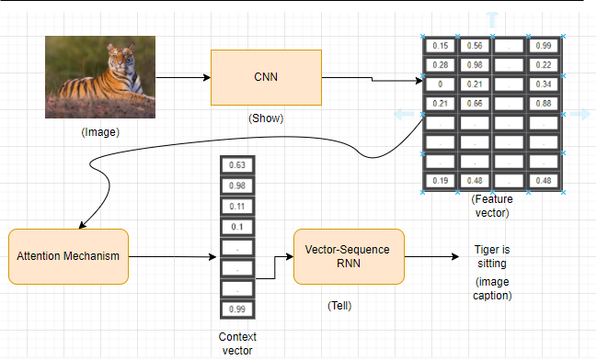

Fig.3.3. Architecture Diagram
3.3.1 Image Feature Encoder

A CNN is used in Image Captioning to extract characteristics from an image, which are subsequently input into an RNN along with the captions. We utilise an ImageNet-trained model to extract the features. VGG-16, Resnet-50, and InceptionV3 were the models

we used. Vgg16 contains about 134 million parameters, with a top-5 error rate of 7.3 percent on ImageNet. InceptionV3 features 21 million parameters, with a top-5 error rate of 3.46 percent on ImageNet. On ImageNet, the human top-5 error rate is 5.1 percent. Inception-V3 The ImageNet Project aims to identify and categorise pictures into about 22,000 item categories in the field of computer vision research. The model is built using 1.2 million training photos, with additional 50,000 images used for validation and 100,000 images used for testing. Szegedy et al. introduced the Inception V3 model, which uses a CNN-based architecture and has set a new standard for categorization and detection. The model’s architecture is its defining characteristic, since it maximises the use of computational resources. The model’s depth and breadth have been enlarged as a result of the design. Inception V3 has lesser weights than both VGG and ResNet, with a total file size of 96MB.we used INCeption V3 for Feature Extraction

School of Computer Science & Engineering, KLE Technological University, Hubballi - 31. 11

Image Captioning Using Deep Learning For Visually Impaired
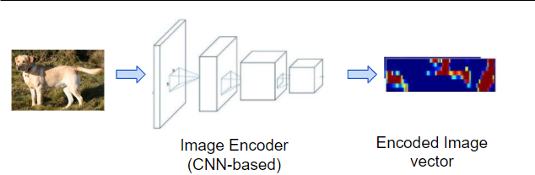

Fig.3.4. Image feature Encoder
3.3.2 Sequence Decoder

Encoder: since the image encoding has already been done by the pre-trained Inception model, the Encoder here is very simple. It consists of a Linear layer that takes the pre-encoded image features and passes them on to the Decoder.

Sequence Decoder: this is a recurrent network built with GRUs. The captions are passed in as the input after first going through an Embedding layer.

Attention: as the Decoder generates each word of the output sequence, the Attention module helps it to focus on the most relevant part of the image for generating that word. Sentence Generator: this module consists of a couple of Linear layers. It takes the output from the Decoder and produces a probability for each word from the vocabulary, for each position in the predicted sequence.
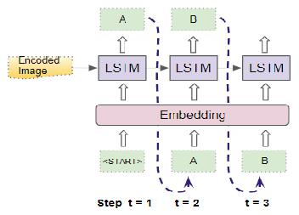

Fig.3.5 Sequence Decoder

School of Computer Science & Engineering, KLE Technological University, Hubballi - 31. 12

Image Captioning Using Deep Learning For Visually Impaired

3.3.3 Sentence Generator
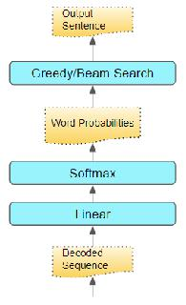

Fig. Sentence Generator
This module is made up of a few Linear layers. It uses the Decoder's output to generate probabilities for each word in the vocabulary and each location in the expected sequence.

School of Computer Science & Engineering, KLE Technological University, Hubballi - 31. 13

Image Captioning Using Deep Learning For Visually Impaired

3.4 Model Building and Evaluation
This Section explains about model and model evaluation

3.4.1 Model Building
This is the stage we had created our image captioning model by building three other models such as, Encoder, Decoder and Attention.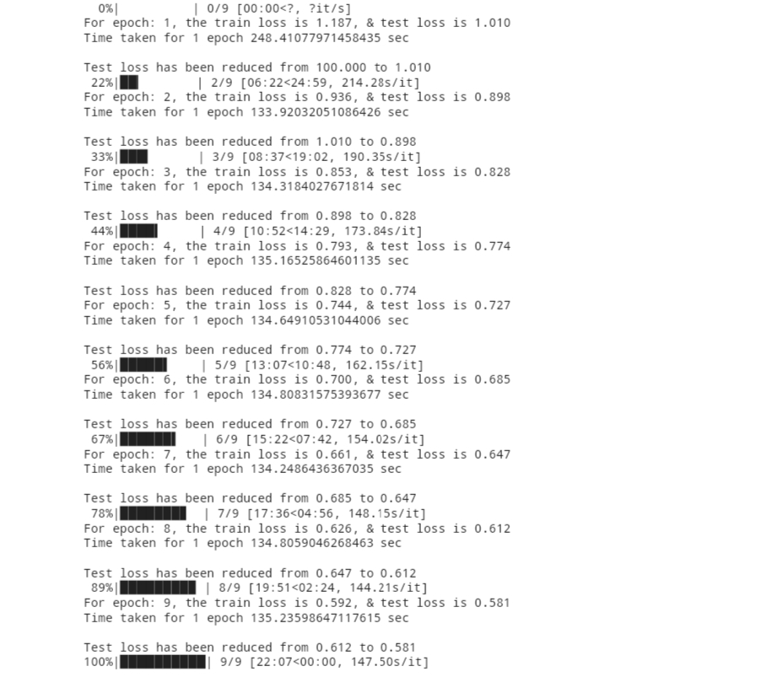

Fig. 3.6 Model Architecture

3.5 Low Level Diagrams

The image is uploaded and the object detection is done. After the object is detected its fed to a CNN model. Further captioning is done in a LSTM model with the help of a training dataset. The caption with highest probability will come out as an output.
Finally, the caption is converted to audio output.

Low level diagrams
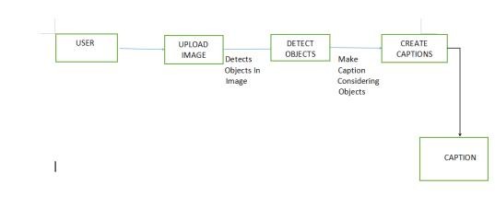

Figure 3.7: low level design 1.
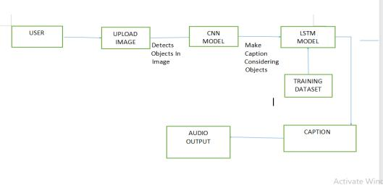

Figure 3.8: low level design 2.

Image Captioning Using Deep Learning For Visually Impaired

Chapter 4

RESULT AND DISCUSSION

This chapter gives a brief description about the Result. It tells about the setup for the experiment thereafter shows the Result analysis of the experiment carried out with the routing protocols.

4.1 Result

4.1. Epoch vs Test Loss
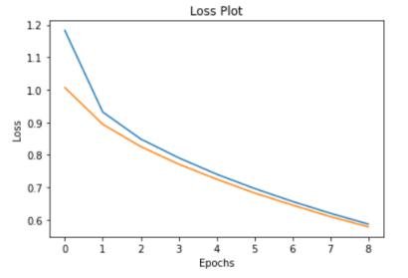

Figure 4.1: Epoch vs Test Loss

The graph here shows the the Epoch vs Test loss of the on the training data. Epoch is the number of passes over the data. Loss is the error over the training set typically in terms of mean squared error (for regression) or log loss (for classification). The model is getting constant test loss at the around epoch 9.

School of Computer Science & Engineering, KLE Technological University, Hubballi - 31 15

Image Captioning Using Deep Learning For Visually Impaired

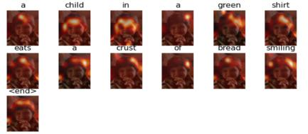

Figure 4.2:

The Real Caption: “a little child in a green shirt eats a crust of bread smiling.”

Predicted Caption: “a child in a green shirt eats a crust of bread smiling.”

Blue Score of the image caption is : 87.72279297934199

School of Computer Science & Engineering, KLE Technological University, Hubballi - 31. 16

Image Captioning Using Deep Learning For Visually Impaired
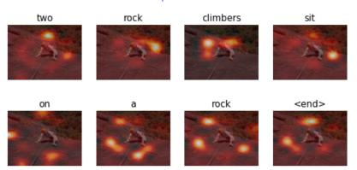

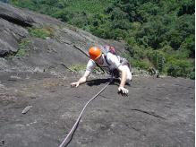

Figure 4.3:

The Real Caption: “a gentleman is rock climbing.”

Predicted Caption: “a rock climbers sit on a rock.”

Blue Score of the image caption is: 53.45224838248488

School of Computer Science & Engineering, KLE Technological University, Hubballi - 31. 17

Image Captioning Using Deep Learning For Visually Impaired

Chapter 5

CONCLUSION AND FUTURE SCOPE OF THE WORK

Image captioning has many advantages in almost every complex area of Artificial Intelligence. The main use case of our model is to help visually impaired people browse the internet and make it easy for them to comprehend images on the internet. We have used pre-trained models and powerful deep learning frameworks such as Convolutional Neural Network and Long Short-Term Memory to train and caption the images. We have mainly trained this dataset on Flickr30k and have received satisfying results for the most part. Attention Model could have been implemented though the results generated by the model could not have produced very meaningful sentences. Bigger dataset might increase sentence relevance and vocabulary. Better object detection by tuning hyper parameters. Object colour detection is not very accurate as of now. It was found later in the project phase. More research is required to improve this area

REFERENCES

- D. S. Gaikwad and M. Zaveri, “Vanet routing protocols and mobility models: A survey,” in Trends in Network and Communications (D. C. Wyld, M. Wozniak, N. Chaki,
- Meghanathan, and D. Nagamalai, eds.), (Berlin, Heidelberg), pp. 334–342, Springer Berlin Heidelberg, 2011.

- C. Amritkar and V. Jabade, "Image Caption Generation Using Deep Learning Technique," 2018 Fourth International Conference on Computing Communication Control and Automation (ICCUBEA), 2018, pp. 1-4, doi: 10.1109/ICCUBEA.2018.8697360.
- S. Yan, F. wu, J. Smith and W. Lu,"Image Captioning via a Hierarchical Attention Mechanism and Policy Gradient Optimization," LATEX CLASS FILES, vol. 14, 11 January 2019.
- J. Hessel, N. Savva and M. J. Wilber, "Image Representations and New Domains in Neural Image Captioning," ACL Anthology, vol. Proceedings of the Fourth Workshop on Vision and Language, p. 29–39, 18 September 2015
- ‘Image Captioning using Deep Learning: A Systematic Literature Review’ by Murk Chohan, Adil Khan, Muhammad Saleem Mahar, Saif Hassan, Abdul Ghafoor, Mehmood Khan
- O. Vinyals, A. Toshev, S. Bengio and D. Erhan,"A Neural Image Caption Generator," CVPR 2015 Open Access Repository, vol. Xiv, 17 November 2014.
- Show, Attend and Tell: Neural Image Caption Generation with Visual Attention’ by Kelvin Xu and his team.

