Date:05-10-25
Implementation Details:
LOGIN PAGE: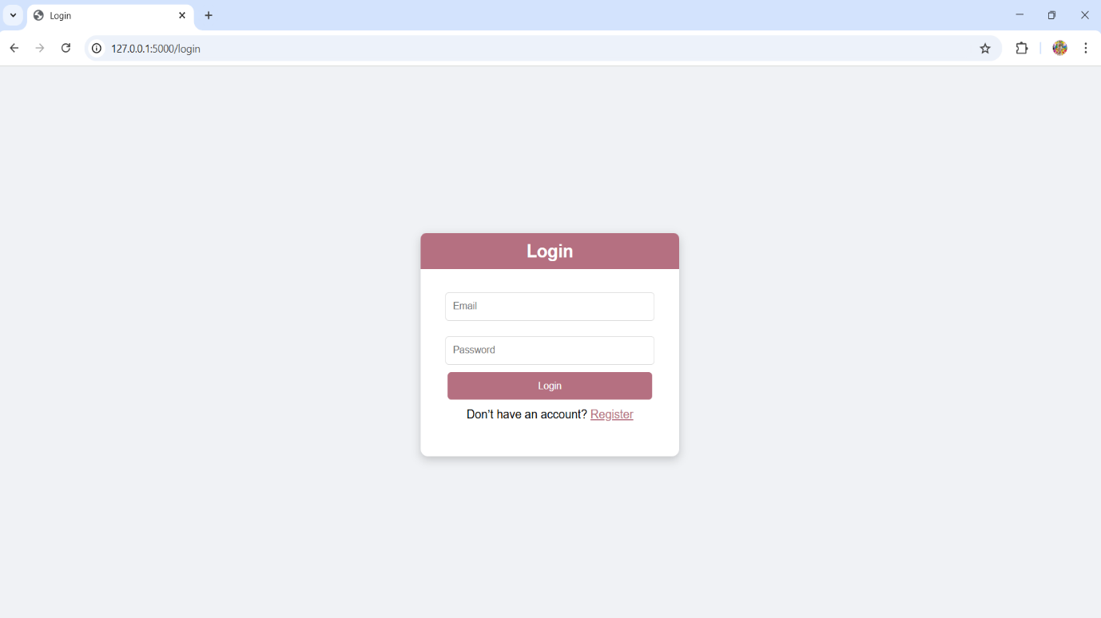
REGISTER PAGE:
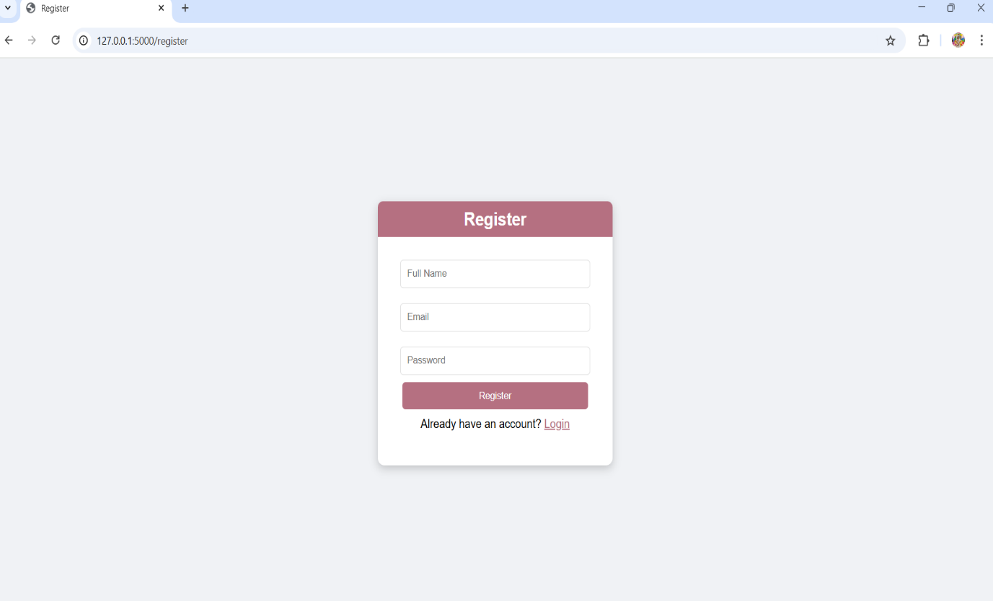

DASHBOARD PAGE: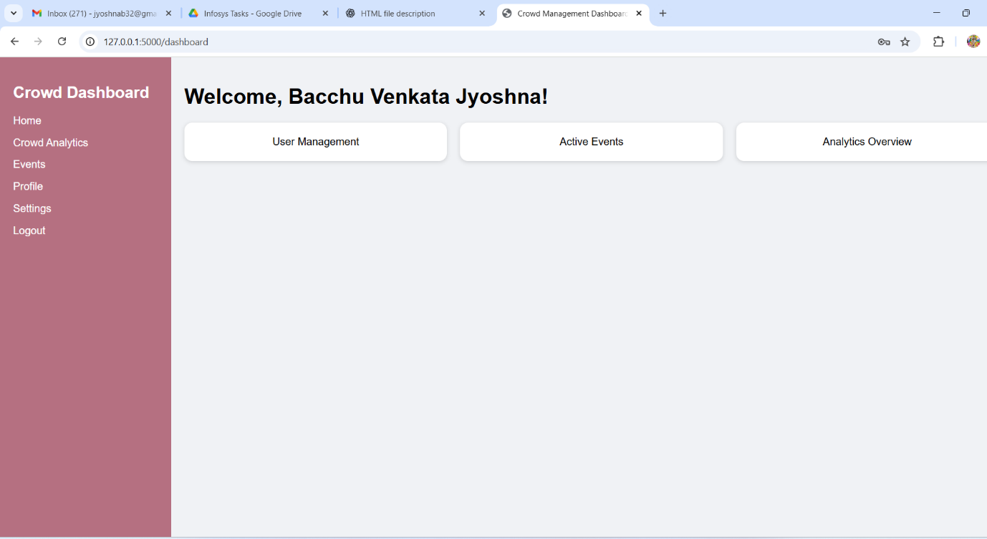

🔹 login.html
• Contains a form for entering email and password.
• Redirects to dashboard after successful login.
• Provides a link to the register page.
🔹 register.html
• Collects name, email, and password.
• Saves user in memory
• Redirects back to login page after registration.
🔹 dashboard.html
• Displays sidebar menu and user-specific greeting (using {{ username }} from Flask session).
• Contains cards for User Management, Active Events, and Analytics.

