WORK EXPERIENCE

t

Skills

Web Designing using HTML,CSS

JavaScript & Reactjs.

Beginner level video editing

Fluent in MS Office

Ahmad Sayeed

Ahmadsayeedbaksh.business@gmail.com

+880 1609 373600

Core Qualifications

Advanced knowledge in Frontend development

Code and quality standards

Time management

Adaptability

Analytical skills

Conflict resolution

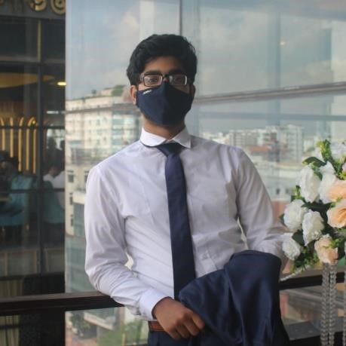

Baksh

CFO(Co-Founder) – Inertia (2023 > Present)

Inertia is a web development company which aims to help digitalize Bangladesh by giving access to high quality websites at a cheap rate for various schools and charity organisation

Freelancer (2024 > Present)

Projects

Saf1 Portfolio

as seen on my portfolio, this webpage presented Safwan Jahan Rian, a UI/UX designer from Bangladesh, showcasing his portfolio and design skills.

Animarta

as seen on my portfolio, this project was aimed to showcase a futuristic design service offering 3D art and AI image generation for visual content enhancement.

EDUCATION

Secondary School Certificate (2023)

The Buds residential Model School and College, Sreemangal

Higher Secondary School Certificate (2025)

Sreemangal Government College, Sreemangal

Language

Bangla - Native English - Bilingual Hindi – Advanced French- Basics