**Kubernetes-2**

Create the K8s EKS,further you have to do the deployment of the Nginx application and access the application outside the cluster.

**Step 1: Set up the Prerequisites**

* AWS CLI
* EKSctl
* Kubectl
* IAM user with EKS permissions

After the above set up completed.

**Step 2: Create EKS Cluster with eksctl**

eksctl create cluster \

--name nginx-cluster \

--region us-east-2 \

--nodegroup-name standard-workers \

--node-type t3.medium \

--nodes 2 \

--nodes-min 1 \

--nodes-max 3 \

--managed

Kubectl version

Once the cluster is created, configure kubectl to interact with it

aws eks --region ap-east-1 update-kubeconfig --name nginx-cluster

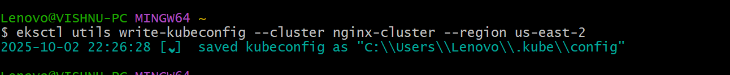

Verify connection:

Kubectl get nodes

**Step 4: Deploy Nginx Application**

Create a deployment:

kubectl create deployment nginx-app --image=nginx

Expose it via a LoadBalancer service:

kubectl expose deployment nginx-app \

--port=80 \

--target-port=80 \

--type=LoadBalancer

**Step 5: Access Nginx Outside the Cluster**

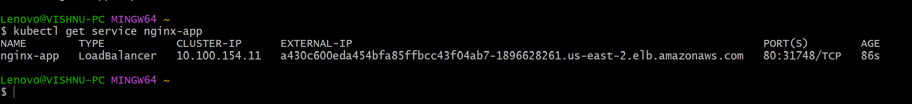

**Browse the External IP :**

**http://<External-IP>**

[**http://a430c600eda454bfa85ffbcc43f04ab7-1896628261.us-east-2.elb.amazonaws.com/**](http://a430c600eda454bfa85ffbcc43f04ab7-1896628261.us-east-2.elb.amazonaws.com/)

