

**Team**

**16WH1A1238**

**K. Sai Keerthi**

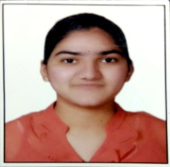

**16WH1A1258**

**T. Soumya**

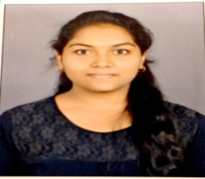

**TEAM**

**11**

**Tools and Technology**

* **Image Processing**
* **Matlab Online R2019b**

**Conclusion and Future Scope**

In this project, we have done tracking of single object in which a video source is given as input. Object Tracking means tracking the progress of objects as they movie in visual scene, thus involves processing spatial as well as temporal changes. Future enhancement of this project is **Multiple Object Tracking,** which performs automatic detection and motion based tracking of moving objects in a video. Detection of moving objects and motion based tracking are important components of many computer vision applications including activity recognition and traffic monitoring. The main steps for tracking multiple objects in a video are 1)Detecting moving objects in each frame. 2) Associating the detections corresponding to the same object over time.

**Guide**

**Ms. N. Pujitha**

**Assistant Professor of IT**

**Pujitha.n@bvrithyderabad.edu.in**

**Architecture**

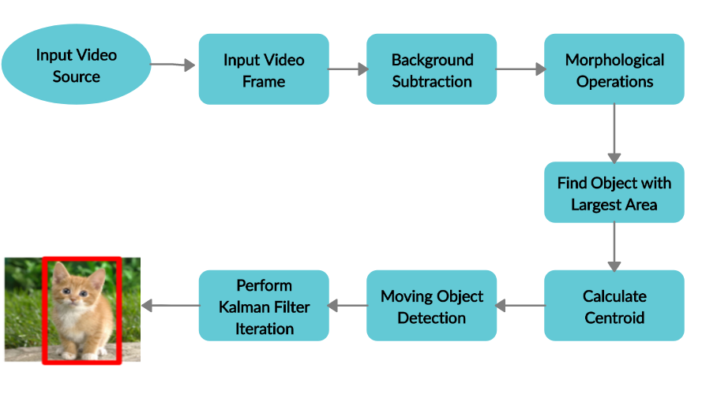

**Modules**

Background Estimation

Frame differencing

Object Registration

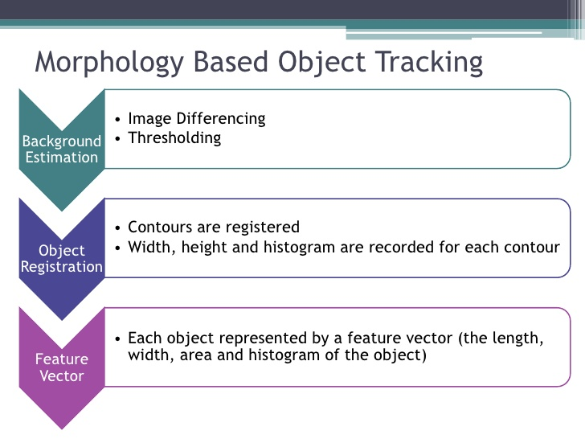

**Abstract**

Single Object Tracking describes the basic technological aspects of Digital Image Processing with special reference to satellite image processing. Basically, all satellite image-processing operations can be grouped into three categories: Image Rectification and Restoration, Enhancement and Information Extraction. Single Object Tracking deals with initial processing of raw image data to correct for geometric distortion, to calibrate the data radio metrically and to eliminate noise present in the data. The enhancement processors are applied to image data in order to effectively display the data for subsequent visual interpretation. It involves techniques for increasing the visual distinction between features in a scene.

**Web 2.0 technologies made users to spend more time on the Internet to search for answers about various questions.**

**Single Object Tracking**

**BVRIT HYDERABAD**

**College of Engineering for Women**

**Department of Information Technology**

**Mini Project - Academic Year 2019-20**