

**Flow Chart**

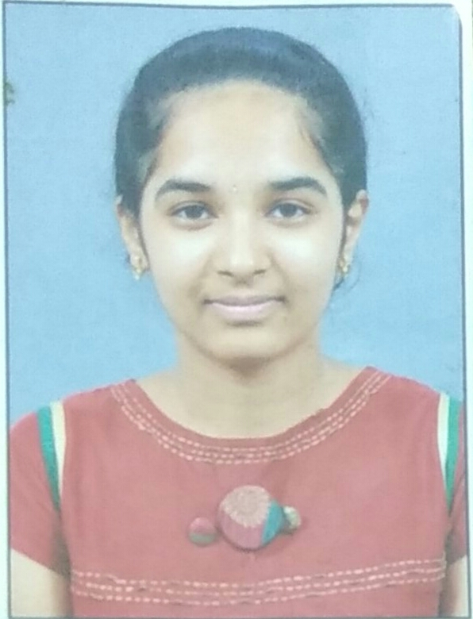 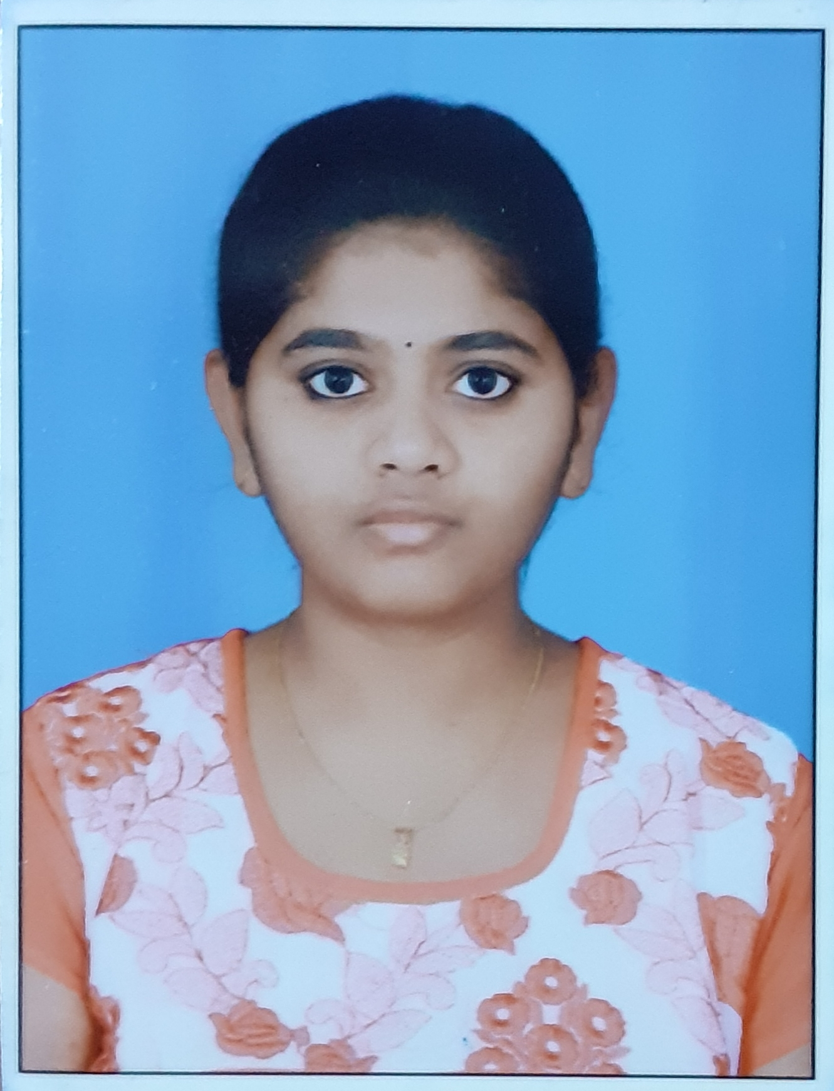

**Guide**

**Mr. CH. Anil Kumar**

**Assistant Professor of IT**

**anilkumar.ch@bvrithyderabad.edu.in**



**TEAM**

**6**

**16wh1a1223**

**G.D.Ramya Shruthi**

**16wh1a1216**

**E. Meghana**

**Tools and Technologies**

* **Python 3**
* **Jupyter Notebook**
* **Pandas**
* **Sklearn**
* **Numpy**

**Conclusion and Future Scope**

In this project, we got to know how to build a recommender system that gives the top 5 movies which are similar to the movies users watch. Through machine learning libraries the desired output is obtained. The future scope of this project is that, dataset containing all movies can be considered instead of only Netflix movies and also develop a live website and integrate the model with it.

**Modules**

Data Preparation

Model Building

Results

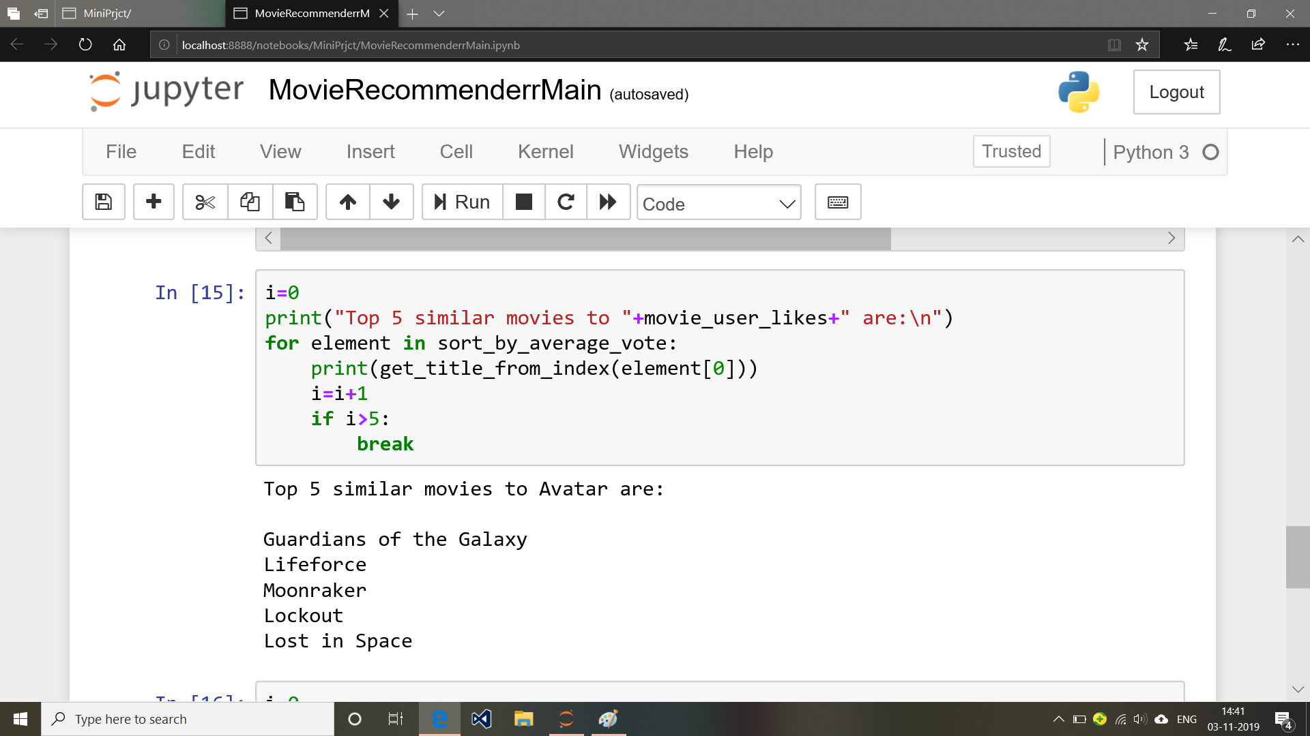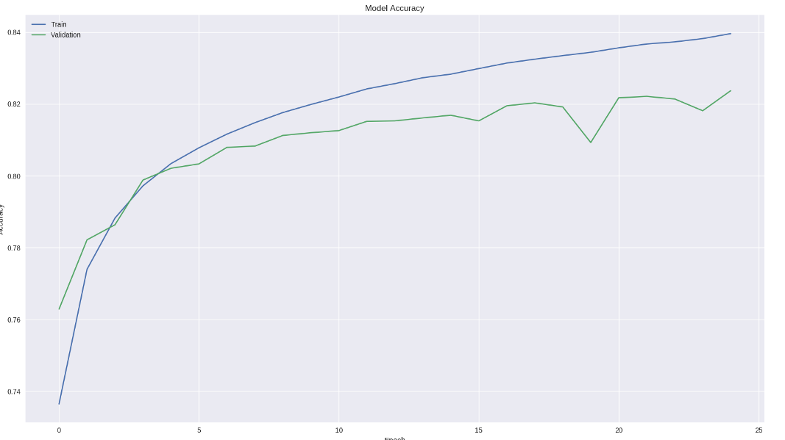

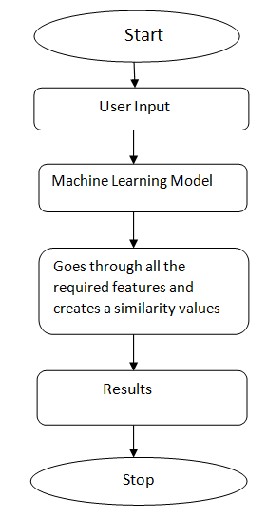

**Movie Recommender**

**Abstract**

Movie Recommender is a machine learning project which helps users to search similar kind of movies. This model is a standalone model which can be integrated to a website containing movies to make this a full fledged one. Movie Recommender suggests the top 5 movies which are similar to the user given movie name from Netflix. The model uses text extraction and feature similarity properties to draw the output, It uses two different vectorizers and shows the differences between them.

**Team**

**BVRIT HYDERABAD**

**College of Engineering for Women**

**Department of Information Technology**

**Mini Project - Academic Year 2019-20**