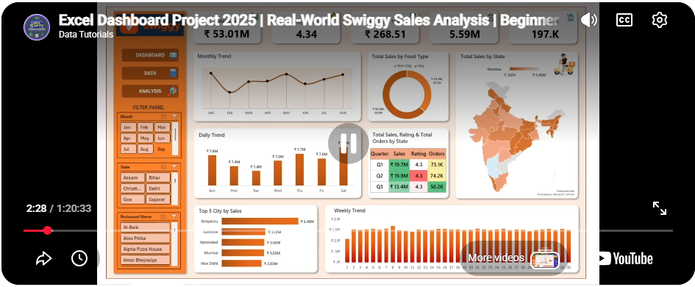
https://www.bing.com/videos/riverview/relatedvideo?q=dashboard+using+excel+with+downloadable+data&&mid=BF30177C762219C1B7CCBF30177C762219C1B7CC&churl=https%3a%2f%2fwww.youtube.com%2fchannel%2fUCBOs6624oqScw8PaU-Jzw9A&FORM=VRDGAR

https://www.bing.com/videos/riverview/relatedvideo?q=dashboard+using+excel+&&mid=F0395CAB2732A0D16E42F0395CAB2732A0D16E42&churl=https%3a%2f%2fwww.youtube.com%2fchannel%2fUCaCF_vQrpzHNcPqhiYyqr2g&FORM=VRDGAR

Swiggy Sales Analysis – Excel Dashboard 📌 Project Overview
This project analyzes Swiggy food delivery sales data using Microsoft Excel to identify sales trends, category performance, and regional insights. The goal is to transform a large raw dataset into meaningful business insights through data preparation, analysis, and interactive dashboards.
📂 Dataset Description
Type: Food delivery sales data
Records: ~197,000 rows
Key Fields:
Order Date
City & State
Restaurant Name
Food Category
Dish Name
Food Type (Veg / Non-Veg – derived)
Price
Rating
Rating Count
This is a practice dataset used for analytical and portfolio purposes.
🧹 Data Preparation
The dataset was prepared for analysis using the following steps:
Converted date fields into month, week, and quarter formats
Created calculated fields such as Total Sales, Average Order Value (AOV), and Quarter
Ensured correct data types for numerical and date columns
Derived Veg / Non-Veg classification using keyword-based logic on dish names
Veg/Non-Veg classification was derived using keyword rules (e.g., chicken, murgh, gosht, egg handling) and may differ from predefined categorizations used in tutorials.
📈 Analysis Performed
Monthly, weekly, and daily sales trend analysis
Sales comparison by Veg vs Non-Veg
State-wise and city-wise sales performance
Identification of top-performing cities by total sales
Quarterly comparison of sales, orders, and ratings
Restaurant-level sales analysis
📊 Dashboard Highlights
KPI cards for:
Total Sales
Total Orders
Average Rating
Rating Count
Average Order Value (AOV)
Interactive slicers for:
Month
Category
Restaurant
Visualizations include:
Line charts for sales trends
Bar charts for city performance
Donut chart for Veg vs Non-Veg sales
Geographic map for state-wise sales
🛠 Tools & Skills Used
Microsoft Excel
Pivot Tables & Pivot Charts
Excel formulas for data transformation
Data Analysis & Validation
Dashboard Design & Data Visualization
🎯 Key Insights
Sales show clear monthly and weekly trends
A small number of cities contribute a significant portion of total revenue
Veg and Non-Veg categories show different revenue distributions
Certain restaurants consistently outperform others in both sales and ratings
🚀 Outcome
The final dashboard provides a consolidated, interactive view of Swiggy’s sales performance, enabling quick identification of high-performing regions, peak ordering periods, and category-level insights to support data-driven decision-making.

