# Markdown Basics

## Favorite Foods

1. Donuts
2. Waffles
3. Rice

## Images

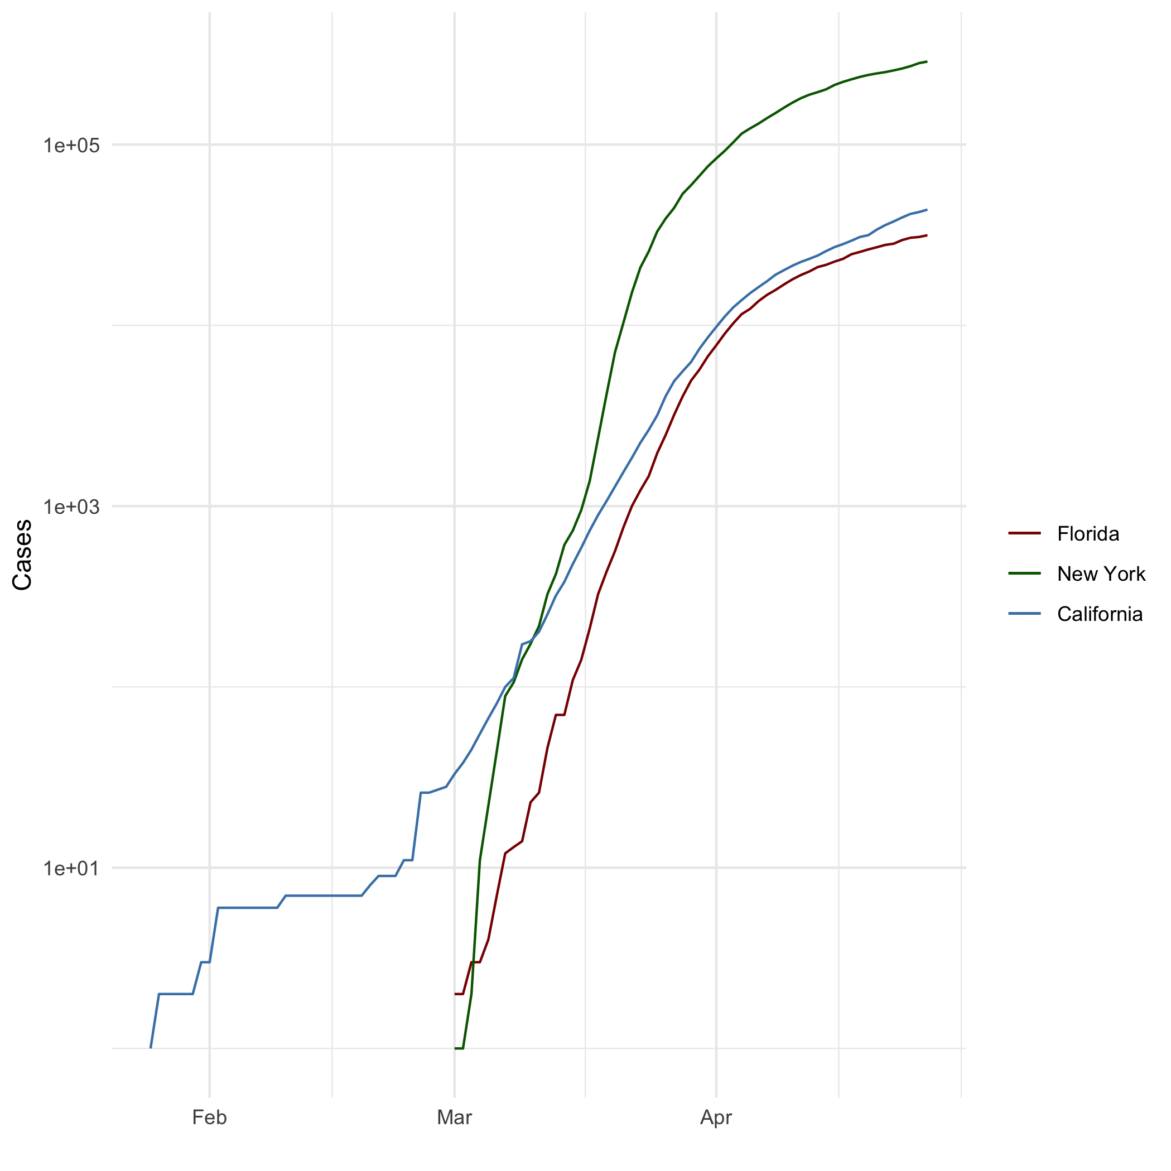 ## Add a Quote > “Do or do not. There is not try.” > — Yoda

## Add an Equation

$$a^{2}+b^{2}=c^{2}$$

## Add a Footnote [^1]: I am Ironman.

## Add Citations

* Lander, J. P. (2017). *R for Everyone*. Pearson Education, Inc.
* Field, A., Miles, J., & Field, Z. (2012). *Discovering Statistics Using R*. SAGE Publications.

# Inline Code

## NY Times COVID-19 Data

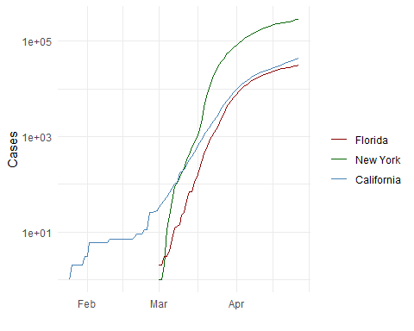

## R4DS Height vs Earnings

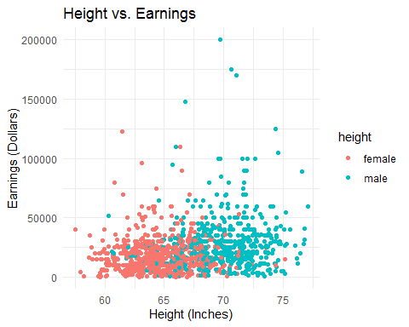

# Tables

## Knitr Table with Kable

One Ring to Rule Them All

|  |  |  |  |  |
| --- | --- | --- | --- | --- |
| name | race | in_fellowship | ring_bearer | age |
| Aragon | Men | TRUE | FALSE | 88 |
| Bilbo | Hobbit | FALSE | TRUE | 129 |
| Frodo | Hobbit | TRUE | TRUE | 51 |
| Galadriel | Elf | FALSE | FALSE | 7000 |
| Sam | Hobbit | TRUE | TRUE | 36 |
| Gandalf | Maia | TRUE | TRUE | 2019 |
| Legolas | Elf | TRUE | FALSE | 2931 |
| Sauron | Maia | FALSE | TRUE | 7052 |
| Gollum | Hobbit | FALSE | TRUE | 589 |

|  |  |  |  |  |
| --- | --- | --- | --- | --- |
| name | race | in_fellowship | ring_bearer | age |
| Aragon | Men | TRUE | FALSE | 88 |
| Bilbo | Hobbit | FALSE | TRUE | 129 |
| Frodo | Hobbit | TRUE | TRUE | 51 |
| Galadriel | Elf | FALSE | FALSE | 7000 |
| Sam | Hobbit | TRUE | TRUE | 36 |
| Gandalf | Maia | TRUE | TRUE | 2019 |
| Legolas | Elf | TRUE | FALSE | 2931 |
| Sauron | Maia | FALSE | TRUE | 7052 |
| Gollum | Hobbit | FALSE | TRUE | 589 |

## Pandoc Table

The Lord of the Rings

|  |  |  |  |  |
| --- | --- | --- | --- | --- |
| Name | Race | Is In Fellowship? | Is Ring Bearer? | Age |
| Aragon | Men | Yes | No | 88 |
| Bilbo | Hobbit | No | Yes | 129 |
| Frodo | Hobbit | Yes | Yes | 51 |
| Sam | Hobbit | Yes | Yes | 36 |
| Sauron | Maia | No | Yes | 7052 |

# References

Lander, J. P. (2017). *R for Everyone*. Pearson Education, Inc.