**Documentation**

<https://github.com/BVlad917/flcd_labs>

Write a program that:

1. Reads the elements of a FA (from file).

2. Displays its elements, using a menu: the set of states, the alphabet, all the transitions, the initial state and the set of final states.

3. For a DFA, verifies if a sequence is accepted by the FA.

**Deliverables:**

1. FA.in - input file (*on Github*)
2. Source code (*on Github*)
3. Documentation. It should also include in BNF or EBNF format the form in which the FA.in file should be written (*on Moodle and Github*)

***Max grade = 9***

***Max grade = 10:*** Use FA to detect tokens <identifier> and <integer constant> in the scanner program

**Analysis:** The finite automata will be read from an input file. It will support two main operations: we can verify if the finite automata is a DFA or not and we can verify if a given sequence is accepted by the finite automata. Internally, the finite automata will store all relevant information, such as: the states, the alphabet, the transitions, and the initial and final states. Finally, the finite automata will be used in the Scanner to check if a given sequence is a valid integer or a valid identifier given our language specification.

**Implementation:**

letter ::= “a” | “b” | “c” | … | “z” | “A” | “B” | “C” | … | “Z”

digit ::= “0” | “1” | “2” | … | “9”

state ::= letter{letter|digit}

accepted ::= letter|digit|”_”|”+”|”-”|”#”

transition ::= “(”state”,”accepted”,”state”)”

states ::= “Q=”state{“ ”state}

alphabet ::= “S=accepted{“ ”accepted}”

transitions ::= “T=”transition{“ ”transition}

initial_state ::= “IS=”state

final_states ::= “FS=”state{“ ”state}

comment_line ::= “#”{digit|letter|” ”|”^” |”(”|”)”|”-”|”?”|”[”|”]”|”+”|”-”|”*”|”$”|”’”|”|”}

input_file ::= {comment_line} ”\n” states “\n” alphabet “\n” transitions “\n” initial_state “\n” final_states

The input file is read and parsed when the finite automata is initialized (in the constructor, so it needs a file path as input). The two main methods the FA implements are: verify if the FA is a DFA or not, and verify if a given sequence is accepted by the FA.

To check if the FA is a DFA or not, we create a dictionary where the keys are “(state, accepted)” pairs, and the values are “result” (i.e., the key is “(from, accepted)” and the value is “to”). We group this dictionary by key (i.e., put in a list all “results” which have the same key), and we check that all the values in this grouped dictionary (where the values are now lists) have length of at most 1.

To verify if a given sequence is accepted by the FA, we use a modified DFS algorithm in which we push on a stack pairs where the first element is the current state and the second element is the currently remaining sequence. Each time we pop an element from the stack we take the state’s neighbors (which can be accessed using the first element in the currently remaining sequence) and we push that neighbor state along with the currently remaining sequence WITHOUT the first character. If we get to a point where the currently remaining sequence is empty AND the current state is a final state, then the sequence is accepted by the FA. If we get to the end of the DFS algorithm and the condition was never satisfied, then the sequence is not accepted by the FA.

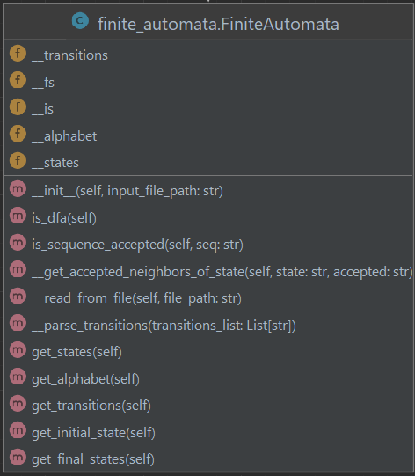

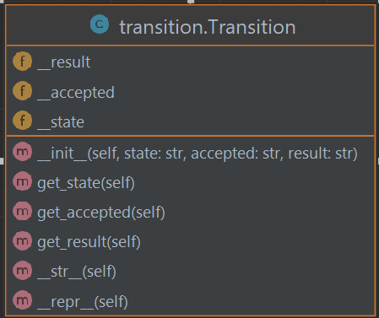

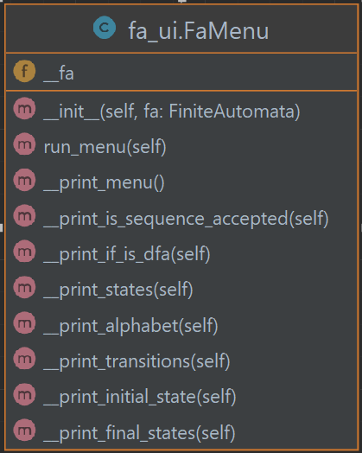

**Testing:** We created tests for the two main methods of the Finite Automata program (checking if the FA is a DFA or not, and checking if a given sequence is accepted by the FA)

Tests for checking if a given sequence is accepted:

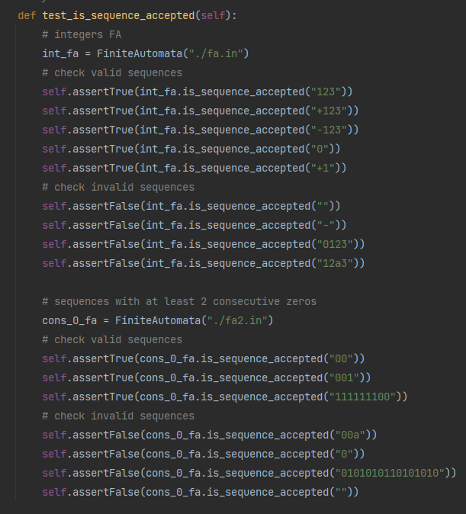

Tests for checking if the FA is a DFA or not:

