Wallkill Reporting Draft

NYSDEC SMAS

2020-11-02

# Section 1 - General

Table 1: Wallkill River (WALK) sampling locations. Locations are ordered from upstream to downstream according to river mile and mainstem confluence

| **Location ID** | **Group** | **Rivermile** | **WI/PWL** | **Waterbody   Classification** | **Description** | **Latitude** | **Longitude** |
| --- | --- | --- | --- | --- | --- | --- | --- |
| 13-WALK-60.1 | Wallkill Main Stem | 60.1 | 1306-0017 | C | OIL CITY RD. AT USFWS WILDLIFE REFUGE (BEFORE 2017. SAMPLES WERE TAKEN 0.4 MILES OFF STATE LINE RD. ON FARM RD.). | 41.29083 | -74.53056 |
| 13-POCH-1.8 | Upper Wallkill Trib | 1.8 | 1306-0078 | C | TRANSPORT LN OFF COUTNY ROUTE 1. ACCESS BEHIND BARN NEXT TO CALF PEN. FOLLOW PEN OM THE LEFT SIDE AND ACCESS RIVER FROM BEHIND. | 41.30042 | -74.47224 |
| 13-RUTG-1.5 | Upper Wallkill Trib | 1.5 | 1306-0006 | C | 20 METERS DOWNSTREAM OF COUNTY RTE 12. | 41.33579 | -74.48799 |
| 13-QKER-0.9 | Upper Wallkill Trib | 0.9 | 1306-0025 | C | 30 M BELOW RT. 6 BRIDGE. | 41.32722 | -74.41639 |
| 13-RIOG-0.7 | Upper Wallkill Trib | 0.7 | 1306-0061 | C | AT 6 1/2 STATION RD. OVERPASS. DOWNSTREAM OF VILLAGE OF GOSHEN. | 41.40115 | -74.35923 |
| 13-WCHEE-0.6 | Upper Wallkill Trib | 0.6 | 1306-0061 | C | HARTLEY RD. | 41.40860 | -74.37299 |
| 13-WALK-46.6 | Wallkill Main Stem | 46.6 | 1306-0017 | C | AT ECHO LAKE RD. BRIDGE. | 41.41222 | -74.37805 |
| 13-MONH-4.1 | Upper Wallkill Trib | 4.1 | 1306-0074 | C | 200 M UPSTREAM OF MIDDLETOWN STP DISCHARGE. | 41.42833 | -74.42389 |
| 13-MONH-0.4 | Upper Wallkill Trib | 0.4 | 1306-0074 | C | 20 M ABOVE GOLF LINKS RD. BRIDGE. 4.1 MI. BELOW STP. | 41.42361 | -74.38111 |
| 13-LGUN-6.0 | Upper Wallkill Trib | 6.0 | 1306-0059 | B | AT MAPES RD. BRIDGE. | 41.45587 | -74.49380 |
| 13-GUNK-40.3 | Upper Wallkill Trib | 40.3 | 1306-0048 | A | AT KOHLER RD. | 41.42198 | -74.56069 |
| 13-GUNK-37.7 | Upper Wallkill Trib | 37.7 | 1306-0047 | B | AT RTE 24 BRIDGE. | 41.44134 | -74.52977 |
| 13-GUNK_T35-0.2 | Upper Wallkill Trib | 0.2 | 1306-0047 | B | AT RTE 24 BRIDGE. | 41.43961 | -74.53890 |
| 13-MASO-0.2 | Upper Wallkill Trib | 0.2 | 1306-0072 | B | AT COUNTY ROUTE 50 (GOLF LINKS RD.) OVERPASS. UPSTREAM OF CONFLUENCE WITH WALLKILL RIVER. | 41.43765 | -74.37287 |
| 13-WALK-44.4 | Wallkill Main Stem | 44.4 | 1306-0038 | B | AT MIDWAY RD. BRIDGE. | 41.43879 | -74.36565 |
| 13-WALK-35.6 | Wallkill Main Stem | 35.6 | 1306-0038 | B | 20 M BELOW RT. 211 BRIDGE. | 41.50250 | -74.26334 |
| 13-WALK-29.9 | Wallkill Main Stem | 29.9 | 1306-0038 | B | ACCESS VIA PARK ON FARM MEADOW LANE. | 41.54217 | -74.20946 |
| 13-TINW-0.5 | Middle Wallkill Trib | 0.5 | 1306-0068 | A | AT ULSTER AVE./RTE 208 BRIDGE. | 41.57325 | -74.18353 |
| 13-WALK-26.9 | Wallkill Main Stem | 26.9 | 1306-0038 | B | DOWNSTREAM OF TIN BROOK. SR 208. | 41.57630 | -74.19071 |
| 13-DWAR-2.0 | Middle Wallkill Trib | 2.0 | 1306-0062 | C | 10 M ABOVE BATES RD. BRIDGE. | 41.62444 | -74.19945 |
| 13-WALK-22.8 | Wallkill Main Stem | 22.8 | 1306-0038 | B | 10 M ABOVE BRIDGE. | 41.63500 | -74.18889 |
| 13-WALK-19.0 | Wallkill Main Stem | 19.0 | 1306-0045 | B | LAZY RIVER CAMPGROUND-20 M ABOVE SHAWANGUNK CONFL. | 41.68306 | -74.16444 |
| 13-GUNK-0.4 | Middle Wallkill Trib | 0.4 | 1306-0045 | B | 150 M BELOW CO. RT. 9 BRIDGE. | 41.68722 | -74.17278 |
| 13-PKIL-0.4 | Middle Wallkill Trib | 0.4 | 1306-0044 | B(T) | 10 M ABOVE RTE 208 BRIDGE. | 41.72528 | -74.10472 |
| 13-WALK-9.8 | Wallkill Main Stem | 9.8 | 1306-0027 | B | (MULTIPLATE) UPSTREAM OF NEW PALTZ GOLF COURSE. BOAT LAUNCH UPSTREAM OF RTE 209 AT 41.743779 / -74.092916. | 41.76574 | -74.09297 |
| 13-WKLEI-0.6 | Lower Wallkill Trib | 0.6 | 1306-0042 | C | DUG RD. | 41.77490 | -74.09750 |
| 13-WALK-2.1 | Wallkill Main Stem | 2.1 | 1306-0027 | B | OFF SR 213. NEAR DASHVILLE. | 41.82530 | -74.04720 |
| 13-WALK-0.7 | Wallkill Main Stem | 0.7 | 1306-0037 | B | STURGEON POOL DEEP HOLE. | 41.84705 | -74.04382 |
| 13-SWAK-1.7 | Lower Wallkill Trib | 1.7 | 1306-0039 | B |  | 41.83242 | -74.03169 |
| 13-WALK-0.8 | Wallkill Main Stem | 0.8 | 1306-0037 | B | AT SHORELINE OF STURGEON POOL. CLOSEST MAY BE OFF SR 213. | 41.84790 | -74.03718 |

# Section 1A - Water Chemistry and Stream Discharge

## Analyte Table

Table 2: Water chemistry analytes sampled as part of the Wallkill River Stream Assessment Survey. Table lists sampled analytes and analytical specifications. ^ Precision objectives are defined by results of duplicate samples as described in Appendix III

| **Analytes** | **Analytical  Lab** | **Method** | **Precision** | **Accuracy** | **Calibration:   Initial** | **Calibration:   Ongoing** | **Calibration:   Blanks** | **Detection   Limit** | **Reporting   Limit** |
| --- | --- | --- | --- | --- | --- | --- | --- | --- | --- |
| Temperature | in situ | 2550 B | ± 1oC | ± 1.5oC | Factory Set | ~ | ~ | ~ | ~ |
| Dissolved Oxygen | in situ | 4500-O G | ± 1% | ± 2% | Daily | ~ | ~ | ~ | ~ |
| pH | in situ | 4500-H+B | ± .05 SU | ± .2 SU | Weekly | ~ | ~ | ~ | ~ |
| Salinity | in situ | Calculated | 0.001 ppt | ± 1% | N/A | ~ | ~ | ~ | ~ |
| Specific Conductance | in situ | 2510 B | ± 1µs/cm | ± 1% | Weekly | ~ | ~ | ~ | ~ |
| Ammonia | ALS | D6919-09 | ^ | ± 20% | As needed | Every 10 | Every 10 | 0.008 mg/L | 0.01 mg/L |
| Total Kjeldahl Nitrogen | ALS | EPA 351.2 | ^ | ± 20% | Daily | Every 10 | Every 10 | 0.08 mg/L | 0.1 mg/L |
| Nitrogen, Nitrate | ALS | EPA 353.2 | ^ | ± 20% | Daily | Every 10 | Every 10 | 0.02 mg/L | 0.05 mg/L |
| Nitrogen, Total | ALS | Calculated | ^ |  |  |  |  |  |  |
| Total Phosphorus | ALS | EPA 365.1 | ^ | ± 20% | Daily | Every 10 | Every 10 | 0.002 mg/L | 0.003 mg/L |
| Ortho-phosphate | ALS | EPA 365.1 | ^ | ± 20% | Daily | Every 10 | Every 10 | 0.001 mg/L | 0.005 mg/L |
| Total Dissolved Solids | ALS | SM 2540C | ^ | ± 20% | Daily | Every 20 | Every 20 | 4.0 mg/L | 10 mg/L |
| Turbidity | ALS | EPA 180.1 | ^ | ± 10% | Daily | Every 10 | Every 10 | 0.06 NTU | 0.1 NTU |
| Dissolved Organic Carbon | ALS | 5310C | ^ | ± 20% | As needed | Ever 10 | Every 10 | 0.4 mg/L | 10 mg/L |
| Alkalinity | ALS | SM 2320B | ^ | ± 20% | Daily | Every 10 | Every 10 | 1.0 mg/L | 2.0 mg/L |
| Hardness | ALS | SM 2340C | ^ | ± 20% | Daily | Every 10 | Every 10 | 0.3 mg/L | 2.0 mg/L |
| Calcium | ALS | EPA 200.7 | ^ | ± 20% | Daily | Every 10 | Every 10 | 0.1 mg/L | 1.0 mg/L |
| Magnesium | ALS | EPA 200.7 | ^ | ± 20% | Daily | Every 10 | Every 10 | 0.04 mg/L | 1.0 mg/L |
| Potassium | ALS | EPA 200.7 | ^ | ± 20% | Daily | Every 10 | Every 10 | 0.06 mg/L | 2.0 mg/L |
| Sodium | ALS | EPA 200.7 | ^ | ± 20% | Daily | Every 10 | Every 10 | 0.03 mg/L | 1.0 mg/L |
| Chloride | ALS | EPA 300.0 | ^ | ± 20% | As needed | Every 10 | Every 10 | 0.02 mg/L | 0.2 mg/L |
| Fluoride | ALS | EPA 300.0 | ^ | ± 20% | As needed | Every 10 | Every 10 | 0.004 mg/L | 0.1 mg/L |
| Sulfate | ALS | EPA 300.0 | ^ | ± 20% | As needed | Every 10 | Every 10 | 0.02 mg/L | 0.2 mg/L |
| Iron (total) | ALS | EPA 200.7 | ^ | ± 20% | Daily | Every 10 | Every 10 | 6 µ/L | 100 µ/L |
| Manganese (total) | ALS | EPA 200.7 | ^ | ± 20% | Daily | Every 10 | Every 10 | 0.5 µ/L | 10 µ/L |
| Arsenic (total) | ALS | EPA 200.8 | ^ | ± 20% | Daily | Every 10 | Every 10 | 0.3 µ/L | 1 µ/L |
| Silver (total) | ALS | EPA 200.8 | ^ | ± 20% | Daily | Every 10 | Every 10 | 0.07 µ/L | 1 µ/L |
| Aluminum (total) | ALS | EPA 200.8 | ^ | ± 20% | Daily | Every 10 | Every 10 | 4.0 µ/L | 50 µ/L |
| Cadmium (total) | ALS | EPA 200.8 | ^ | ± 20% | Daily | Every 10 | Every 10 | 0.03 µ/L | 1 µ/L |
| Copper (total) | ALS | EPA 200.8 | ^ | ± 20% | Daily | Every 10 | Every 10 | 0.04 µ/L | 1 µ/L |
| Lead (total) | ALS | EPA 200.8 | ^ | ± 20% | Daily | Every 10 | Every 10 | 0.08 µ/L | 1 µ/L |
| Nickel (total) | ALS | EPA 200.8 | ^ | ± 20% | Daily | Every 10 | Every 10 | 0.04 µ/L | 1 µ/L |
| Zinc (total) | ALS | EPA 200.8 | ^ | ± 20% | Daily | Every 10 | Every 10 | 0.7 µ/L | 10 µ/L |
| Aluminum (dissolved) | ALS | EPA 200.8 | ^ | ± 20% | Daily | Every 10 | Every 10 | 0.9 µ/L | 10 µ/L |
| Cadmium (dissolved) | ALS | EPA 200.8 | ^ | ± 20% | Daily | Every 10 | Every 10 | 0.02 µ/L | 1 µ/L |
| Copper (dissolved) | ALS | EPA 200.8 | ^ | ± 20% | Daily | Every 10 | Every 10 | 0.02 µ/L | 1 µ/L |
| Lead (dissolved) | ALS | EPA 200.8 | ^ | ± 20% | Daily | Every 10 | Every 10 | 0.02 µ/L | 1 µ/L |
| Nickel (dissolved) | ALS | EPA 200.8 | ^ | ± 20% | Daily | Every 10 | Every 10 | 0.1 µ/L | 1 µ/L |
| Zinc (dissolved) | ALS | EPA 200.8 | ^ | ± 20% | Daily | Every 10 | Every 10 | 3 µ/L | 5 µ/L |

## Water Chemistry by PWL ID

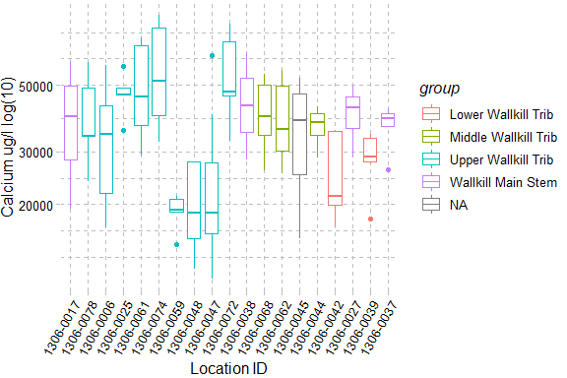

Figure 1: Calcium, The X-axis presents sampling locations from upstream to downstream and axis labels correspond with Table 1, Figure 1 and Figure 2. Point symbols match with WI/PWL segmentation as indicated in the plot legend. The total number of reported values illustrated for each sampling location can vary due to non-detection and QA/QC procedures. Descriptions of removed records are presented in Appendix III.

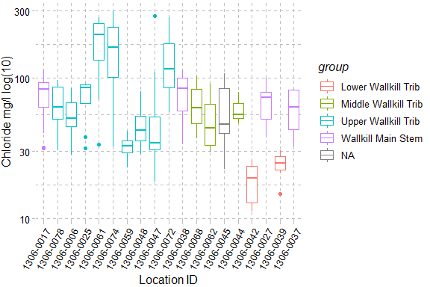

Figure 2: Chloride, The X-axis presents sampling locations from upstream to downstream and axis labels correspond with Table 1, Figure 1 and Figure 2. Point symbols match with WI/PWL segmentation as indicated in the plot legend. The total number of reported values illustrated for each sampling location can vary due to non-detection and QA/QC procedures. Descriptions of removed records are presented in Appendix III.

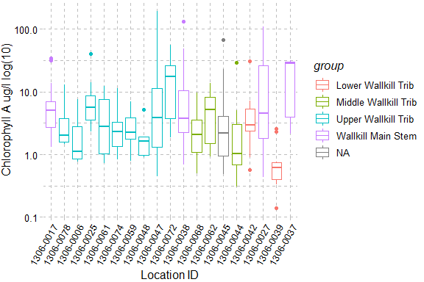

Figure 3: Chlorophyll A, The X-axis presents sampling locations from upstream to downstream and axis labels correspond with Table 1, Figure 1 and Figure 2. Point symbols match with WI/PWL segmentation as indicated in the plot legend. The total number of reported values illustrated for each sampling location can vary due to non-detection and QA/QC procedures. Descriptions of removed records are presented in Appendix III.

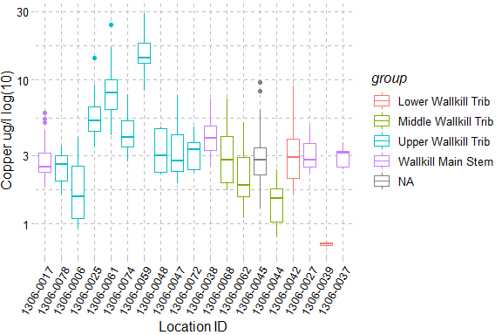

Figure 4: Copper, The X-axis presents sampling locations from upstream to downstream and axis labels correspond with Table 1, Figure 1 and Figure 2. Point symbols match with WI/PWL segmentation as indicated in the plot legend. The total number of reported values illustrated for each sampling location can vary due to non-detection and QA/QC procedures. Descriptions of removed records are presented in Appendix III.

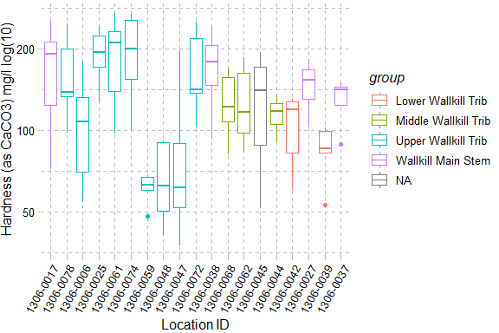

Figure 5: Hardness (as CaCO3), The X-axis presents sampling locations from upstream to downstream and axis labels correspond with Table 1, Figure 1 and Figure 2. Point symbols match with WI/PWL segmentation as indicated in the plot legend. The total number of reported values illustrated for each sampling location can vary due to non-detection and QA/QC procedures. Descriptions of removed records are presented in Appendix III.

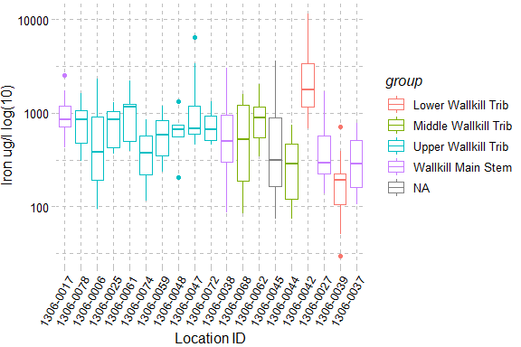

Figure 6: Iron, The X-axis presents sampling locations from upstream to downstream and axis labels correspond with Table 1, Figure 1 and Figure 2. Point symbols match with WI/PWL segmentation as indicated in the plot legend. The total number of reported values illustrated for each sampling location can vary due to non-detection and QA/QC procedures. Descriptions of removed records are presented in Appendix III.

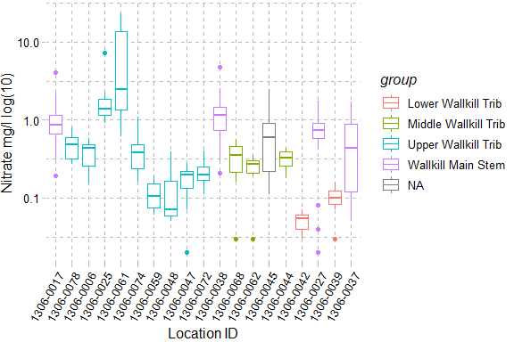

Figure 7: Nitrate, The X-axis presents sampling locations from upstream to downstream and axis labels correspond with Table 1, Figure 1 and Figure 2. Point symbols match with WI/PWL segmentation as indicated in the plot legend. The total number of reported values illustrated for each sampling location can vary due to non-detection and QA/QC procedures. Descriptions of removed records are presented in Appendix III.

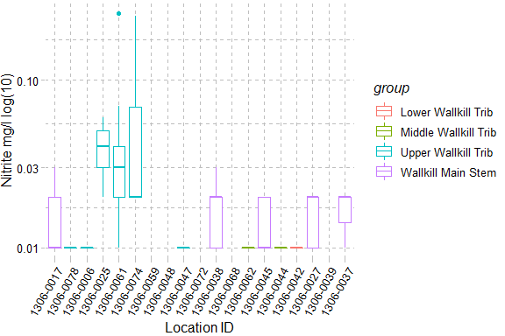

Figure 8: Nitrite, The X-axis presents sampling locations from upstream to downstream and axis labels correspond with Table 1, Figure 1 and Figure 2. Point symbols match with WI/PWL segmentation as indicated in the plot legend. The total number of reported values illustrated for each sampling location can vary due to non-detection and QA/QC procedures. Descriptions of removed records are presented in Appendix III.

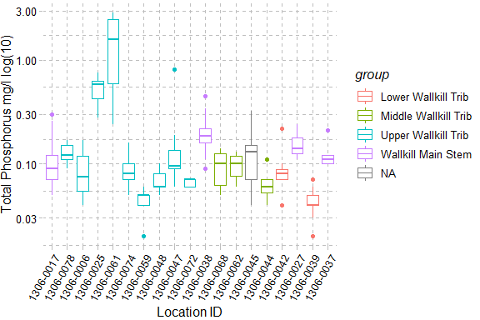

Figure 9: Total Phosphorus, The X-axis presents sampling locations from upstream to downstream and axis labels correspond with Table 1, Figure 1 and Figure 2. Point symbols match with WI/PWL segmentation as indicated in the plot legend. The total number of reported values illustrated for each sampling location can vary due to non-detection and QA/QC procedures. Descriptions of removed records are presented in Appendix III.

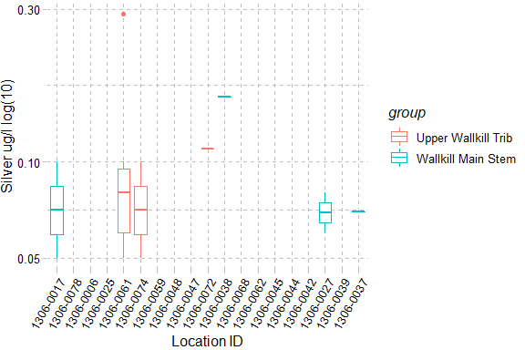

Figure 10: Silver, The X-axis presents sampling locations from upstream to downstream and axis labels correspond with Table 1, Figure 1 and Figure 2. Point symbols match with WI/PWL segmentation as indicated in the plot legend. The total number of reported values illustrated for each sampling location can vary due to non-detection and QA/QC procedures. Descriptions of removed records are presented in Appendix III.

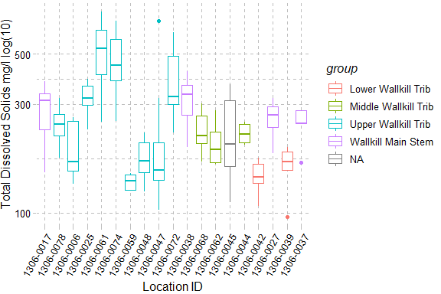

Figure 11: Total Dissolved Solids, The X-axis presents sampling locations from upstream to downstream and axis labels correspond with Table 1, Figure 1 and Figure 2. Point symbols match with WI/PWL segmentation as indicated in the plot legend. The total number of reported values illustrated for each sampling location can vary due to non-detection and QA/QC procedures. Descriptions of removed records are presented in Appendix III.

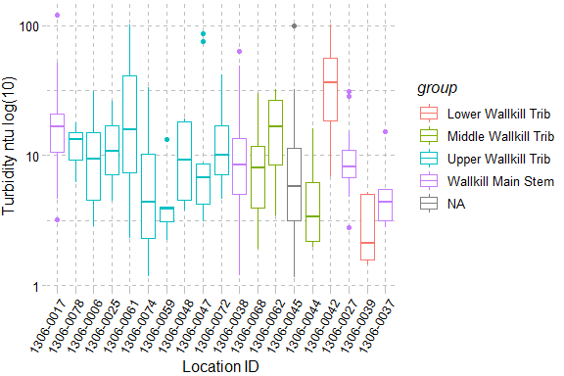

Figure 12: Turbidity, The X-axis presents sampling locations from upstream to downstream and axis labels correspond with Table 1, Figure 1 and Figure 2. Point symbols match with WI/PWL segmentation as indicated in the plot legend. The total number of reported values illustrated for each sampling location can vary due to non-detection and QA/QC procedures. Descriptions of removed records are presented in Appendix III.

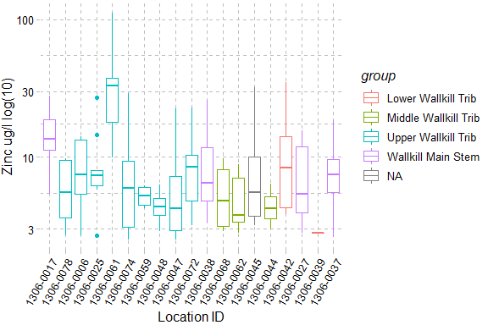

Figure 13: Zinc, The X-axis presents sampling locations from upstream to downstream and axis labels correspond with Table 1, Figure 1 and Figure 2. Point symbols match with WI/PWL segmentation as indicated in the plot legend. The total number of reported values illustrated for each sampling location can vary due to non-detection and QA/QC procedures. Descriptions of removed records are presented in Appendix III.

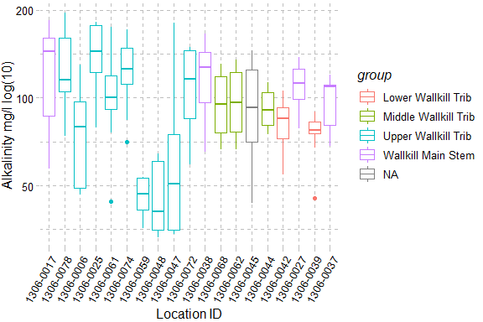

Figure 14: Alkalinity, The X-axis presents sampling locations from upstream to downstream and axis labels correspond with Table 1, Figure 1 and Figure 2. Point symbols match with WI/PWL segmentation as indicated in the plot legend. The total number of reported values illustrated for each sampling location can vary due to non-detection and QA/QC procedures. Descriptions of removed records are presented in Appendix III.

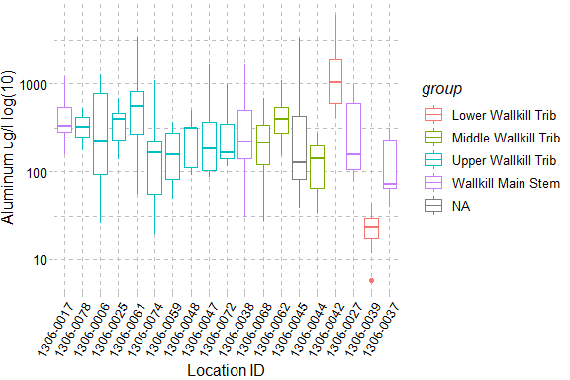

Figure 15: Aluminum, The X-axis presents sampling locations from upstream to downstream and axis labels correspond with Table 1, Figure 1 and Figure 2. Point symbols match with WI/PWL segmentation as indicated in the plot legend. The total number of reported values illustrated for each sampling location can vary due to non-detection and QA/QC procedures. Descriptions of removed records are presented in Appendix III.

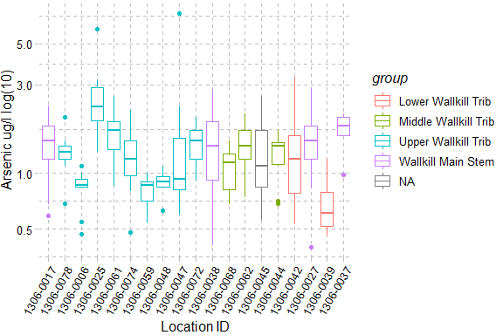

Figure 16: Arsenic, The X-axis presents sampling locations from upstream to downstream and axis labels correspond with Table 1, Figure 1 and Figure 2. Point symbols match with WI/PWL segmentation as indicated in the plot legend. The total number of reported values illustrated for each sampling location can vary due to non-detection and QA/QC procedures. Descriptions of removed records are presented in Appendix III.

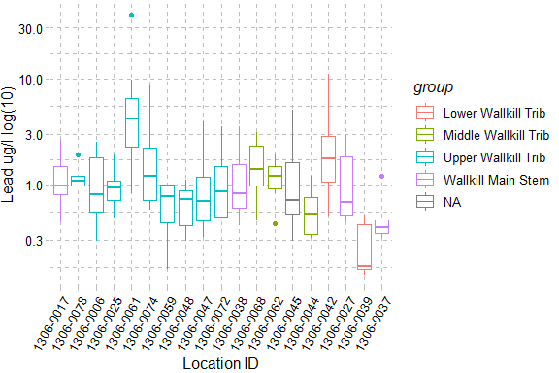

Figure 17: Lead, The X-axis presents sampling locations from upstream to downstream and axis labels correspond with Table 1, Figure 1 and Figure 2. Point symbols match with WI/PWL segmentation as indicated in the plot legend. The total number of reported values illustrated for each sampling location can vary due to non-detection and QA/QC procedures. Descriptions of removed records are presented in Appendix III.

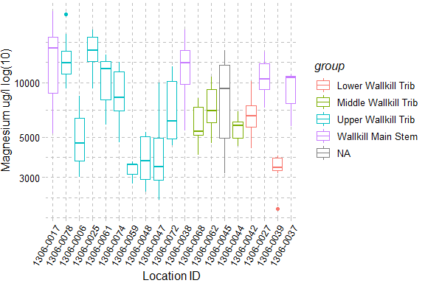

Figure 18: Magnesium, The X-axis presents sampling locations from upstream to downstream and axis labels correspond with Table 1, Figure 1 and Figure 2. Point symbols match with WI/PWL segmentation as indicated in the plot legend. The total number of reported values illustrated for each sampling location can vary due to non-detection and QA/QC procedures. Descriptions of removed records are presented in Appendix III.

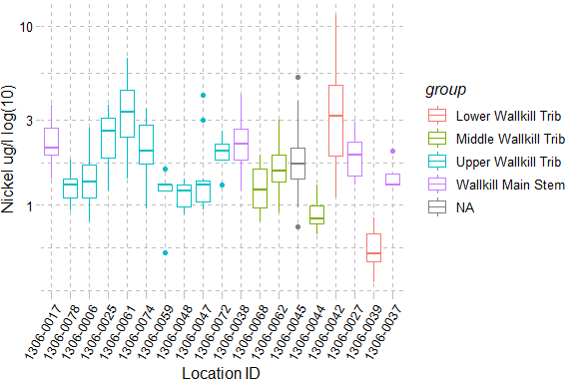

Figure 19: Nickel, The X-axis presents sampling locations from upstream to downstream and axis labels correspond with Table 1, Figure 1 and Figure 2. Point symbols match with WI/PWL segmentation as indicated in the plot legend. The total number of reported values illustrated for each sampling location can vary due to non-detection and QA/QC procedures. Descriptions of removed records are presented in Appendix III.

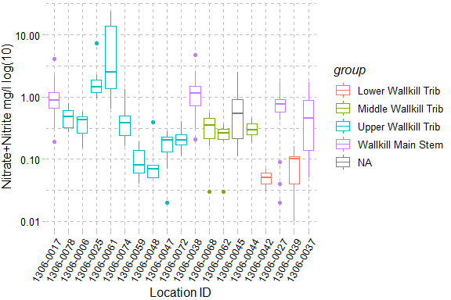

Figure 20: Nitrate+Nitrite, The X-axis presents sampling locations from upstream to downstream and axis labels correspond with Table 1, Figure 1 and Figure 2. Point symbols match with WI/PWL segmentation as indicated in the plot legend. The total number of reported values illustrated for each sampling location can vary due to non-detection and QA/QC procedures. Descriptions of removed records are presented in Appendix III.

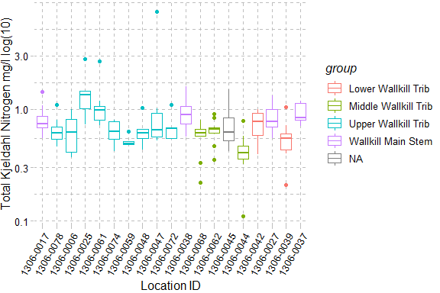

Figure 21: Total Kjeldahl Nitrogen, The X-axis presents sampling locations from upstream to downstream and axis labels correspond with Table 1, Figure 1 and Figure 2. Point symbols match with WI/PWL segmentation as indicated in the plot legend. The total number of reported values illustrated for each sampling location can vary due to non-detection and QA/QC procedures. Descriptions of removed records are presented in Appendix III.

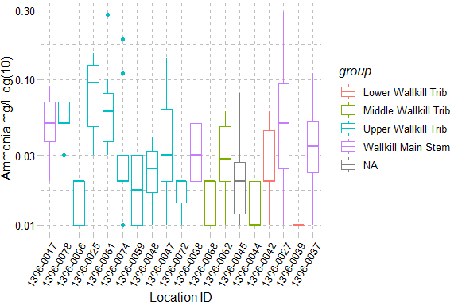

Figure 22: Ammonia, The X-axis presents sampling locations from upstream to downstream and axis labels correspond with Table 1, Figure 1 and Figure 2. Point symbols match with WI/PWL segmentation as indicated in the plot legend. The total number of reported values illustrated for each sampling location can vary due to non-detection and QA/QC procedures. Descriptions of removed records are presented in Appendix III.

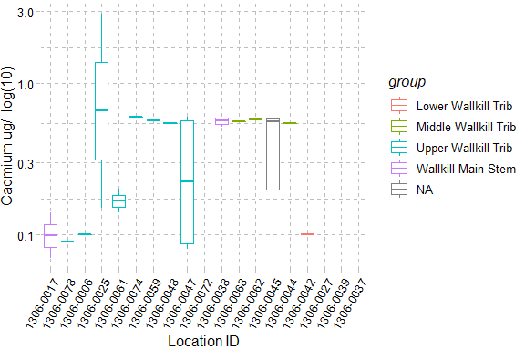

Figure 23: Cadmium, The X-axis presents sampling locations from upstream to downstream and axis labels correspond with Table 1, Figure 1 and Figure 2. Point symbols match with WI/PWL segmentation as indicated in the plot legend. The total number of reported values illustrated for each sampling location can vary due to non-detection and QA/QC procedures. Descriptions of removed records are presented in Appendix III.

# Section 1B - Benthic Macroinvertebrate Community

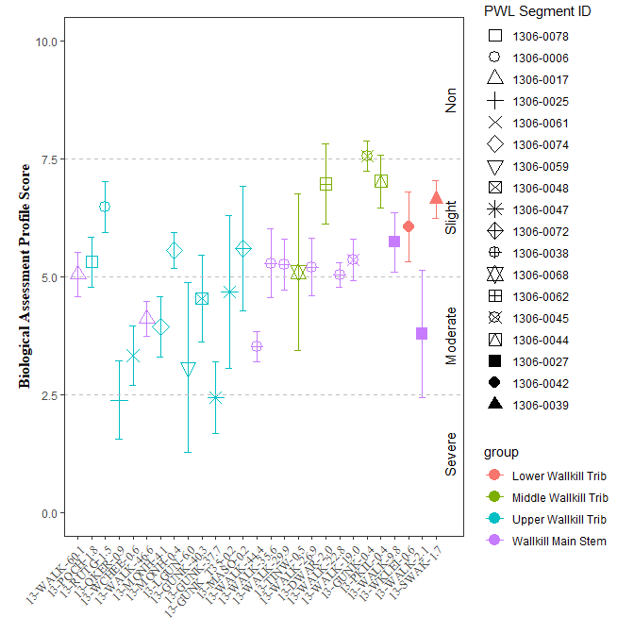

Figure 24: Biological Assessment Profile (BAP) Scores and 95% confidence intervals for benthic macroinvertebrate community assessment data for the Wallkill River Survey, 2017-2019. Symbology corresponds with WI/PWL segmentation as indicated in the plot legend.

`

# Section 1C - Stream Reach Physical Characteristics

Table 3: Ranked habitat characteristics and calculated HMA for the Wallkill River Survey, 2017-2019. Epifaunal substrate (Epi. Cover); Embeddedness/Pool Substrate Characterization (Embed. Pool.); Velocity Depth Regime/Pool Variability (Vel/Dep Reg.); Sediment Deposition (Sed. Dep.); Channel Flow Status (Flow Status); Channel Alteration (Chan. Alt.); Riffle Frequency/Stream Sinuosity (Rif. Freq.)

| **SITE_ID** | **Gradient** | **Epi.  Cover** | **Embed.   Pool.** | **Vel/Dep.   Reg.** | **Sed.   Dep.** | **Flow   Status** | **Chan.   Alt** | **Rif.   Freq** |
| --- | --- | --- | --- | --- | --- | --- | --- | --- |
| 13-WALK-60.1 | Low | 12.0 | 8.0 | 8.0 | 5.0 | 10.0 | 7.0 | 2.0 |
| 13-POCH-1.8 | High | 11.5 | 14.5 | 7.5 | 14.0 | 16.0 | 13.5 | 5.0 |
| 13-RUTG-1.5 | High | 15.5 | 15.0 | 15.0 | 14.0 | 16.5 | 15.5 | 14.5 |
| 13-QKER-0.9 | High | 13.0 | 3.0 | 9.0 | 3.0 | 18.0 | 12.0 | 5.0 |
| 13-QKER-0.9 | Low | 5.0 | 5.0 | 4.0 | 10.0 | 15.0 | 10.0 | 13.0 |
| 13-RIOG-0.7 | Low | 17.0 | NA | 14.0 | 15.0 | 15.0 | 16.0 | 13.0 |
| 13-WCHEE-0.6 | High | 10.5 | 12.5 | 10.5 | 10.5 | 18.5 | 15.5 | 9.5 |
| 13-WALK-46.6 | High | 13.5 | NA | NA | 7.5 | 16.5 | 11.5 | 7.5 |
| 13-MONH-4.1 | High | NA | 12.0 | 10.0 | 14.5 | 15.5 | 16.0 | 16.5 |
| 13-MONH-0.4 | High | 16.0 | 15.5 | 15.0 | 12.5 | 18.5 | 16.0 | 15.5 |
| 13-LGUN-6.0 | High | 9.0 | 20.0 | 10.0 | 11.0 | 19.0 | 19.0 | 13.0 |
| 13-GUNK-40.3 | High | 10.0 | 15.0 | 2.0 | 6.0 | 18.0 | 17.0 | 0.0 |
| 13-GUNK-37.7 | High | 11.0 | 15.0 | 10.0 | NA | 19.0 | 8.0 | 9.0 |
| 13-GUNK_T35-0.2 | High | 15.0 | 11.0 | 10.0 | 16.0 | 19.0 | 16.0 | 13.0 |
| 13-MASO-0.2 | High | 17.0 | 18.0 | 14.0 | 17.0 | 17.0 | 17.0 | 16.0 |
| 13-WALK-44.4 | High | 14.0 | 13.5 | 9.5 | 15.0 | 19.5 | 14.0 | 14.0 |
| 13-WALK-35.6 | High | 10.0 | 14.0 | 13.0 | 14.0 | 18.0 | 13.0 | 5.0 |
| 13-WALK-35.6 | Low | 11.0 | 12.0 | 18.0 | 17.0 | 19.0 | 19.0 | 9.0 |
| 13-WALK-29.9 | High | 11.0 | 17.0 | 13.5 | 18.0 | 20.0 | 19.0 | 12.0 |
| 13-TINW-0.5 | High | 10.5 | 12.5 | 11.0 | 7.5 | 17.0 | 16.5 | 11.0 |
| 13-WALK-26.9 | High | NA | 15.5 | 17.0 | 17.5 | 19.5 | 18.5 | 11.0 |
| 13-DWAR-2.0 | High | 13.5 | 18.5 | 14.5 | 16.0 | 15.5 | 18.5 | 15.0 |
| 13-WALK-22.8 | High | 15.0 | 16.0 | 14.5 | 16.0 | 20.0 | 14.0 | 15.5 |
| 13-WALK-19.0 | High | 16.0 | 17.0 | 15.0 | 11.0 | 18.5 | 13.5 | 15.5 |
| 13-GUNK-0.4 | High | 19.0 | 15.5 | 19.0 | 15.5 | 18.5 | 17.5 | 19.0 |
| 13-PKIL-0.4 | High | 14.5 | 14.0 | 14.0 | 14.5 | 15.5 | 14.5 | 16.0 |
| 13-WKLEI-0.6 | High | 9.0 | 4.0 | 10.0 | 5.0 | 14.0 | 18.0 | 5.0 |
| 13-WKLEI-0.6 | Low | 5.0 | 5.0 | 5.0 | 6.0 | 12.0 | 15.0 | 7.0 |
| 13-WALK-2.1 | Low | 15.0 | 13.0 | 11.0 | 11.0 | 17.0 | 15.0 | 14.0 |
| 13-SWAK-1.7 | High | 13.0 | 15.5 | 16.0 | 17.5 | 17.0 | 17.0 | 18.5 |

# Section 1D - User Perception

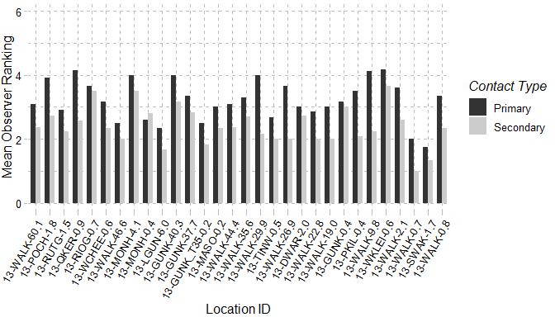

Figure 25: Mean observer ranking of recreational ability for Wallkill River sampling locations. Columns represent observer rankings for the desire to participate in 1° and 2° contact recreation. Ranking of recreation ability was performed for all locations during each site visit.

Table 4: Mean observer ranked value for factors influencing desire to participate in 1° and 2° contact recreation in the Wallkill River. Factors were ranked on a 10 scale (0 – Best/Natural; 10 Worst/Severe) according to perceived impact on a location. Ranking of recreation ability was performed for all locations during each site visit

| **Site   ID** | **Water   Clarity** | **Suspended  Phytoplankton** | **Periphyton** | **Macrophyte** | **Odor** | **Trash** | **Dishcarge   Pipes** |
| --- | --- | --- | --- | --- | --- | --- | --- |
| 13-WALK-60.1 | 5 | 0 | 1 | 1 | 0 | 1 | 0 |
| 13-POCH-1.8 | 6 | 1 | 3 | 0 | 2 | 0 | 0 |
| 13-RUTG-1.5 | 4 | 0 | 4 | 1 | 1 | 2 | 0 |
| 13-QKER-0.9 | 6 | 4 | 4 | 4 | 2 | 1 | 0 |
| 13-RIOG-0.7 | 2 | 0 | 3 | 1 | 3 | 2 | 0 |
| 13-WCHEE-0.6 | 6 | 1 | 2 | 0 | 1 | 1 | 0 |
| 13-WALK-46.6 | 4 | 0 | 3 | 1 | 0 | 1 | 0 |
| 13-MONH-4.1 | 3 | 0 | 6 | 2 | 5 | 2 | 2 |
| 13-MONH-0.4 | 2 | 0 | 3 | 0 | 5 | 2 | 1 |
| 13-LGUN-6.0 | 4 | 2 | 0 | 0 | 1 | 0 | 2 |
| 13-GUNK-40.3 | 5 | 1 | 3 | 2 | 3 | 1 | 2 |
| 13-GUNK-37.7 | 2 | 0 | 4 | 0 | 4 | 4 | 2 |
| 13-GUNK_T35-0.2 | 5 | 1 | 5 | 1 | 0 | 1 | 1 |
| 13-MASO-0.2 | 2 | 0 | 2 | 0 | 4 | 3 | 1 |
| 13-WALK-44.4 | 6 | 1 | 3 | 1 | 0 | 1 | 0 |
| 13-WALK-35.6 | 6 | 1 | 4 | 0 | 1 | 2 | 1 |
| 13-WALK-29.9 | 7 | 0 | 3 | 1 | 0 | 1 | 0 |
| 13-TINW-0.5 | 1 | 0 | 2 | 0 | 0 | 2 | 0 |
| 13-WALK-26.9 | 6 | 0 | 4 | 1 | 0 | 0 | 0 |
| 13-DWAR-2.0 | 4 | 0 | 4 | 2 | 1 | 3 | 2 |
| 13-WALK-22.8 | 6 | 0 | 3 | 1 | 0 | 2 | 0 |
| 13-WALK-19.0 | 7 | 0 | 4 | 1 | 1 | 3 | 0 |
| 13-GUNK-0.4 | 4 | 0 | 1 | 0 | 1 | 2 | 0 |
| 13-PKIL-0.4 | 3 | 0 | 4 | 2 | 0 | 1 | 0 |
| 13-WALK-9.8 | 7 | 0 | 4 | 1 | 0 | 1 | 0 |
| 13-WKLEI-0.6 | 8 | 1 | 3 | 0 | 1 | 0 | 0 |
| 13-WALK-2.1 | 6 | 0 | 2 | 2 | 0 | 1 | 0 |
| 13-WALK-0.7 | 6 | 0 | 3 | 0 | 0 | 0 | 0 |
| 13-SWAK-1.7 | 2 | 0 | 3 | 1 | 0 | 0 | 0 |
| 13-WALK-0.8 | 8 | 4 | 5 | 0 | 1 | 2 | 0 |

Table 5: Most frequently ranked factor influencing observer desire to participate in 1° and 2° contact recreation in the Wallkill River. Factors influencing desire to recreate were ranked and a primary factor influencing the desire to participate in 1° and 2° contact recreation was chosen during each site visit. Column values represent the factor selected most frequently at each site.

| **SITE_ID** | **Primary** | **Secondary** |
| --- | --- | --- |
| 13-WALK-60.1 | Water Clarity | None, Water clarity |
| 13-POCH-1.8 | Water Clarity | Water clarity |
| 13-RUTG-1.5 | Periphyton | Proximity to development roads |
| 13-QKER-0.9 | Water Clarity | Other, Suspended Phytoplankton, Water clarity |
| 13-RIOG-0.7 | Odor, Other | None |
| 13-WCHEE-0.6 | Water Clarity | None |
| 13-WALK-46.6 | Water Clarity | None, Other |
| 13-MONH-4.1 | Odor | Periphyton |
| 13-MONH-0.4 | Odor | Odor |
| 13-LGUN-6.0 | None, Other, Water Clarity | None |
| 13-GUNK-40.3 | Water Clarity | Other |
| 13-GUNK-37.7 | Odor, Periphyton | Trash |
| 13-GUNK_T35-0.2 | Water Clarity | Other |
| 13-MASO-0.2 | Odor | Other |
| 13-WALK-44.4 | Water Clarity | None, Water clarity |
| 13-WALK-35.6 | Water Clarity | None, Other, Water clarity |
| 13-WALK-29.9 | Water Clarity | Water clarity |
| 13-TINW-0.5 | None, Other, Water Clarity | None |
| 13-WALK-26.9 | Water Clarity | Other |
| 13-DWAR-2.0 | None, Water Clarity | None, Water clarity |
| 13-WALK-22.8 | Water Clarity | Other |
| 13-WALK-19.0 | Water Clarity | Water clarity |
| 13-GUNK-0.4 | Other, Water Clarity | None |
| 13-PKIL-0.4 | Proximity_to_Development_Roads, Water Clarity | None, Proximity to development roads |
| 13-WALK-9.8 | Water Clarity | Water clarity |
| 13-WKLEI-0.6 | Water Clarity | Water clarity |
| 13-WALK-2.1 | Water Clarity | None |
| 13-WALK-0.7 | None, Water Clarity | None |
| 13-SWAK-1.7 | None, Proximity_to_Development_Roads | None |
| 13-WALK-0.8 | Water Clarity | Suspended Phytoplankton |

# Section 1E - Sediment and Porewater Microtox® Analysis

Toxicity testing of surface waters, sediments, porewaters, and effluents are routinely performed as part of the RIBS program (<https://www.dec.ny.gov/chemical/29854.html>). Sediment toxicity was evaluated according to SOP #403-16 Microtox® Acute Toxicity Test for Sediments, Porewaters and Effluents. Testing procedures use a bioassay to assess potential acute toxicity in sediments and surface waters to aquatic life (SOP #403-16). Sediment and extracted sediment porewater samples are tested using a bioluminescent bacterium Vibrio fischeri (V. fischeri). Tests are a measure of light reduction between collected samples and a control following a 15-minute exposure period and expressed as the median effect concentration (EC50) of a sample that causes a 50% reduction in light emission from the V. fischeri. Appendix X (Fact Sheet: Acute & Chronic Toxicity Assessments of NY Streams & Rivers) describes toxicity testing procedures, Assessment criteria and results classifications.

Table 6: Wallkill River Microtox® sediment and porewater toxicity results for select locations in the Wallkill River Survey. Sediment samples were collected for toxicity testing in baseflow conditions during macroinvertebrate community collection at sampling locations.

| **Station ID** | **Sample Date** | **Sediment   Assessment** | **Porewater   Assessment** | **Sediment   EC50** | **Porewater   EC50** |
| --- | --- | --- | --- | --- | --- |
| 13-QKER-0.9 | 8/2/2017 | Non-toxic | Non-toxic | 78.18 | > 100 |
| 13-WCHEE-0.6 | 8/2/2017 | Non-toxic | Non-toxic | 65.38 | > 100 |
| 13-WALK-46.6 | 8/2/2017 | Severe | Non-toxic | 4.46 | > 100 |
| 13-MONH-4.1 | 7/26/2017 | Moderate | Non-toxic | 24.29 | > 100 |
| 13-MONH-0.4 | 8/2/2017 | Slight | Non-toxic | 42.21 | > 100 |
| 13-WALK-35.6 | 8/2/2017 | Moderate | Non-toxic | 38.73 | > 100 |
| 13-WALK-29.9 | 8/3/2017 | Slight | Non-toxic | 43.07 | > 100 |
| 13-WALK-26.9 | 8/3/2017 | Moderate | Toxic | 36.92 | 69.53 |
| 13-WALK-22.8 | 8/3/2017 | Slight | Non-toxic | 42.33 | > 100 |
| 13-WALK-19.0 | 8/3/2017 | Moderate | Toxic | 37.3 | 84.11 |
| 13-GUNK-0.4 | 8/3/2017 | Non-toxic | Toxic | 64.1 | 42.67 |
| 13-WKLEI-0.6 | 8/3/2017 | Slight | Non-toxic | 59.37 | > 100 |