Wallkill Reporting Draft

NYSDEC SMAS

2020-12-29

# Section 1A - Water Chemistry and Stream Discharge

## Water Chemistry Methdology

SMAS and HREP  
Methods used for water chemistry data collection are described by NYSDEC standard operating procedures (SOP). The collection of water chemistry samples followed procedures described in SOP #210(17-19) Collection of Water Column Samples for the Rotating Integrated Basin Studies (RIBS) Program. Where the depth of water permitted, water chemistry samples were collected using the depth-integrating suspended sediment sampler – wading (DH-81) method (SOP #210(17-19)), section 11.2). Where the depth of water was too shallow water chemistry samples were collected using the direct grab method (SOP #210(¬17-19), section 11.6). Water samples were processed using a contract lab with NYS Environmental Laboratory Approval Program (ELAP) certification.

PEERS

Methods used for water chemistry data collection are described by NYSDEC standard operating procedures (SOP). The collection of water chemistry samples followed procedures described in SOP #210-18 Collection of Water Column Samples for the Rotating Integrated Basin Studies (RIBS) Program. Water chemistry samples were collected using the direct grab method (SOP #210-18, section 11.6). Water samples were processed using a contract lab with NYS Environmental Laboratory Approval Program (ELAP) certification. No discharge was collected at these locations.

For samples collected by SMAS and HREP, stream discharge was measured using the velocity-area method according to Turnipseed and Sauer (2010). The velocity-area method (Midsection Method) calculates discharge by subdividing a stream cross-section into 10 equally spaced stations and measuring depth and velocity within each station and summing the products (Turnipseed and Sauer, 2010). A top-set wading rod and Sontek FlowTracker was used. Methods are described in detail in Turnipseed and Sauer (2010) and Appendix I provides pertinent elements. Appendix II provides the field sheet used in collection of stream depth and velocity for discharge calculations.

The collection of water chemistry samples and stream discharge spanned three years (2017, 2018, 2019), included 39 sampling locations, and covered a range of stream flow conditions. PEERS sampling was conducted during 2018 only and included a reduced suite of water quality analytes at nine sampling locations to broaden sampling coverage. Locations were generally sampled eight times with the exception of PEERS sites which were sampled five times. Ambient water chemistry sampling included in situ and lab measured water quality analytes (Table). Where applicable, chemistry results were analyzed for exceedances of state water quality standards and summarized below using R programing software (R Core Team, 2017). All raw chemistry results (in situ and lab reported) with all applicable standards and exceedance determinations accompany this report as Attachment I.

All Wallkill River survey data were subjected to the quality assurance/quality control (QA/QC) protocols detailed in Appendix III. For water chemistry, an evaluation of the precision, accuracy, and completeness of processed water chemistry samples after lab analyses were performed following the methods detailed in part A of Appendix III of this report. Appendix III.B includes a compilation of quality assurance results for each site. Only data meeting the highest data quality standard are reported and used in this report (Appendix III).

Table : Water chemistry analytes sampled as part of the Wallkill River Stream Assessment Survey. Table lists sampled analytes and analytical specifications. ^ Precision objectives are defined by results of duplicate samples as described in Appendix III

| **Analytes** | **Analytical  Lab** | **Method** | **Precision** | **Accuracy** | **Calibration:   Initial** | **Calibration:   Ongoing** | **Calibration:   Blanks** | **Detection   Limit** | **Reporting   Limit** |
| --- | --- | --- | --- | --- | --- | --- | --- | --- | --- |
| Temperature | in situ | 2550 B | ± 1oC | ± 1.5oC | Factory Set | ~ | ~ | ~ | ~ |
| Dissolved Oxygen | in situ | 4500-O G | ± 1% | ± 2% | Daily | ~ | ~ | ~ | ~ |
| pH | in situ | 4500-H+B | ± .05 SU | ± .2 SU | Weekly | ~ | ~ | ~ | ~ |
| Salinity | in situ | Calculated | 0.001 ppt | ± 1% | N/A | ~ | ~ | ~ | ~ |
| Specific Conductance | in situ | 2510 B | ± 1µs/cm | ± 1% | Weekly | ~ | ~ | ~ | ~ |
| Ammonia | ALS | D6919-09 | ^ | ± 20% | As needed | Every 10 | Every 10 | 0.008 mg/L | 0.01 mg/L |
| Total Kjeldahl Nitrogen | ALS | EPA 351.2 | ^ | ± 20% | Daily | Every 10 | Every 10 | 0.08 mg/L | 0.1 mg/L |
| Nitrogen, Nitrate | ALS | EPA 353.2 | ^ | ± 20% | Daily | Every 10 | Every 10 | 0.02 mg/L | 0.05 mg/L |
| Nitrogen, Total | ALS | Calculated | ^ |  |  |  |  |  |  |
| Total Phosphorus | ALS | EPA 365.1 | ^ | ± 20% | Daily | Every 10 | Every 10 | 0.002 mg/L | 0.003 mg/L |
| Ortho-phosphate | ALS | EPA 365.1 | ^ | ± 20% | Daily | Every 10 | Every 10 | 0.001 mg/L | 0.005 mg/L |
| Total Dissolved Solids | ALS | SM 2540C | ^ | ± 20% | Daily | Every 20 | Every 20 | 4.0 mg/L | 10 mg/L |
| Turbidity | ALS | EPA 180.1 | ^ | ± 10% | Daily | Every 10 | Every 10 | 0.06 NTU | 0.1 NTU |
| Dissolved Organic Carbon | ALS | 5310C | ^ | ± 20% | As needed | Ever 10 | Every 10 | 0.4 mg/L | 10 mg/L |
| Alkalinity | ALS | SM 2320B | ^ | ± 20% | Daily | Every 10 | Every 10 | 1.0 mg/L | 2.0 mg/L |
| Hardness | ALS | SM 2340C | ^ | ± 20% | Daily | Every 10 | Every 10 | 0.3 mg/L | 2.0 mg/L |
| Calcium | ALS | EPA 200.7 | ^ | ± 20% | Daily | Every 10 | Every 10 | 0.1 mg/L | 1.0 mg/L |
| Magnesium | ALS | EPA 200.7 | ^ | ± 20% | Daily | Every 10 | Every 10 | 0.04 mg/L | 1.0 mg/L |
| Potassium | ALS | EPA 200.7 | ^ | ± 20% | Daily | Every 10 | Every 10 | 0.06 mg/L | 2.0 mg/L |
| Sodium | ALS | EPA 200.7 | ^ | ± 20% | Daily | Every 10 | Every 10 | 0.03 mg/L | 1.0 mg/L |
| Chloride | ALS | EPA 300.0 | ^ | ± 20% | As needed | Every 10 | Every 10 | 0.02 mg/L | 0.2 mg/L |
| Fluoride | ALS | EPA 300.0 | ^ | ± 20% | As needed | Every 10 | Every 10 | 0.004 mg/L | 0.1 mg/L |
| Sulfate | ALS | EPA 300.0 | ^ | ± 20% | As needed | Every 10 | Every 10 | 0.02 mg/L | 0.2 mg/L |
| Iron (total) | ALS | EPA 200.7 | ^ | ± 20% | Daily | Every 10 | Every 10 | 6 µ/L | 100 µ/L |
| Manganese (total) | ALS | EPA 200.7 | ^ | ± 20% | Daily | Every 10 | Every 10 | 0.5 µ/L | 10 µ/L |
| Arsenic (total) | ALS | EPA 200.8 | ^ | ± 20% | Daily | Every 10 | Every 10 | 0.3 µ/L | 1 µ/L |
| Silver (total) | ALS | EPA 200.8 | ^ | ± 20% | Daily | Every 10 | Every 10 | 0.07 µ/L | 1 µ/L |
| Aluminum (total) | ALS | EPA 200.8 | ^ | ± 20% | Daily | Every 10 | Every 10 | 4.0 µ/L | 50 µ/L |
| Cadmium (total) | ALS | EPA 200.8 | ^ | ± 20% | Daily | Every 10 | Every 10 | 0.03 µ/L | 1 µ/L |
| Copper (total) | ALS | EPA 200.8 | ^ | ± 20% | Daily | Every 10 | Every 10 | 0.04 µ/L | 1 µ/L |
| Lead (total) | ALS | EPA 200.8 | ^ | ± 20% | Daily | Every 10 | Every 10 | 0.08 µ/L | 1 µ/L |
| Nickel (total) | ALS | EPA 200.8 | ^ | ± 20% | Daily | Every 10 | Every 10 | 0.04 µ/L | 1 µ/L |
| Zinc (total) | ALS | EPA 200.8 | ^ | ± 20% | Daily | Every 10 | Every 10 | 0.7 µ/L | 10 µ/L |
| Aluminum (dissolved) | ALS | EPA 200.8 | ^ | ± 20% | Daily | Every 10 | Every 10 | 0.9 µ/L | 10 µ/L |
| Cadmium (dissolved) | ALS | EPA 200.8 | ^ | ± 20% | Daily | Every 10 | Every 10 | 0.02 µ/L | 1 µ/L |
| Copper (dissolved) | ALS | EPA 200.8 | ^ | ± 20% | Daily | Every 10 | Every 10 | 0.02 µ/L | 1 µ/L |
| Lead (dissolved) | ALS | EPA 200.8 | ^ | ± 20% | Daily | Every 10 | Every 10 | 0.02 µ/L | 1 µ/L |
| Nickel (dissolved) | ALS | EPA 200.8 | ^ | ± 20% | Daily | Every 10 | Every 10 | 0.1 µ/L | 1 µ/L |
| Zinc (dissolved) | ALS | EPA 200.8 | ^ | ± 20% | Daily | Every 10 | Every 10 | 3 µ/L | 5 µ/L |
| * Indicates sampling performed as part of PEERS suite. | | | | | | | | | |

## Exceedances of Water Quality Standards

Exceedances of water quality standards occurred in 13 of 21 WI/PWL segments. A total of 32 lab-measured, and 6 in situ water quality analytes, were analyzed and out of the 6101 lab-measured records and 1475 in situ water quality records, there were 65 exceedances of established water quality standards (6 NYCRR Part 703). There were exceedances in . Chloride and nutrient concentrations across the Wallkill watershed were generally elevated relative to statewide data concentrations. Nutrients are regulated by a narrative water quality standard stating: “None in amounts that result in growths of algae, weeds, and slimes that will impair the waters for their best usages” (6 NYCRR 703.2).

Plots illustrating the range of analyte concentration values within each WI/PWL segments from both mainstem and tributaries, are included in this report (Figure-) from upstream to downstream. Locations on a WI/PWL tributary segments are inserted between mainstem WI/PWL segments. The total number of values represented for each WI/PWL segment can vary due to non-detection and QA/QC procedures. Descriptions of removed records are presented in Appendix III. Analytes selected for presentation were subset to those of specific interest to the study. Therefore, the analytes presented here include: Chloride; Chlorophyll-a; inorganic nitrogen (NO2+NO3); organic nitrogen (Total Kjeldahl Nitrogen); Total Phosphorus; Total Dissolved Solids; Dissolved Oxygen (in situ), Temperature (in situ), Conductance (in situ) and pH (in situ). To provide context, each figure contains lines representing the 25th, 75th, and 95th percentiles of each analyte collected statewide by SMAS from 2001 to 2019. Exceedance within a PWL segment are indicated by an asterisk. Site specific exceedances are quantified in Section II.

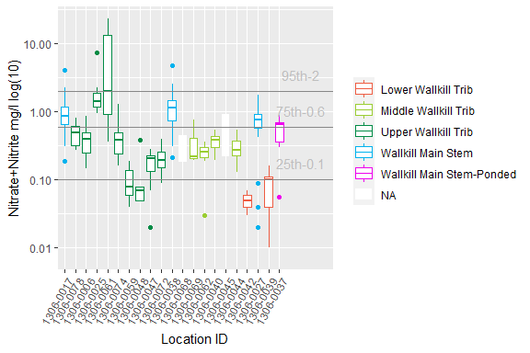

Figure : Nitrate+Nitrite, The X-axis presents WI/PWL ID of the sampling locations from upstream to downstream. Color of the box represents the location of the WI/WPL in the watershed as indicated in the plot legend. Stars at the bottom of the graph indicate an exceedance of a WQS in that PWL segment

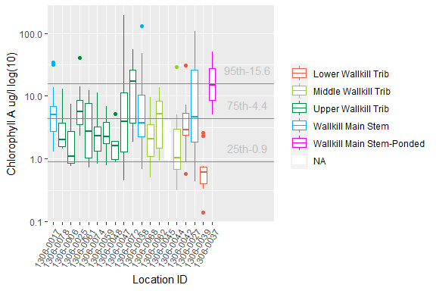

Figure : Chlorophyll A, The X-axis presents WI/PWL ID of the sampling locations from upstream to downstream. Color of the box represents the location of the WI/WPL in the watershed as indicated in the plot legend. Stars at the bottom of the graph indicate an exceedance of a WQS in that PWL segment

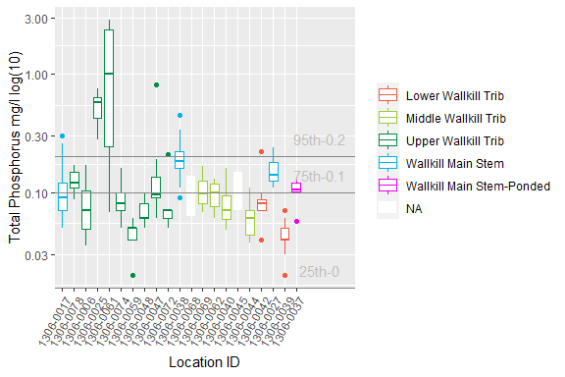

Figure : Total Phosphorus, The X-axis presents WI/PWL ID of the sampling locations from upstream to downstream. Color of the box represents the location of the WI/WPL in the watershed as indicated in the plot legend. Stars at the bottom of the graph indicate an exceedance of a WQS in that PWL segment

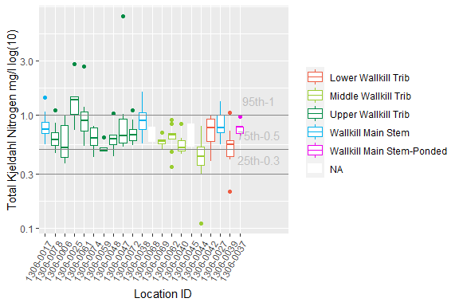

Figure : Total Kjeldahl Nitrogen, The X-axis presents WI/PWL ID of the sampling locations from upstream to downstream. Color of the box represents the location of the WI/WPL in the watershed as indicated in the plot legend. Stars at the bottom of the graph indicate an exceedance of a WQS in that PWL segment

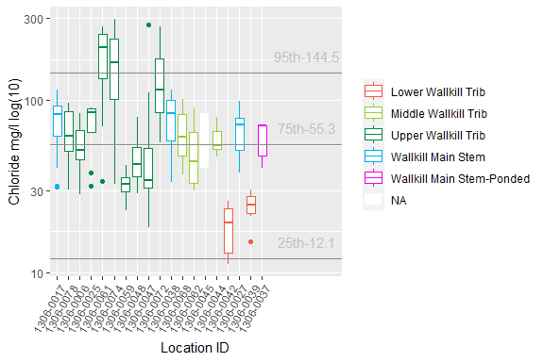

Figure : Chloride, The X-axis presents WI/PWL ID of the sampling locations from upstream to downstream. Color of the box represents the location of the WI/WPL in the watershed as indicated in the plot legend. Stars at the bottom of the graph indicate an exceedance of a WQS in that PWL segment

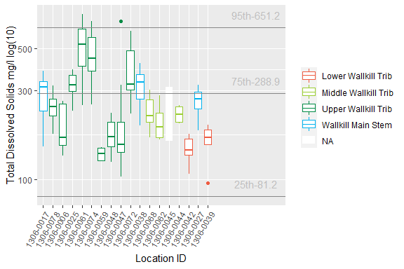

Figure : Total Dissolved Solids, The X-axis presents WI/PWL ID of the sampling locations from upstream to downstream. Color of the box represents the location of the WI/WPL in the watershed as indicated in the plot legend. Stars at the bottom of the graph indicate an exceedance of a WQS in that PWL segment

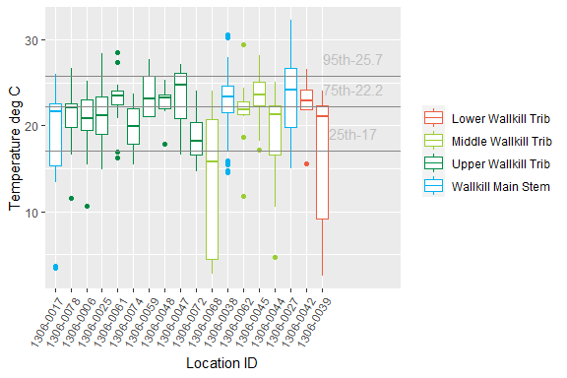

Figure : Temperature, The X-axis presents WI/PWL ID of the sampling locations from upstream to downstream and axis labels correspond with Table 1, Figure 1 and Figure 2. Color of the box represents the location of the WI/WPL in the watershed as indicated in the plot legend. Stars at the bottom of the graph indicate an exceedance of a WQS in that PWL segment

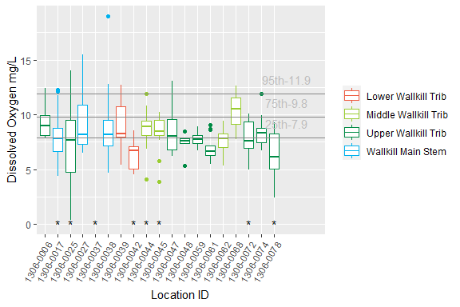

Figure : Dissolved Oxygen, The X-axis presents WI/PWL ID of the sampling locations from upstream to downstream and axis labels correspond with Table 1, Figure 1 and Figure 2. Color of the box represents the location of the WI/WPL in the watershed as indicated in the plot legend. Stars at the bottom of the graph indicate an exceedance of a WQS in that PWL segment

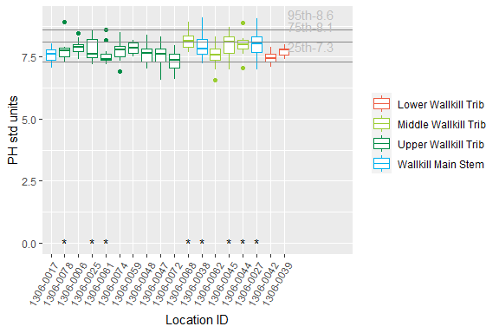

Figure : PH, The X-axis presents WI/PWL ID of the sampling locations from upstream to downstream and axis labels correspond with Table 1, Figure 1 and Figure 2. Color of the box represents the location of the WI/WPL in the watershed as indicated in the plot legend. Stars at the bottom of the graph indicate an exceedance of a WQS in that PWL segment

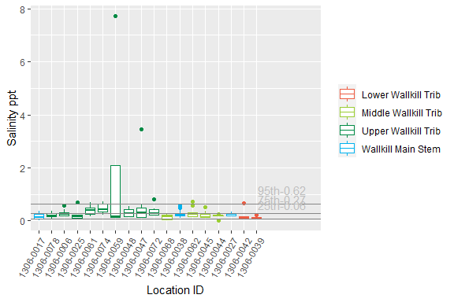

Figure : Salinity, The X-axis presents WI/PWL ID of the sampling locations from upstream to downstream and axis labels correspond with Table 1, Figure 1 and Figure 2. Color of the box represents the location of the WI/WPL in the watershed as indicated in the plot legend. Stars at the bottom of the graph indicate an exceedance of a WQS in that PWL segment

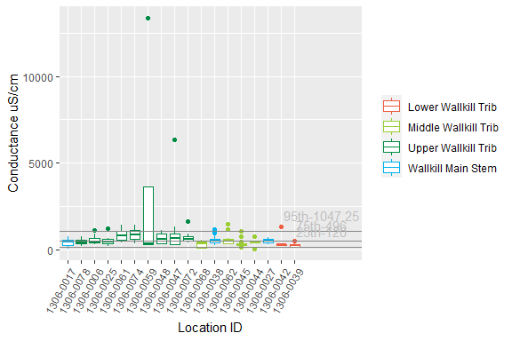

Figure : Conductance, The X-axis presents WI/PWL ID of the sampling locations from upstream to downstream and axis labels correspond with Table 1, Figure 1 and Figure 2. Color of the box represents the location of the WI/WPL in the watershed as indicated in the plot legend. Stars at the bottom of the graph indicate an exceedance of a WQS in that PWL segment

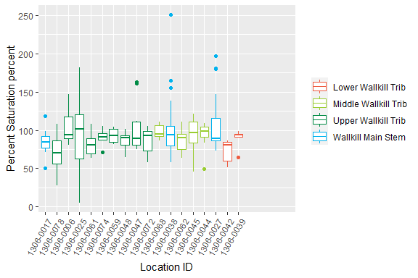

Figure : Percent Saturation, The X-axis presents WI/PWL ID of the sampling locations from upstream to downstream and axis labels correspond with Table 1, Figure 1 and Figure 2. Color of the box represents the location of the WI/WPL in the watershed as indicated in the plot legend. Stars at the bottom of the graph indicate an exceedance of a WQS in that PWL segment

# Section 1B - Benthic Macroinvertebrate Community

Benthic macroinvertebrate communities were sampled to evaluate water quality impacts to the aquatic life use. Where appropriate riffle habitat was present, collection of macroinvertebrates was preformed using the kick method described in section 9.4 of SOP #208-19 Biological Monitoring of Surface Waters in New York State. With the exception of PEERS sites, replicate (n=4/site) macroinvertebrate samples were collected once at each site during years water chemistries were collected. For traveling kick samples, the contents of replicates for each site were field-inspected to determine major groups of organisms present, and then preserved in alcohol for lab inspection and identification of 100-specimen subsamples. For non-wadable sites, multiplates were deployed for a five-week colonization period, scraped, contents preserved and processed to a minimum of 250 organisms and a quarter of the sample. If target counts were not met, samples were processed in their entirety. Specimens were identified to lowest possible taxonomic resolution, typically genus or species.

Biological assessments of water quality are generated from Biological Assessment Profile (BAP) scores (SOP #208-19). BAP scores are calculated by taking the average of five normalized 10-scale community metrics and assigning that score to a four-tiered system of impact category of non (7.5-10), slight (5.0-7.5), moderate (2.5-5.0), or severe (0-2.5) impacts see (Figure). A final BAP score below 5 suggests that the sampled stream is not achieving its aquatic life use goals (Figure 10; SOP #208-19). A BAP score above 5 indicates that the sampled stream is attaining its aquatic life use goals (Figure 10; SOP #208-19). Expected variability in the results of benthic macroinvertebrate community samples is presented in Smith and Bode (2004).

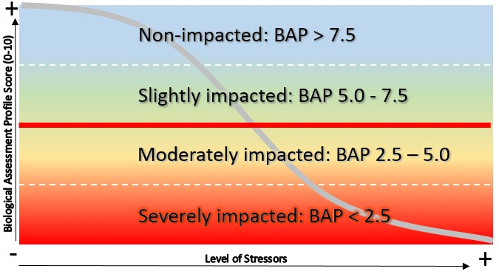

Biological Assessment Profile (BAP) score impact categories based on the macroinvertebrate community. Scores below 5 suggest impairment to aquatic life and scores above 5 indicate attainment of aquatic life of use.

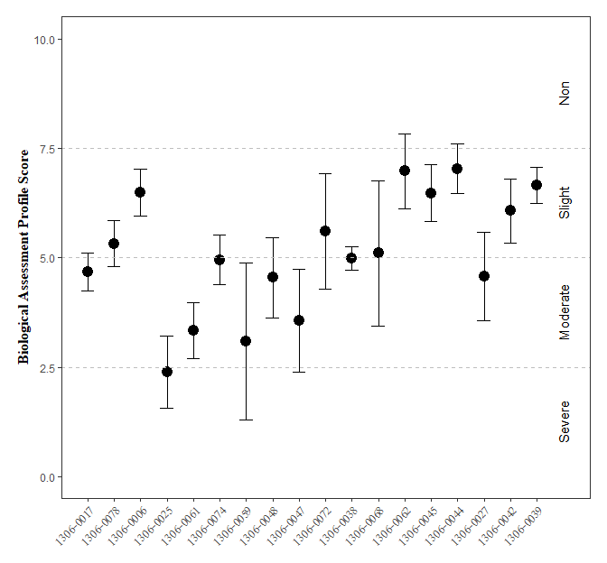

Figure : Biological Assessment Profile (BAP) Scores and 95% confidence intervals for benthic macroinvertebrate community assessment data for the Wallkill River Survey, 2017-2019. Symbology corresponds with WI/PWL segmentation as indicated in the plot legend.

On average, Biological Assessment Profile (BAP) scores ranged from severely to slightly impacted across all sites on the WI/PWL segments in the Wallkill watershed a (SOP #208-19). Segments with mean BAP scores that fall below the BAP impairment threshold, include segments 1306-0017, 1306-0025, 1306-0061, 1306-0074, 1306-0059, 1306-0048, 1306-0047, 1306-0038, 1306-0027 (Figure). However ninety-five percent confidence intervals suggest inconclusive results for segments 1306-0017, 1306-0078, 1306-0074, 1306-0048, 1306-0038, 1306-0027.

`

# Section 1C - Stream Reach Physical Characteristics

Assessments of physical habitat conditions were performed by field crews at sites along with macroinvertebrate collections following the methods detailed in section 9.10 of SOP #208-19. Each habitat category was averaged over the two years of sampling conducted at each location. The information collected in these assessments are used to calculate the Habitat Model Affinity (HMA) (Table 3), an overall estimate of habitat quality which describes potential habitat stress on aquatic life. The HMA is based on rankings of individual habitat characteristics on a scale from 0 (poor) to 20 (optimal) which are then compared to a statewide reference condition (Appendix IV). HMA scores are used to make final physical habitat assessments; Natural (80-100), Altered (70 – 80), Moderate (60 – 70), and Severe (< 60). Results are described in terms of percent similarity to the reference condition.

Habitat model affinity (HMA) scores and resulting final physical habitat assessments ranged from natural to severe alteration across all sites (SOP #208-19; Table). Physical habitat final assessments demonstrate that habitat may have been a factor influencing benthic communities at sampling locations where HMA scores indicate moderate or severely altered conditions (Table); natural (n=15), altered (n=5), moderate (n=8), severe (n=2).

Table : Ranked habitat characteristics and calculated HMA for the Wallkill River Survey, 2017-2019. Epifaunal substrate (Epi. Cover); Embeddedness/Pool Substrate Characterization (Embed. Pool.); Velocity Depth Regime/Pool Variability (Vel/Dep Reg.); Sediment Deposition (Sed. Dep.); Channel Flow Status (Flow Status); Channel Alteration (Chan. Alt.); Riffle Frequency/Stream Sinuosity (Rif. Freq.); Left and Right Bank Stability (L.B. and R.B. Stability); Left and Right Bank Vegetation (L.B. and R.B. Veg); Width of Left and Right Bank Vegetative Zone (L.B. and R.B. Veg Zone); Habitat Model Affinity Score (HMA Score); HMA Assessment (HMA Assess.)

| **SITE_ID** | **PWL ID** | **Gradient** | **Epi.  Cover** | **Embed.   Pool.** | **Vel/Dep.   Reg.** | **Sed.   Dep.** | **Flow   Status** | **Chan.   Alt** | **Rif.   Freq** | **L.B.   Stability** | **R.B.   Stability** | **L.B.   Veg** | **R.B.  Veg** | **L.B.   Veg Zone** | **R.B.   Veg Zone** | **HMA   Score** | **HMA   Assess.** |
| --- | --- | --- | --- | --- | --- | --- | --- | --- | --- | --- | --- | --- | --- | --- | --- | --- | --- |
| 13-WALK-60.1 | 1306-0017 | Low | 12.0 | 8.0 | 8.0 | 5.0 | 10.0 | 7.0 | 2.0 | 8.0 | 4.0 | 7.0 | 5.0 | 7.0 | 6.0 | 59.7 | Severe |
| 13-POCH-1.8 | 1306-0078 | High | 11.5 | 14.5 | 7.5 | 14.0 | 16.0 | 13.5 | 5.0 | 6.5 | 6.0 | 6.0 | 3.0 | 4.0 | 3.0 | 61.0 | Moderate |
| 13-RUTG-1.5 | 1306-0006 | High | 15.5 | 15.0 | 15.0 | 14.0 | 16.5 | 15.5 | 14.5 | 3.0 | 7.5 | 6.5 | 8.5 | 4.0 | 8.5 | 79.6 | Altered |
| 13-QKER-0.9 | 1306-0025 | High | 13.0 | 3.0 | 9.0 | 3.0 | 18.0 | 12.0 | 5.0 | 8.0 | 8.0 | 7.0 | 7.0 | 3.0 | 4.0 | 55.2 | Severe |
| 13-QKER-0.9 | 1306-0025 | Low | 5.0 | 5.0 | 4.0 | 10.0 | 15.0 | 10.0 | 13.0 | 8.0 | 8.0 | 7.0 | 7.0 | 4.0 | 4.0 | 67.1 | Moderate |
| 13-RIOG-0.7 | 1306-0061 | Low | 17.0 | NA | 14.0 | 15.0 | 15.0 | 16.0 | 13.0 | 6.0 | 6.0 | 6.0 | 6.0 | 4.0 | 4.0 | 85.2 | Natural |
| 13-WCHEE-0.6 | 1306-0061 | High | 10.5 | 12.5 | 10.5 | 10.5 | 18.5 | 15.5 | 9.5 | 7.5 | 6.5 | 6.5 | 6.0 | 5.0 | 4.0 | 68.0 | Moderate |
| 13-WALK-46.6 | 1306-0017 | High | 13.5 | NA | NA | 7.5 | 16.5 | 11.5 | 7.5 | 7.0 | 5.5 | NA | 6.5 | 7.5 | 7.0 | 76.0 | Altered |
| 13-MONH-4.1 | 1306-0074 | High | NA | 12.0 | 10.0 | 14.5 | 15.5 | 16.0 | 16.5 | 7.5 | 7.0 | 8.0 | 3.0 | 8.5 | 2.5 | 76.2 | Altered |
| 13-MONH-0.4 | 1306-0074 | High | 16.0 | 15.5 | 15.0 | 12.5 | 18.5 | 16.0 | 15.5 | 7.0 | 7.0 | 7.5 | 6.0 | 6.0 | 4.5 | 81.2 | Natural |
| 13-LGUN-6.0 | 1306-0059 | High | 9.0 | 20.0 | 10.0 | 11.0 | 19.0 | 19.0 | 13.0 | 7.0 | 9.0 | 4.0 | NA | 9.0 | NA | 82.3 | Natural |
| 13-GUNK-40.3 | 1306-0048 | High | 10.0 | 15.0 | 2.0 | 6.0 | 18.0 | 17.0 | 0.0 | 9.0 | 7.0 | 7.0 | 8.0 | 6.0 | 9.0 | 63.0 | Moderate |
| 13-GUNK-37.7 | 1306-0047 | High | 11.0 | 15.0 | 10.0 | NA | 19.0 | 8.0 | 9.0 | 7.0 | 7.0 | 5.0 | 4.0 | 5.0 | 5.0 | 68.0 | Moderate |
| 13-GUNK_T35-0.2 | 1306-0047 | High | 15.0 | 11.0 | 10.0 | 16.0 | 19.0 | 16.0 | 13.0 | 9.0 | 9.0 | 4.0 | 10.0 | 5.0 | 10.0 | 81.2 | Natural |
| 13-MASO-0.2 | 1306-0072 | High | 17.0 | 18.0 | 14.0 | 17.0 | 17.0 | 17.0 | 16.0 | 7.0 | 7.0 | 6.0 | 6.0 | 2.0 | 2.0 | 80.1 | Natural |
| 13-WALK-44.4 | 1306-0038 | High | 14.0 | 13.5 | 9.5 | 15.0 | 19.5 | 14.0 | 14.0 | 8.0 | 7.0 | 5.0 | 6.0 | 5.0 | 6.5 | 75.4 | Altered |
| 13-WALK-35.6 | 1306-0038 | High | 10.0 | 14.0 | 13.0 | 14.0 | 18.0 | 13.0 | 5.0 | 6.0 | 5.0 | 6.0 | 6.0 | 5.0 | 5.0 | 66.3 | Moderate |
| 13-WALK-35.6 | 1306-0038 | Low | 11.0 | 12.0 | 18.0 | 17.0 | 19.0 | 19.0 | 9.0 | 9.0 | 7.0 | 8.0 | 6.0 | 9.0 | 6.0 | 90.6 | Natural |
| 13-WALK-29.9 | 1306-0038 | High | 11.0 | 17.0 | 13.5 | 18.0 | 20.0 | 19.0 | 12.0 | 8.0 | 8.0 | 10.0 | 8.5 | 9.5 | 6.0 | 87.3 | Natural |
| 13-TINW-0.5 | 1306-0068 | High | 10.5 | 12.5 | 11.0 | 7.5 | 17.0 | 16.5 | 11.0 | 5.0 | 7.5 | 6.5 | 7.0 | 6.5 | 9.5 | 70.7 | Altered |
| 13-WALK-26.9 | 1306-0038 | High | NA | 15.5 | 17.0 | 17.5 | 19.5 | 18.5 | 11.0 | 9.0 | 8.0 | 8.5 | 5.0 | 9.0 | 3.0 | 87.0 | Natural |
| 13-DWAR-2.0 | 1306-0062 | High | 13.5 | 18.5 | 14.5 | 16.0 | 15.5 | 18.5 | 15.0 | 9.0 | 7.0 | 8.0 | 8.0 | 6.0 | 5.5 | 84.5 | Natural |
| 13-WALK-22.8 | 1306-0038 | High | 15.0 | 16.0 | 14.5 | 16.0 | 20.0 | 14.0 | 15.5 | 8.5 | 9.0 | 7.0 | 7.5 | 5.0 | 6.0 | 84.5 | Natural |
| 13-WALK-19.0 | 1306-0038 | High | 16.0 | 17.0 | 15.0 | 11.0 | 18.5 | 13.5 | 15.5 | 8.5 | 9.0 | 7.0 | 7.0 | 6.0 | 4.5 | 82.0 | Natural |
| 13-GUNK-0.4 | 1306-0045 | High | 19.0 | 15.5 | 19.0 | 15.5 | 18.5 | 17.5 | 19.0 | 9.0 | 8.5 | 9.0 | 7.0 | 7.0 | 5.5 | 92.8 | Natural |
| 13-PKIL-0.4 | 1306-0044 | High | 14.5 | 14.0 | 14.0 | 14.5 | 15.5 | 14.5 | 16.0 | 5.5 | 5.0 | 8.0 | 6.0 | NA | 3.5 | 80.4 | Natural |
| 13-WKLEI-0.6 | 1306-0042 | High | 9.0 | 4.0 | 10.0 | 5.0 | 14.0 | 18.0 | 5.0 | 10.0 | 6.0 | 8.0 | 6.0 | 6.0 | 10.0 | 61.3 | Moderate |
| 13-WKLEI-0.6 | 1306-0042 | Low | 5.0 | 5.0 | 5.0 | 6.0 | 12.0 | 15.0 | 7.0 | 2.0 | 2.0 | 9.0 | 8.0 | 9.0 | 6.0 | 61.1 | Moderate |
| 13-WALK-2.1 | 1306-0027 | Low | 15.0 | 13.0 | 11.0 | 11.0 | 17.0 | 15.0 | 14.0 | 9.0 | 8.0 | 8.0 | 6.0 | 10.0 | 1.0 | 91.3 | Natural |
| 13-SWAK-1.7 | 1306-0039 | High | 13.0 | 15.5 | 16.0 | 17.5 | 17.0 | 17.0 | 18.5 | 9.0 | 9.0 | 8.0 | 8.0 | 9.0 | 7.5 | 91.2 | Natural |

# Section 1D - User Perception

Perceptions of recreational ability were ranked at all sampling locations during each site visit as per standard site visit protocols (SOP #208-19). The observer ranking of recreational ability is a method of evaluating impacts to recreational use of a stream segment. Impacts to recreational use have been correlated with “impairment of aquatic life use from nutrient enrichment” and rankings below slightly impacted are indicative of significant impacts to recreational ability (Smith et al. 2014). The ranking assesses primary (1°) and secondary (2°) contact recreation, as well as a user’s desire to fish.

The first two questions of the recreational use evaluation describe the observers perceived ability to participate in 1° and 2° contact recreation (Appendix V). Results of this ranking are the primary gauge of whether the Wallkill River is achieving its designated recreational uses. (Figure) illustrates the average observer ranking for desire to participate in 1° and 2° contact recreation at each sampling location. Results of this survey suggest observers (NYSDEC field staff) considered the desire to participate in 1° and 2° contact recreation to be slightly impacted at PWL segments 1306-0078, 1306-0025, 1306-0061, 1306-0074, 1306-0048, 1306-0072, 1306-0038, 1306-0062, 1306-0045, 1306-0044, 1306-0027, 1306-0042.

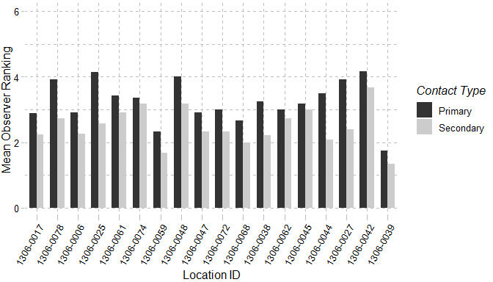

Figure : Mean observer ranking of recreational ability for Wallkill River sampling locations. Columns represent observer rankings for the desire to participate in 1° and 2° contact recreation. Ranking of recreation ability was performed for all locations during each site visit.

Additional questions on a scale of 0-10 (0 – Best/Natural; 10 Worst/Severe) help determine the factors influencing the user’s perception. Those factors are: 1) Water Clarity; 2) Trash; 3) Periphyton; 4) Odor; 5) Discharge Pipes. (Table) shows the mean recorded value for these factors at each sampling location and (Table) shows the most commonly selected factors reducing an observer’s desire to participate in 1° and 2° contact recreation. Other factors described by observers were: 1) Low Dissolved Oxygen; 2) Proximity to Road; 3) Proximity to a State Superfund Site; 4) Proximity to WWTF effluent discharge.

Table : Mean observer ranked value for factors influencing desire to participate in 1° and 2° contact recreation in the Wallkill River. Factors were ranked on a 10 scale (0 – Best/Natural; 10 Worst/Severe) according to perceived impact on a location. Ranking of recreation ability was performed for all locations during each site visit

| **SH_PWL_ID** | **Site   ID** | **Water   Clarity** | **Suspended  Phytoplankton** | **Periphyton** | **Macrophyte** | **Odor** | **Trash** | **Dishcarge   Pipes** |
| --- | --- | --- | --- | --- | --- | --- | --- | --- |
| 1306-0017 | 13-WALK-60.1 | 5 | 0 | 1 | 1 | 0 | 1 | 0 |
| 1306-0078 | 13-POCH-1.8 | 6 | 1 | 3 | 0 | 2 | 0 | 0 |
| 1306-0006 | 13-RUTG-1.5 | 4 | 0 | 4 | 1 | 1 | 2 | 0 |
| 1306-0025 | 13-QKER-0.9 | 6 | 4 | 4 | 4 | 2 | 1 | 0 |
| 1306-0061 | 13-RIOG-0.7 | 2 | 0 | 3 | 1 | 3 | 2 | 0 |
| 1306-0061 | 13-WCHEE-0.6 | 6 | 1 | 2 | 0 | 1 | 1 | 0 |
| 1306-0017 | 13-WALK-46.6 | 4 | 0 | 3 | 1 | 0 | 1 | 0 |
| 1306-0074 | 13-MONH-4.1 | 3 | 0 | 6 | 2 | 5 | 2 | 2 |
| 1306-0074 | 13-MONH-0.4 | 2 | 0 | 3 | 0 | 5 | 2 | 1 |
| 1306-0059 | 13-LGUN-6.0 | 4 | 2 | 0 | 0 | 1 | 0 | 2 |
| 1306-0048 | 13-GUNK-40.3 | 5 | 1 | 3 | 2 | 3 | 1 | 2 |
| 1306-0047 | 13-GUNK-37.7 | 2 | 0 | 4 | 0 | 4 | 4 | 2 |
| 1306-0047 | 13-GUNK_T35-0.2 | 5 | 1 | 5 | 1 | 0 | 1 | 1 |
| 1306-0072 | 13-MASO-0.2 | 2 | 0 | 2 | 0 | 4 | 3 | 1 |
| 1306-0038 | 13-WALK-44.4 | 6 | 1 | 3 | 1 | 0 | 1 | 0 |
| 1306-0038 | 13-WALK-35.6 | 6 | 1 | 4 | 0 | 1 | 2 | 1 |
| 1306-0038 | 13-WALK-29.9 | 7 | 0 | 3 | 1 | 0 | 1 | 0 |
| 1306-0068 | 13-TINW-0.5 | 1 | 0 | 2 | 0 | 0 | 2 | 0 |
| 1306-0038 | 13-WALK-26.9 | 6 | 0 | 4 | 1 | 0 | 0 | 0 |
| 1306-0062 | 13-DWAR-2.0 | 4 | 0 | 4 | 2 | 1 | 3 | 2 |
| 1306-0038 | 13-WALK-22.8 | 6 | 0 | 3 | 1 | 0 | 2 | 0 |
| 1306-0038 | 13-WALK-19.0 | 7 | 0 | 4 | 1 | 1 | 3 | 0 |
| 1306-0045 | 13-GUNK-0.4 | 4 | 0 | 1 | 0 | 1 | 2 | 0 |
| 1306-0044 | 13-PKIL-0.4 | 3 | 0 | 4 | 2 | 0 | 1 | 0 |
| 1306-0027 | 13-WALK-9.8 | 7 | 0 | 4 | 1 | 0 | 1 | 0 |
| 1306-0042 | 13-WKLEI-0.6 | 8 | 1 | 3 | 0 | 1 | 0 | 0 |
| 1306-0027 | 13-WALK-2.1 | 6 | 0 | 2 | 2 | 0 | 1 | 0 |
| 1306-0039 | 13-SWAK-1.7 | 2 | 0 | 3 | 1 | 0 | 0 | 0 |

Table : Most frequently ranked factor influencing observer desire to participate in 1° and 2° contact recreation in the Wallkill River. Factors influencing desire to recreate were ranked and a primary factor influencing the desire to participate in 1° and 2° contact recreation was chosen during each site visit. Column values represent the factor selected most frequently at each site.

| **PWL ID** | **SITE** | **Primary** | **Secondary** |
| --- | --- | --- | --- |
| 1306-0017 | 13-WALK-60.1 | Water Clarity | None, Water clarity |
| 1306-0078 | 13-POCH-1.8 | Water Clarity | Water clarity |
| 1306-0006 | 13-RUTG-1.5 | Periphyton | Proximity to development roads |
| 1306-0025 | 13-QKER-0.9 | Water Clarity | Other, Suspended Phytoplankton, Water clarity |
| 1306-0061 | 13-RIOG-0.7 | Odor, Other | None |
| 1306-0061 | 13-WCHEE-0.6 | Water Clarity | None |
| 1306-0017 | 13-WALK-46.6 | Water Clarity | None, Other |
| 1306-0074 | 13-MONH-4.1 | Odor | Periphyton |
| 1306-0074 | 13-MONH-0.4 | Odor | Odor |
| 1306-0059 | 13-LGUN-6.0 | None, Other, Water Clarity | None |
| 1306-0048 | 13-GUNK-40.3 | Water Clarity | Other |
| 1306-0047 | 13-GUNK-37.7 | Odor, Periphyton | Trash |
| 1306-0047 | 13-GUNK_T35-0.2 | Water Clarity | Other |
| 1306-0072 | 13-MASO-0.2 | Odor | Other |
| 1306-0038 | 13-WALK-44.4 | Water Clarity | None, Water clarity |
| 1306-0038 | 13-WALK-35.6 | Water Clarity | None, Other, Water clarity |
| 1306-0038 | 13-WALK-29.9 | Water Clarity | Water clarity |
| 1306-0068 | 13-TINW-0.5 | None, Other, Water Clarity | None |
| 1306-0038 | 13-WALK-26.9 | Water Clarity | Other |
| 1306-0062 | 13-DWAR-2.0 | None, Water Clarity | None, Water clarity |
| 1306-0038 | 13-WALK-22.8 | Water Clarity | Other |
| 1306-0038 | 13-WALK-19.0 | Water Clarity | Water clarity |
| 1306-0045 | 13-GUNK-0.4 | Other, Water Clarity | None |
| 1306-0044 | 13-PKIL-0.4 | Proximity_to_Development_Roads, Water Clarity | None, Proximity to development roads |
| 1306-0027 | 13-WALK-9.8 | Water Clarity | Water clarity |
| 1306-0042 | 13-WKLEI-0.6 | Water Clarity | Water clarity |
| 1306-0027 | 13-WALK-2.1 | Water Clarity | None |
| 1306-0039 | 13-SWAK-1.7 | None, Proximity_to_Development_Roads | None |

# Section 1E - Sediment and Porewater Microtox® Analysis

Toxicity testing of surface waters, sediments, porewaters, and effluents are routinely performed as part of the RIBS program (<https://www.dec.ny.gov/chemical/29854.html>). Sediment toxicity was evaluated according to SOP #403-16 Microtox® Acute Toxicity Test for Sediments, Porewaters and Effluents. Testing procedures use a bioassay to assess potential acute toxicity in sediments and surface waters to aquatic life (SOP #403-16). Sediment and extracted sediment porewater samples are tested using a bioluminescent bacterium Vibrio fischeri (V. fischeri). Tests are a measure of light reduction between collected samples and a control following a 15-minute exposure period and expressed as the median effect concentration (EC50) of a sample that causes a 50% reduction in light emission from the V. fischeri. Appendix X (Fact Sheet: Acute & Chronic Toxicity Assessments of NY Streams & Rivers) describes toxicity testing procedures, Assessment criteria and results classifications.

Results from Microtox® Acute Toxicity Test for Sediments, Porewaters and Effluents collected in 2017 are found in (Table). In the Wallkill Watershed, sediments ranged from non-toxic to severe and porewaters ranged from non-toxic to toxic.

Table : Wallkill River Microtox® sediment and porewater toxicity results for select locations in the Wallkill River Survey. Sediment samples were collected for toxicity testing in baseflow conditions during macroinvertebrate community collection at sampling locations.

| **Station ID** | **Sample Date** | **Sediment   Assessment** | **Porewater   Assessment** | **Sediment   EC50** | **Porewater   EC50** |
| --- | --- | --- | --- | --- | --- |
| 13-QKER-0.9 | 8/2/2017 | Non-toxic | Non-toxic | 78.18 | > 100 |
| 13-WCHEE-0.6 | 8/2/2017 | Non-toxic | Non-toxic | 65.38 | > 100 |
| 13-WALK-46.6 | 8/2/2017 | Severe | Non-toxic | 4.46 | > 100 |
| 13-MONH-4.1 | 7/26/2017 | Moderate | Non-toxic | 24.29 | > 100 |
| 13-MONH-0.4 | 8/2/2017 | Slight | Non-toxic | 42.21 | > 100 |
| 13-WALK-35.6 | 8/2/2017 | Moderate | Non-toxic | 38.73 | > 100 |
| 13-WALK-29.9 | 8/3/2017 | Slight | Non-toxic | 43.07 | > 100 |
| 13-WALK-26.9 | 8/3/2017 | Moderate | Toxic | 36.92 | 69.53 |
| 13-WALK-22.8 | 8/3/2017 | Slight | Non-toxic | 42.33 | > 100 |
| 13-WALK-19.0 | 8/3/2017 | Moderate | Toxic | 37.3 | 84.11 |
| 13-GUNK-0.4 | 8/3/2017 | Non-toxic | Toxic | 64.1 | 42.67 |
| 13-WKLEI-0.6 | 8/3/2017 | Slight | Non-toxic | 59.37 | > 100 |