Automation of Assessment: Project Overview

Zachary M. Smith

2020-04-03

# Introduction

The New York State Department of Environmental Conservation’s (NYSDEC’s) Bureau of Water Assessment and Management (BWAM) has made it a top priority to automate waterbody assessments as dictated by NYSDEC’s Consolidated Assessment and Listing Methodology (CALM). For this process to work efficiently, BWAM will need to 1) establish authoritative data repositories and 2) establish a standardized process for applying the assessment process outlined in the CALM.

# CALM

## Overview

The NYSDEC maintains a CALM that describes the processes and procedures used to assess the quality of New York’s surface waters and determine the attainment status in each waterbody consistent with applicable water quality standards and guidance values. The following dichotomous key and Figure 1 provide two ways of simplifying the assessment process outlined in the CALM. The assessments are used by New York state for management purposes and ultimately reported to the United State Environmental Protection Agency (USEPA) in the form of a 303d list.

* Dichotomous Key
  + 1a.) The following requirements are **NOT** met:
    - ELAP certified lab used for analytics (Not applicable until we consider external data sources)
    - Project has an approved QAPP (Not applicable until we consider external data sources)
    - < 10 years old (assessment_period(); within_assess_period == FALSE)
      * **Requires manual review**
  + 1b.) The above requirements are met (assessment_period(); within_assess_period == TRUE) [2]
  + 2a.) Does not meet the required minimum number of samples or minimum number of years for assessment. (assessment_min_req(); min_req_met == FALSE) [3]
  + 2b.) Meets the required minimum number of samples and minimum number of years for assessment. (assessment_min_req(); min_req_met == TRUE) [5]
  + 3a.) There is a Water Quality Standard violation
    - **Classify as Impaired/Unconfirmed IR3**
  + 3b.) There is no Water Quality Standard violation [4]
  + 4a.) >= 75% IQR of Water Quality Standard
    - **Classify as Stressed/Unconfirmed IR3**
  + 4b.) < 75% IWR of Water Quality Standard
    - **Classify as Fully Supported/Unconfirmed IR3**
  + 5a.) There is a Water Quality Standard violation [7]
  + 5b.) There is no Water Quality Standard violation [6]
  + 6a.) >= 75% IQR of Water Quality Standard
    - **Classify as Stressed/Confirmed IR1**
  + 6b.) < 75% IWR of Water Quality Standard
    - **Classify as Fully Supported/Confirmed IR1**
  + 7a.) >= 2 violations over >= 2 years [8]
  + 7b.) < 2 violations over >= 2 years
    - **Classify as Impaired/Unconfirmed IR3**
  + 8a.) A TMDL exists for the parameter
    - **Classify as Impaired/Confirmed IR4**
  + 8b.) A TMDL does not exist for the parameter [9]
  + 9a.) A Long Term Consent order or another restoration plan exists
    - **Classify as Impaired/Confirmed IR4b**
  + 9b.) A Long Term Consent order or another restoration plan do not exist [10]
  + 10a.) The parameter is considered a pollutant
    - **Classify as Impaired/Confirmed IR4c**
  + 10b.) The parameter is not considered a pollutant
    - **Classify as Impaired/Confirmed IR5**

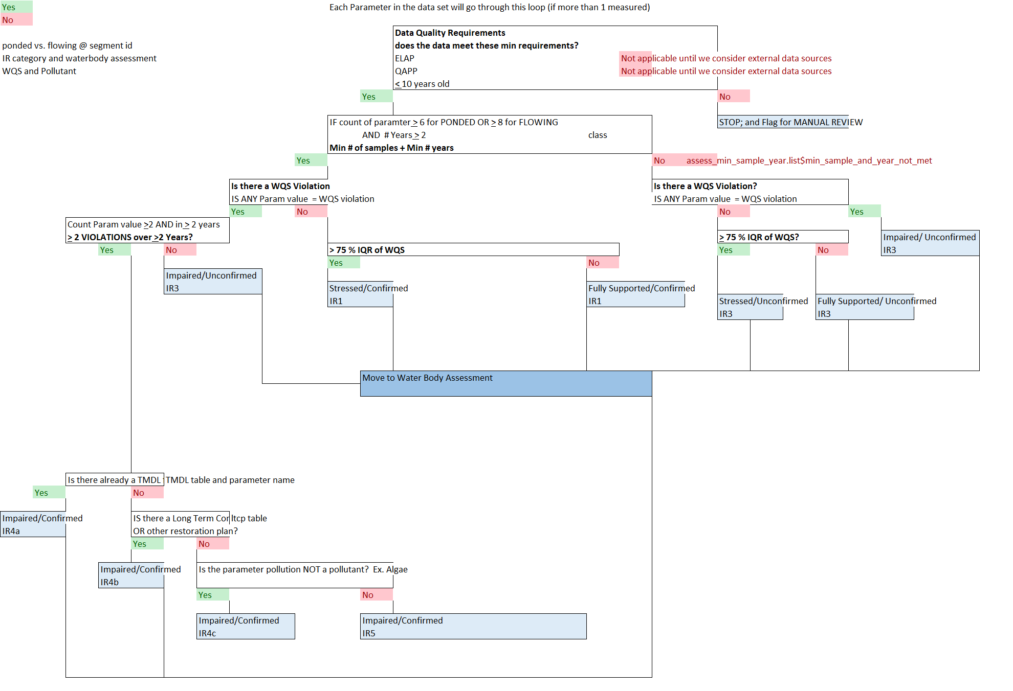

Figure 1: A decision tree to vizualize the assessment process as defined in the NYSDEC CALM.

## Data Modernization

BWAM is piloting the Division of Water’s (DOW’s) Data Modernization effort in partnership with the New York State Office of Information Technology Services (ITS) which will create a robust data workflow for all BWAM related data (Figure 2). Progress of the Data Modernization and Automation of Assessment projects are not dependent upon one another, but these projects are not mutually exclusive. The process developed for the Automation of Assessment will ultimately be inserted in the data workflow produced by the Data Modernization project (Figure 2). Furthermore, the Data Modernization effort will ultimately produce the authoritative data repositories, in the form of Oracle databases, necessary for automating assessments. No definitive deadline has been establish for the completion of the authoritative Oracle databases; however, the Data Modernization development process has forced the Stream Monitoring and Assessment Section (SMAS), the Lake Monitoring and Assessment Section (LMAS), and the Water Assessment and Implementation Section (WAIS) to begin to compile, re-structure, and re-format their data sets into interim-databases in preparation for the creation of these authoritative Oracle databases. These interim-databases will serve as the current authoritative databases with the expectation that there will be changes to the structure and format of the data once the Oracle databases are finalized, but these changes will be relatively minor. Attempting to align these two efforts as much as possible should ultimately be cost effective, because these two efforts have the potential to be mutually beneficial.

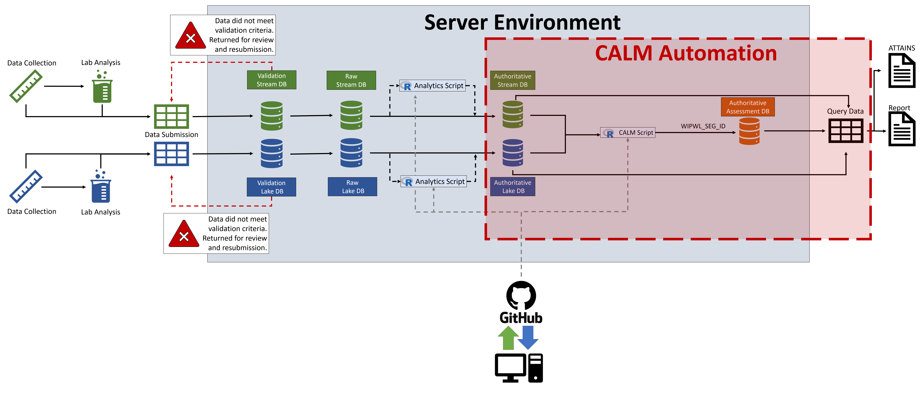

Figure 2: An overview of New York State Department of Environmental Conservation’s (NYSDEC’s) Bureau of Water Assessment and Management (BWAM) data workflow. The portion of the process surrounded by the red dotted box is most relavent to the automation of assessments. Within the red box are two authoratative database (i.e., the authoratative stream and lake databases) for storing observed water quality variables. Relavent observed values are quired out of these authoratitative databases and processed with an R-script applying CALM logic to assess waterbodies. The assessments produced by the R-script are stored within the authoratative Assessment database, which can be subsequently queried for reporting purposes.

# Water Quality Standards and Guidance Values

NYS’s water quality standards (WQS) are derived in [Title 6 NYCRR, Part 702](https://govt.westlaw.com/nycrr/Browse/Home/NewYork/NewYorkCodesRulesandRegulations?guid=I06b83300b5a111dda0a4e17826ebc834&originationContext=documenttoc&transitionType=Default&contextData=(sc.Default)) and defined in [Title 6 NYCRR, Part 703](https://govt.westlaw.com/nycrr/Browse/Home/NewYork/NewYorkCodesRulesandRegulations?guid=I070d30d0b5a111dda0a4e17826ebc834&originationContext=documenttoc&transitionType=Default&contextData=(sc.Default)).

NYS’s ambient water quality guidance values

## Waterbody Class Hierarchy

Fresh and saline surface water classes generally conform to a descending alphabetical hierarchy (Figure 3). Class D represents the most upstream class of the fresh surface waters, while class AA-Special represents the most downstream class. Similarly, class SD represents the most upstream class of the saline surface waters, while class SA represents the most downstream class.

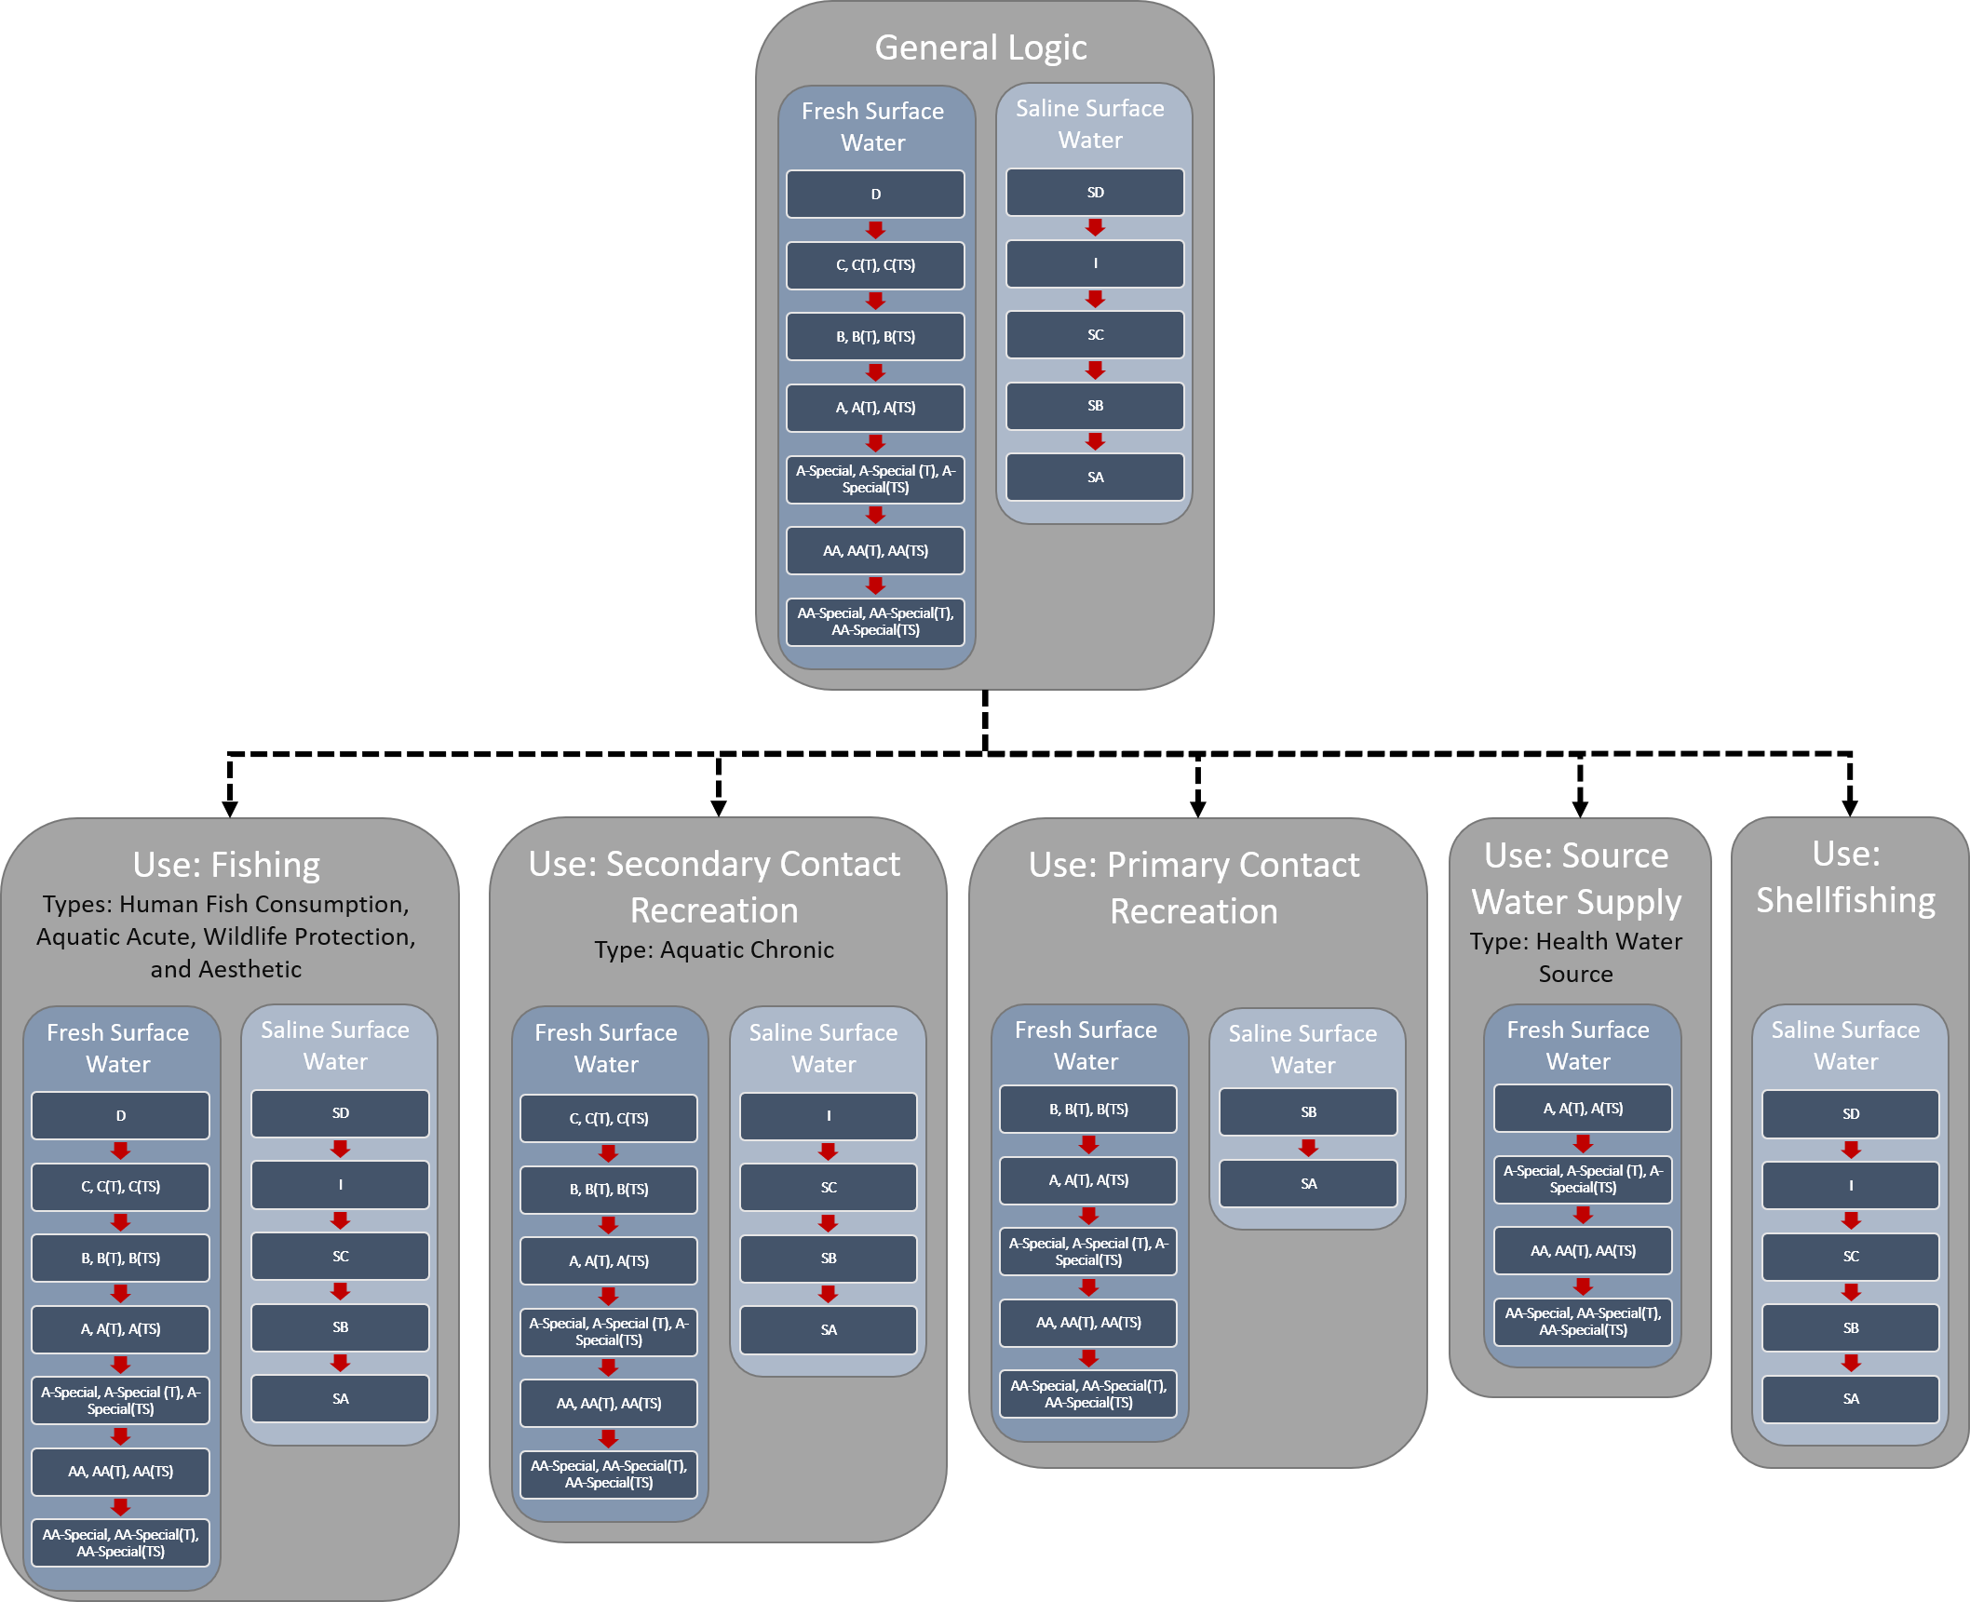

Figure 3: The General Logic box at the head of the figure depicts the standard waterbody class hierarchy for which New York State Deparment of Environmental Conservation’s water quality standards are inherited in descending alphabetical order. The subsequent boxes show the class hierarchy specific to waterbody designated uses. Water quality standard types included in the boxes reflect the assignments found in [TOGS 1.1.1](https://www.dec.ny.gov/docs/water_pdf/togs111.pdf) Part 1A-Section 3. Water Classes and Type.

WQS assigned to upstream classes are inherited by all downstream classes. The most upstream class associated with a WQS will be referred to as the “root” class for a given standard. For example, fishing use WQSs have a root of D and SD classes, and therefore will be applicable to all downstream fresh surface water classes (i.e., C, B, A, A-Special, AA, AA-Special, and their associated Trout (T) and Trout Spawning (TS) variants) and saline surface water classes (i.e., I, SC, SB, and SA), respectively. D and SD represent the most upstream classes in fresh and saline surface waters, respectively, and therefore influence all other classes. However, D and SD classes do not always represent the root class for a given WQS. The root class for source water supply WQSs is A, and therefore the hierarchy only extends in sequential order from A, A-Special, AA, and AA-Special. Inheritance through the hierarchy does not necessarily imply that all class have the same WQSs; in many instances, the WQSs become increasingly more restrictive moving downstream through the hierarchy. WQSs will not become less restrictive moving downstream through the hierarchy (Dissolved Solids and Total and Fecal Coliforms represent discrepancies to this rule). Although most WQSs are inherited according to the logic in Figure 3, there are multiple discrepancies.

### Discrepancies

The following WQS do not follow the logic depicted in Figure 3. It is important to specifically document all of these instances because these instances will require special attention within the standardized assessment automation process.

#### Class I

In [TOGS 1.1.1](https://www.dec.ny.gov/docs/water_pdf/togs111.pdf) Part 1A-Section 3. Water Classes and Type, WQSs for the saline surface water class I should be defined for types Human Consumption of Fish (H(FC)), Aquatic Chronic (A(C)), Aquatic Acute (A(A)), Wildlife Protection (W), and Aesthetic (E). However, in Table 1 of [TOGS 1.1.1](https://www.dec.ny.gov/docs/water_pdf/togs111.pdf) and in [Title 6 NYCRR, Part 703.5](https://govt.westlaw.com/nycrr/Document/I4ed90418cd1711dda432a117e6e0f345?viewType=FullText&originationContext=documenttoc&transitionType=CategoryPageItem&contextData=(sc.Default)&bhcp=1), class I water’s are frequently and inconsistently excluded from the above mentioned types; this creates a class hierarchy that follows the logic in Figure 4 rather than the logic in Figure 3. 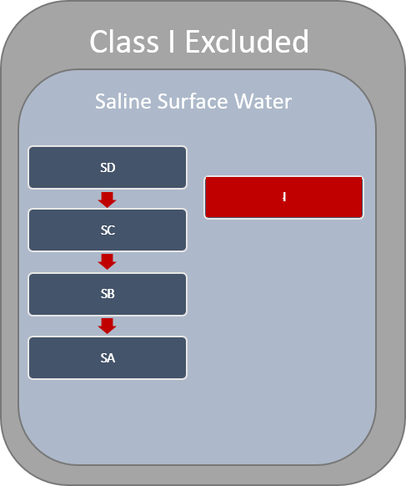

No I: Aldrin (309-00-2), Aldrin and Dieldrin (309-00-2; 60-57-1), Arsenic (NA), Hexavalent Chromium (NA), Endosulfan (115-29-7), Endrin (72-20-8), Hexachlorocyclopentadiene (77-47-4), Trichlorobenzenes (87-61-6, 120-82-1, 108-70-3, 12002-48-1)

DO: different standard for I “Shall not be less than 4.0 mg/L at any time.”; “SD:SA = Acute: Shall not be less than 3.0 mg/L at any time.”

Root C: Azinphosmethyl (86-50-0), Demeton (8065-48-3, 298-03-3, 126-75-0), Hydrogen sulfide (7783-06-4), Malathion (121-75-5), Methoxychlor (72-43-5), Mirex (2385-85-5), Toxaphene (8001-35-2; A(C))

Yes I: Ammonia and Ammonium (7664-41-7), Benzene (71-43-2), Boron (NA), Cadmium (NA), Chlordane (57-74-9), dibenzofurans (NA), Total Residual Chlorine (NA), Chlorobenzene (108-90-7), Copper (NA), Cyanide (NA), p,p′-DDD (72-54-8), p,p′-DDE (72-55-9), p,p′-DDT (50-29-3), Dieldrin (60-57-1), 2,4-Dimethylphenol (105-67-9), 2,4-Dinitrophenol (51-28-5), Heptachlor (76-44-8), Heptachlor expoxide (1024-57-3), Hexachlorobenzene (118-74-1), Hexachlorobutadiene (87-68-3), alpha-Hexachlorocyclohexane (319-84-6), beta-Hexachlorocyclohexane (319-85-7), delta-Hexachlorocyclohexane (319-86-8), epsilon-Hexachlorocyclohexane (6108-10-7), gamma-Hexachlorocyclohexane (58-89-9), Hexachloroethane (67-72-1), Lead (NA), Mercury (NA), Methylene chloride (75-09-2), Nickel (NA), Octachlorostyrene (29082-74-4), Polychlorinated biphenyls (NA), Toluene (108-88-3), Toxaphene (8001-35-2), Trichloroethene (79-01-6), Zinc (NA), pH, total coliforms, fecal coliforms.

#### Aquatic (Acute)

Aquatic (Acute) designates a type of WQS. The class hierarchy associated with Aquatic (Acute) WQSs are treated inconsistently by NYSDEC. In many instances, the class hierarchy follows the rules depicted in Figure 3, but there are multiple instances where Aquatic (Acute) WQSs are only applicable to fresh and saline surface water classes D and SD, respectively (Figure 5).

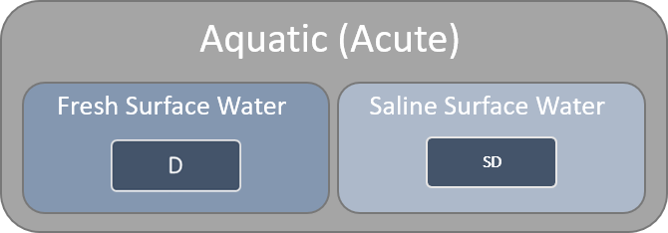

Figure 5: Many water quality standards of type Aquatic (Acute) are only applicable for fresh and saline surface waters D and SD, respectively. Therefore, Aquatic (Acute) standards are not always inherited by the classes downstream of D and SD in their respective hierarchies. There is no standaridized logic dictating when Aquatic (Acute) water quality standards are or are not inherited by their descendants.

Table (X) is a modified version of the table in [Title 6 NYCRR, Part 703.5](https://govt.westlaw.com/nycrr/Document/I4ed90418cd1711dda432a117e6e0f345?viewType=FullText&originationContext=documenttoc&transitionType=CategoryPageItem&contextData=(sc.Default)&bhcp=1) subset to only include parameters associated with type Aquatic Acute; Aquatic Chronic types were also retained when they corresponded with an Aquatic Acute standard for a given parameter. In fresh surface waters the Aquatic Acute WQSs for un-ionized ammonia as NH3, benzidine, and carbofuran are only applicable to class D waters. While in saline surface waters arsenic, cadmium, hexavalent chromium, and cyanide are only applicable to class SD waters. Endosulfan and total residual chlorine were only applicable to classes D and SD within fresh and saline surface waters, respectively. In all instances described, the Aquatic Acute standards are superseded by more stringent Aquatic Chronic standards for all classes downstream in the hierarchy– except when class I’s are missing (see Class I). There are also instances in Table (X) where the entire class hierarchy is specified for the Aquatic Acute type (e.g., fresh surface water arsenic and saline surface water Copper). This creates an odd discrepancy for assessments. For example, the arsenic fresh surface water Aquatic Acute and Aquatic Chronic standards are applicable to classes C, B, A, A-Special, AA, and AA-Special. Conversely, the arsenic saline surface water Aquatic Acute standard is only applicable to class SD waters, while the Aquatic Chronic standard is applicable to classes SC, SB, and SA. Thus, a class A waterbody would be assessed for both Aquatic Acute and Aquatic Chronic standards, while the saline counterpart class SA would only be assessed by the Aquatic Chronic standard. 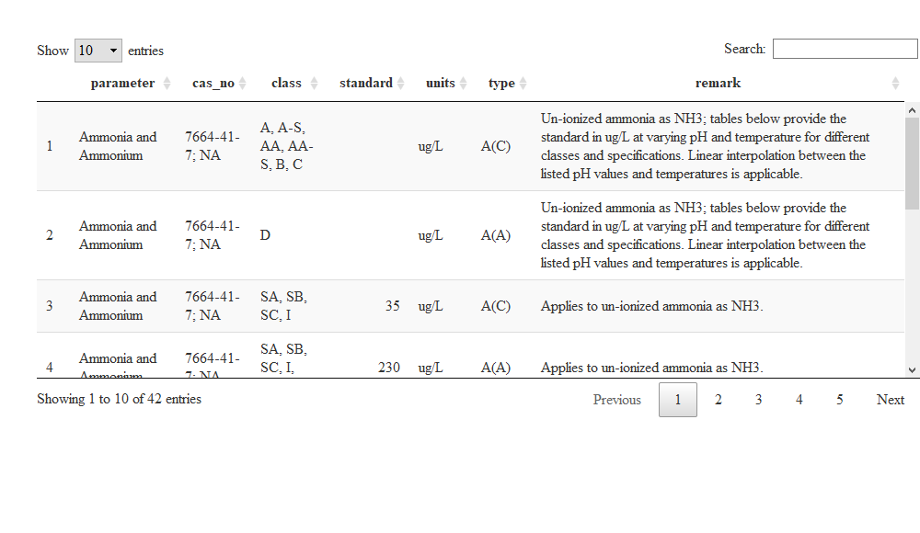

#### Trout and Trout Spawning Waters

Fresh surface water classes C, B, A, A-Special, AA, and AA-Special have variants designating Trout (T) and Trout Spawning (TS) waterbodies (e.g., C(T) and C(TS)). For the majority of parameters, these variants have the same WQS as the non-T/TS waterbody classes (Figure 3). Dissolved oxygen and ammonia as NH3 WQS differ between non-T/TS, T, and TS waterbody class variants (Figure 6); non-T/TS variants have the least stringent standards, while TS variants have the most stringent standards.

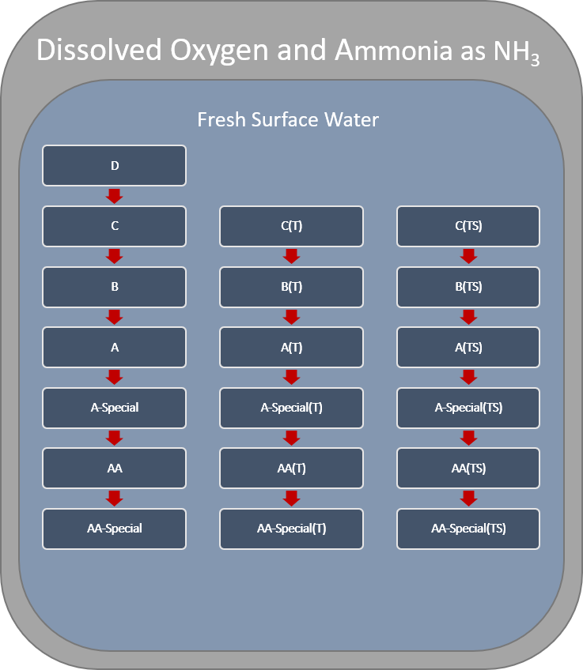

Figure 6: New York State’s fresh surface water dissolved oxygen and ammonia as NH3 water quality standards for class C, B, A, A-Special, AA, and AA-Special differ amoung Trout (T) and Trout Spawning (TS) class variants.

#### Dissolved Solids

The WQS for dissolved solids in fresh surface waters is defined as “Shall be kept as low as practicable to maintain the best usage of waters but in no case shall it exceed 500 mg/L” for classes C, B, A, AA, and AA-Special (Figure 7). The standard for class A-Special is “Shall not exceed 200 mg/L.” This deviates from the general logic depicted in Figure 3 because the A-Special class is more stringent than it’s downstream classes, AA and AA-Special.

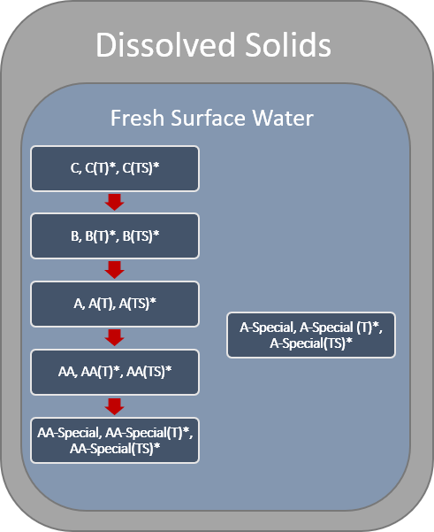

Figure 7: New York State’s fresh surface water dissolved solids water quality standards are more stringent for class A-Special than the other waterbody classes. This deviates from the general logic that the downstream classes (i.e., AA and AA-Special) will inherit the standards of class A-Special.

#### Total and Fecal Coliforms

The WQSs for total and fecal coliforms in fresh surface waters follow the logic dictated in Figure 3, except there is no total coliform standard applicable to class AA-Special (Figure 8) and there are no fecal coliform standards applicable to class AA or AA-Special (Figure 9). 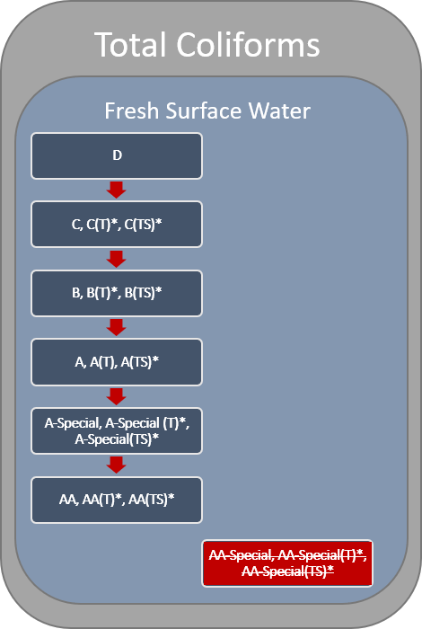

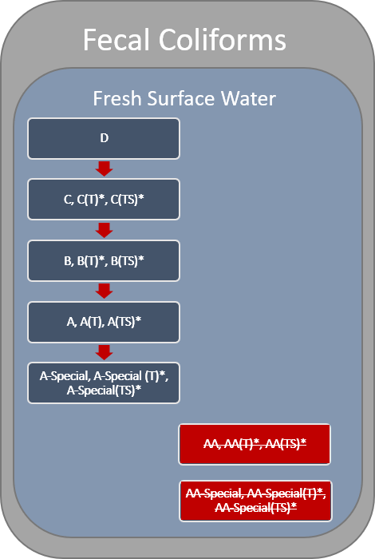

Figure 9: There are no fecal coliform standards defined for fresh water surface classes AA or AA-Special in New York State.