# Water Quality Standards and Guidance Values

Water quality standards (WQSs) and guidance values (GVs) are narrative or numeric criteria for determining the condition of a waterbody. New York State’s (NYS’s) WQSs and GVs are defined in [Title 6 NYCRR, Part 703](https://govt.westlaw.com/nycrr/Browse/Home/NewYork/NewYorkCodesRulesandRegulations?guid=I070d30d0b5a111dda0a4e17826ebc834&originationContext=documenttoc&transitionType=Default&contextData=(sc.Default)) and [TOGS 1.1.1](https://www.dec.ny.gov/docs/water_pdf/togs111.pdf), respectively. WQSs and GVs are applicable to three water types, fresh surface water, saline surface water, and groundwater, as determined by the relationship among WQSs/GVs, WQS/GV-type, best usages, and waterbody class; this chapter will elucidate this relationship as it pertains to numeric-WQSs/GVs used to assess fresh and saline surface waters in NYS.

## Waterbody Class

Fresh and saline surface water classes generally conform to a descending alphabetical hierarchy (Figure 3). Class D represents the most upstream class of the fresh surface waters, while the various A-classes represent the most downstream classes (Figure 3A). Similar to the fresh surface water classes, class SD represents the most upstream class of the saline surface waters, while class SA represents the most downstream class (Figure 3B). Class I, within saline surface waters, is downstream of class SC and upstream of class SB, which creates a discrepancy in the descending alphabetical hierarchy of saline surface water classes.

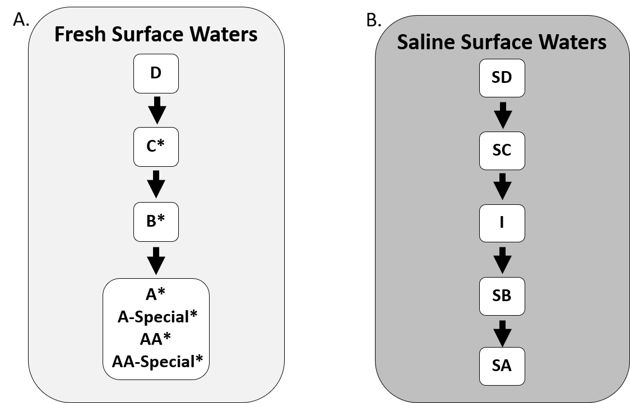

Figure 3: The standard waterbody class hierarchy of fresh (A) and saline surface waters (B) for which New York State’s water quality standards are inherited in descending alphabetical order. The white-boxes represent the waterbody classes and the arrows indicate the direction that water quality standards are inherited through the class hierarchy. * Fresh surface water classes that have non-trout, trout (T), and trout spawning (TS) variants.

WQSs and GVs assigned to upstream classes are inherited by all downstream classes. The most upstream class associated with a WQS or GV will be referred to as the “root” class for a given standard. For example, WQSs and GVs with root D or SD classes will be applicable to all downstream fresh surface water classes (i.e., C, B, A-classes, and their associated Trout (T) and Trout Spawning (TS) variants) and saline surface water classes (i.e., I, SC, SB, and SA), respectively. D and SD represent the most upstream classes in fresh and saline surface waters, respectively, and therefore influence all other classes. However, D and SD classes do not always represent the root class; the root is determined by the designated the type of a WQS or GV and best usage supported.

### Designated Best Uses and Standard Types

Waterbodies in NYS are assigned designated best use(s) (i.e., Fishing, Secondary Contact Recreation, Primary Contact Recreation, Source Water Supply, and Shellfishing) determined by the waterbody class. Fishing, Primary Contact Recreation, and Secoundary Contact Recreation uses are applicable to fresh and saline surface waters, while the Source Water Supply and Shellfishing uses are only applicable to fresh and saline surface waters, respectively. Figure 4 overlays the class hierarchy depicted in Figure 3 on the designated best uses the classes support. For example, all fresh surface water class support the Fishing use, while only A-classes support the Source Water Supply use (Figure 4A). Furthermore, A-classes support all fresh surface water uses (i.e., Fishing, Secondary Contact Recreation, Primary Contact Recreation, Source Water Supply), while classes C and D only support the fresh surface water Fishing use. To determine the best use supported by a WQS or GV, the WQS- or GV-type must be used as a cross-walk.

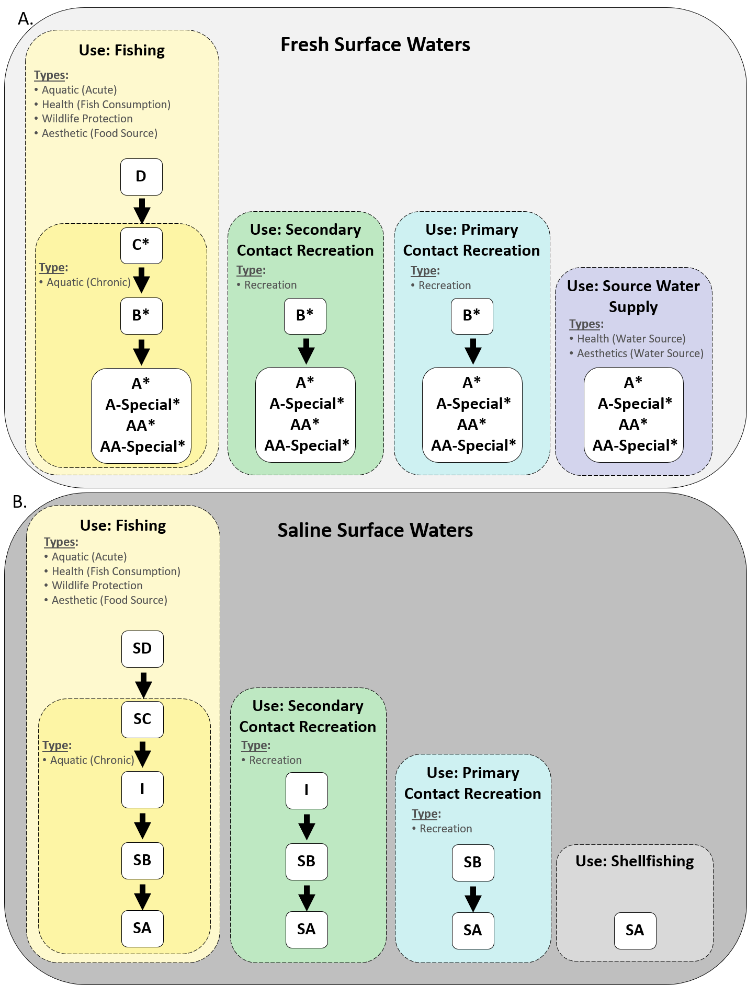

Figure 4: The designated waterbody uses and associated waterbody types of fresh (A) and saline surface waters (B) in New York State overlain with the water quality standards waterbody class hierarchy.The white-boxes represent the waterbody classes and the arrows indicate the direction that water quality standards are inherited through the class hierarchy. * Fresh surface water classes that have non-trout, trout (T), and trout spawning (TS) variants.

[Title 6 NYCRR, Part 702](https://govt.westlaw.com/nycrr/Browse/Home/NewYork/NewYorkCodesRulesandRegulations?guid=I06b83300b5a111dda0a4e17826ebc834&originationContext=documenttoc&transitionType=Default&contextData=(sc.Default)) defines eight WQS/GV-types that provide an link between a WQS or GV and the best use the standard supports (Table 1, Figure 4). WQS/GV-types are measurements that are representatitive of a specific aspect of a best usage. For example, Aesthetic (Water Source) standards assess aspects of a source water supply that would be offputting but not harmful (i.e., taste, odor, and discoloration), while Health (Water Source) standards assess the presence of harmful substances in a source water supply. Both types support the source water supply use but represent different components necessary for protecting the use.

Table 1: The relationship between the best usage and the standard-type.

|  |  |  |
| --- | --- | --- |
| Best.Use | Type | Source |
| Fishing | Aquatic (Acute) | Title 6 NYCRR, Part 702.9 |
| Fishing | Aquatic (Chronic) | Title 6 NYCRR, Part 702.9 |
| Fishing | Health (Fish Consumption) | Title 6 NYCRR, Part 702.8 |
| Fishing | Wildlife | Title 6 NYCRR, Part 702.13 |
| Fishing | Aesthetic (Food Source) | Title 6 NYCRR, Part 702.14 |
| Secondary Contact Recreation | Recreation | Title 6 NYCRR, Part 702.12 |
| Primary Contact Recreation | Recreation | Title 6 NYCRR, Part 702.12 |
| Source Water Supply | Health (Water Source) | Title 6 NYCRR, Part 702.2 |
| Source Water Supply | Aesthetic (Water Source) | Title 6 NYCRR, Part 702.14 |
| Shellfishing | Not Applicable | Not Applicable |

In practice, the types specified in the WQS or GV tables in [Title 6 NYCRR, Part 703](https://govt.westlaw.com/nycrr/Browse/Home/NewYork/NewYorkCodesRulesandRegulations?guid=I070d30d0b5a111dda0a4e17826ebc834&originationContext=documenttoc&transitionType=Default&contextData=(sc.Default)) and [TOGS 1.1.1](https://www.dec.ny.gov/docs/water_pdf/togs111.pdf) must be utilized to cross-walk the WQSs and GVs in these tables to the best use(s) supported. When multiple WQS-types are listed for a single parameter, [Title 6 NYCRR, Part 703.5](https://govt.westlaw.com/nycrr/Browse/Home/NewYork/NewYorkCodesRulesandRegulations?guid=I070d30d0b5a111dda0a4e17826ebc834&originationContext=documenttoc&transitionType=Default&contextData=(sc.Default)%20specifies%20that%20the%20most%20stringent%20standard%20will%20be%20applied.%20For%20example,%20in%20%5BTitle%206%20NYCRR,%20Part%20703.5%5D(https://govt.westlaw.com/nycrr/Browse/Home/NewYork/NewYorkCodesRulesandRegulations?guid=I070d30d0b5a111dda0a4e17826ebc834&originationContext=documenttoc&transitionType=Default&contextData=(sc.Default))%20the%20WQSs%20for%20dissolved%20mercury%20differ%20between%20four%20fishing%20types%20types:%201) Health (Fish Consumption), 2) Aquatic (Chronic), 3) Aquatic (Acute), and 4) Wildlife. Therefore, there are four standards for assessing the fishing use (i.e., Health (Fish Consumption), Aquatic (Chronic), Aquatic (Acute), and Wildlife types). For all fresh and saline surface water classes the Health (Fish Consumption) standard is the most stringent, rendering the remaining types irrelavent and unapplicable to any assessment. WQS/GV-types provide a link between most WQSs/GVs and the use supported, but not all standards are assigned a type.

Many of the WQSs defined outside of [Title 6 NYCRR, Part 703.5](https://govt.westlaw.com/nycrr/Browse/Home/NewYork/NewYorkCodesRulesandRegulations?guid=I070d30d0b5a111dda0a4e17826ebc834&originationContext=documenttoc&transitionType=Default&contextData=(sc.Default)) do not have defined WQS/GV-types, and therefore support all designated best uses associated with a given class. For example, the dissolved oxygen (DO) WQS defined in [Title 6 NYCRR, Part 703.3](https://govt.westlaw.com/nycrr/Document/I4ed90412cd1711dda432a117e6e0f345?viewType=FullText&originationContext=documenttoc&transitionType=CategoryPageItem&contextData=(sc.Default)) has no defined type for fresh surface water classes. If DO is used to assess a class C waterbody, the assessment will only support the Fishing use. While, if DO is used to assess a class A waterbody, the assessment will support Fishing, Secondary Contact Recreation, Primary Contact Recreation, and Source Water Supply uses. The generic application of WQSs or GVs to best usages when types are absent provides no direct relationship between the standard and the best usage.

Although most WQSs and GVs adhere to the logic represented in Figure 4, there are multiple discrepancies in [Title 6 NYCRR, Part 703](https://govt.westlaw.com/nycrr/Browse/Home/NewYork/NewYorkCodesRulesandRegulations?guid=I070d30d0b5a111dda0a4e17826ebc834&originationContext=documenttoc&transitionType=Default&contextData=(sc.Default)) and [TOGS 1.1.1](https://www.dec.ny.gov/docs/water_pdf/togs111.pdf).

### Discrepancies

The following WQS do not follow the logic depicted in Figure 4. It is important to specifically document all discrepancies as these instances will require special attention during the development of an automated assessment process.

#### Class I

In [TOGS 1.1.1](https://www.dec.ny.gov/docs/water_pdf/togs111.pdf) Part 1A-Section 3. Water Classes and Type, WQSs for the saline surface water class I are associated with types Health (Consumption of Fish), Aquatic (Chronic), Aquatic (Acute), Wildlife Protection, and Aesthetic– “Aesthetic” should most likely represent “Aesthetic (Food Source)” to align with the types defined in [Title 6 NYCRR, Part 703.5](https://govt.westlaw.com/nycrr/Browse/Home/NewYork/NewYorkCodesRulesandRegulations?guid=I070d30d0b5a111dda0a4e17826ebc834&originationContext=documenttoc&transitionType=Default&contextData=(sc.Default))). However, in Table 1 of [TOGS 1.1.1](https://www.dec.ny.gov/docs/water_pdf/togs111.pdf) and in [Title 6 NYCRR, Part 703.5](https://govt.westlaw.com/nycrr/Document/I4ed90418cd1711dda432a117e6e0f345?viewType=FullText&originationContext=documenttoc&transitionType=CategoryPageItem&contextData=(sc.Default)&bhcp=1), class I water’s are frequently and inconsistently excluded from the above mentioned types. This creates a class hierarchy that follows the logic in Figure 5 rather than the logic in Figure 3.

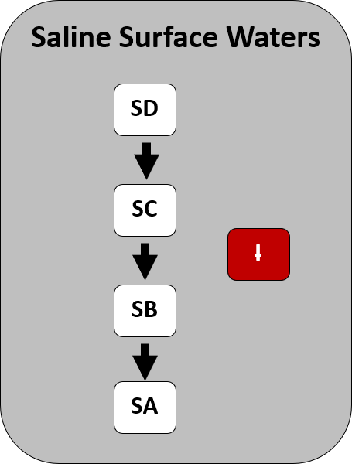

Figure 5: In some instances New York State saline surface water standards exclude class I from the hierarchy of class. The white-boxes represent the waterbody classes and the arrows indicate the direction that water quality standards are inherited through the class hierarchy. The red-box indicates that the waterbody class has been excluded from the hierarchy.

#### Aquatic (Acute)

Aquatic (Acute) designates a type of WQS or GV. [Title 6 NYCRR, Part 702.9d](https://govt.westlaw.com/nycrr/Document/I4ed8b5f2cd1711dda432a117e6e0f345?viewType=FullText&originationContext=documenttoc&transitionType=CategoryPageItem&contextData=(sc.Default)&bhcp=1) states: *“Where the waters are to be suitable for fish, shellfish and wildlife propagation and survival, both Aquatic (Chronic) and Aquatic (Acute) standards or guidance values shall apply.”* However, the class hierarchy associated with Aquatic (Acute) WQSs are treated inconsistently in [Title 6 NYCRR, Part 703.5](https://govt.westlaw.com/nycrr/Document/I4ed90418cd1711dda432a117e6e0f345?viewType=FullText&originationContext=documenttoc&transitionType=CategoryPageItem&contextData=(sc.Default)&bhcp=1) and [TOGS 1.1.1](https://www.dec.ny.gov/docs/water_pdf/togs111.pdf). In many instances, the class hierarchy follows the rules depicted in Figure 3, but there are multiple instances where Aquatic (Acute) WQSs and GVs are only applicable to fresh and saline surface water classes D and SD, respectively (Figure 6).

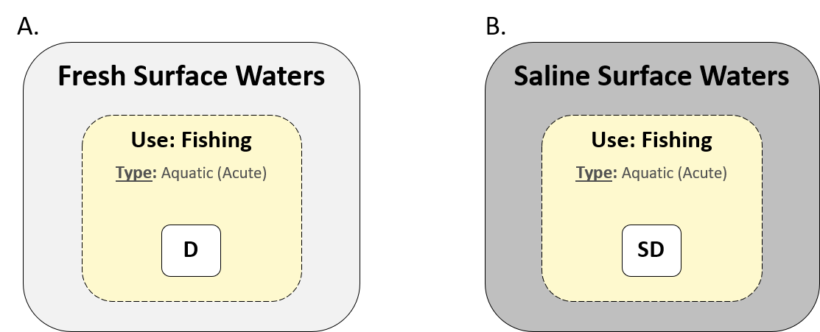

Figure 6: Many water quality standards of type Aquatic (Acute) are only applicable for fresh and saline surface waters D and SD, respectively. Therefore, Aquatic (Acute) standards are not always inherited by the classes downstream of D and SD in their respective hierarchies. There is no standardized logic dictating when Aquatic (Acute) water quality standards are or are not inherited by their descendants.

Table 2 is a modified version of the table in [Title 6 NYCRR, Part 703.5](https://govt.westlaw.com/nycrr/Document/I4ed90418cd1711dda432a117e6e0f345?viewType=FullText&originationContext=documenttoc&transitionType=CategoryPageItem&contextData=(sc.Default)&bhcp=1) subset to only include parameters associated with type Aquatic Acute; Aquatic Chronic types were also retained when they corresponded with an Aquatic Acute standard for a given parameter. In fresh surface waters the Aquatic Acute WQSs for un-ionized ammonia as NH3, benzidine, and carbofuran are only applicable to class D waters. While in saline surface waters arsenic, cadmium, hexavalent chromium, and cyanide are only applicable to class SD waters. Endosulfan and total residual chlorine were only applicable to classes D and SD within fresh and saline surface waters, respectively. In all instances described, the Aquatic Acute standards are superseded by more stringent Aquatic Chronic standards for all classes downstream in the hierarchy– except when class I’s are missing (see Class I). There are also instances in Table 2 where the entire class hierarchy is specified for the Aquatic Acute type (e.g., fresh surface water arsenic and saline surface water Copper). This creates an odd discrepancy for assessments. For example, the arsenic fresh surface water Aquatic Acute and Aquatic Chronic standards are applicable to classes C, B, A, A-Special, AA, and AA-Special. Conversely, the arsenic saline surface water Aquatic Acute standard is only applicable to class SD waters, while the Aquatic Chronic standard is applicable to classes SC, SB, and SA. Thus, a class A waterbody would be assessed for both Aquatic Acute and Aquatic Chronic standards, while the most downstream saline class, class SA, would only be assessed by the Aquatic Chronic standard.

Table 2: All Aquatic (Acute) water quality standards in Title 6 NYCRR, Part 703.5. Aquatic (Chronic) water quality standards were included, if they were present for any of the same parameters that also had an Aquatic (Acute) standard.

|  |  |  |  |  |  |  |
| --- | --- | --- | --- | --- | --- | --- |
| parameter | cas_no | class | standard | units | type | remark |
| Ammonia and Ammonium | 7664-41-7; NA | A, A-S, AA, AA-S, B, C | NA | ug/L | A(C) | Un-ionized ammonia as NH3; tables below provide the standard in ug/L at varying pH and temperature for different classes and specifications. Linear interpolation between the listed pH values and temperatures is applicable. |
| Ammonia and Ammonium | 7664-41-7; NA | D | NA | ug/L | A(A) | Un-ionized ammonia as NH3; tables below provide the standard in ug/L at varying pH and temperature for different classes and specifications. Linear interpolation between the listed pH values and temperatures is applicable. |
| Ammonia and Ammonium | 7664-41-7; NA | SA, SB, SC, I | 3.5e+01 | ug/L | A(C) | Applies to un-ionized ammonia as NH3. |
| Ammonia and Ammonium | 7664-41-7; NA | SA, SB, SC, I, SD | 2.3e+02 | ug/L | A(A) | Applies to un-ionized ammonia as NH3. |
| Arsenic | NA | A, A-S, AA, AA-S, B, C | 1.5e+02 | ug/L | A(C) | Dissolved arsenic form. |
| Arsenic | NA | A, A-S, AA, AA-S, B, C, D | 3.4e+02 | ug/L | A(A) | Dissolved arsenic form. |
| Arsenic | NA | SA, SB, SC | 6.3e+01 | ug/L | A(C) | Dissolved arsenic form. |
| Arsenic | NA | SD | 1.2e+02 | ug/L | A(A) | Dissolved arsenic form. |
| Azinphosmethyl | 86-50-0 | A, A-S, AA, AA-S, B, C | 5.0e-03 | ug/L | A(C) | For the waters of the Great Lakes System, the department will substitute a guidance value for the aquatic Type standard if so determined under section 702.15(c) of this Title. |
| Azinphosmethyl | 86-50-0 | SA, SB, SC | 1.0e-02 | ug/L | A(C) | NA |
| Benzidine | 92-87-5 | A, A-S, AA, AA-S, B, C | 1.0e-01 | ug/L | A(C) | For the waters of the Great Lakes System, the department will substitute a guidance value for the aquatic Type standard if so determined under section 702.15(c) and (d) of this Title. |
| Benzidine | 92-87-5 | D | 1.0e-01 | ug/L | A(A) | For the waters of the Great Lakes System, the department will substitute a guidance value for the aquatic Type standard if so determined under section 702.15(c) and (d) of this Title. |
| Cadmium | NA | A, A-S, AA, AA-S, B, C | NA | ug/L | A(C) | (0.85) exp(0.7852 [ln (ppm hardness)] - 2.715) |
| Cadmium | NA | A, A-S, AA, AA-S, B, C, D | NA | ug/L | A(A) | (0.85) exp(1.128 [ln (ppm hardness)] - 3.6867) |
| Cadmium | NA | SA, SB, SC, I | 7.7e+00 | ug/L | A(C) | NA |
| Cadmium | NA | SD | 2.1e+01 | ug/L | A(A) | NA |
| Carbofuran | 1563-66-2 | A, A-S, AA, AA-S, B, C | 1.0e+00 | ug/L | A(C) | For the waters of the Great Lakes System, the department will substitute a guidance value for the aquatic Type standard if so determined under section 702.15(c) and (d) of this Title. |
| Carbofuran | 1563-66-2 | D | 1.0e+01 | ug/L | A(A) | For the waters of the Great Lakes System, the department will substitute a guidance value for the aquatic Type standard if so determined under section 702.15(c) and (d) of this Title. |
| Chlorine, Total Residual | NA | A, A-S, AA, AA-S, B, C | 5.0e+00 | ug/L | A(C) | NA |
| Chlorine, Total Residual | NA | D | 1.9e+01 | ug/L | A(A) | NA |
| Chlorine, Total Residual | NA | SA, SB, SC, I | 7.5e+00 | ug/L | A(C) | NA |
| Chlorine, Total Residual | NA | SD | 1.3e+01 | ug/L | A(A) | NA |
| Chromium | NA | A, A-S, AA, AA-S, B, C | NA | ug/L | A(C) | (0.86) exp(0.819 [ln (ppm hardness)] + 0.6848) |
| Chromium | NA | A, A-S, AA, AA-S, B, C, D | NA | ug/L | A(A) | (0.316) exp(0.819 [ln (ppm hardness)] + 3.7256) |
| Chromium (hexavalent) | NA | A, A-S, AA, AA-S, B, C | 1.1e+01 | ug/L | A(C) | Applies to dissolved form. |
| Chromium (hexavalent) | NA | A, A-S, AA, AA-S, B, C, D | 1.6e+01 | ug/L | A(A) | Applies to dissolved form. |
| Chromium (hexavalent) | NA | SA, SB, SC | 5.4e+01 | ug/L | A(C) | Applies to acid-soluble form. |
| Chromium (hexavalent) | NA | SD | 1.2e+03 | ug/L | A(A) | Applies to acid-soluble form. |
| Copper | NA | A, A-S, AA, AA-S, B, C | NA | ug/L | A(C) | (0.96) exp(0.8545 [ln (ppm hardness)] - 1.702) |
| Copper | NA | A, A-S, AA, AA-S, B, C, D | NA | ug/L | A(A) | (0.96) exp(0.9422 [ln (ppm hardness)] - 1.7) |
| Copper | NA | SA, SB, SC, I | NA | ug/L | A(C) | Standard is 3.4 ug/L except in New York/New Jersey harbor where it is 5.6 ug/L. |
| Copper | NA | SA, SB, SC, I, SD | NA | ug/L | A(A) | Standard is 4.8 ug/L except in New York/New Jersey harbor where it is 7.9 ug/L. |
| Cyanide | NA | A, A-S, AA, AA-S, B, C | 5.2e+00 | ug/L | A(C) | As free cyanide: the sum of HCN and CN− expressed as CN. |
| Cyanide | NA | A, A-S, AA, AA-S, B, C, D | 2.2e+01 | ug/L | A(A) | As free cyanide: the sum of HCN and CN− expressed as CN. |
| Cyanide | NA | SA, SB, SC | 1.0e+00 | ug/L | A(C) | As free cyanide: the sum of HCN and CN− expressed as CN. |
| Cyanide | NA | SD | 1.0e+00 | ug/L | A(A) | As free cyanide: the sum of HCN and CN− expressed as CN. |
| Dieldrin | 60-57-1 | A, A-S, AA, AA-S, B, C | 5.6e-02 | ug/L | A(C) | NA |
| Dieldrin | 60-57-1 | A, A-S, AA, AA-S, B, C, D | 2.4e-01 | ug/L | A(A) | NA |
| Endosulfan | 115-29-7 | A, A-S, AA, AA-S, B, C | 9.0e-03 | ug/L | A(C) | NA |
| Endosulfan | 115-29-7 | D | 2.2e-01 | ug/L | A(A) | For the waters of the Great Lakes System, the department will substitute a guidance value for the aquatic Type standard if so determined under section 702.15(d) of this Title. |
| Endosulfan | 115-29-7 | SA, SB, SC | 1.0e-03 | ug/L | A(C) | NA |
| Endosulfan | 115-29-7 | SD | 3.4e-02 | ug/L | A(A) | NA |

#### Chlorobenzene

Chlorobenzene (108-90-7)…

#### Trout and Trout Spawning Waters

Fresh surface water classes C, B, A, A-Special, AA, and AA-Special have variants designating Trout (T) and Trout Spawning (TS) waterbodies (e.g., C(T) and C(TS)). For the majority of parameters, these variants have the same WQS as the non-T/TS waterbody classes (Figure 3). Dissolved oxygen and ammonia as NH3 WQS differ between non-T/TS, T, and TS waterbody class variants (Figure 7); non-T/TS variants have the least stringent standards, while TS variants have the most stringent standards. These parameters do not have an assigned WQS/GV-type, therefore

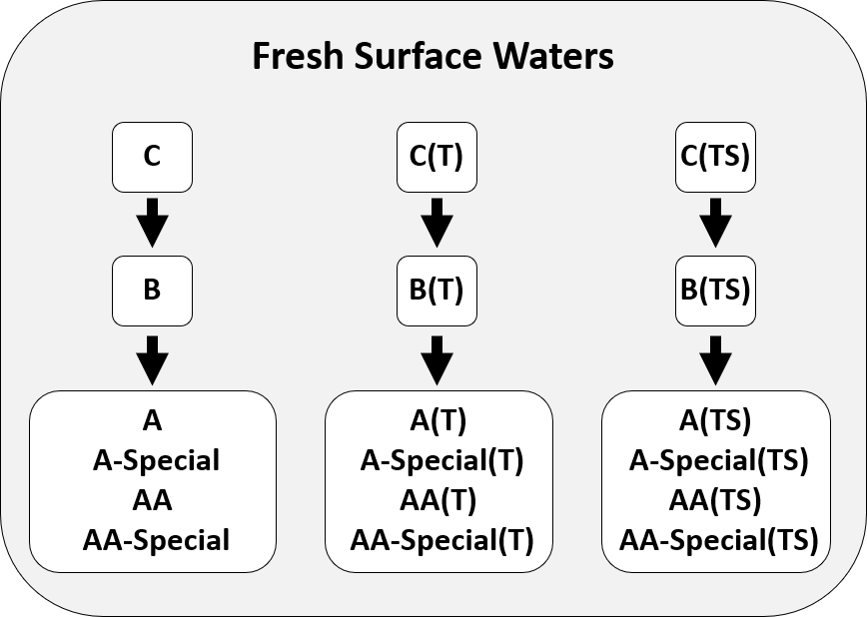

Figure 7: New York State’s fresh surface water dissolved oxygen and ammonia as NH3 water quality standards for class C, B, A, A-Special, AA, and AA-Special differ among non-Trout, Trout (T), and Trout Spawning (TS) class variants.

#### Class A Variants

Most fresh surface water class A variants have the same WQSs or GVs, but there are several instances where not all class A variants have defined standards or the standard deviates from the standard for the rest of the A variants.

##### Dissolved Solids

The dissolved solids A-Special WQS (200 mg/L) is more stringent than the other A variants (500 mg/L; [Title 6 NYCRR, Part 703.3](https://govt.westlaw.com/nycrr/Document/I4ed90412cd1711dda432a117e6e0f345?viewType=FullText&originationContext=documenttoc&transitionType=CategoryPageItem&contextData=(sc.Default)&bhcp=1)).

##### Total and Fecal Coliforms

The WQSs for total and fecal coliforms in fresh surface waters follow the logic dictated in Figure 3, except there is no total coliform standard applicable to class AA-Special and there are no fecal coliform standards applicable to class AA or AA-Special [Title 6 NYCRR, Part 703.4](https://govt.westlaw.com/nycrr/Document/I4ed90415cd1711dda432a117e6e0f345?viewType=FullText&originationContext=documenttoc&transitionType=CategoryPageItem&contextData=(sc.Default)).