Week 1 crib notes: What’s in a Name? Classification, phylogenies, and binomials
Open with the point that biology needs shared language for naming and for describing relationships. Linnaean ranks are a practical filing system; phylogenetic trees are hypotheses about common ancestry. The two often align, but ranks are human-made categories whereas trees are statements about evolutionary history. Emphasise that today’s task is reasoning with evidence, not memorising taxonomy.
Biologically relevant content to seed (keep it concrete). Remind them that “closer relatives share a more recent common ancestor”, which usually means they share derived traits (synapomorphies). Similarity can mislead: some traits are ancestral (shared because they’re old), and some similarities are convergent. The outgroup idea is crucial: a non-member helps you “root” the tree and decide direction of change. With the laminated set, the mushroom is the obvious outgroup; use it to reinforce that classification boundaries matter (animals vs fungi) and that “outgroup” is a tool, not an insult.
Give them a simple trait ladder they can reach for without panic: backbone/vertebrae (frog, shark, cat), four limbs (frog, cat), exoskeleton + jointed appendages (butterfly), radial symmetry and cnidocytes (jellyfish, at least conceptually), segmentation (earthworm), and then the bigger idea that these traits support nested groupings. If you want one sentence on ranks: “Phylum is a deep split; genus is a shallow split.” Keep binomial nomenclature rules crisp: Genus species, Genus capitalised, species lower-case, italicised (or underlined in handwriting). Mention why this matters: common names vary and can be ambiguous.
How to direct group work (say this explicitly). “Pick roles now: one person moves cards, one scribes the tree, one checks traits, one speaks for the group.” “Start with the outgroup; then do quick two-pile sorts before you draw the tree.” “Every branch point on your tree needs a trait label you can say out loud.” If they stall, prompt with a choice rather than a lecture: “Which two are definitely closer: frog–cat or frog–shark? What trait supports that?” If they’re arguing in circles, force a decision: “Commit to one tree, then we’ll stress-test it.”
Fast checks as you circulate. Look for (i) the outgroup placed at the base, (ii) at least four labelled nodes, (iii) at least one admission of uncertainty (“this is our best hypothesis”), and (iv) binomial formatting correct. Common pitfalls to gently correct: grouping by habitat (“both live in water”), treating evolution as a ladder, forgetting that a tree can be revised, and using “more advanced” language. Your closing line can be: “A good tree is the one you can defend with traits, and revise when the evidence changes.”

Week 1 practorial. What’s in a Name? Classification, phylogenies, and binomials
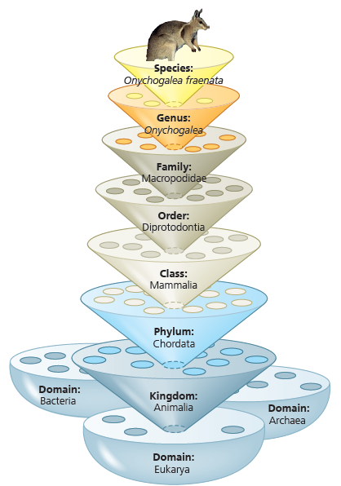
At your bench you have seven laminated photos: jellyfish, earthworm, butterfly, frog, shark, domestic cat, and mushroom. Work as one team. It helps to give yourselves quick roles (card mover, scribe, “trait checker”, spokesperson) so everyone contributes.
Your goal: build a simple evolutionary tree you can explain, then practise how scientific names and ranks help us communicate about biodiversity.

Figure 1.1: Linnaean classification. At each level, or “rank,” species are placed in groups within more inclusive groups.

- Outgroup (animal vs not)
Choose the photo that is not an animal and place it slightly apart. On your page, write one sentence explaining why it’s outside Animalia. This is your outgroup: it helps you decide where the “root” (the base) of your tree belongs.
- Quick sorting rounds (think in traits)
Do three fast “two-pile” sorts. For each sort, physically split the photos into two groups, then write one trait that justifies the split.
Use these prompts:
• Backbone (vertebrate) vs no backbone
• Bilateral symmetry vs not (adult form)
• Jointed legs + exoskeleton vs not
If you’re unsure, make a best guess and be ready to justify it.
- Build your tree (a hypothesis you can defend)
On paper, draw a rooted phylogenetic tree that includes all seven photos. Place the outgroup at the base. Add at least four labelled branch points (nodes). Each node label should be a trait shared by everything above that node, and not shared by the group that branches off.
Examples you may use (if you can explain them): vertebral column; four limbs; exoskeleton + jointed appendages; cnidocytes; radial symmetry (adult); segmented body.
- Use Linnaean ranks (where they help)
Choose at least one rank (e.g., Phylum or Class) and write it next to part of your tree where it genuinely adds clarity. You do not need to fill in every rank for every organism: only what you can justify.
- Binomial names (format matters)
Next to each organism, write a binomial name: Genus species. Use the real name if you know it; if not, invent a plausible Latin-style one. Rules: Genus capitalised, species lower-case, and both italicised (or underlined if handwriting). Keep names consistent with your tree: only share a genus if you are claiming very close relationship.
- Share one confident split and one uncertain split
Be ready to briefly explain one split you feel good about and one you’re unsure about. Trees are hypotheses: changing your mind after discussion is normal.

