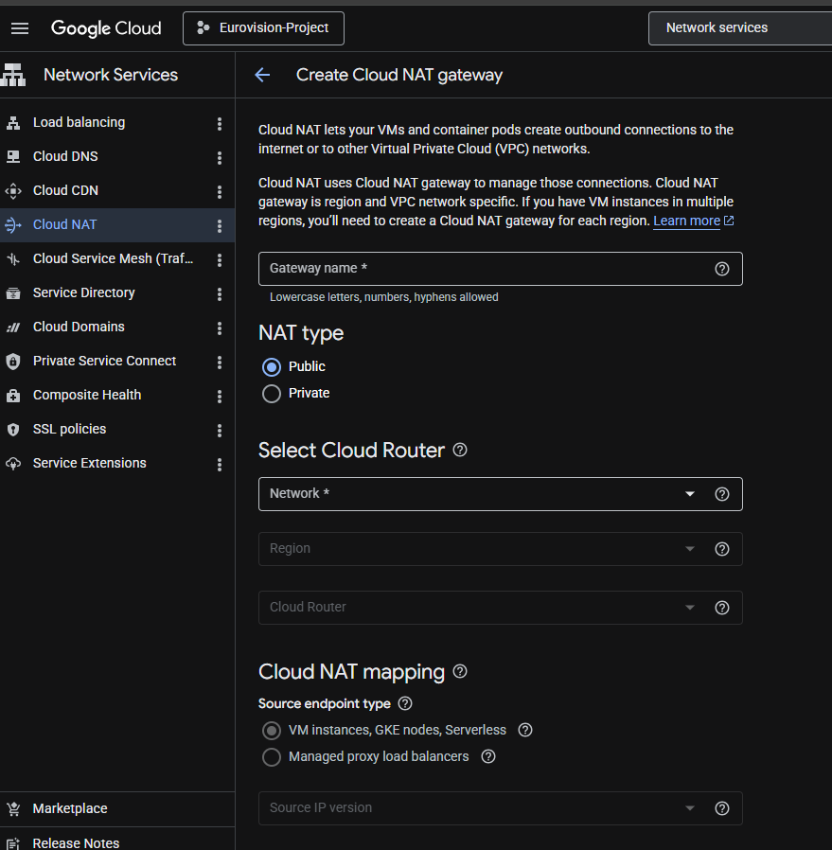
We configured a Google Cloud NAT gateway to provide outbound internet access for private VM instances (dc2-spark, dc3-spark, dc4-spark) that only use internal IP addresses inside the VPC network.
Without Cloud NAT, these internal VMs could communicate only inside the private network and were unable to download packages, install Spark dependencies, or access external repositories such as archive.apache.org.
Configuration details:
NAT Gateway Name: eurovision-nat
Network: default
Region: europe-west1
Cloud Router: eurovision-router
NAT Type: Public
This approach was chosen because:
Only dc1-spark uses an external IP for administration access.
dc2, dc3, and dc4 remain private and more secure by using only internal IP addresses.
Cloud NAT allows secure outbound internet connectivity without exposing the VMs directly to inbound internet traffic.
All Spark nodes can now install software and dependencies while remaining inside the internal Google Cloud network architecture.

