Exploratory Data Analysis on Avocado data set

## Exploratory Data Analysis on Avocado data set

The dataset contains 18,249 rows and 14 columns, including:

* **Date**: Date of observation.
* **average_price**: Price of a single avocado.
* **Total Volume**: Total volume of avocados sold.
* **4046, 4225, 4770**: PLU codes for different sizes of avocados.
* **Total Bags, Small Bags, Large Bags, XLarge Bags**: Number of avocados sold in bags of different sizes.
* **type**: Type of avocado (conventional or organic).
* **year**: Year of observation.
* **region**: Region where the data was recorded.

### Load necessary libraries

### Import Data

### Understanding the Structure of the Data

tibble [18,249 × 13] (S3: tbl_df/tbl/data.frame)  
 $ date : Date[1:18249], format: "2015-12-27" "2015-12-20" ...  
 $ average_price: num [1:18249] 1.33 1.35 0.93 1.08 1.28 1.26 0.99 0.98 1.02 1.07 ...  
 $ total_volume : num [1:18249] 64237 54877 118220 78992 51040 ...  
 $ x4046 : num [1:18249] 1037 674 795 1132 941 ...  
 $ x4225 : num [1:18249] 54455 44639 109150 71976 43838 ...  
 $ x4770 : num [1:18249] 48.2 58.3 130.5 72.6 75.8 ...  
 $ total_bags : num [1:18249] 8697 9506 8145 5811 6184 ...  
 $ small_bags : num [1:18249] 8604 9408 8042 5677 5986 ...  
 $ large_bags : num [1:18249] 93.2 97.5 103.1 133.8 197.7 ...  
 $ x_large_bags : num [1:18249] 0 0 0 0 0 0 0 0 0 0 ...  
 $ type : chr [1:18249] "conventional" "conventional" "conventional" "conventional" ...  
 $ year : num [1:18249] 2015 2015 2015 2015 2015 ...  
 $ region : chr [1:18249] "Albany" "Albany" "Albany" "Albany" ...

### Quick glimpse of data

Rows: 18,249  
Columns: 13  
$ date <date> 2015-12-27, 2015-12-20, 2015-12-13, 2015-12-06, 2015-11…  
$ average_price <dbl> 1.33, 1.35, 0.93, 1.08, 1.28, 1.26, 0.99, 0.98, 1.02, 1.…  
$ total_volume <dbl> 64236.62, 54876.98, 118220.22, 78992.15, 51039.60, 55979…  
$ x4046 <dbl> 1036.74, 674.28, 794.70, 1132.00, 941.48, 1184.27, 1368.…  
$ x4225 <dbl> 54454.85, 44638.81, 109149.67, 71976.41, 43838.39, 48067…  
$ x4770 <dbl> 48.16, 58.33, 130.50, 72.58, 75.78, 43.61, 93.26, 80.00,…  
$ total_bags <dbl> 8696.87, 9505.56, 8145.35, 5811.16, 6183.95, 6683.91, 83…  
$ small_bags <dbl> 8603.62, 9408.07, 8042.21, 5677.40, 5986.26, 6556.47, 81…  
$ large_bags <dbl> 93.25, 97.49, 103.14, 133.76, 197.69, 127.44, 122.05, 56…  
$ x_large_bags <dbl> 0.00, 0.00, 0.00, 0.00, 0.00, 0.00, 0.00, 0.00, 0.00, 0.…  
$ type <chr> "conventional", "conventional", "conventional", "convent…  
$ year <dbl> 2015, 2015, 2015, 2015, 2015, 2015, 2015, 2015, 2015, 20…  
$ region <chr> "Albany", "Albany", "Albany", "Albany", "Albany", "Alban…

### Quick Summary Statistics

date average_price total_volume x4046   
 Min. :2015-01-04 Min. :0.440 Min. : 85 Min. : 0   
 1st Qu.:2015-10-25 1st Qu.:1.100 1st Qu.: 10839 1st Qu.: 854   
 Median :2016-08-14 Median :1.370 Median : 107377 Median : 8645   
 Mean :2016-08-13 Mean :1.406 Mean : 850644 Mean : 293008   
 3rd Qu.:2017-06-04 3rd Qu.:1.660 3rd Qu.: 432962 3rd Qu.: 111020   
 Max. :2018-03-25 Max. :3.250 Max. :62505647 Max. :22743616   
 x4225 x4770 total_bags small_bags   
 Min. : 0 Min. : 0 Min. : 0 Min. : 0   
 1st Qu.: 3009 1st Qu.: 0 1st Qu.: 5089 1st Qu.: 2849   
 Median : 29061 Median : 185 Median : 39744 Median : 26363   
 Mean : 295155 Mean : 22840 Mean : 239639 Mean : 182195   
 3rd Qu.: 150207 3rd Qu.: 6243 3rd Qu.: 110783 3rd Qu.: 83338   
 Max. :20470573 Max. :2546439 Max. :19373134 Max. :13384587   
 large_bags x_large_bags type year   
 Min. : 0 Min. : 0.0 Length:18249 Min. :2015   
 1st Qu.: 127 1st Qu.: 0.0 Class :character 1st Qu.:2015   
 Median : 2648 Median : 0.0 Mode :character Median :2016   
 Mean : 54338 Mean : 3106.4 Mean :2016   
 3rd Qu.: 22029 3rd Qu.: 132.5 3rd Qu.:2017   
 Max. :5719097 Max. :551693.7 Max. :2018   
 region   
 Length:18249   
 Class :character   
 Mode :character

### Skim a data frame, getting useful summary statistics

Data summary

|  |  |
| --- | --- |
| Name | avocado_data |
| Number of rows | 18249 |
| Number of columns | 13 |
| _______________________ |  |
| Column type frequency: |  |
| character | 2 |
| Date | 1 |
| numeric | 10 |
| ________________________ |  |
| Group variables | None |

**Variable type: character**

| skim_variable | n_missing | complete_rate | min | max | empty | n_unique | whitespace |
| --- | --- | --- | --- | --- | --- | --- | --- |
| type | 0 | 1 | 7 | 12 | 0 | 2 | 0 |
| region | 0 | 1 | 4 | 19 | 0 | 54 | 0 |

**Variable type: Date**

| skim_variable | n_missing | complete_rate | min | max | median | n_unique |
| --- | --- | --- | --- | --- | --- | --- |
| date | 0 | 1 | 2015-01-04 | 2018-03-25 | 2016-08-14 | 169 |

**Variable type: numeric**

| skim_variable | n_missing | complete_rate | mean | sd | p0 | p25 | p50 | p75 | p100 | hist |
| --- | --- | --- | --- | --- | --- | --- | --- | --- | --- | --- |
| average_price | 0 | 1 | 1.41 | 0.40 | 0.44 | 1.10 | 1.37 | 1.66 | 3.25 | ▂▇▅▁▁ |
| total_volume | 0 | 1 | 850644.01 | 3453545.36 | 84.56 | 10838.58 | 107376.76 | 432962.29 | 62505646.52 | ▇▁▁▁▁ |
| x4046 | 0 | 1 | 293008.42 | 1264989.08 | 0.00 | 854.07 | 8645.30 | 111020.20 | 22743616.17 | ▇▁▁▁▁ |
| x4225 | 0 | 1 | 295154.57 | 1204120.40 | 0.00 | 3008.78 | 29061.02 | 150206.86 | 20470572.61 | ▇▁▁▁▁ |
| x4770 | 0 | 1 | 22839.74 | 107464.07 | 0.00 | 0.00 | 184.99 | 6243.42 | 2546439.11 | ▇▁▁▁▁ |
| total_bags | 0 | 1 | 239639.20 | 986242.40 | 0.00 | 5088.64 | 39743.83 | 110783.37 | 19373134.37 | ▇▁▁▁▁ |
| small_bags | 0 | 1 | 182194.69 | 746178.51 | 0.00 | 2849.42 | 26362.82 | 83337.67 | 13384586.80 | ▇▁▁▁▁ |
| large_bags | 0 | 1 | 54338.09 | 243965.96 | 0.00 | 127.47 | 2647.71 | 22029.25 | 5719096.61 | ▇▁▁▁▁ |
| x_large_bags | 0 | 1 | 3106.43 | 17692.89 | 0.00 | 0.00 | 0.00 | 132.50 | 551693.65 | ▇▁▁▁▁ |
| year | 0 | 1 | 2016.15 | 0.94 | 2015.00 | 2015.00 | 2016.00 | 2017.00 | 2018.00 | ▇▇▁▇▂ |

### Missing Values

date average_price total_volume x4046 x4225   
 0 0 0 0 0   
 x4770 total_bags small_bags large_bags x_large_bags   
 0 0 0 0 0   
 type year region   
 0 0 0

[1] 0

### Exploratory Data Analysis Questions:

**1. What is the distribution of avocado prices?**

***Option (a) - Histogram***

* A histogram is a bar chart that groups data into bins, showing the frequency or count of values within each bin.

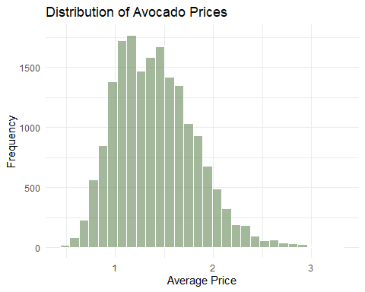

***Option (b) - Density plot***

* A density plot displays the proportion of data points within each range, providing a continuous and visually appealing estimate of the distribution, particularly useful for larger datasets. It uses a smooth curve to represent the data distribution.
* They are created using kernel density estimation (KDE), which smooths the data to show its underlying shape without the abrupt transitions seen in histograms.

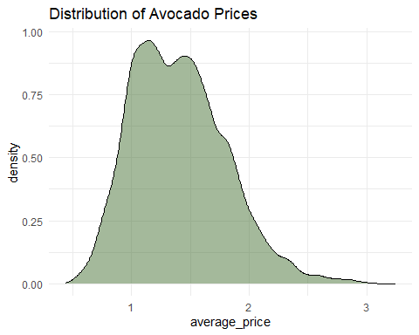

**Boxplot**

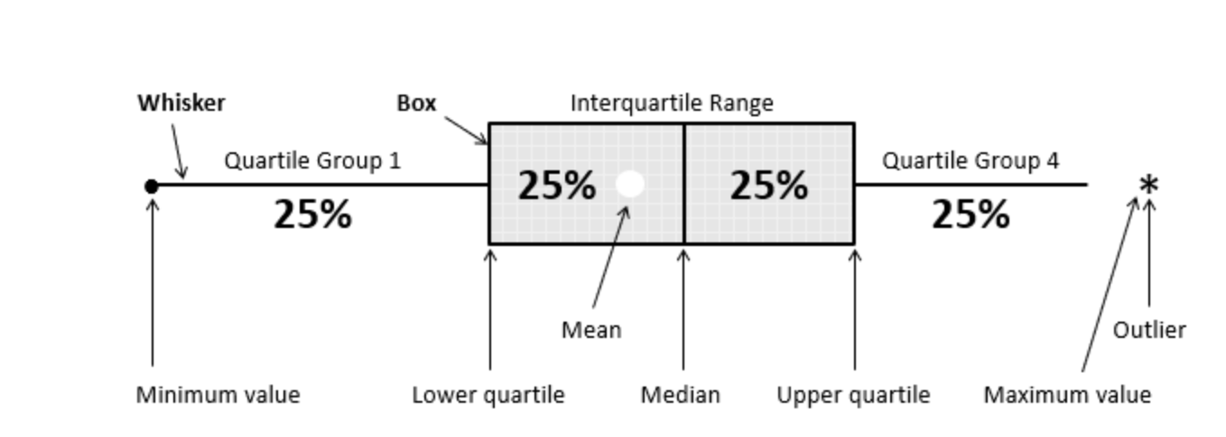

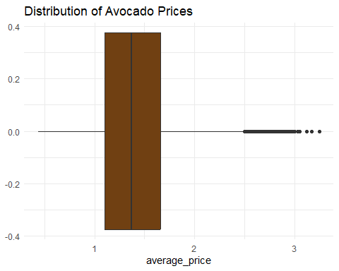

**2. How does the total volume of avocados sold vary over time?**

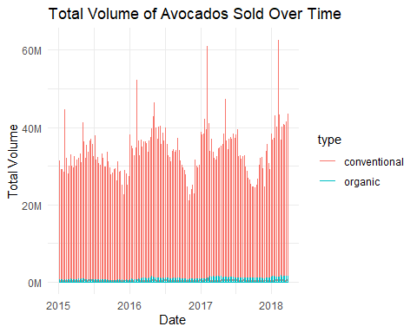

***Break the display using facet_wrap***

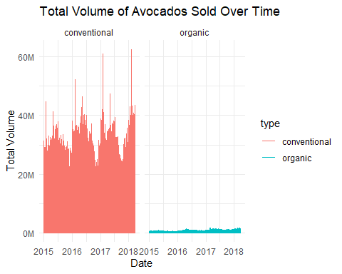

***Free the y-axis for each facet***

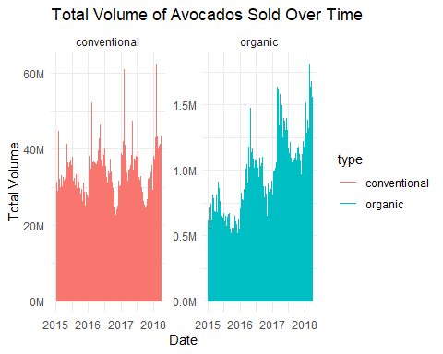

**3. How do average prices vary across regions?**

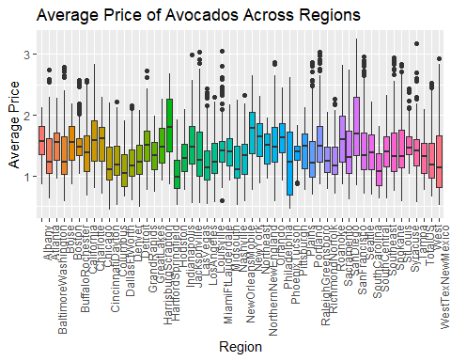

***Arrange the box plots using the median of the average price for each region***

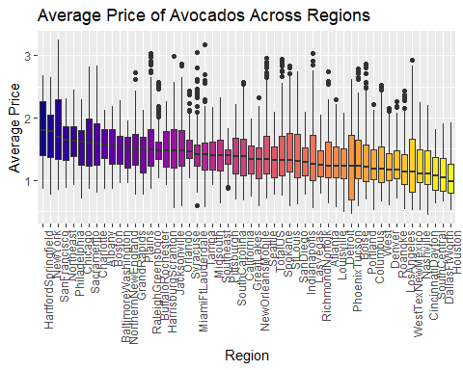

**4. How do average prices vary across regions based on the type of avocado?**

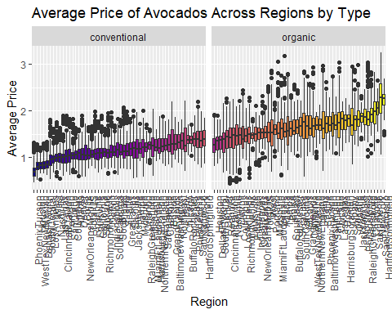

**5. What are the trends in avocado sales over the years for each type?**

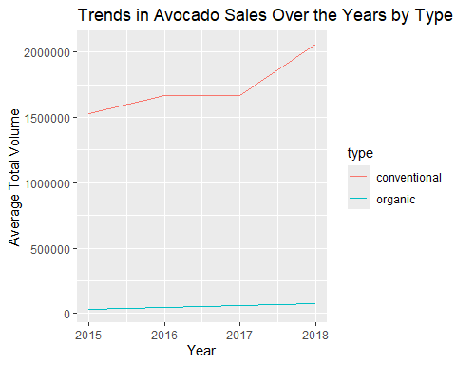

**6. Are there seasonal patterns in the average price of avocados?**

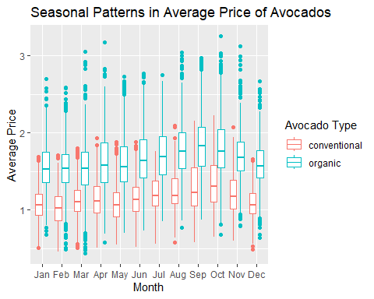

**7. Which regions have the highest and lowest average avocado prices?**

# A tibble: 5 × 2  
 region avg_price  
 <fct> <dbl>  
1 HartfordSpringfield___organic 2.23  
2 SanFrancisco___organic 2.21  
3 NewYork___organic 2.05  
4 Sacramento___organic 1.97  
5 Charlotte___organic 1.94

# A tibble: 5 × 2  
 region avg_price  
 <fct> <dbl>  
1 SouthCentral___conventional 0.869  
2 DallasFtWorth___conventional 0.846  
3 WestTexNewMexico___conventional 0.842  
4 Houston___conventional 0.825  
5 PhoenixTucson___conventional 0.728

**8. How are bag sizes (small, large, x-large) distributed by different type?**

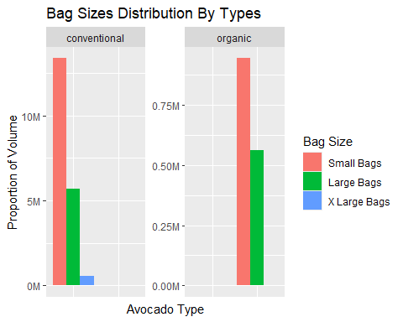

**9. How are avocado sizes (x4046, x4225, x4770) distributed by different type?**

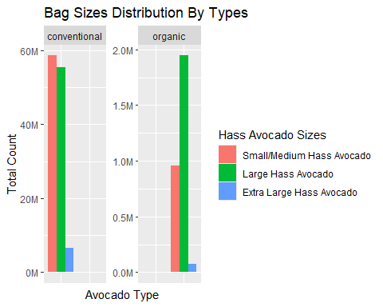

**10. How are total number of avocado sizes (x4046, x4225, x4770) sold over time?**

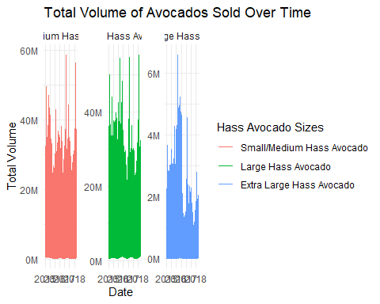

**11. Is there a correlation between avocado sales volumes and prices?**

