Running Head: Predation Affects Virus Transmission

**Predator Niche Overlap Predicts Effects on Aphid Vectors and a Vector-borne Virus**

Benjamin W. Lee, Tobin D. Northfield, and David W. Crowder

Department of Entomology, Washington State University, Pullman, WA, USA

Corresponding author:

Benjamin W. Lee

WSU Entomology

166 FSHN Building

Pullman, WA, USA 99164

914-275-6540

[benjamin.w.lee@wsu.edu](mailto:benjamin.w.lee@wsu.edu)

Author Contributions: BWL and DWC conceived the experiments. BWL performed the experiments. BWL and TDN analyzed the data. All authors wrote the manuscript.

Data and code used for analysis are available upon request from Zenodo (Lee, 2021), (doi: 10.5281/zenodo.5190534) and will be made publicly available in this repository pending acceptance of this manuscript. This manuscript does not include any novel code.ABSTRACT

Multiple predator species can enhance or disrupt prey suppression based on whether different predators forage in complementary or overlapping niches. Interactions between predator species are primarily evaluated by resulting effects on prey abundance, although alterations of prey behavior also occur. When prey are vectors of plant pathogens, changes in their movement among plants may affect pathogen transmission as strongly as changes in vector abundance. Here we assessed how single predator species, and pairs of species with varying degrees of niche overlap, affected pea aphid vectors and transmission of an aphid-borne pathogen, pea-enation mosaic virus (PEMV). Foliar foraging predators reduced vector abundance but altered vector behavior in ways that promoted PEMV transmission, resulting in no net effects on PEMV prevalence. Predator pairings also enhanced vector suppression but caused vectors to move to parts of plants that were more susceptible to PEMV. Surprisingly, pathogen prevalence was only reduced in predator pairings that did not exhibit super-additive predation rates. Our study shows that enhanced predator consumption of vectors due to niche complementarity can affect pathogen transmission differently than it affects vector dispersal and feeding behaviors. Nonetheless, long-term suppression of vector populations may ultimately reduce pathogen transmission.

Key Words: *predation risk, habitat domain, vector, virus, trait-mediated effects, biodiversity*

INTRODUCTION

When multiple predator species attack the same prey, interactions between predators range from synergistic to antagonistic, with effects that cascade across trophic levels (Sih et al. 1998; Ives et al. 2005). The predator habitat domain framework, which defines spatial niches of predators, can predict how multiple predators affect prey (Preisser et al. 2007; Schmitz 2007). Predators that forage in distinct niches may enhance prey suppression by preventing prey from seeking refuges (Losey and Denno 1998; Straub and Snyder 2008). Yet, predators with overlapping niches may compete or feed on each other, reducing predation risk (Snyder and Ives, 2001). Prey behavioral responses to multiple predators can affect population dynamics and trophic cascades if survival, reproduction, or feeding behaviors are affected (Northfield et al. 2017). However, effects of these behavioral responses on other ecosystem functions have rarely been assessed.

Many insect herbivores are vectors of plant viruses that cause substantial damage to plant health (Jones and Naidu, 2019). Plant virus transmission is affected by vector behaviors such as host selection, the duration and location of feeding, and dispersal (Fereres and Moreno, 2009). Empirical studies and models suggest that even small shifts in vector behaviors such as host preference, feeding location or duration, and movement between hosts can greatly alter rates of virus spread (Eigenbrode et al. 2018; Crowder et al. 2019). Predators, which often forage on vectors, can thus affect virus transmission both by reducing vector abundance and by altering vector behaviors (Long and Finke, 2015; Lee et al. 2021). However, such effects on vector abundance and behavior may conflict to produce variable net effects on virus transmission. A study examining lady beetles’ effects on aphid vectors carrying Pea-enation Mosaic Virus found predators significantly reduced vector abundance but increased vector dispersal between host plants, resulting in no overall effect on virus transmission (Lee et al. 2022). Examining predators' impacts on both vector populations and specific vector behaviors is thus crucial to understanding their role in virus transmission dynamics.

While theories using habitat domain to predict multiple predator effects on prey abundance are well supported (Woodcock and Heard, 2011), effects on vector behavior and pathogen spread may differ. In a case of predator-predator synergy, a foliar foraging ladybeetle induced aphid prey to drop from hosts and become vulnerable to a ground beetle (Losey and Denno 1999). If aphids were vectors, however, predator-induced dropping might have accelerated pathogen transmission by increasing vector movement to new plants (Nelson et al. 2004). One study assessing effects of multiple predators on vector-borne pathogens found that increasing predator species richness reduced vector abundance but did not influence host plant occupancy by vectors (Long and Finke, 2015). However, predator foraging strategies were not considered, making the importance of interactions between predator species on vectors unclear. Testing habitat domain theories of multiple predators on pathogens will require comparisons between predators that forage across varied habitats alongside measurements of vector behaviors.

Here, we expanded on a habitat domain framework for multiple predator effects to include vector behaviors that mediate pathogen transmission by assessing how three predator species affected an aphid vector and a viral plant pathogen. We manipulated the composition of predator communities in a substitutive experiment and assessed how individual and combined effects of foliar and ground foraging predators affected vector abundance, feeding location, dispersal, and virus transmission. We show interactions among multiple predators have variable but predictable effects on vector abundance, movement, and feeding behavior. Expanding the habitat domain framework to consider prey behavior in addition to abundance would enhance our understanding of how multiple predators affect prey and how these effects cascade through ecosystems.

METHODS

Study System

In the Palouse region of Eastern Washington, USA, pea aphids (*Acyrthosiphon pisum* Harris) are specialist legume herbivores that transmit pathogens such as *Pea enation mosaic virus* (PEMV) (Chisholm et al. 2018). PEMV is a persistently transmitted, bipartite ds-RNA virus that attacks many legume species and causes severe economic damage to pea, *Pisum sativum* (Chisholm et al. 2018). Diverse aphid predators exist in legume fields and include both foliar species like lady beetles (Coccinellidae), *Nabis spp*. (Nabidae), and big-eye bugs (Geocoridae), and ground foraging predators including beetles of the families Carabidae and Staphylinidae (Sandhi and Reddy, 2020). Here we focused on two foliar predators, lady beetles *Coccinella septempunctata* and *Hippodamia convergens*, and a generalist ground predator, the carabid *Pterostichus melanarius*.

Background Theory and Justification

Using a habitat domain framework, we predicted how predators may alter vector behaviors that affect PEMV transmission (Fig. 1). Pea aphid habitat includes all of *P. sativum* plants, which overlaps entirely with the habitat of *H. convergens* and *C. septempunctata* and partially with *P. melanarius*. Infectious pea aphids spread PEMV by feeding on healthy hosts, and transmission occurs more readily when aphids feed on younger plant tissue (Chisholm et al. 2018). Thus, a pea aphid’s ability to transmit pathogens is primarily determined by their abundance, feeding location, and movement between hosts. In response to predation, pea aphids engage in avoidance behaviors specific to the nature of the threat (Fig. 1a). When attacked by foliar predators, aphids can drop from hosts or hide in places where plant architecture prevents predator access (Losey and Denno, 1998). Contrastingly, ground predators can only access aphids on the lower portions of hosts but may attack aphids moving between plants (Snyder and Ives, 2001).

Combinations of foliar and ground foraging predators may have either additive or enhanced ability to consume aphids, as aphids are either unable to escape from foliar predators or leave the host and become vulnerable to ground predators (Losey and Denno 1999; Schmitz, 2007). We expected virus transmission to decrease as ground predators reduce dispersal of both disturbed and naturally dispersing aphids (Fig. 1b). Multiple foliar foraging predators with overlapping habitats are predicted to reduce predation through interference competition (Schmitz 2007), though species’ preference for different foraging locations may result in niche complementarity and greater prey suppression (Straub and Snyder, 2008). In either scenario, aphids may avoid predation by moving between hosts, promoting transmission (Fig. 1c). Additionally, aphids may seek refuge on the tops of plants where smaller surfaces reduce predator access, accelerating transmission by feeding on more susceptible tissue (Chisholm et al. 2019, Fig. 1b, c).

Field Experiment

To test our predictions, we conducted a field experiment to evaluate multiple predator effects on: (i) aphid abundance, (ii) aphid behavior, and (iii) PEMV prevalence. Pea aphids originated from individuals collected in commercial pea fields in Washington and were maintained on potted pea plants (*P. sativum* cv. “Banner”) in greenhouses at Washington State University (Pullman, WA, USA) with the following conditions: 23 ± 2oC, L16:D8 photoperiod. Our PEMV isolate was obtained from University of Idaho and maintained by transferring aphids fed on PEMV infected pea into uninfected colonies, introducing clean plants as needed. Samples from infectious and uninfectious colonies were tested monthly for the presence of PEMV; these samples confirmed 100% infection levels in the infectious aphid colony and 0% in the uninfectious colony.

Adult *Coccinella septempunctata* (C7)and *H. convergens* (HC) individuals were hand-collected from pea and alfalfa fields and adjacent weedy foliage in Eastern Washington. Adult *Pterostichus* *melanarius* (PT)were collected from the same locations using 10 × 7.5 cm plastic pitfall traps buried flush with the soil for 24 h. All predators were held for up to 2 wk before experiments in growth chambers at 22 oC in 9 × 50 mm Petri dishes and provided a moist cotton ball and *ad libitum* pea aphids, which were readily consumed. Predators were starved for 24 h prior to use in experiments.

The field experiment was conducted June to July 2019 on bare-soil plots at the Palouse Conservation Farm in Pullman, WA, USA. Pea plants (cv ‘Banner’) were grown in greenhouses for 2 wk in 10 cm pots in potting soil (Sun Gro® Sunshine® LC1 Grower Mix) prior to use. For each replicate, a 3 × 3 grid of plants spaced 40 cm apart were buried in pots and covered with soil, then covered with an open-bottom 60 × 60 × 60 cmmesh tent which was buried to prevent escape of aphids or predators. For experiments, 25 7 d-old PEMV-infectious *A. pisum* apterous adults were placed at the base of the center pea plant and confined within a mesh barrier for 24 h to establish prior to experiment start. After 24 h, the mesh was removed and predators were added. Cages were assigned to one of six predator treatments or a no-predator control. Predator treatments consisted of *i*) 4 individuals from each single predator species, or *ii*) 2 individuals of each of two species in a pair, with 3 unique single-species and 3 paired-species groups. This substitutive design allowed us to examine effects of individual species and species pairings with constant densities. Predators and aphids foraged freely, and aphid abundance and feeding location on each plant was recorded every 2 d for 6 d. Predators found dead were replaced, though we did not observe intraguild predation, as predator bodies recovered were intact. After 6 d, all aphids were removed with aspirators, and each pot received imidacloprid (Bayer Crop Science, NJ, USA) watered into the soil to kill remaining aphids. Plants then grew for 7 d to allow for PEMV symptoms to develop. After 7 d, aboveground tissue from plants was collected, frozen in liquid nitrogen, and stored at -80oC. PEMV prevalence was assessed using rt-PCR.

Statistical Analysis

To assess effects of predator treatments on aphids and PEMV, we ran generalized linear mixed models (GLMMs). For aphid abundance, feeding location, and dispersal, models included densities of HC, C7, and PT, day (2, 4, or 6), and all two-way interactions as fixed effects, with cage as a random effect. We assumed aphid abundance had a negative binomial distribution, accounting for overdispersion in the count data. The proportion of aphids feeding on the upper half of host plants (feeding location) and the proportion of aphids dispersed from the center release plant (dispersal) were examined using a binomial distribution with a ‘logit’ link function. For PEMV prevalence, we ran two models on how aphid responses and predator treatments affected prevalence using GLMMs with a binomial distribution including parameters describing the proportion of infected plants (*p*) and the number of host plants within each mesocosm (*n*). The first model investigated effects of aphid responses on PEMV prevalence and included aphid abundance, feeding location, and dispersal from day 6 as fixed effects, with cage as a random effect. The second model investigated direct effects of predator treatments on PEMV prevalence and included densities of HC, C7, and PT, and all two-way interactions as fixed effects, with cage included as a random effect.

We next conducted statistical inference tests by systematically removing key parameters from models and evaluating model fit. For each response, we began with GLMMs previously described, which included all two-way interactions between predator treatments. We conducted likelihood ratio tests to compare this full model to models with a single interaction term removed (i.e. HC:C7, HC:PT, or C7:PT) or all interactions removed. The interaction terms describe more (positive interaction) or fewer (negative interaction) aphids than predicted by single-species impacts, which can be interpreted as risk reduction or risk enhancement, respectively (Northfield et al. 2014). A log-link function was used, assuming a multiplicative risk model (Sih et al. 1998). Thus, a statistical rejection of a simplified model indicated that the interaction or interactions removed in the ‘reduced model’ improved model fit (Northfield et al. 2014). All analyses were conducted using R v 3.5.2 (R Working Group, 2018). GLMMs were run using the “glmmTMB” package (Brooks et al. 2017) and significance tests based on Wald tests from the “glmmTMB” package and analysis of deviance χ2 tests using the ‘car’ package (Fox and Weisberg 2019).

RESULTS

Effects of Predators on Aphid Responses and PEMV Prevalence

Predators reduced aphid abundance except for *P. melanarius* (Fig. 2) (HC: GLMM, Z = -5.53, *P* < 0.001; C7: Z = -5.63, *P* < 0.001). Pairing *C. septempunctata* and *P. melanarius* reduced aphid abundance beyond that of individual effects (Z = -2.88, *P* = 0.004). Both lady beetle species increased the proportion of aphids feeding on upper portion of plants (Fig. 2); *C. septempunctata* produced this effect throughout (Z = 3.87, *P* < 0.001), while *H. convergens* did so over time (Z = 5.70, *P* < 0.001). *C. septempunctata* induced greater aphid dispersal from their starting host (Z = 2.43, *P* = 0.015). Pairing *H. convergens* and *P. melanarius* moderately reduced aphid dispersal, though not significantly (Z = -1.40, *P* = 0.16).

PEMV prevalence was lowest in cages with paired *H. convergens* and *P. melanarius* (χ2 = 3.854, *P* = 0.049), with no strong effects of other treatments (Fig. 3a; Appendix S1: Table S1). PEMV prevalence was greater when aphids fed higher on host plants (Z = 3.28, *P* = 0.012, Fig. 3c) and when more aphids dispersed (Z = 3.28, *P* = 0.001, Fig. 3d). Aphid abundance also contributed positively to PEMV prevalence, though not significantly (Z = 1.50, *P* = 0.13, Fig. 3b).

Effects of Predator Diversity

Removing all interaction terms as an overall diversity effect test significantly reduced model fit, showing predator diversity affected PEMV (χ2 = 10.49, df = 3, *P* = 0.015). When interactions were evaluated separately, model fit improved when models included interactions between *H. convergens* and *C. septempunctata* (χ2 = 3.07, df = 1, *P* = 0.079), *C. septempunctata* and *P. melanarius* (χ2 = 7.89, df = 1, *P* = 0.005), but not between *H. convergens* and *P. melanarius* (χ2 = 0.22, df = 1, *P* = 0.64). This suggests predator diversity contributed to reduced aphid abundance beyond additive effects when *C. septempunctata* was paired with *H. convergens* or *P. melanarius* (Fig. 4; Appendix S1: Table S2). For models of aphid feeding and dispersal, removal of interactions did not affect model fit, indicating no sub-or super-additive predator diversity effects (Fig. 4; Appendix S1: Table S2).

DISCUSSION

Disease ecology models that consider community-wide interactions suggest predator-induced changes in vector behavior can contribute more to virus transmission than variation in vector abundance (Crowder et al. 2019). Our study further supports this view by showing that predator diversity enhanced predation whether predators occupy distinct or overlapping habitat domains, but the effects of multiple predators on aphid behavior contributed more to PEMV prevalence than effects on aphid abundance. This suggests limitations of using predator habitat domain theory to predict emergent effects of diversity on virus transmission and that the framework should be expanded to capture prey behavior. Projecting effects of increasing predator diversity on pathogen transmission and ecosystem functions thus requires careful evaluation of prey abundance and behavior, and specific predator-predator and predator-prey interactions.

In our study lady beetles reduced aphid populations (Fig. 2), and although we predicted that interference may reduce predation, the two lady beetle species paired enhanced predation beyond expected additive effects (Appendix S1: Fig. S1). Previous studies show intraspecific competition may exert greater effects than interspecific competition in lady beetles when species partition plant space (Straub and Snyder, 2008). Our study also used adult lady beetles that are less likely to engage in intraguild predation than larvae (Rondoni et al. 2012). Predation enhancement was strongest with *C. septempunctata* and *P. melanarius*, supporting niche complementarity between these species. However, predation enhancement was not observed with *H. convergens* and *P. melanarius* (Fig. 4a). *C. septempunctata* is larger than *H. convergens* and may have more readily induced aphids to drop from hosts and become vulnerable to ground beetles (Hoki et al. 2014).

Despite strong effects on aphid abundance, lady beetles did not reduce aphid populations below ~100 individuals, and the majority of those fed upon the top portions of plants where PEMV transmission is more likely (Chisholm et al. 2019). Foliar predators often have difficulty accessing prey at the top regions of plants, which serve as refuges for aphids (Grevstad and Klepetka, 1992). Given that feeding location was driven by predator identity (Fig. 4c; Appendix S1: Table S2), increasing predator biodiversity may affect feeding location and transmission if additional species access prey in refuges (Northfield et al. 2012). The existence and location of refuges on plants and the relative susceptibility of host structures may mediate how multiple predator effects on vector feeding location determine transmission outcomes.

Increased rates of vector dispersal could accelerate virus transmission if more susceptible hosts are encountered, or reduce transmission if feeding is interrupted (Crowder et al. 2019). We show aphid dispersal promoted PEMV (Fig. 3d), suggesting greater contact with additional hosts promoted transmission. We predicted pairs of foliar and ground foraging predators may reduce vector dispersal by increasing risk of movement, while foliar predators with overlapping habitats would increase aphid dispersal by inducing aphids to drop from hosts (Fig. 1). Yet, predators with fully overlapping habitat domains (HC and C7) did not enhance aphid dispersal (Fig. 4b). It is possible that enhanced predation by *H. convergens* and *C. septempunctata* masked effects on aphid movement if dispersing aphids were easily captured. In support of predictions, mesocosms with *H. convergens* and *P. melanarius* had lowest rates of aphid dispersal and PEMV prevalence (Fig. 3a; Appendix S1: Table S1). Interestingly, *H. convergens* and *P. melanarius* were the only diversity treatment where there was no synergistic effect on predation rates. An intermediate intensity of predation, like that posed by a low density of *H. convergens*, may reduce abundance without generating colony-wide disturbance, limiting behaviors associated with transmission.

Consistently, the presence of *C. septempunctata* increased aphid dispersal, heightened feeding location, and enhanced other predators’ ability to suppress aphid abundance (Appendix S1: Table S1). The outsized role of a single predator species indicates the potential for species identity to drive how predators indirectly affect transmission. Highly disruptive predator species may be more likely to generate prey avoidance behaviors that allow for synergistic multiple predator effects to manifest, while predators that consume aphids with minimal disturbance may function additively. Though predator habitat domain will likely determine how prey react upon disturbance (i.e., seeking refuge on or off hosts) (Schmitz et al. 2007), the frequency or intensity of predator disturbance may influence the strength of interactive effects between predators.

This initial examination of how spatial theories of multiple predator effects might predict pathogen transmission highlights the importance of prey behavior and documents how specific characteristics of systems can mediate diversity effects. In general, enhanced predation risk resulting from increased predator diversity did not reduce virus prevalence, as predators induced aphid vector behaviors that increased transmission likelihood. Given that behavioral responses were driven more by predator and host identities than by predator-predator interactions, habitat domain theory alone may not fully capture vector responses and pathosystem characteristics important to local transmission. By affecting the habitat available for predators to exploit, host plant structure may be an important determinant of how predators affect pathogen transmission if vectors within refuges can escape predation. Increasing predator diversity could thus reduce transmission if species better suited to accessing refuges, such as parasitoid wasps, are present (Northfield et al. 2012), even if effects on total prey abundance are similar. Space use within habitats, where species may reduce interference by partitioning subsections of hosts, may also complicate assumptions about the nature of predator-predator interactions.

While our study did not fully support predictions for multiple predators’ effects on vector abundance and behavior, habitat domain theory serves a useful tool to guide experimentation on species interactions. Recent efforts to expand the habitat domain framework have focused on explaining patterns of predator-prey interactions across broader landscapes (Schmitz et al. 2017). Indeed, across larger spatial and temporal scales, the relative contributions of vector abundance and behaviors to pathogen spread will vary as vectors make foraging and movement decisions in response to changes in population density, host conditions, and levels of predation risk (Crowder et al. 2019; Culshaw-Maurer et al. 2020). However, given the significance of individual vector behaviors to rates of transmission, experiments examining specific predator-predator and predator-prey interactions are required to detect emergent effects and improve predictions.

ACKNOWLEDGEMENTS

We thank P. Urquell and G. Dickel, for help with data analysis, S. Basu and undergraduate researchers for assistance with data collection, and S. Eigenbrode for review of the manuscript. The research was supported by USDA-NIFA Grant 2019-67011-29602 to BWL.

LITERATURE CITED

Brooks ME, Kristensen K, van Benthem KJ, Magnusson A, Berg CW, Nielsen A, Skaug HJ, Maechler M, Bolker BM (2017). glmmTMB Balances Speed and Flexibility Among Packages for Zero-inflated Generalized Linear Mixed Modeling. *The R Journal*, **9**, 378–400.

Chisholm, P.J., Eigenbrode, S.D., Clark, R.E., Basu, S. & Crowder, D.W. (2019) Plant-mediated interactions between a vector and a non-vector herbivore promote the spread of a plant virus. *Proceedings of the Royal Society B: Biological Sciences*, **286**, 20191383.

Crowder, D.W., Li, J., Borer, E.T., Finke, D.L., Sharon, R., Pattemore, D.E., et al. (2019) Species interactions affect the spread of vector-borne plant pathogens independent of transmission mode. *Ecology*, **100**, 1–10.

Culshaw-Maurer, M., Sih, A. & Rosenheim, J. (2020) Bugs scaring bugs : enemy-risk effects in biological control systems. *Ecology Letters*, **23,** 1693-1714.

Eigenbrode, S.D., Bosque-Pérez, N. & Davis, T.S. (2018) Insect-Borne Plant Pathogens and Their Vectors: Ecology, Evolution, and Complex Interactions. *Annual Review of Entomology*, **63**, 169-191.

Fereres, A. & Moreno, A. (2009) Behavioural aspects influencing plant virus transmission by homopteran insects, *Virus* Research. **141**, 158–168.

Fox, J., and S. Weisberg. 2018. Visualizing fit and lack of fit in complex regression models with predictor effect plots and partial residuals. *Journal of Statistical Software*. **87**,1–27.

Grevstad, F.S. & Klepetka, B.W. (1992) The influence of plant architecture on the foraging efficiencies of a suite of ladybird beetles feeding on aphids. *Oecologia*, **92**, 399–404.

Hoki, E., Losey, J. & Ugine, T.A. (2014) Comparing the consumptive and non-consumptive effects of a native and introduced lady beetle on pea aphids (*Acyrthosiphon pisum*). *Biological Control*, **70**, 78–84.

Ives, A.R., Cardinale, B.J. & Snyder, W.E. (2005) A synthesis of subdisciplines: Predator-prey interactions, and biodiversity and ecosystem functioning. *Ecology Letters*, **8**, 102–116.

Jones, R.A.C. & Naidu, R.A. (2019) Global Dimensions of Plant Virus Diseases: Current Status and Future Perspectives. *Annual Review of Virology*, **6**, 387–409.

Lee, B.W., Basu, S., Bera, S., Casteel, C.L., & Crowder, D.W. (2021) Responses to predation risk cues and alarm pheromones affect plant virus transmission by an aphid vector. *Oecologia*, **196,** 1005-1015

Lee, B.W., Clark, R.E., Basu, S., & Crowder, D.W. (2022) Predators affect a plant virus through density and trait-mediated indirect effects on vectors. *Food Webs*. **33**, e00251

Long, E.Y. & Finke, D.L. (2015) Predators indirectly reduce the prevalence of an insect-vectored plant pathogen independent of predator diversity. *Oecologia,* **177**, 1067–1074.

Losey, J.E. & Denno, R.F. (1998) Positive predator-predator interactions: Enhanced predation rates and synergistic suppression of aphid populations. *Ecology*, **79**, 2143–2152.

Nelson, E. H., Matthews, C.E., & Rosenheim, J.A. (2004) Predators reduce prey population growth by inducing changes in prey behavior. *Ecology,* **85**, 1853-1858.

Northfield, T.D., Snyder, G.B., Ives, A.R. & Snyder, W.E. (2010) Niche saturation reveals resource partitioning among consumers. *Ecology Letters*, **13**, 338–348.

Northfield, T.D., Snyder, W.E., Snyder, G.B. & Sanford, D. (2012) A simple plant mutation abets a predator-diversity cascade. *Ecology*, **93**, 411–420.

Northfield, T.D., Crowder, D.W., Takizawa,T., & Snyder, W.E. (2014) Pairwise interactions between functional groups improve biological control. *Biological Control,* **78**, 49-54.

Paudel, S., Bechinski, E.J., Stokes, B.S., Pappu, H.R. & Eigenbrode, S.D. (2018) Deriving economic models for pea aphid (Hemiptera: Aphididae) as a direct-pest and a virus-vector on commercial lentils. *Journal of Economic Entomology*, **111**, 2225–2232.

Preisser, L., Orrock, L. & Schmitz, J. (2007) Predator Hunting Mode and Habitat Domain Alter Nonconsumptive Effects in Predator-Prey. *Ecology.* **88**, 2744–2751.

R Development Core Team. 2018. R version 3.5.2. R: A language and environment for statistical computing. R Foundation for Statistical Computing, Vienna, Austria.

Sandhi, R.K. & Reddy, G.V.P. (2020) Biology, Ecology, and Management Strategies for Pea Aphid (Hemiptera: Aphididae) in Pulse Crops. *Journal of Integrated Pest Management*, **11**, 1-20.

Schmitz, O.J. (2007) Predator Diversity and Trophic Interactions. *Ecology*, **88**, 2415–2426.

Schmitz, O.J., Miller, J.R.B., Trainor, A.M. & Abrahms, B. (2017) Toward a community ecology of landscapes: predicting multiple predator-prey interactions across geographic space. *Ecology*, **98**, 2281–2292.

Sih, A., Englund, G., & Wooster, D. (1998) Emergent impacts of multiple predators on prey. *Trends in Ecology and Evolution*, **13**, 350-355

Snyder, W.E. & Ives, A.R. (2001) Generalist predators disrupt biological control by a specialist parasitoid. *Ecology,* **82**, 705–716.

Straub, C.S. & Snyder, W.E. (2008) Increasing enemy biodiversity strengthens herbivore suppression on two plant species. *Ecology*, **89**, 1605–1615.Woodcock, B., Heard, M. (2011) Disentangling the effects of predator hunting mode and habitat domain on the top-down control of insect herbivores. *Journal of Animal Ecology*, **80**, 495-503

FIGURE LEGENDS

**Figure 1.** Theorized multiple predator effects on prey and virus transmission contingent on habitat domain overlap in a multi-host system. a) Aphid vectors’ habitat domain consists of entire host plants, with their capacity to vector pathogens determined by abundance, interplant movement and on-host feeding location. b) Predators with distinct habitat domains may enhance predation risk by preventing prey escape and reduce virus transmission through capture of dispersing vectors. c) Predators with overlapping habitat domains are predicted to reduce predation risk due to interference interactions and enhance virus transmission by stimulating greater interplant movement.

**Figure 2.** Effects of predator treatments on mean aphid abundance and feeding location over time. Bars represent values from predator treatments, while points represent values from no-predator controls. Error bars indicate 95% confidence intervals.

**Figure 3.** Effects of (a) paired predator treatments and (b-d) aphid abundance, feeding location, and dispersal on PEMV prevalence in field mesocosms. (a) Asterisk indicates significant difference from control (Tukey’s HSD test, α = .05). (b-d) Lines indicate predicted slope from binomial GLMM, and β and p-values represent coefficients and significance tests from the model (Appendix S1: Table S1).

**Figure 1**

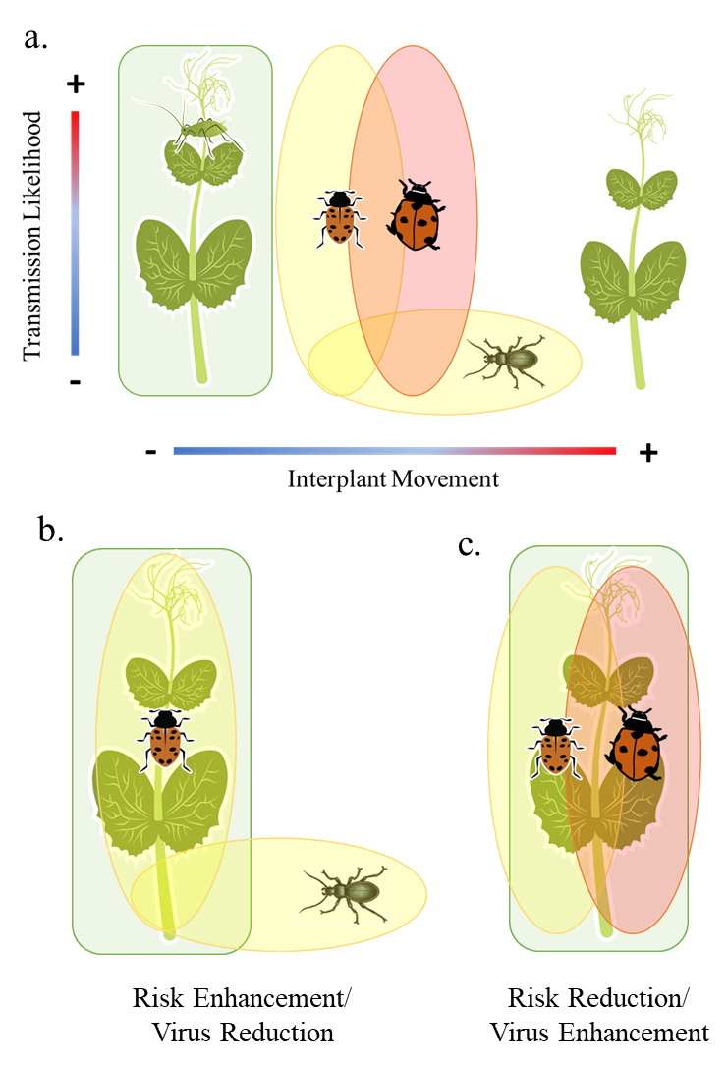

**Figure 2**

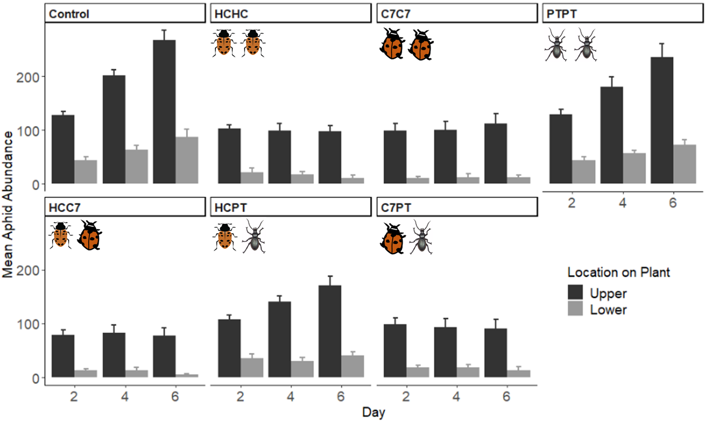

**Figure 3**

