SECURITY INCIDENT REPORT
SSH Brute-Force Attack — Detection & Response Simulation
Report ID | SIEM-LAB-2026-001
Analyst | Brandon White
Environment | Home SIEM Lab — Splunk Enterprise (Ubuntu indexer)
Date of Activity | July 17, 2026
Severity | Medium (simulated / lab environment)
Status | Detected — Closed (planned exercise)
MITRE ATT&CK | T1110 — Brute Force / T1110.001 — Password Guessing

1. Executive Summary
This report documents a controlled SSH brute-force attack simulated against a Windows 11 endpoint within a self-built home SIEM lab, and the detection logic built in Splunk to identify it. The exercise was designed to validate end-to-end log pipeline functionality (endpoint → Universal Forwarder → Splunk indexer) and to produce a working correlation search capable of flagging a successful account compromise following repeated failed authentication attempts.
The attack was launched from a Kali Linux host using Hydra against the OpenSSH service on the victim endpoint. After a series of failed login attempts, a valid credential was used to complete a successful authentication — replicating a realistic brute-force-to-compromise pattern. This activity was successfully captured in Windows Security Event Logs (Event IDs 4625 and 4624), forwarded to Splunk, and identified using a custom SPL detection search.

2. Environment & Architecture
The lab consisted of three isolated virtual machines on a host-only VirtualBox network:
- Splunk Indexer — Ubuntu Server 24.04, Splunk Enterprise 10.4.1, running as a dedicated non-root service account
- Victim Endpoint — Windows 11 (Home Edition), Sysmon (SwiftOnSecurity config) + Splunk Universal Forwarder, OpenSSH Server enabled
- Attacker Host — Kali Linux, Hydra v9.7 used to conduct the brute-force
Log data flowed from the victim endpoint via the Universal Forwarder over TCP 9997 to the Splunk indexer, where it was parsed using the Splunk Add-on for Microsoft Windows for CIM-compliant field extraction (user, EventCode, host).

3. Attack Timeline
Time | Event | Detail
16:44:42 | Failed logon (4625) | First failed SSH authentication attempt from Kali via Hydra, account: windowsvic
16:44:46 – 16:46:06 | Multiple failed logons (4625) | Continued brute-force attempts using a small custom wordlist
16:46:06 | Successful logon (4624) | Correct credential included in wordlist; authentication succeeded immediately following the failed attempt cluster
16:46:06+ | Detection search executed | Correlation search identified successful logon preceded by 3+ failed attempts within rolling window

4. Detection Logic
Two detection searches were developed. The first identifies a general spike in failed authentication attempts (volumetric brute-force indicator); the second — the primary detection used for alerting — correlates failed attempts with a subsequent success on the same account, which is a stronger, higher-fidelity indicator of an actual compromise rather than noisy scanning.

4.1 Volumetric Detection (Failed Logon Spike)
index=main sourcetype=WinEventLog EventCode=4625 user=windowsvic
| bucket _time span=5m
| stats count as failed_attempts by _time, user
| where failed_attempts >= 3
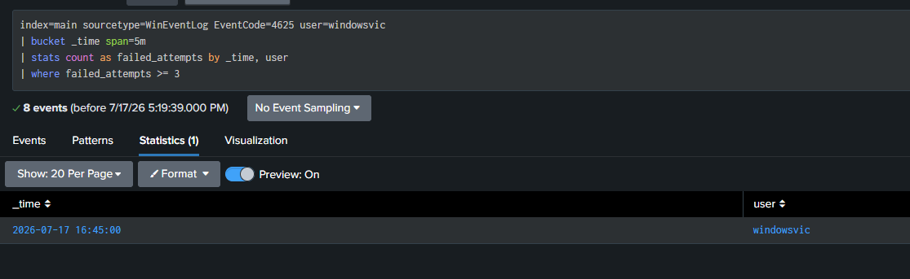
Figure 1 — Volumetric detection identifying a 5-minute bucket with 3+ failed logons.

4.2 Compromise Detection (Failed → Success Correlation)
Note: Windows logs the account name with inconsistent casing between event types (e.g. “WindowsVic” on success events vs. “windowsvic” on failure events). Since SPL field comparisons are case-sensitive, the account name was normalized with lower() before correlation to avoid silently splitting a single account's activity into two separate groups.
index=main sourcetype=WinEventLog (EventCode=4625 OR EventCode=4624) user=windowsvic
| eval user=lower(user)
| eval status=case(EventCode=4625, "failed", EventCode=4624, "success")
| sort 0 _time
| streamstats current=t window=10 count(eval(status="failed")) as failed_count by user
| eval failed_count=if(isnull(failed_count),0,failed_count)
| where status="success" AND failed_count>=3
| table _time, user, failed_count, status
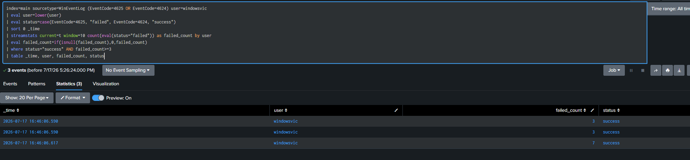
Figure 2 — Compromise detection: successful logons each preceded by 3+ recent failures.

4.3 Supporting Evidence — Raw Event Sequence
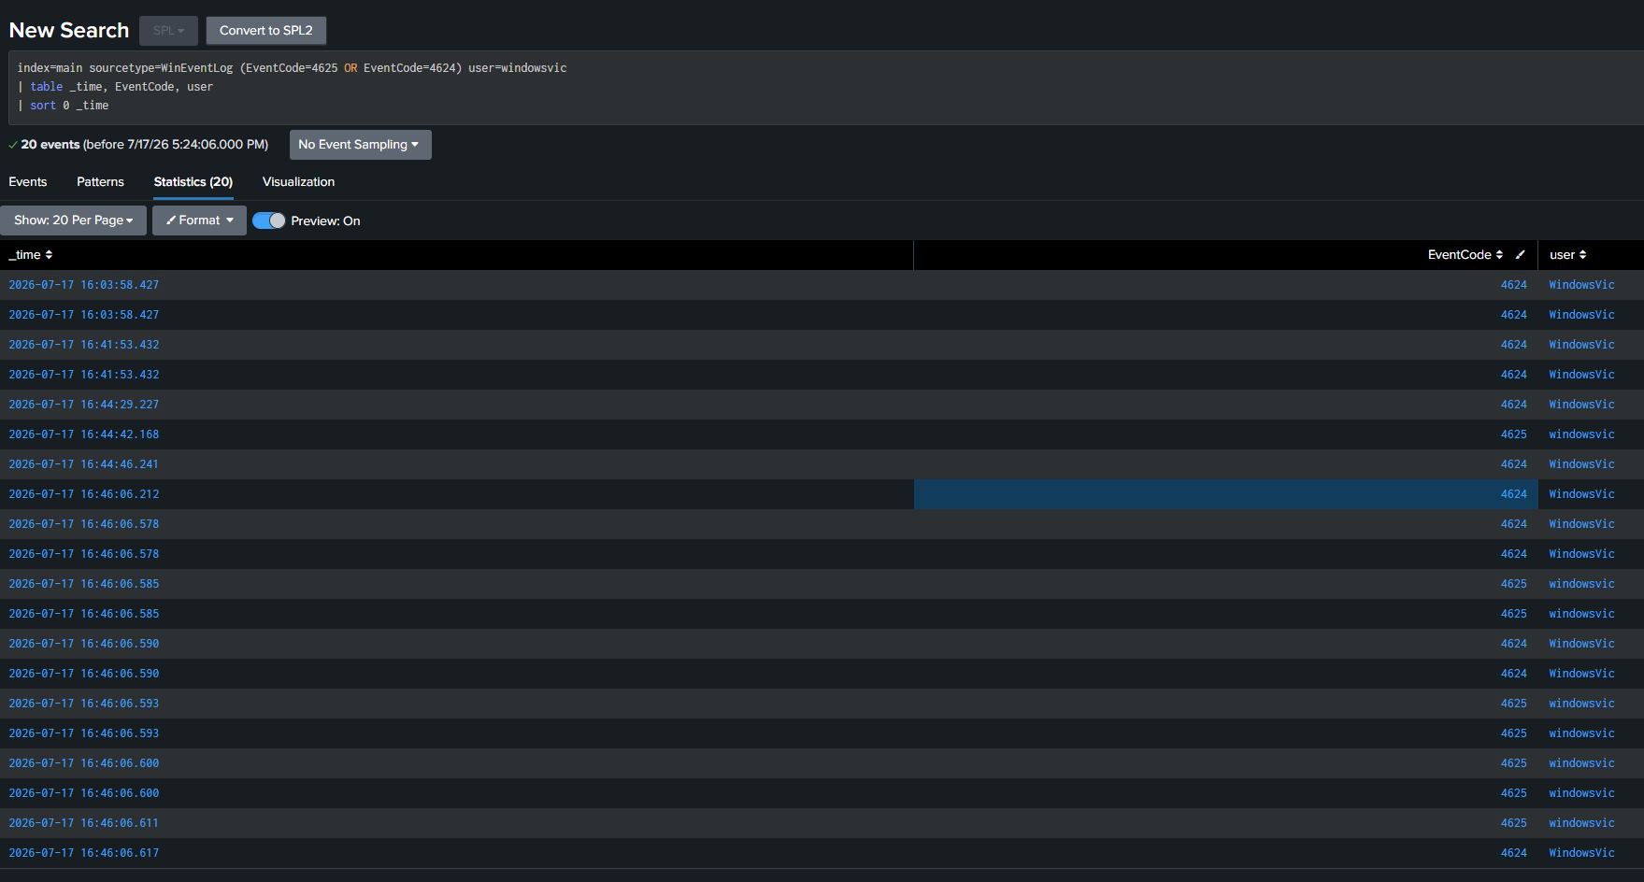
Figure 3 — Raw indexed events showing the failed-attempt cluster immediately preceding the successful logon.

5. Alerting Configuration
Alert Name | Brute Force Success Detection – SSH
Search | Section 4.2 correlation query
Schedule | Cron (*/5 * * * *) — every 5 minutes
Trigger Condition | Number of results > 0
Trigger Action | Add to Triggered Alerts
Severity Assigned | High — indicates a successful compromise, not just scanning activity

6. False Positive Considerations
- A legitimate user mistyping their password 3 or more times before succeeding would trigger this alert identically to an attacker.
- Shared service accounts with automated retry logic (e.g. scheduled tasks with stale credentials) could produce similar patterns.
- Tuning recommendation: increase fidelity by requiring the failed attempts to originate from a distinct source IP different from the eventual successful source, or by requiring failures from multiple source IPs (indicating distributed guessing rather than a single user's typos).
- In a production environment, this detection would be paired with account-specific baselining (e.g. flag only for privileged/service accounts, or accounts with no history of recent failed logons).

7. Recommendations
- Enforce account lockout policies after a defined number of failed SSH authentication attempts.
- Disable password authentication in favor of key-based SSH authentication where feasible.
- Deploy fail2ban or an equivalent rate-limiting control on internet-facing SSH services.
- Extend this detection to include source IP correlation and geolocation for distributed brute-force identification.
- Layer in Sysmon Event ID 3 (network connection) data to correlate the originating attack source at the process level.

8. Conclusion
This exercise validated the full SIEM pipeline from endpoint telemetry generation through detection and alerting, and produced a working, documented correlation search mapped to MITRE ATT&CK T1110.001. The detection logic distinguishes between noisy brute-force scanning and confirmed account compromise, reflecting a higher-fidelity approach to alerting suitable for reducing analyst fatigue in a production SOC context.

