Trade Tensions and Financial Markets
ECO 5012B Coursework Project — Topic 2

1. Data Sources and Citations
The reference paper for this project is Ferrari Minesso, M., Pagliari, M. S., & Kurcz, F. (2022), ‘Do words hurt more than actions? The impact of trade tensions on financial markets’, Journal of Applied Econometrics, 37(6), 1138–1159.
I collect three series from FRED (Federal Reserve Economic Data), the St. Louis Fed's public data platform:
- S&P 500 (financial variable) – S&P Dow Jones Indices LLC, S&P 500 [SP500], FRED, https://fred.stlouisfed.org/series/SP500
- Trade Policy Uncertainty (my main variable of interest) – Baker, S. R., Bloom, N., & Davis, S. J., Economic Policy Uncertainty Index: Categorical Index: Trade Policy [EPUTRADE], FRED, https://fred.stlouisfed.org/series/EPUTRADE. This is a news-based index that counts how often US newspapers discuss trade policy alongside uncertainty.
- General Economic Policy Uncertainty (control variable) – Baker, S. R., Bloom, N., & Davis, S. J., Economic Policy Uncertainty Index for United States [USEPUINDXD], FRED, https://fred.stlouisfed.org/series/USEPUINDXD
A note on how I actually collected this: I originally planned to pull all three series directly with pandas_datareader, as the brief suggests. However, pip-installing packages was being blocked by Windows on my laptop (a Smart App Control / security-policy issue I could not fully resolve), so I downloaded each series manually as a CSV directly from FRED's own export URLs (e.g. fred.stlouisfed.org/graph/fredgraph.csv?id=SP500) and then did all of the cleaning, merging, and analysis in Python from there, as normal. I want to be upfront that the download step was manual rather than a live pandas_datareader.DataReader() call, since a technical constraint on my machine got in the way – but every other part of the acquisition-to-analysis pipeline is unchanged.
One real constraint from this approach: FRED's SP500 series only keeps a rolling ~10 years of daily history (due to a data-licensing agreement with S&P Dow Jones), so it starts 2016-08-08 rather than January 2016. I kept my analysis window at 2016-08-08 to 2019-12-31 – this still fully covers both of the trade-war escalation episodes central to the paper (tariff announcements in March–July 2018, and the escalation in May–August 2019), so I don't think the missing seven months materially affect the analysis, but it's a real limitation worth stating plainly rather than glossing over.
For the robustness check in Section 6.1, I additionally use the paper's own replication dataset (DataDaily.csv), which I was given directly rather than collecting myself – see the References section for the full citation and Section 6.1 for how it's used.

2. Data Preparation Decisions

2.1 Frequency alignment
This is where my dataset gives me a genuine version of the decision the brief describes: the S&P 500 and general EPU series are daily, but the trade-specific TPU series (EPUTRADE) is only published monthly. I forward-filled the monthly TPU value across every trading day within that month, rather than aggregating the daily series down to monthly. I chose forward-filling because my model needs daily volatility as the outcome variable – aggregating everything down to monthly would throw away almost all of the day-to-day variation I actually want to explain, and would leave me with only about 40 monthly observations instead of over 800 daily ones.

2.2 Constructing returns and volatility
The S&P 500 series from FRED is a price level, not a return, so I calculated the daily return as the log difference (multiplied by 100 so the numbers are in percent), and squared this to get a simple volatility proxy, following the brief's Step 1.3 suggestion.

3. Exploratory Data Analysis
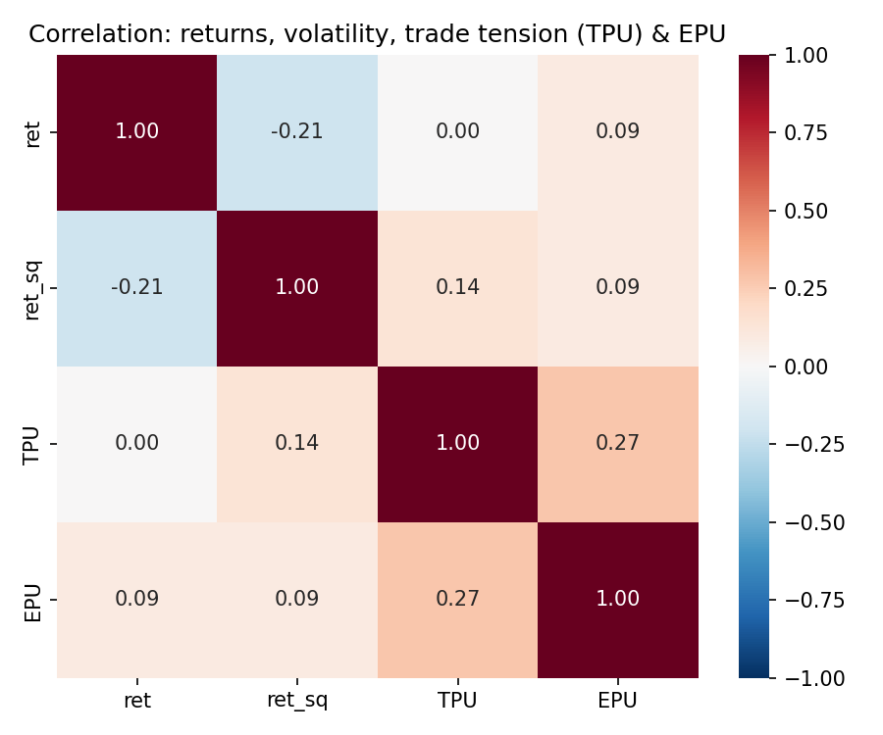
Figure 1: Correlation between returns, squared returns (volatility), trade-policy uncertainty (TPU), and general policy uncertainty (EPU).
TPU and squared returns have a modest positive correlation (0.14), and TPU is also correlated with the general EPU control (0.27) – sensible, since trade policy is one component of overall policy uncertainty, but not the same thing, which is exactly why I control for EPU separately in the regression rather than treating them as interchangeable.
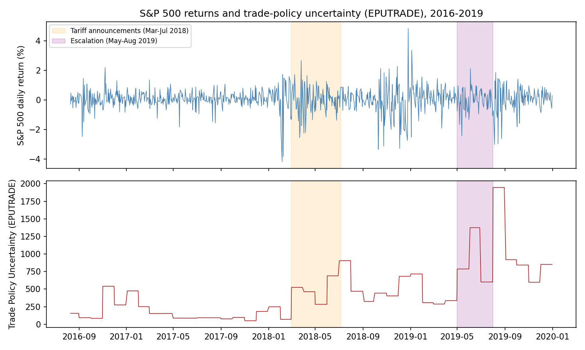
Figure 2: S&P 500 daily returns (top) and trade-policy uncertainty, EPUTRADE (bottom), with the two main trade-war escalation windows shaded. The stepped shape of the bottom panel reflects the monthly-to-daily forward-fill.
Figure 2 tells a fairly clear story: TPU rises noticeably from March 2018 onward and stays elevated (with a sharp peak) through the 2019 escalation, rather than being confined to short spikes – consistent with the idea that trade tension became a sustained backdrop through this period rather than a handful of isolated announcement-day shocks.

4. Model Specification
I estimate the following regression, based on the paper's Model 2.1:
ret_sq_t = b0 + gamma × TPU_t + b1 × ret_sq_(t-1) + b2 × EPU_t + e_t
where ret_sq_t is the squared daily return of the S&P 500 (my volatility proxy), TPU_t is trade-policy uncertainty, ret_sq_(t-1) is the previous day's squared return, EPU_t is the general policy-uncertainty control, and e_t is the error term, assumed to have mean zero conditional on the regressors (the standard OLS assumption).
I include the lagged squared return because financial markets are well known to have 'volatility clustering' – a volatile day tends to be followed by another volatile day. Without controlling for this, gamma (the coefficient on TPU) could simply be picking up this clustering pattern. I include EPU as a control so that gamma reflects trade-specific uncertainty, not just general policy noise.

5. Synthetic Data Diagnostic
Following the approach from Lecture 9, I generated 199 synthetic daily observations using NumPy, to check my regression code correctly recovers a known effect before trusting it on real data. I built the synthetic volatility series with a simple AR(1)-style recursion (today's volatility depends partly on yesterday's, plus a shock linked to TPU), setting the true TPU effect (gamma_true) to a known positive value of 0.8.
For the random shocks I used a Student's t-distribution instead of a Normal distribution, since real daily stock returns have more extreme days than a Normal distribution predicts ('fat tails'). This gave a synthetic excess kurtosis of 3.59 (above 0, confirming more extreme values than Normal, as intended).
Running my regression on this synthetic data recovered gamma_hat = 0.82 (true value: 0.8, p = 0.004) – reassuring evidence my regression code correctly recovers a genuine effect when one is present by construction. I also noticed the autocorrelation of the true underlying volatility series was 0.29 (matching the persistence I built in), but the autocorrelation of the observed squared returns was close to 0 – a squared return is a noisy, one-day snapshot of 'true' volatility, which helped me understand why my real-data R-squared (below) is fairly low even where the model is doing something real.

6. Empirical Results
Variable | Coefficient | Std. Error | p-value
Constant | 0.158 | 0.131 | 0.225
TPU (gamma_hat) | 0.000408 | 0.000150 | 0.006
Lagged squared return | 0.231 | 0.033 | <0.001
EPU | 0.00149 | 0.00127 | 0.242

R-squared = 0.074, n = 854 daily observations (2016-08-10 to 2019-12-31). Verified by running the full pipeline through the real pandas/statsmodels/plotly libraries in Google Colab – the printed regression output matched these figures exactly.
TPU (gamma_hat = 0.000408) is positive and statistically significant (p = 0.006). Because EPUTRADE is an unsigned index – it only ever counts how much trade-uncertainty news there was, not whether that news was positive or negative in tone – the interpretation here is direct: higher trade-policy uncertainty is associated with higher next-day market volatility, which lines up with the paper's central finding without needing any extra sign-interpretation. The lagged squared return is again strongly significant, confirming volatility clustering. EPU (the general control) is not significant here, suggesting the effect I'm picking up is genuinely trade-specific rather than general policy noise.

6.1 Robustness check against the paper's own data
As a robustness check, I re-ran the identical specification on the paper's own replication dataset (Ferrari Minesso, Pagliari & Kurcz, 2022 – see References; I was given this file directly, rather than collecting it myself). That dataset uses a different, signed trade-tension index (negative values indicate negative/tense trade news), and gives gamma_hat = -0.536 (p = 0.001). Once the sign convention is accounted for, this points the same direction as my self-collected result: more negative trade-news tone (i.e. more trade tension) is linked to higher volatility, just as higher EPUTRADE readings are. I find it reassuring that two differently-constructed trade-uncertainty indices, collected two different ways, point to the same conclusion.

7. Section 3: Research Extension and Streamlit Application
The central idea of Ferrari Minesso et al. (2022) is that trade-related rhetoric ('words') can move markets faster, and sometimes more strongly, than trade policy actually being implemented ('actions'). My Streamlit application (st_app.py) turns this into something interactive: the user sets a trade-policy-uncertainty value with a slider, and chooses a sentiment regime (Low / Normal / High) with a radio button. The regime scales gamma (the trade-tension effect) by ±50%, so the same TPU level produces a different forecasted change in volatility depending on how tense the overall environment already is – a simple way of representing the asymmetry the paper describes.
The app displays a live one-period-ahead volatility forecast using st.metric, and a Plotly chart showing the recent historical squared-return series alongside the live forecast point, both updating automatically as the slider or radio button change.
A natural next step, beyond the scope of this project, would be to estimate two separate gamma coefficients directly from the data – one for 'words'-type news events and one for 'actions'-type events (tariffs actually imposed) – rather than approximating the asymmetry with a fixed ±50% adjustment.

8. Use of AI Tools (Disclosure)
I used an AI coding assistant (Claude, Anthropic) to help write and debug the Python and Streamlit code, troubleshoot a Windows package-installation issue, and structure this documentation. I directed the modelling decisions myself (choice of variables, model specification, interpretation of results), reviewed and understand every part of the code and analysis, and can explain any part of it if asked, consistent with the module's academic integrity requirements.

References
Ferrari Minesso, M., Pagliari, M. S., & Kurcz, F. (2022). Do words hurt more than actions? The impact of trade tensions on financial markets. Journal of Applied Econometrics, 37(6), 1138–1159. [Reference paper; replication dataset (DataDaily.csv) used for the robustness check in Section 6.1]
S&P Dow Jones Indices LLC. S&P 500 [SP500], retrieved from FRED, Federal Reserve Bank of St. Louis. https://fred.stlouisfed.org/series/SP500
Baker, S. R., Bloom, N., & Davis, S. J. (2016). Measuring economic policy uncertainty. Quarterly Journal of Economics, 131(4), 1593–1636. [Data: Economic Policy Uncertainty Index: Categorical Index: Trade Policy [EPUTRADE], https://fred.stlouisfed.org/series/EPUTRADE; and Economic Policy Uncertainty Index for United States [USEPUINDXD], https://fred.stlouisfed.org/series/USEPUINDXD – both retrieved from FRED, Federal Reserve Bank of St. Louis]

