CommissionHub

1. What the App Does
CommissionHub connects:
- A Customer (someone who needs work done)
- An Admin (someone who does the work)
For Customers
- View available services
- Create an account and log in
- Send a request for a project
- Check if their project is finished
For the Admin
- See all customer requests in one place
- Manage and organize requests
- Mark projects as finished
- Delete or keep old requests
- Track earnings using an E-Wallet
What the App Handles
- Saves your account and requests
- Keeps your progress safe
- Shows updates when something changes
- Keeps track of all money earned from completed projects

2. Who Uses the App
User | What they do
Customer | Views services, signs up, sends requests, and checks updates
Admin | Reviews requests, completes them, manages records, and tracks earnings
The App | Saves data, sends updates, and shows the right information to the right person

3. How the App is Used
This shows how actions flow between the Customer and the Admin.
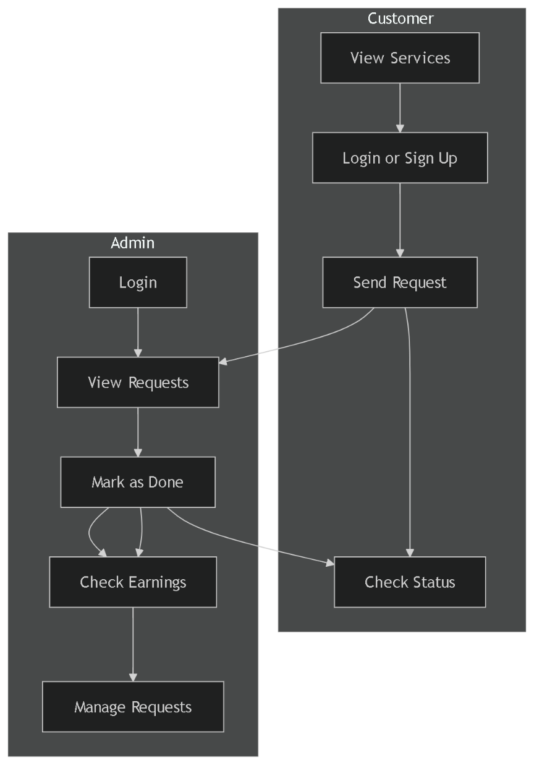

4. What Information the App Stores
Customer Profile
- Name
- Email
- Password
- Date joined
Project Request
- Order ID
- Customer name and email
- Type of service
- Payment method
- Budget
- Deadline
- Project description
- Status (Waiting or Done)
- Date submitted
Notification
- Message (example: “Your project is done!”)
- Date sent
- Seen or not
E-Wallet
- Total earnings (₱)
- Number of completed projects
- List of past earnings
How They Connect
- One customer can send many requests
- Each request creates a notification
- Every completed request adds money to the E-Wallet

5. Step-by-Step Processes
5.1 Customer Ordering a Service

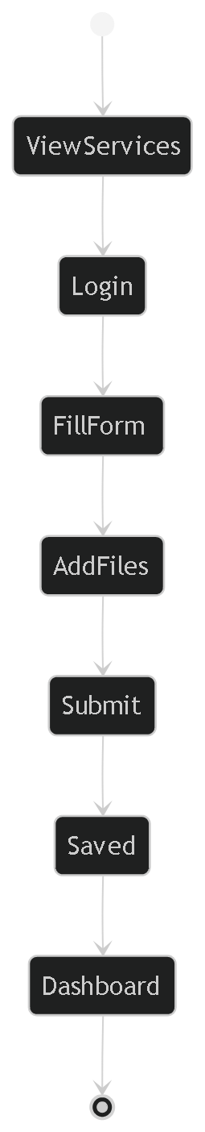

Explanation:
- Customer views services
- Logs in or signs up
- Fills out the form
- (Optional) adds files
- Submits request
- App saves it
- Customer sees it on dashboard

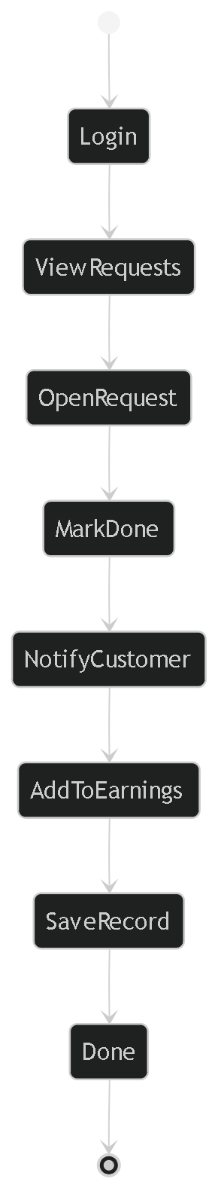
5.2 Admin Completing a Request

Explanation:
- Admin logs in
- Views requests
- Opens a request
- Marks it as done
- Customer is notified
- Payment is added to earnings
- Record is saved

