Shopping Cart Setup Guide

Content

Development Environment Setup 2

Tools Setup 2

Database Setup 3

Import the Shopping Cart project 3

Check out code from repository 3

import source files into Intellij IDEA 3

Configuration 9

Run/Debug Configurations 10

Run the application 14

FAQ’s 16

# Development Environment Setup

## Tools Setup

Install the following Software packages, if not done:

(Overview detail below)

* Java JDK 1.6(jdk1.6.0_26, x86) (<http://www.oracle.com/technetwork/java/javase/overview/index.html> )
* Mercurial scm (<http://mercurial.selenic.com/>)
* TortoiseHg 3.5.2(http://tortoisehg.bitbucket.org/)
* Maven (<http://maven.apache.org/> )
* Jetty (<http://download.eclipse.org/jetty/stable-9/dist/> )(Maven will install it.)
* Chrome (<https://www.google.com/chrome/> )
* SQLWorkbench(<http://www.sql-workbench.net/Workbench-Build115.zip>)
* Outlook, Notepad++, Jabber, Office2010, Oracle (Ask help from the infrastructure team to install.)
* IntelliJ ULTIMATE 14/15 (<http://www.jetbrains.com/idea/download/>)
* Apache tomcat6(tomcat-6.0.44, x86)
* Chrome Developer Extensions :
  + Postman - REST Client (<https://chrome.google.com/webstore/search/postman> )
  + AngularJS Batarang (<https://chrome.google.com/webstore/search/angularjs-batarang> )
  + Ng-inspector (<https://chrome.google.com/webstore/search/ng-inspector-for-angularj> )
  + Clear Cache(<https://chrome.google.com/webstore/detail/clear-cache/cppjkneekbjaeellbfkmgnhonkkjfpdn?utm_source=chrome-app-launcher-info-dialog> )

# Database Setup

Double click database_setup.bat, enter DBA’s user name, password and SID as below.

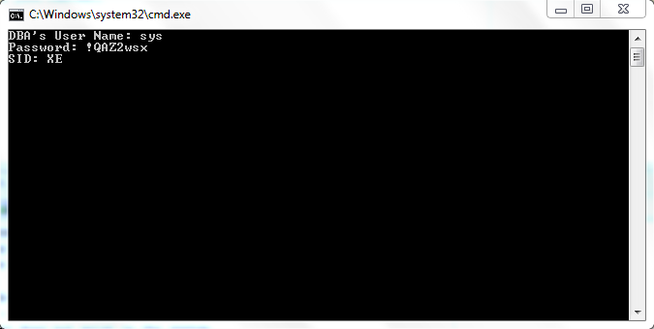

Press Enter button to create a new database user j2ee/j2ee. After this process, you can use Oracle SQL Developer to connect to the database.

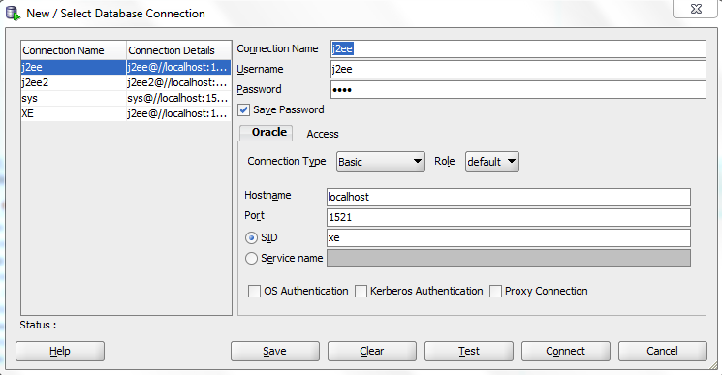

# Import the Shopping Cart project

## Check out code from repository

Check out the cisadmin project using the following command:

hg clone http://hg.ess-sd.de.signintra.com/cis -b Demo D:\project\repository

“D:\project\repository” is your local directory to store the code to be checked out.

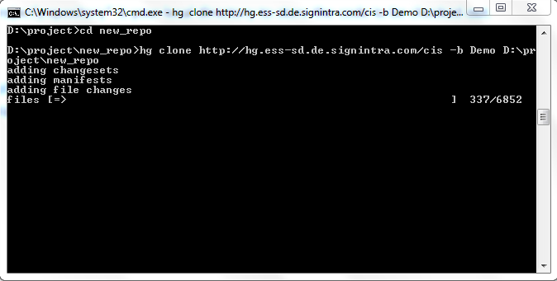

## import source files into Intellij IDEA

Click File -> New -> Project from Existing Sources…

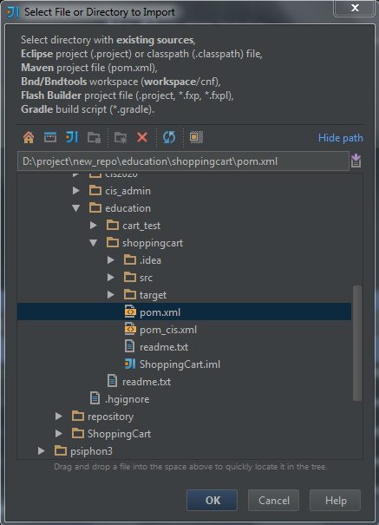

Choose the pom.xml you downloaded, click ok.

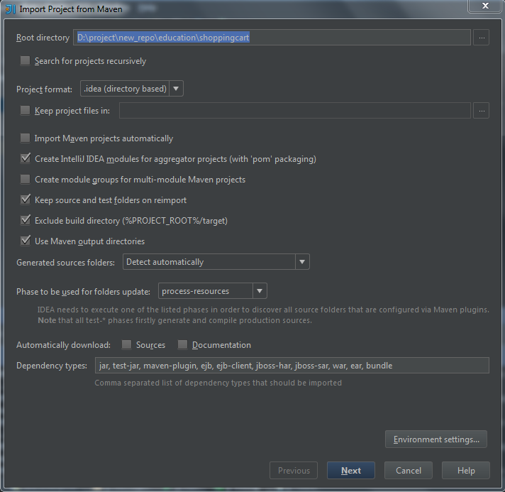

Click next.

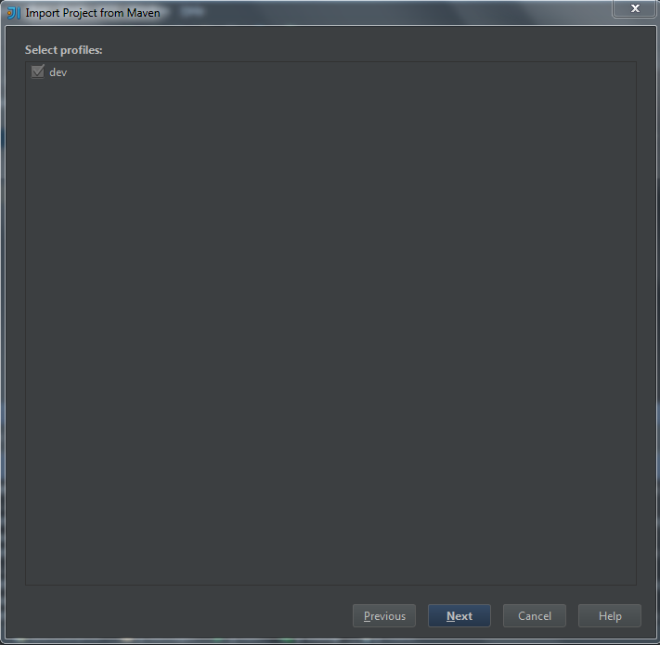

Click next.

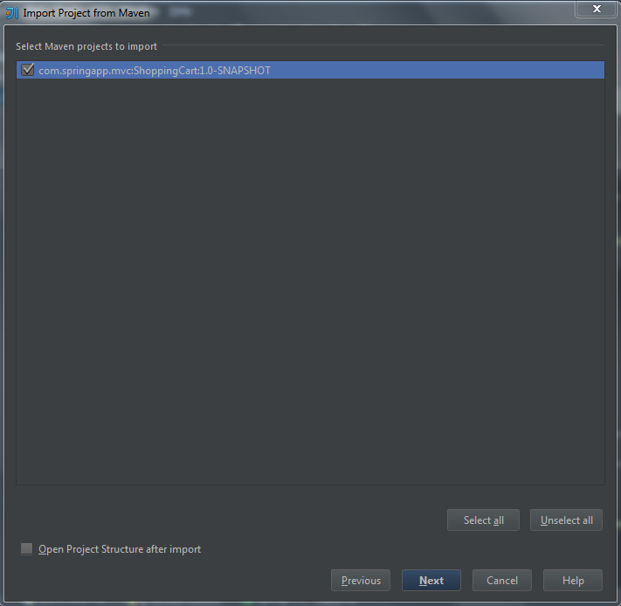

Click next. Specify jdk1.6.0_26 as project SDK, and then click next.

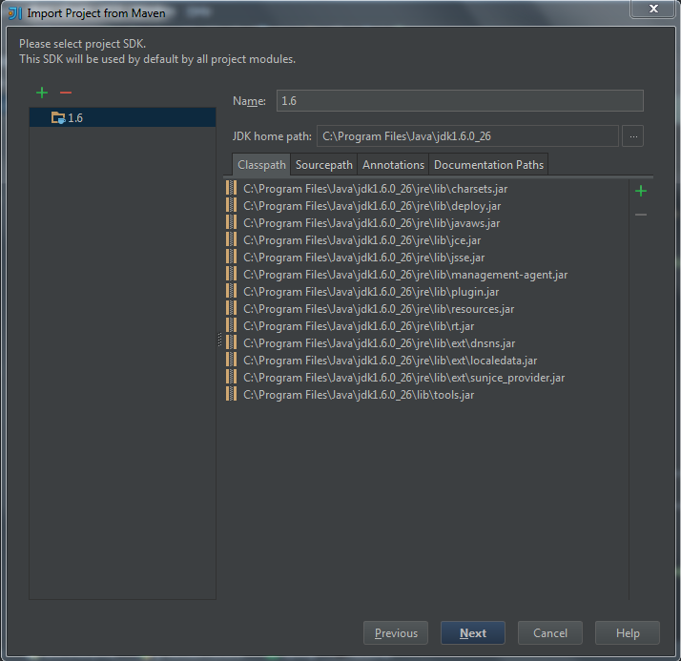

Enter name, location of your project, then click finish.

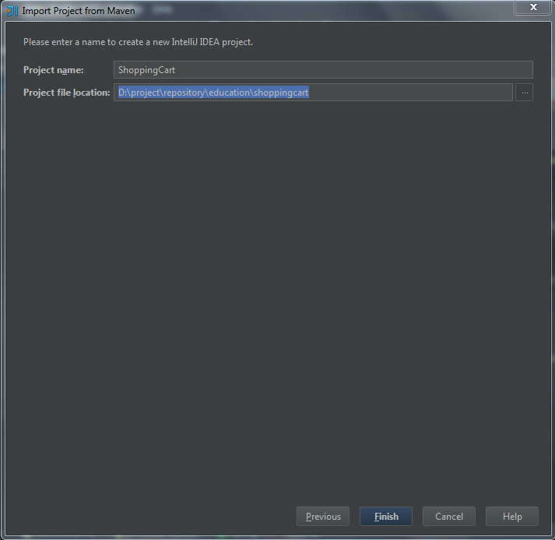

## Configuration

Click File -> Settings.., search for “maven” to configure your maven’s user setting file. You can use this file .

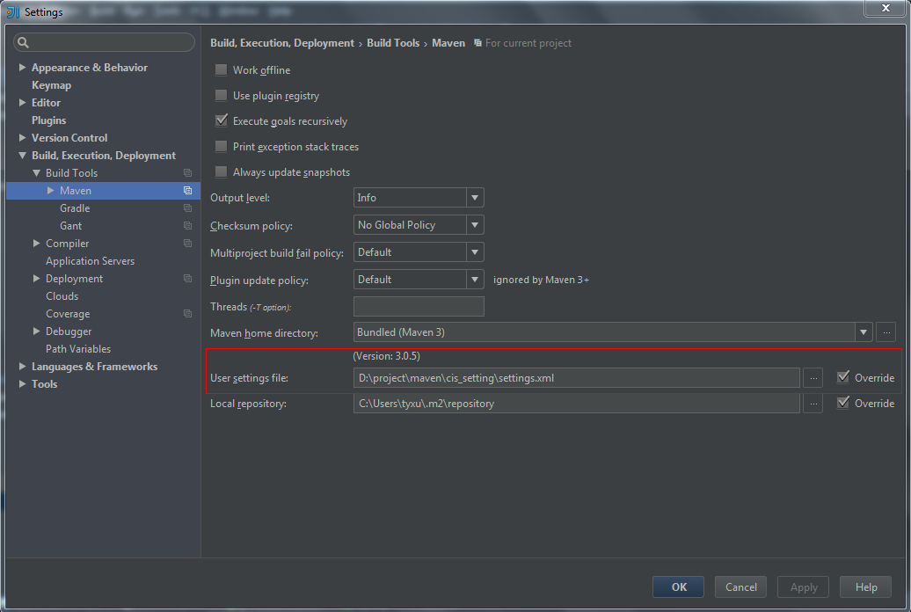

## Run/Debug Configurations

Click this menu to configure run/debug

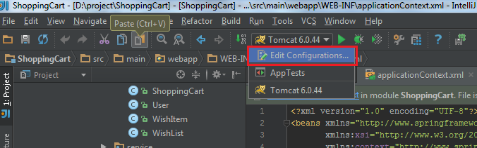

Add maven configurations:

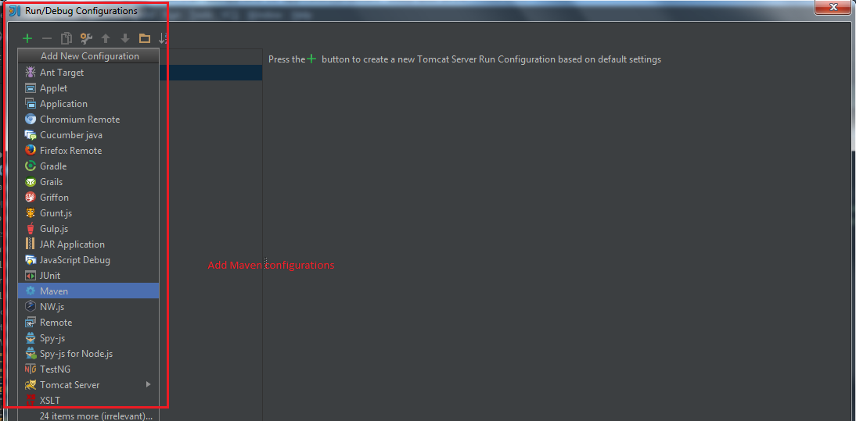

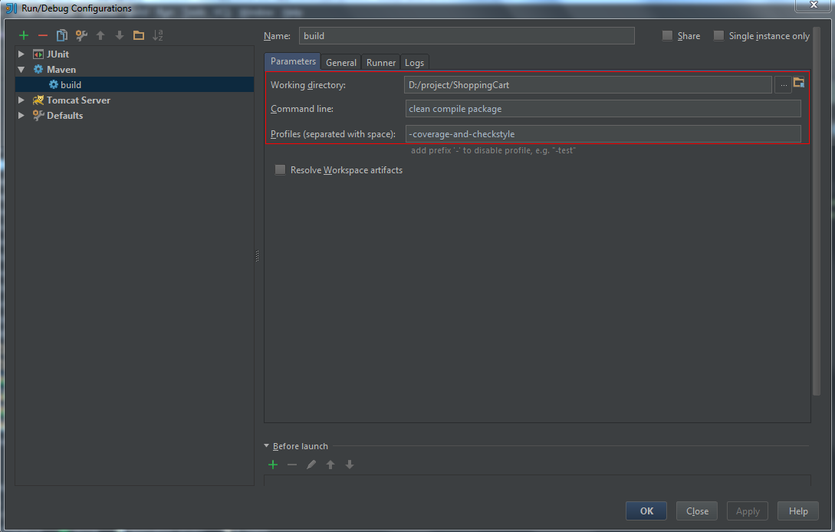

# Oracle driver installation

Open Terminal in IntelliJ, run the command below to install oracle driver.

mvn install:install-file -DgroupId=com.oracle -DartifactId=ojdbc6 -Dversion=11.2.0.1.0 -Dpackaging=jar -Dfile=D:\oraclexe\app\oracle\product\11.2.0\server\jdbc\lib\ojdbc6.jar

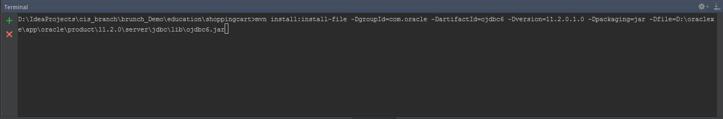

# Run on jetty

Build the project by clicking as bellow. Or you can use maven command: mvn clean compile package to build the project.

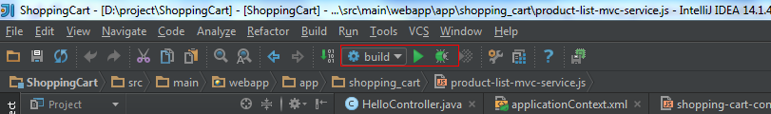

After jetty is started, open a browser, enter the URL: <http://localhost:9081/html/index.html>, you will see the page below.

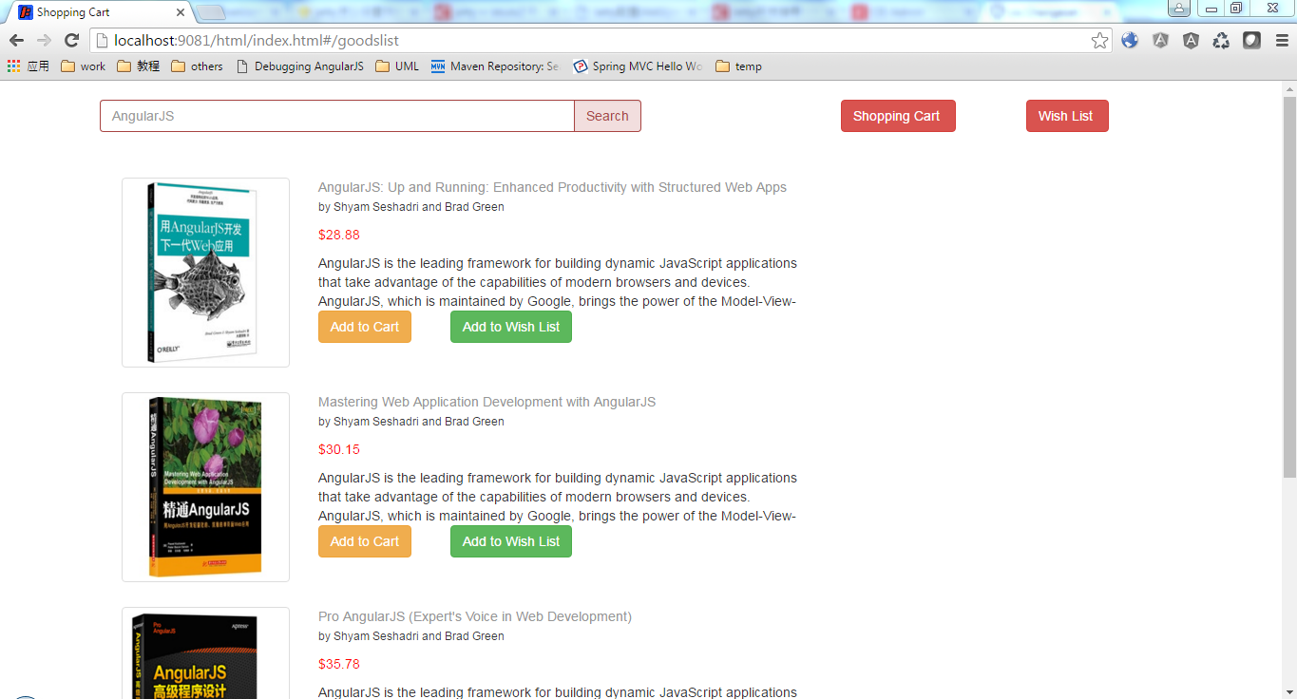

# FAQ’s

If you’ve questions regarding this document, please write a message to the author of this document [Tony.Xu@dbschenker.com](mailto:Tony.Xu@dbschenker.com).