远方小熊的雷达测试教程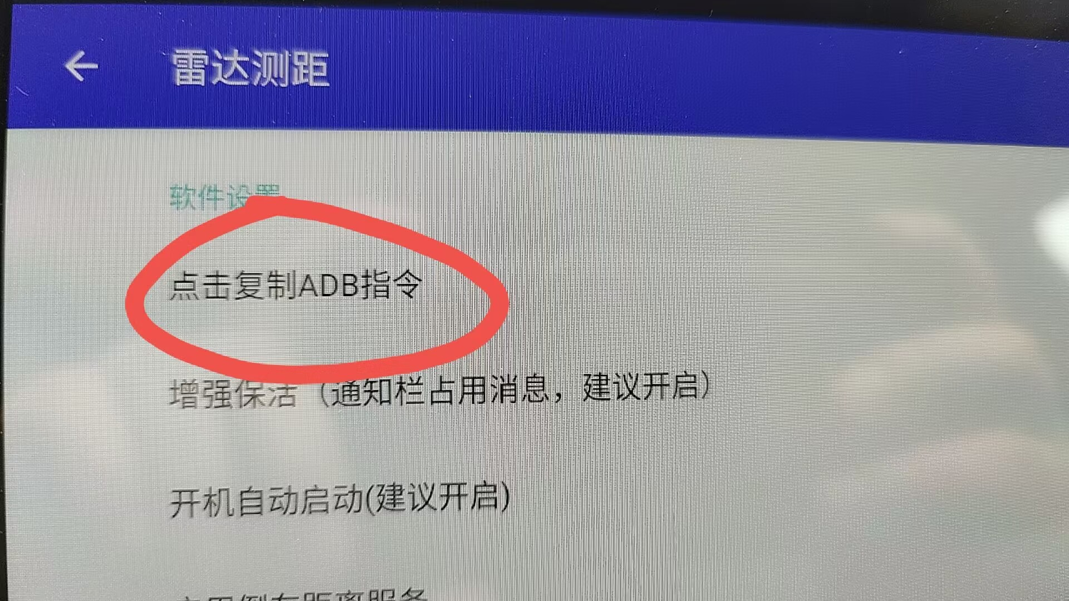
复制了命令，关闭雷达测距，一定要清除掉雷达测距，不能有后台运行。去甲壳虫运行把指令复制上去，然后回到雷达测距
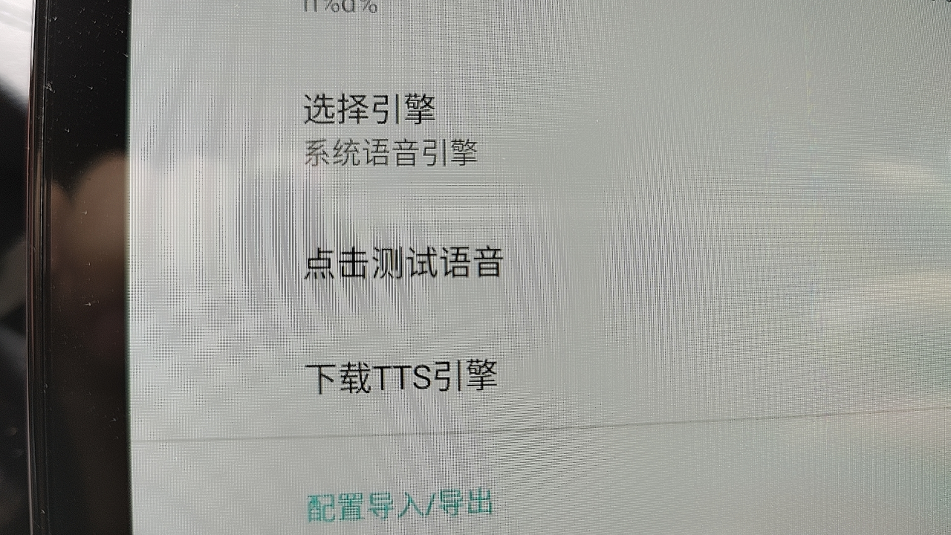
下载语音文件
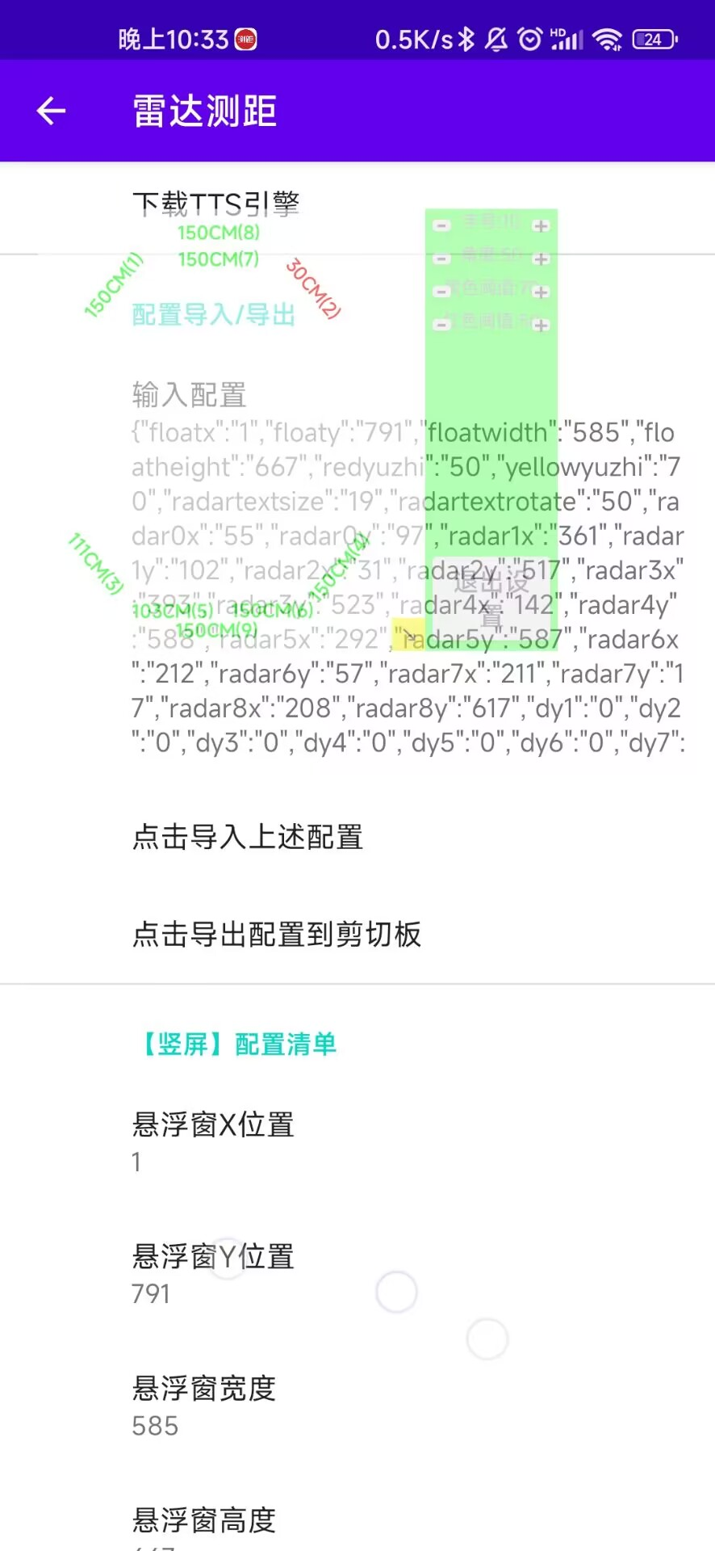
点击输入配置
{"floatx":"1","floaty":"791","floatwidth":"585","floatheight":"667","redyuzhi":"50","yellowyuzhi":"70","radartextsize":"19","radartextrotate":"50","radar0x":"55","radar0y":"97","radar1x":"361","radar1y":"102","radar2x":"31","radar2y":"517","radar3x":"393","radar3y":"523","radar4x":"142","radar4y":"588","radar5x":"292","radar5y":"587","radar6x":"212","radar6y":"57","radar7x":"211","radar7y":"17","radar8x":"208","radar8y":"617","dy1":"0","dy2":"0","dy3":"0","dy4":"0","dy5":"0","dy6":"0","dy7":"0","dy8":"0","dy9":"0","dy10":"0","dy11":"0","dy12":"0","dy13":"0","floatxland":"209","floatyland":"109","floatwidthland":"613","floatheightland":"752","redyuzhiland":"50","yellowyuzhiland":"70","radartextsizeland":"19","radartextrotateland":"50","radar0xland":"55","radar0yland":"100","radar1xland":"403","radar1yland":"95","radar2xland":"8","radar2yland":"565","radar3xland":"451","radar3yland":"584","radar4xland":"168","radar4yland":"659","radar5xland":"319","radar5yland":"659","radar6xland":"249","radar6yland":"73","radar7xland":"249","radar7yland":"41","radar8xland":"246","radar8yland":"705","dy1land":"0","dy2land":"0","dy3land":"0","dy4land":"0","dy5land":"0","dy6land":"0","dy7land":"0","dy8land":"0","dy9land":"0","dy10land":"0","dy11land":"0","dy12land":"0","dy13land":"0"}
然后点击上述配置
最后把极速模式和自启动设置好！
需要语音功能的就设置一下语音引擎。

