Restaurant Management System – Software Requirements & Implementation Specifications
Restaurant Management System – Software Requirements & Implementation Specifications 1
User Requirements 1
Use Case Diagram 1
Class Diagram - Analytical 3
Analytical Class diagram – Description 4
Class Diagram - Design 4
Design Decisions 5
Polymorphic Serialization 5
Class Extent Persistence 5
Multi-Value Attributes 6
Optional Attributes 6
Derived Attributes 6
Class Attributes 6
JSON Serialization Configuration 7
Property Validation 7
General Association Implementation 7
Composition Associations 7
Qualified Associations 7
Association Class/Attribute 8
Reflex Association 8
Association Validation 8
Composite Solution 9
Use Case Scenario : "Make a reservation" 10
Use Case Scenario :"Add a Dish" 12
Use Case Scenario : "Assign a Shift" 14
State Diagram – Process Payment 16
State diagram- Description 17
Authors 17
GUI Mock-up & Implementation 17
Make a Reservation 18
Menu Management (Add a Dish) 18
Staff Hiring & Shift Assignment 18

User Requirements
The Restaurant Management System is developed to enhance the efficiency of restaurant operations by managing customer reservations, order processing, and employee activities. It enables customers to reserve tables and place food orders conveniently. The menu is organized by Menu Type (e.g., All Day) and dishes are defined by their Cuisine, Price, and Ingredients. Each item displays details like price, ingredients, and dietary tags indicating vegetarian or vegan options. Customers can select their preferred dishes, specify quantities, and add them to their order. If a selected dish is out of stock or the requested quantity exceeds availability, the system alerts the customer and prompts them to adjust the order accordingly.
Once the order is finalized, customers can proceed to the payment stage. Payments can be made through Card or Cash. If a payment attempt fails, the system marks the payment status as pending or failed, allowing the customer to retry the payment process. Customers can also access their order history to review previous transactions and payment records.
The reservation module manages bookings by verifying table availability for the requested date and time. After booking, customers receive a confirmation and have the option to modify or cancel their reservations if needed.
For employees, the system provides tools to view and update the status of orders across three stages: “Preparing,” “Served,” and “Completed.” Staff can also manage table reservations by checking table availability and assigning tables to customers. Additionally, employees have access to their personal work records, including salary details and employment history. Work records include department, shift schedule, and hiring date information to track employment history.
The system maintains a categorized menu database containing detailed information for each dish—covering prices, ingredients, and dietary preferences. It enforces business rules such as updating stock levels after order completion and maintaining minimum table capacity requirements for reservations. The system manages payment processes through internal state tracking and tracks payment statuses, including “Pending” and “Completed.”

Use Case Diagram
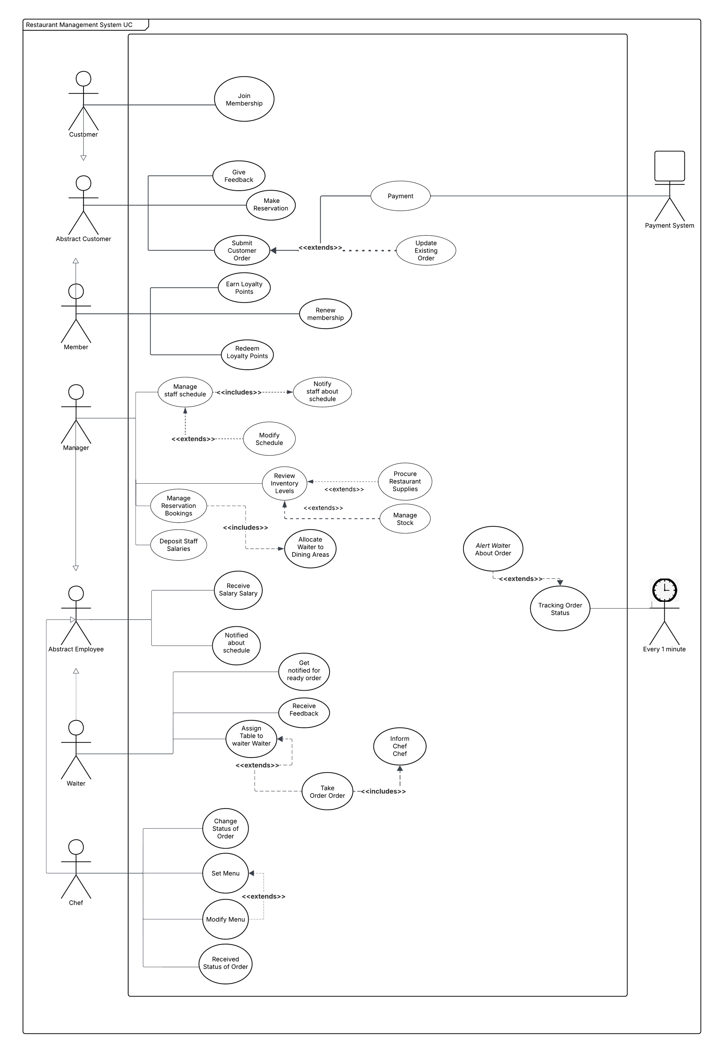

Class Diagram - Analytical

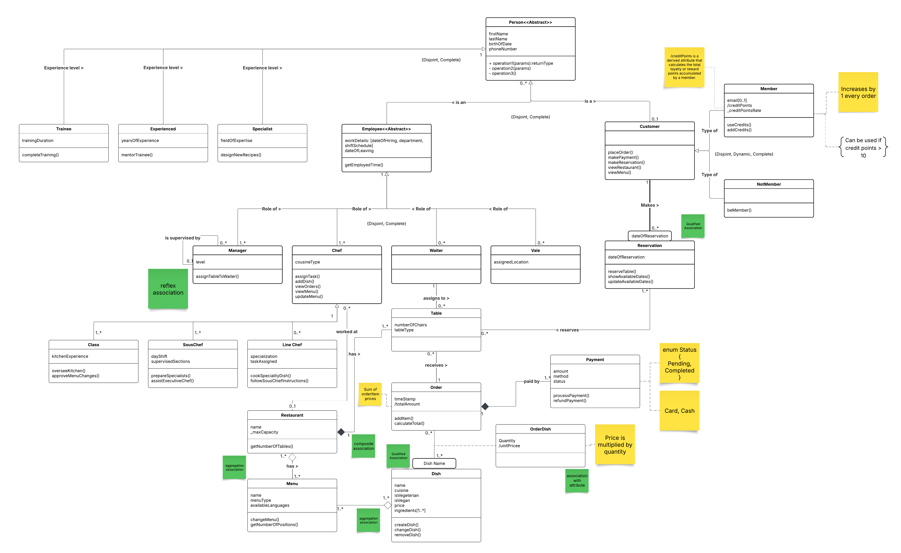

Analytical Class diagram – Description
This analytical class diagram illustrates a restaurant management system that models staff, customers, and daily operations. The system is based on a Person class, which is specialized into Employee and Customer, with employees assigned different roles and experience levels.
The diagram shows how customers interact with the restaurant through reservations, orders, and payments, while staff members such as managers, chefs, and waiters support these activities. Core restaurant elements like menus, dishes, tables, and orders are included, along with their relationships and constraints.
Overall, the diagram provides a clear and structured view of the main entities and interactions required to manage restaurant services efficiently.

Class Diagram - Design

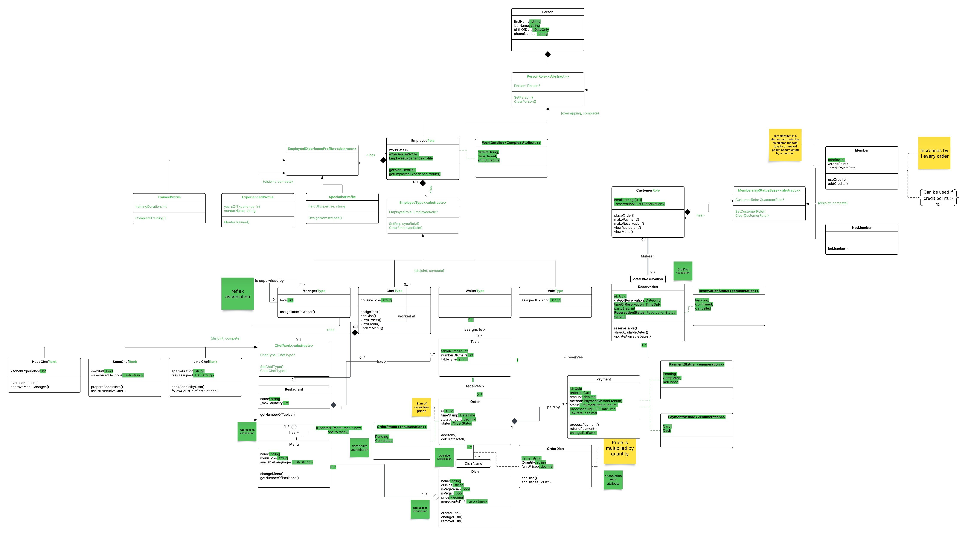Design Decisions
The class diagram above illustrates the necessary changes to model that are not natively supported in the C# language. The final implementation uses class extent persistence through JSON serialization for storing object instances locally, and the design choices associated with this approach are discussed in the following sections. The changes introduced are highlighted in green. This section will explain the transformation process of certain UML constructs such as attribute types (based on UML notations), tagged values, derived attributes, optional attributes, multi-value attributes, and class attributes.

Polymorphic Serialization
Abstract base classes use System.Text.Json polymorphic attributes for type discrimination:
Person uses a Composition pattern to hold references to optional EmployeeRole and CustomerRole components (it does not use polymorphism for these roles)
Customer discriminates Member and NonMember
Employee discriminates Manager, Chef, Waiter, and Valet
EmployeeExperienceProfile discriminates TraineeProfile, ExperiencedProfile, and SpecialistProfile
Each derived type includes a typeDiscriminator string in JSON.

Class Extent Persistence
The Restaurant and Payment classes implement class extent persistence using static collections and JSON serialization.
Restaurant Class:
Static _extent list stores all Restaurant instances
Save() serializes the extent to JSON
Load() deserializes from JSON and replaces the extent
Instances are automatically added to the extent in the constructor via AddToExtent(this)
Public Extent property provides read-only access to the collection
Payment Class:
Static Extent property holds all Payment instances (public getter, private setter)
SaveAll() and LoadAll() handle persistence
Extent is managed separately from instance creation - instances must be explicitly added via AddToExtent() method
Unlike Restaurant, Payment instances are not automatically added to extent in constructor

Multi-Value Attributes
Multi-value attributes are implemented as private lists with public read-only collection properties:
Menu.AvailableLanguages (List)
Dish.Ingredients (List)
SousChef.SupervisedSections (List)
LineChef.TasksAssigned (List)
Customer._reservations (List)
Table._reservations (List)
Table._orders (List)
Order._orderDishes (List)
Order._payments (List)
Waiter._assignedTables (List
)
Manager._subordinates (List)
Chef._restaurant (Restaurant?) - single restaurant reference (0..1 multiplicity)
Dish._orderDishes (List)
Restaurant._chefs (List)
Restaurant._managers (List)
Private fields are marked with [JsonInclude] for serialization. Public properties return IReadOnlyCollection<T> for safe, read-only access.

Optional Attributes
Optional attributes use nullable types:
Customer.Email (string?) - email is optional for customers
Payment.ProcessedOn (DateTime?) - timestamp is null until payment is processed
Dish.Menu (Menu?) - dish can exist without being in a menu (aggregation)
Menu.Restaurant (Restaurant?) - menu can exist independently (aggregation)
Table.Waiter (Waiter?) - table may not have an assigned waiter
Reservation.Table (Table?) - reservation can be made without a specific table (for future reservations)
Reservation.Customer (Customer?) - reservation may not have a customer initially
Manager.Supervisor (Manager?) - top-level managers have no supervisor
Manager.Restaurant (Restaurant?) - manager may work at 0 or 1 restaurant (0..1 multiplicity)
Chef.Restaurant (Restaurant?) - chef may work at 0 or 1 restaurant (0..1 multiplicity)
Nullability indicates optionality and is enforced at the type level.

Derived Attributes
Derived attributes are computed properties without backing fields:
Order.TotalAmount = sum of OrderDish.TotalPrice (calculated using LINQ Sum())
OrderDish.TotalPrice = Dish.Price × Quantity
These are read-only properties computed on access. They use the / prefix notation in UML to indicate derivation.

Class Attributes
Class-level attributes are static properties:
Payment.TaxRate (static decimal) with ChangeTaxRate() for modification
Static properties are shared across all instances.

JSON Serialization Configuration
JsonSerialization.GetDefaultOptions() provides a centralized configuration:
WriteIndented = true - JSON output is formatted with indentation for readability
ReferenceHandler = ReferenceHandler.IgnoreCycles - Prevents infinite loops when serializing circular references (e.g., bidirectional associations)
IncludeFields = true - Enables serialization of private fields marked with [JsonInclude] attribute
Custom DateOnlyJsonConverter for DateOnly serialization (format: "yyyy-MM-dd")
Custom TimeOnlyJsonConverter for TimeOnly serialization (format: "HH:mm:ss")
Polymorphic type discrimination using JsonPolymorphic and JsonDerivedType attributes

Property Validation
Properties with private setters include validation:
Menu.Name and MenuType check for null/whitespace
Dish.Name, Cuisine, and Price validate non-empty strings and positive values
Validation occurs in property setters, not only constructors

General Association Implementation
All associations in the system are implemented with bidirectional reverse connections to maintain referential integrity. Each association maintains references in both participating classes:
One-to-Many associations: The “one” side maintains a collection (List) of the “many” side, while the “many” side maintains a reference to the “one” side
Many-to-Many associations: Both sides maintain collections of each other
Reverse connection consistency: When objects are added or removed from associations, both sides are automatically updated to maintain consistency
Key implementation patterns: - Private collections marked with [JsonInclude] for serialization - Public read-only properties exposing IReadOnlyCollection<T> for safe access - Internal methods (SetX, AddX, RemoveX, SetXInternal) to maintain bidirectional consistency - Automatic reverse connection updates in constructors and association methods - Internal SetXInternal methods allow parent objects to set child references directly (e.g., SetRestaurantInternal for Chef/Manager) - Idempotent operations: AddX methods check for duplicates before adding to prevent duplicate associations
Examples of bidirectional associations: - Customer <-> Reservation (1..): Customer maintains _reservations list, Reservation maintains _customer reference - Reservation ↔ Table (0..1..0..): Reservation maintains _table reference (nullable), Table maintains _reservations list - Waiter <-> Table (1..0..): Waiter maintains _assignedTables list, Table maintains _waiter reference - Restaurant <-> Menu (1..1..): Restaurant maintains _menus list, Menu maintains _restaurant reference - Menu <-> Dish (0....1..): Menu maintains _dishes list, Dish maintains _menu reference - Restaurant <-> Manager (1..0....0..1): Restaurant maintains _managers list, Manager maintains _restaurant reference (0..1 multiplicity) - Restaurant <-> Chef (1..0....0..1): Restaurant maintains _chefs list, Chef maintains _restaurant reference (0..1 multiplicity) - Order <-> Payment (1..1..): Order maintains _payments list, Payment maintains Order reference (composition) - Order <-> Table (1..1..0..): Order maintains Table reference, Table maintains _orders list

Composition Associations
Composition associations enforce a strong ownership relationship where the child object cannot exist without its parent. This is implemented through:
Constructor Requirements: Child objects must receive the parent object in their constructor
OrderDish requires Order in constructor
Payment requires Order in constructor
Table requires Restaurant in constructor (non-nullable, composition)
Automatic Lifecycle Management: Child objects are automatically added to parent collections during construction
OrderDish constructor automatically adds itself to Order._orderDishes
Payment constructor automatically adds itself to Order._payments
Reverse Connection: Child objects maintain references to their parent
OrderDish.Order property references the parent Order
Payment.Order property references the parent Order (non-nullable, cannot be reassigned)
Table.Restaurant property references the parent Restaurant (non-nullable)
Lifecycle Constraints: When parent is removed, children should be removed (enforced through validation)
Composition examples: - Order <-> OrderDish (1..0..): OrderDish cannot exist without Order - Order <-> Payment (1..1..): Payment cannot exist without Order (minimum 1 payment required) - Restaurant <-> Table (1..0..*): Table cannot exist without Restaurant

Qualified Associations
Qualified associations allow lookup of associated objects using a qualifier attribute. The qualifier acts as a key to uniquely identify objects within the association.
Implementation pattern: - A method on the “one” side accepts the qualifier value as a parameter - The method searches the collection using the qualifier - Returns the matching object or null if not found
Qualified associations in the system:
Customer <-> Reservation (qualified by dateOfReservation)
Method: Customer.GetReservation(DateOnly dateOfReservation)
Returns: Reservation? - the reservation for the given date, or null
Implementation: Searches _reservations list for matching DateOfReservation
Also implemented on Table.GetReservation(DateOnly date, TimeOnly time) and Table.GetReservation(DateOnly date) for table-level lookup
Note: Reservations are qualified by both date and time, allowing multiple reservations on the same table for the same date at different times
Order <-> Dish (qualified by dish name)
Method: Order.GetDishByName(string dishName)
Returns: Dish? - the dish with matching name from the order, or null
Implementation: Searches _orderDishes collection, finds OrderDish with matching Dish.Name, returns the Dish object
Uses case-insensitive string comparison for flexibility

Association Class/Attribute
An association class is a class that represents an association between two other classes while also having its own attributes and behavior. In this system, OrderDish serves as an association class between Order and Dish.
Implementation characteristics:
Dual Association: OrderDish maintains references to both Order and Dish
OrderDish.Order - reference to the Order
OrderDish.Dish - reference to the Dish
Own Attributes: OrderDish has its own attributes beyond the association
Name - name of the order item
Quantity - quantity of the dish ordered
TotalPrice - derived attribute (Dish.Price × Quantity)
Reverse Connections: Both Order and Dish maintain collections of OrderDish
Order.Dishes - collection of OrderDish objects
Dish.OrderDishes - collection of OrderDish objects (reverse connection)
Composition Relationship: OrderDish is in composition with Order (cannot exist without Order)
Separate Class File: OrderDish is implemented in its own file (OrderDish.cs) as a separate class, not nested within Order

Reflex Association
A reflex association (also called recursive or self-referential) is an association where a class is associated with itself. In this system, Manager has a reflex association representing the supervisor-subordinate relationship.
Implementation details:
Bidirectional Relationship: Manager can be both supervisor and subordinate
Manager.Supervisor - reference to the supervising Manager (0..1, nullable)
Manager.Subordinates - collection of subordinate Managers (0..*)
Circular Reference Prevention: The system prevents circular supervisor chains
WouldCreateCircularReference() method checks if setting a supervisor would create a cycle
Uses depth-first search through supervisor chain and subordinate chain
Throws InvalidOperationException if circular reference would be created
Methods for Management:
SetSupervisor(Manager supervisor) - sets or changes supervisor, automatically updates both sides
AddSubordinate(Manager subordinate) - adds a subordinate, automatically sets supervisor
RemoveSubordinate(Manager subordinate) - removes subordinate relationship
Automatic Bidirectional Updates: When supervisor is set, the subordinate is automatically added to supervisor’s _subordinates list, and vice versa
Validation: Prevents self-supervision and duplicate relationships
Example hierarchy:
Manager1 (supervisor) -> Manager2 (subordinate of Manager1, supervisor of Manager3) -> Manager3 (subordinate of Manager2)

Association Validation
All associations include comprehensive validation and exception handling to ensure data integrity and prevent invalid states:
Minimum Multiplicity Enforcement
Restaurant.RemoveMenu(): Throws InvalidOperationException if removing the last menu (minimum 1..*)
Menu.RemoveDish(): Throws InvalidOperationException if removing the last dish (minimum 1..*)
Order.RemovePayment(): Throws InvalidOperationException if removing the last payment (minimum 1..*)
Null Reference Validation
All association methods validate that parameters are not null
Throws ArgumentNullException with descriptive messages
Examples: Waiter.AssignTable(), Customer.MakeReservation(), Order.AddDish()
Duplication Prevention
Waiter.AssignTable(): Returns false if table is already assigned (prevents duplicates)
Restaurant.AddMenu(): Throws ArgumentException if menu with same name already exists
Restaurant.AddTable(): Throws ArgumentException if table with same number already exists
Customer.MakeReservation(): Throws ArgumentException if reservation already exists
Chef.SetRestaurant(): Throws InvalidOperationException if chef already works at another restaurant (0..1 multiplicity)
Manager.AddSubordinate(): Throws ArgumentException if subordinate relationship already exists
Composition Validation
OrderDish constructor: Throws ArgumentNullException if Order is null (composition requirement)
Payment constructor: Throws ArgumentNullException if Order is null (composition requirement)
Order.AddDish(): Validates that OrderDish belongs to the correct Order
Circular Reference Prevention
Manager.SetSupervisor(): Checks for circular references before setting supervisor
Manager.AddSubordinate(): Checks if adding subordinate would create circular reference
Uses recursive depth-first search to detect cycles in supervisor/subordinate chains
Self-Reference Prevention
Manager.SetSupervisor(): Throws ArgumentException if manager tries to supervise themselves
Manager.AddSubordinate(): Throws ArgumentException if manager tries to add themselves as subordinate
Invalid State Prevention
Table.Reserve(): Returns false if table is already reserved for the same date and time
Order.CompleteOrder(): Throws InvalidOperationException if order is already completed
Payment.ProcessPayment(): Throws InvalidOperationException if payment is already processed
Payment.SetOrder(): Throws InvalidOperationException if payment is already assigned to a different order (composition constraint)
Argument Validation
All methods validate input parameters (null checks, empty string checks, range checks)
Consistent exception types: ArgumentNullException, ArgumentException, InvalidOperationException
Descriptive error messages for debugging
All validation ensures that associations maintain referential integrity, prevent invalid states, and provide clear error messages when constraints are violated.

Composite Solution
C# doesn't support multiple inheritance, so we needed a way to model a Person who can be both an Employee and a Customer, switch roles at runtime, and support multiple employee types (Chef, Waiter, Manager, Valet) and customer types (Member, NonMember).
Flattening would combine all attributes into a single Person class with discriminator fields and nullable properties, hence we avoided it for the sake of understandable codebase.
Problems with Flattening:
- Person class becomes massive (500+ lines) with 20+ nullable properties
- Every method needs type checking before accessing properties
- Adding a new employee type requires modifying Person class
- Tight coupling makes changes risky
- Difficult to test individual behaviors
- Violates Single Responsibility Principle
Composition uses separate component classes that are combined within Person.
Benefits of Composition:
- Person class stays small (~145 lines) with only core attributes
- Each component is focused and testable independently
- Adding new roles doesn't require changing Person
- Type safety enforced by compiler
- Clean separation of concerns
- Easy to extend without breaking existing code
Key Decision Factors
- Maintainability: System will evolve; composition makes changes safer and easier
- Code Quality: Follows SOLID principles (Single Responsibility, Open/Closed)
- Requirements: Need overlapping roles (employee + customer) and dynamic switching
- Testing: Components can be tested in isolation
- Team Collaboration: Multiple developers can work on different components without conflicts
Trade-offs
- More Classes: 15+ focused classes vs. 1-2 large classes (acceptable trade-off)
- Slight Performance Overhead: Component navigation vs. direct access (negligible in practice)
- Initial Setup: More design work upfront, but better long-term maintainability
Conclusion
Composition was chosen because it provides better maintainability, code quality, and flexibility for a system that requires overlapping roles, dynamic role changes, and future extensibility. The slight increase in initial complexity is outweighed by long-term benefits.

Use Case Scenario : "Make a reservation"
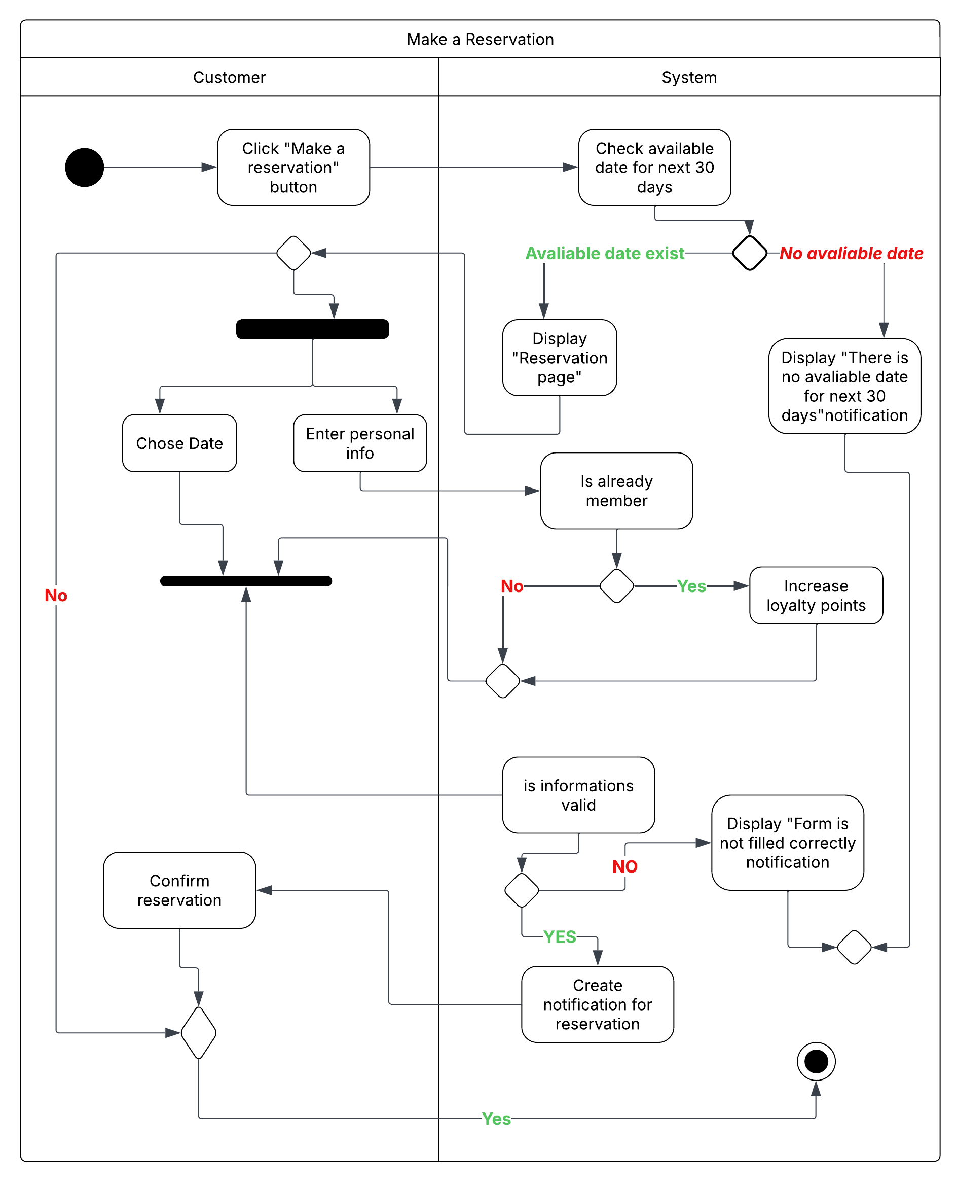

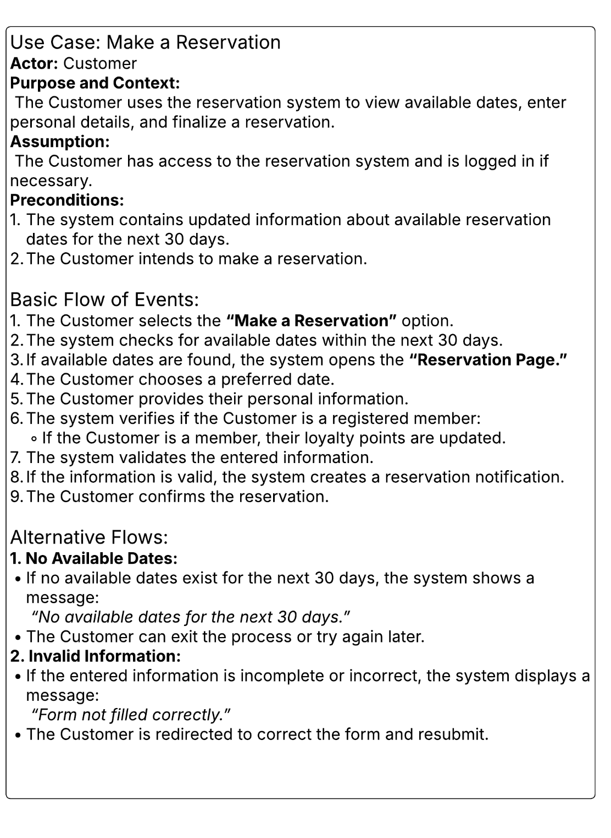

Use Case Scenario :"Add a Dish"
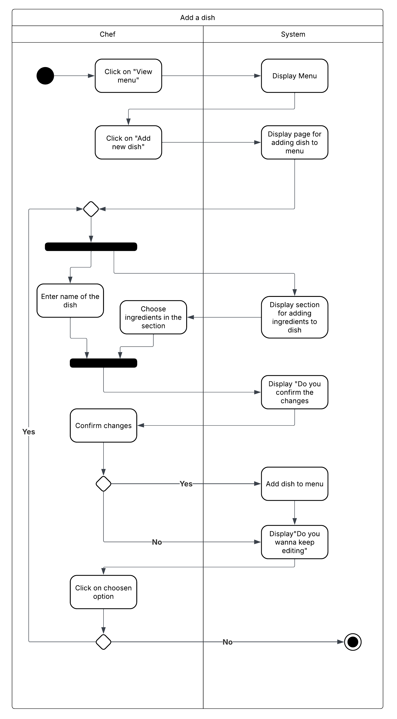

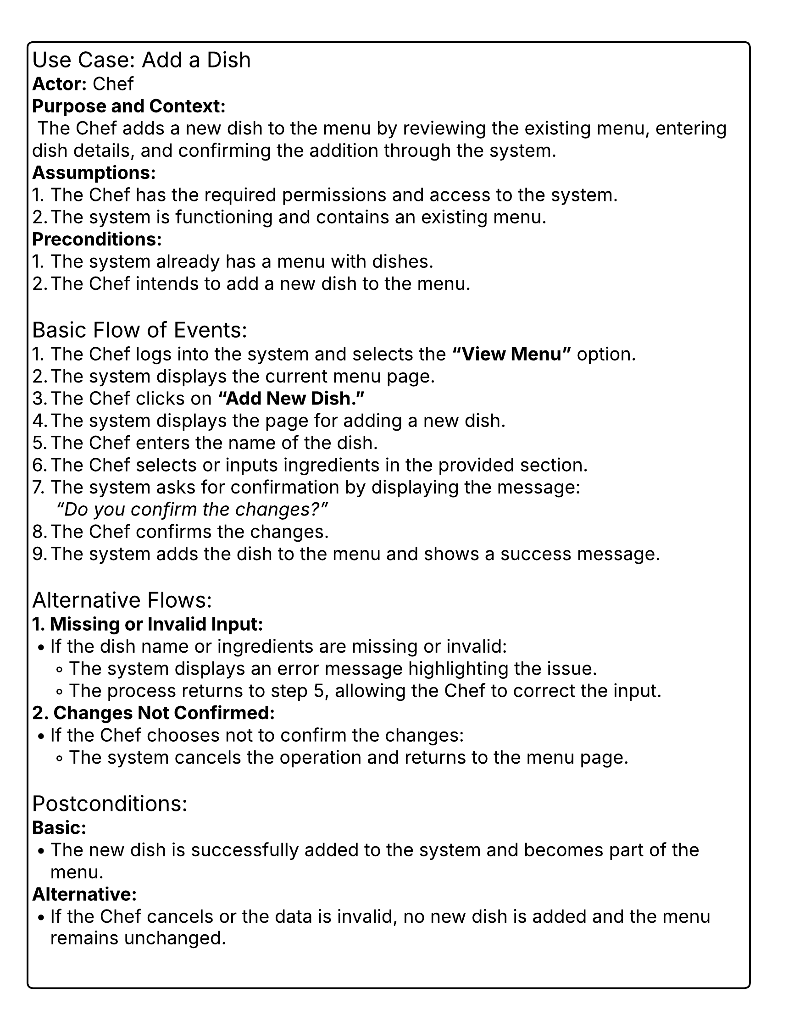

Use Case Scenario : "Assign a Shift"
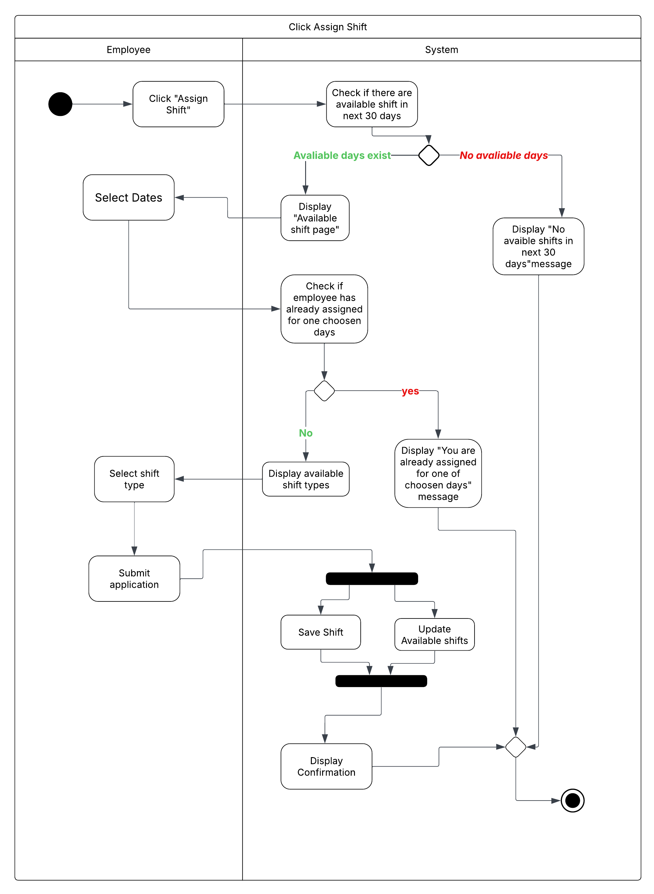

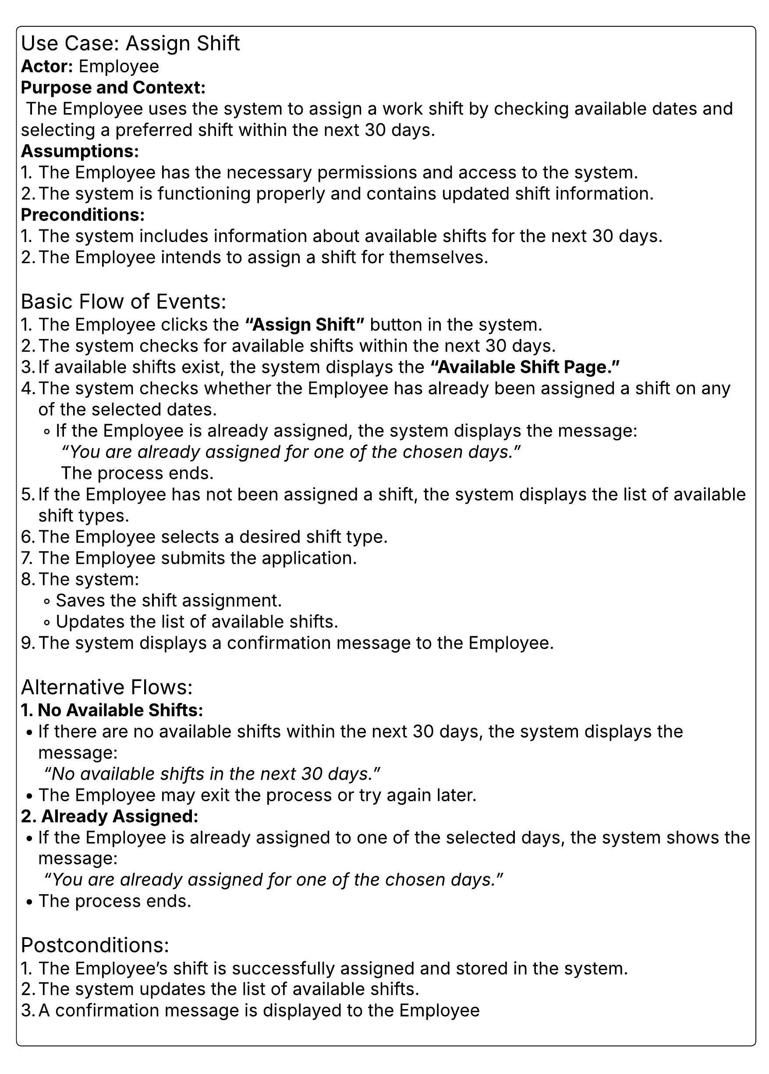

State Diagram – Process Payment
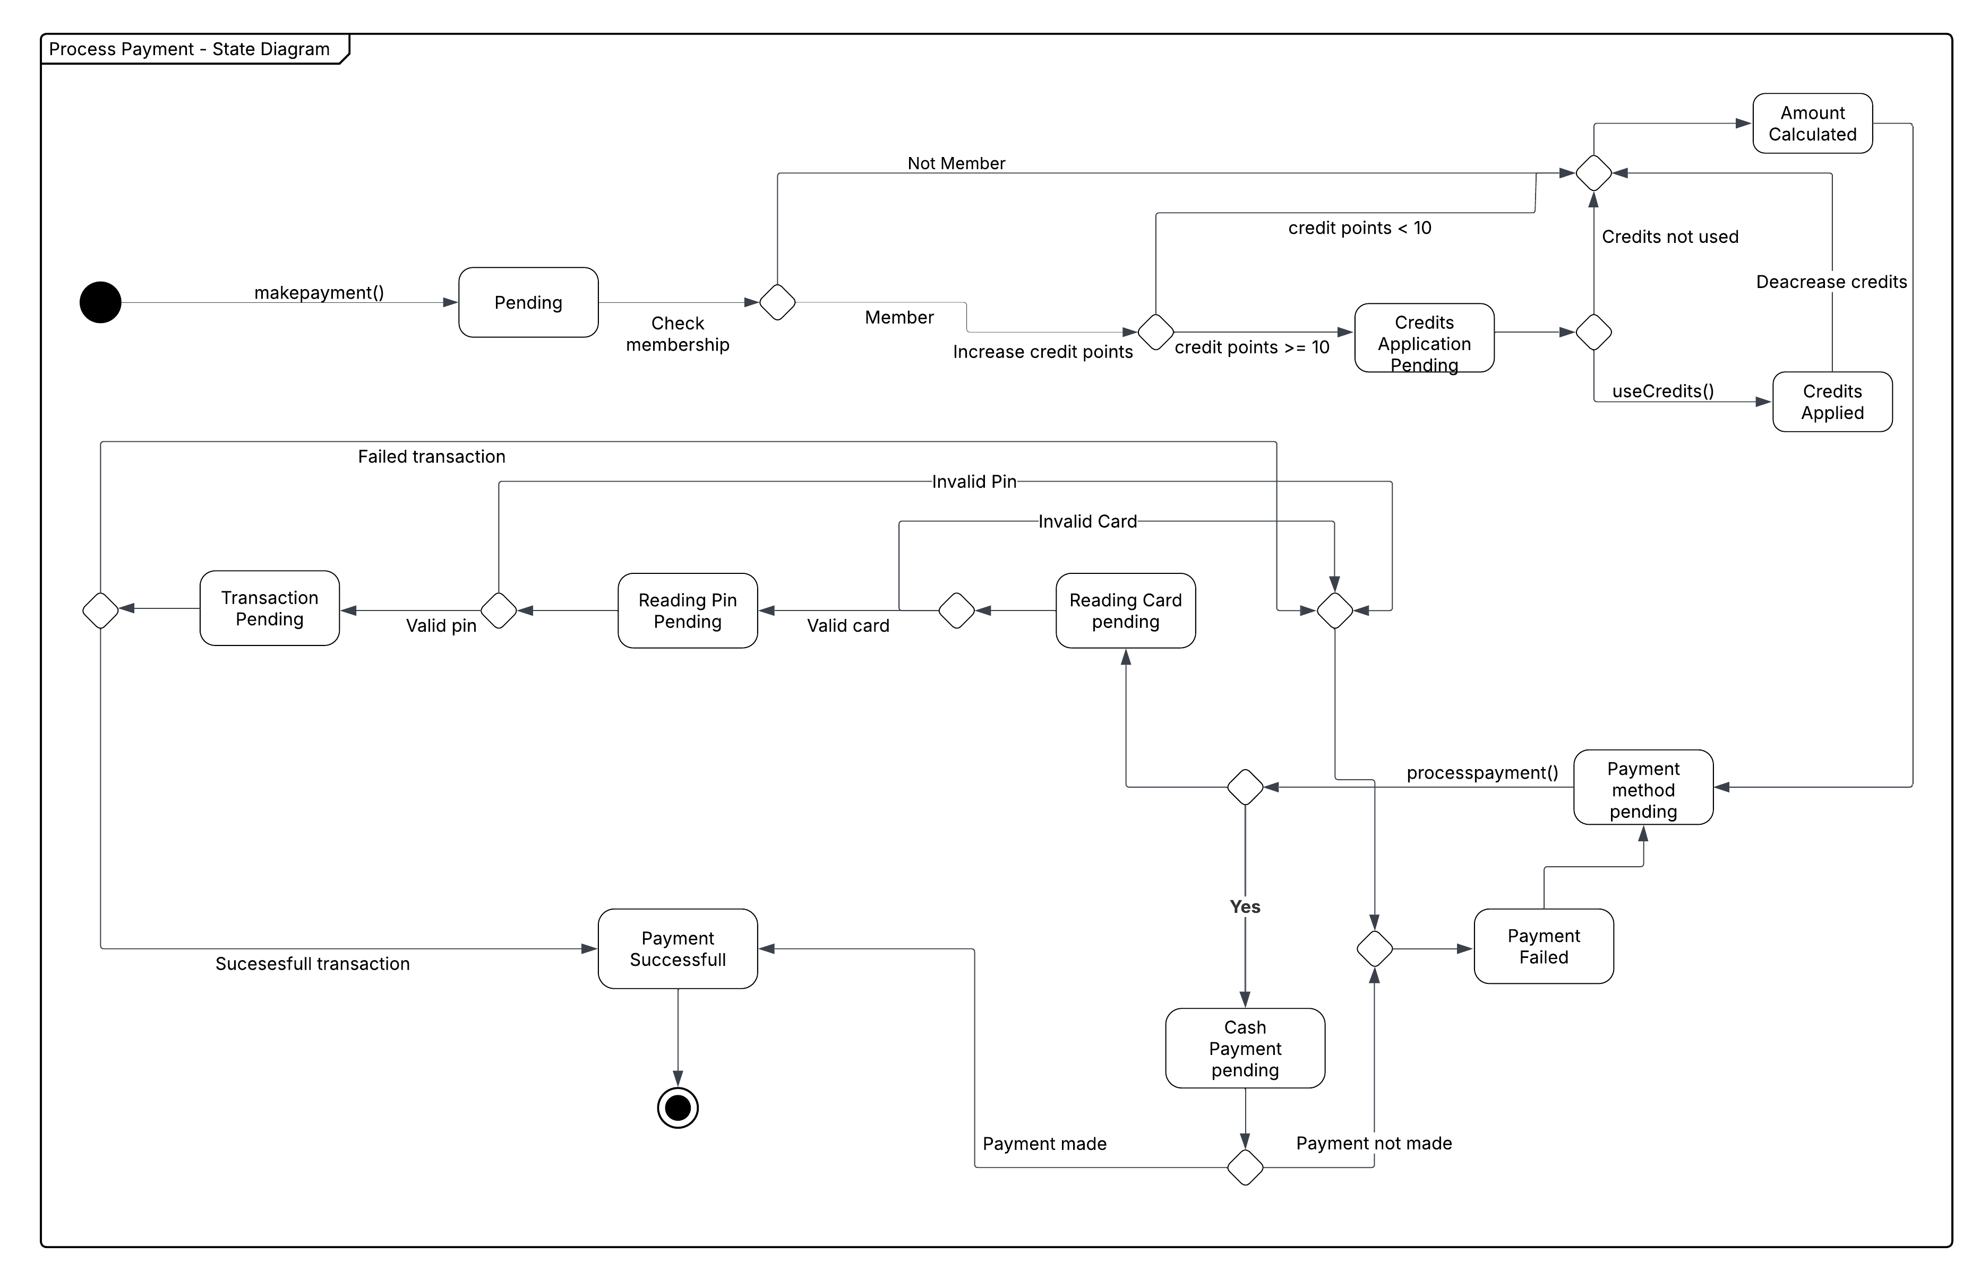

State diagram- Description
This payment processing system first checks membership status to determine credit point eligibility. Members with 10 or more points can apply credits to their purchase, while those with fewer points earn additional credits. The system then validates payment through card reading and PIN verification, with error handling for invalid inputs. Payment concludes successfully through cash processing, or terminates if the transaction fails.

Authors
- Mustafa Mert Atalan s26808
- Beril Yavuz s30017
- Berkay Bayar s25786
- Murside Inci Oldac s30848

GUI Mock-up & Implementation
The following sections detail the Graphical User Interface (GUI) mock-ups for the primary use cases, showcasing the interaction flow and data entry requirements. The design prioritizes ease of use for staff members, with distinct views for Floor Management, Kitchen Display, and Administration.

Make a Reservation
The reservation system is integrated into the Table Detail view. Staff can select a specific table and assign a reservation to it.
GUI Fields:
- Customer Name: Text input for the primary contact.
- Date: Date picker for the reservation day.
- Time: Time selector for the arrival slot.
- Party Size: Numeric input for the number of guests.
Interaction:
Clicking "Confirm Reservation" validates availability and adds the booking to the "Upcoming Reservations" list for that table.
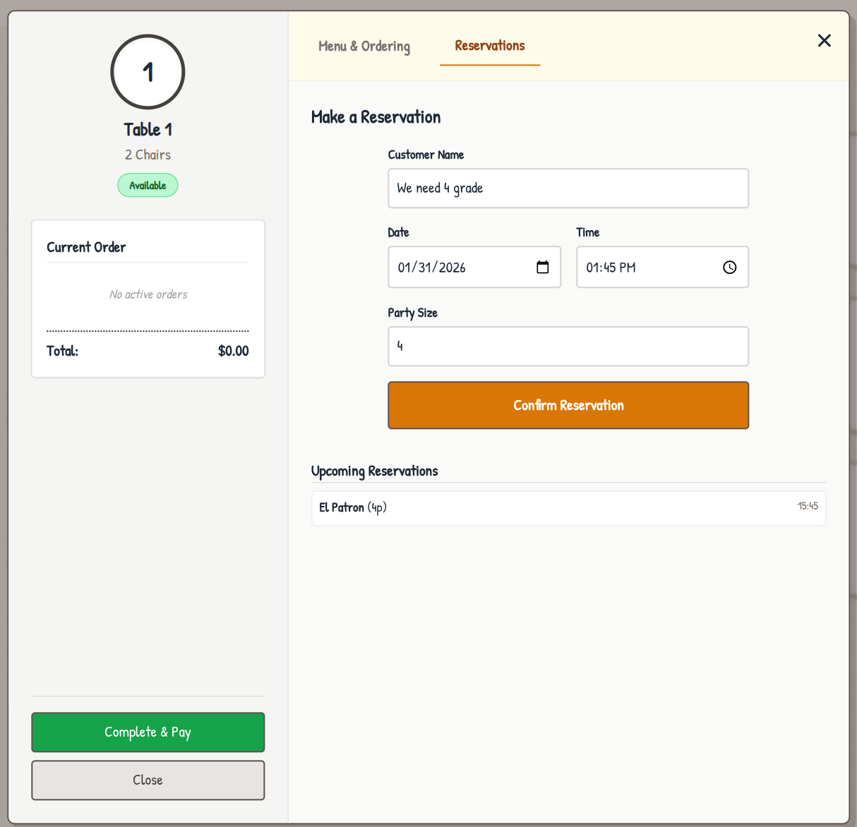

Menu Management (Add a Dish)
Managers can dynamically update the restaurant's menu via the Admin Panel. This ensures the point-of-sale system always reflects current offerings.
GUI Fields:
- Dish Name: Text input for the item name.
- Cuisine: Text input for the cuisine type (e.g., Italian, French).
- Price: Numeric input for the cost.
- Vegetarian: Checkbox to flag dietary preference.
Interaction:
New dishes are immediately added to the "Current Menu Items" list and become available for ordering in the Table Detail view.
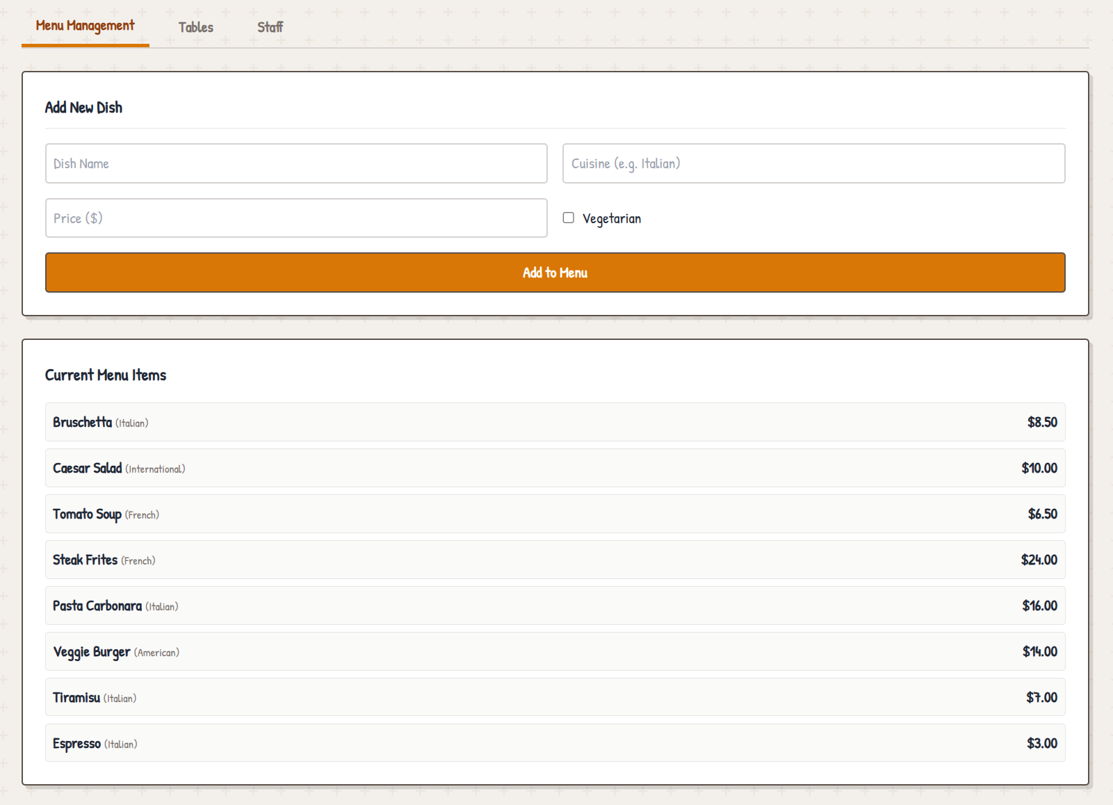

Staff Hiring & Shift Assignment
The Staff Management section within the Admin Panel streamlines the process of onboarding new employees and defining their primary work details.
GUI Fields:
- Full Name: Text input for the employee.
- Role: Dropdown selection (Waiter, Chef, Manager, Valet).
- Department: Text input (e.g., Service, Kitchen).
- Shift: Text input defining the schedule (e.g., Morning, Evening).
- Shift Schedule: Text input defining the work hours.
Interaction:
Submitting the form creates a new Person entity with the appropriate EmployeeRole and updates the Staff Directory.
