Restaurant Management System

User Requirements
The Restaurant Management System is developed to enhance the efficiency of restaurant operations by managing customer reservations, order processing, and employee activities. It enables customers to reserve tables and place food orders conveniently. The menu is organized into categories such as appetizers, main courses, and desserts, with each item displaying details like price, ingredients, and dietary tags indicating vegetarian or vegan options. Customers can select their preferred dishes, specify quantities, and add them to their order. If a selected dish is out of stock or the requested quantity exceeds availability, the system alerts the customer and prompts them to adjust the order accordingly.
Once the order is finalized, customers can proceed to the payment stage. Payments can be made through credit or debit cards, or by using loyalty points accumulated from previous purchases. If a payment attempt fails, the system marks the order as “Pending” for up to 15 minutes, during which the customer can retry the payment before the order is automatically cancelled. Customers can also access their order history to review previous transactions and payment records.
The reservation module ensures that all bookings meet specific table capacity requirements, including minimum and maximum limits. After booking, customers receive a confirmation and have the option to modify or cancel their reservations if needed.
For employees, the system provides tools to view and update the status of orders across three stages: “Preparing,” “Served,” and “Completed.” Staff can also manage table reservations by checking table availability and assigning tables to customers. Additionally, employees have access to their personal work records, including salary details and employment history. Salaries are reviewed annually, with a 2% increment applied based on tenure, which is automatically reflected in the salary information.
The system maintains a categorized menu database containing detailed information for each dish—covering prices, ingredients, and dietary preferences. It enforces business rules such as updating stock levels after order completion and maintaining minimum table capacity requirements for reservations. Integrated with external payment gateways, the system securely manages payment processes and tracks payment statuses, including “Pending” and “Completed.”

Class diagram

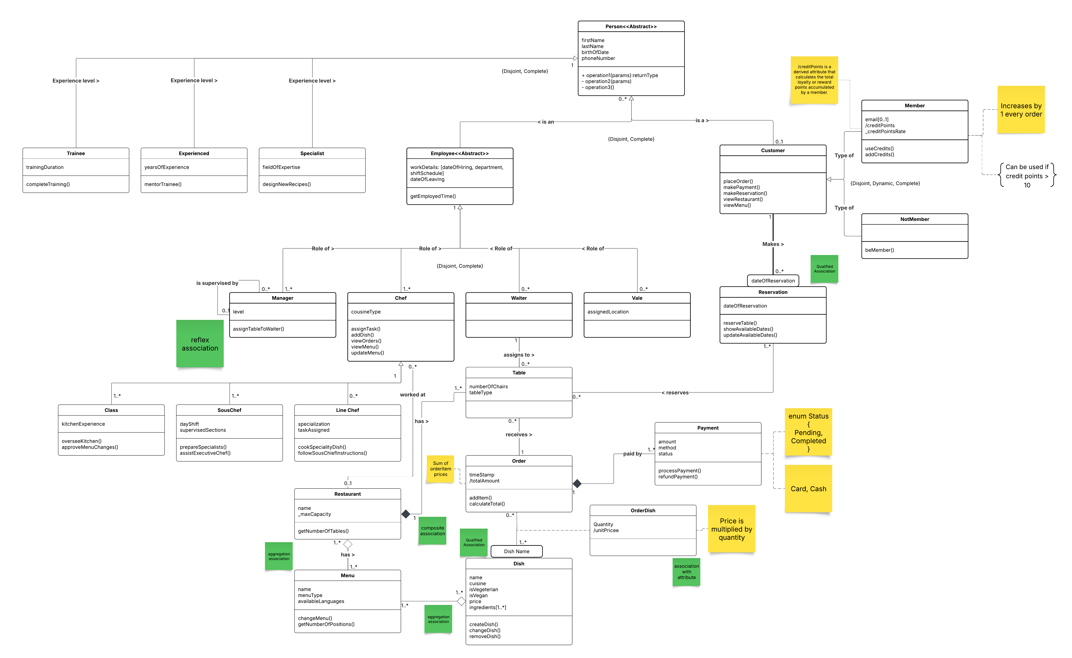

Use Case Diagram

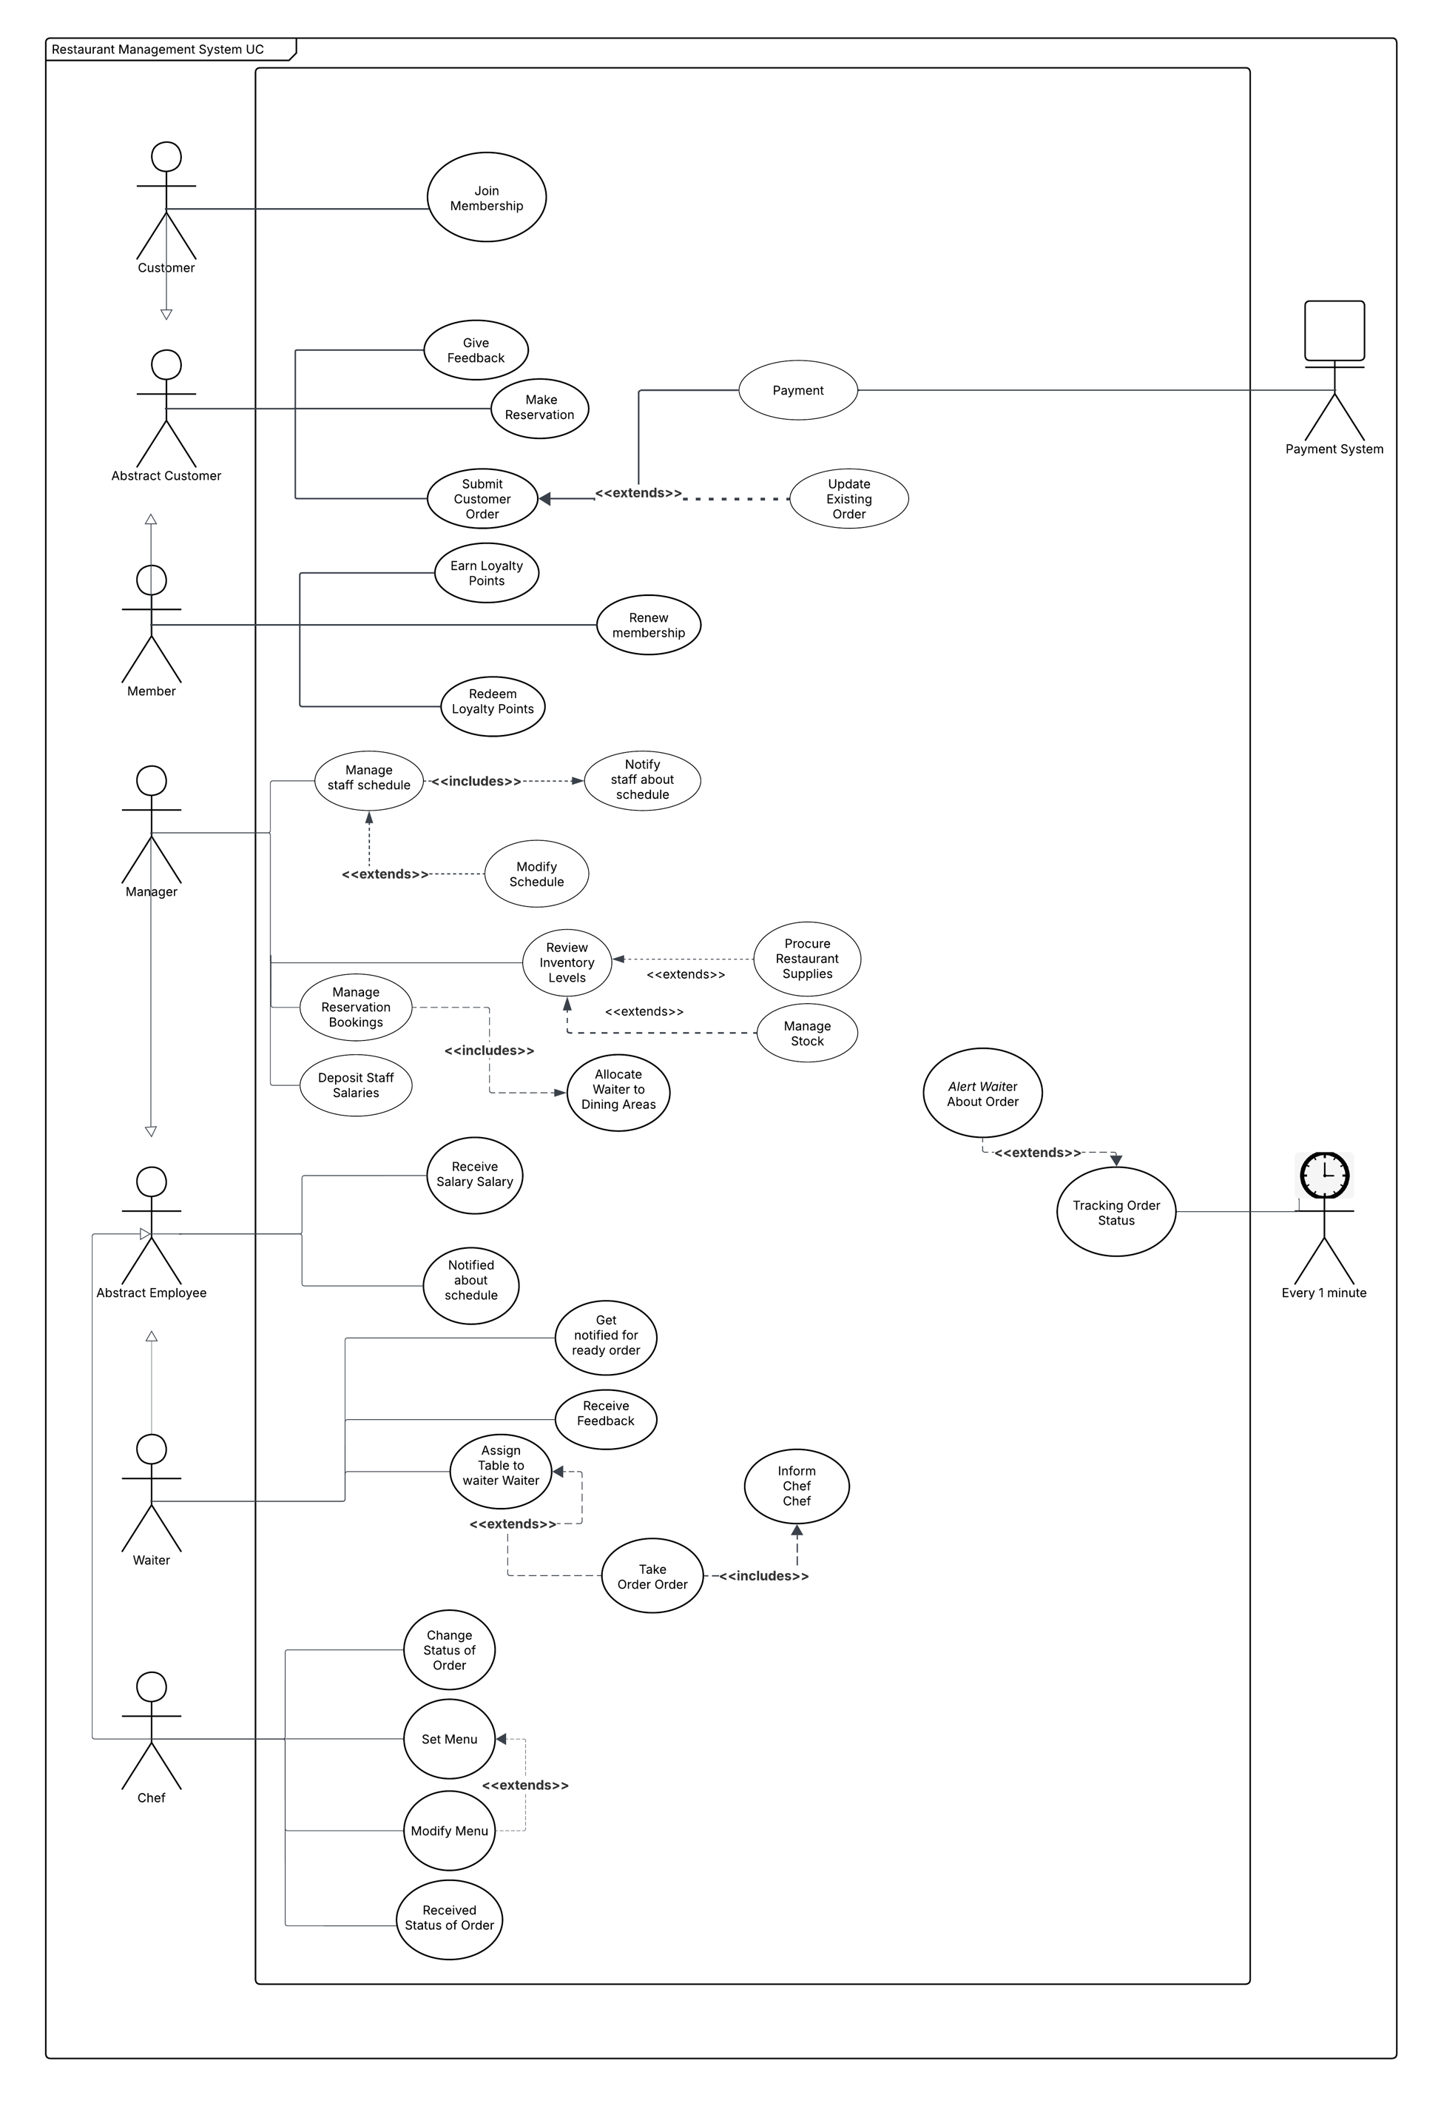

Use Case Scenario : "Make a reservation"
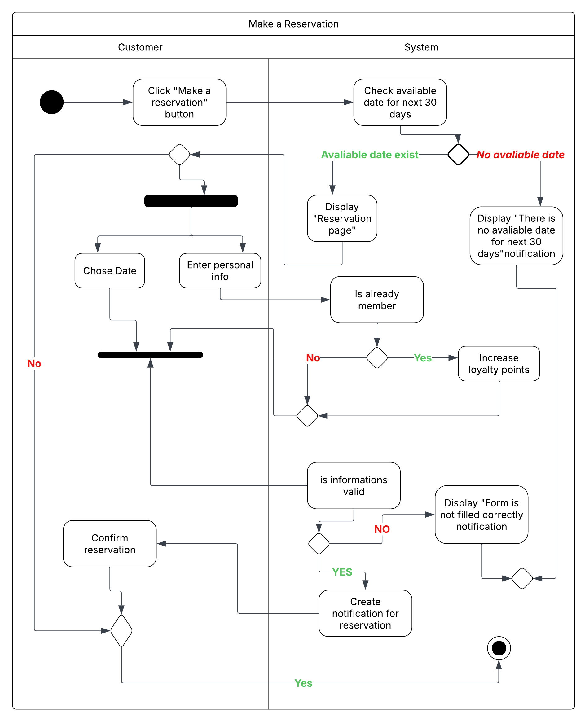

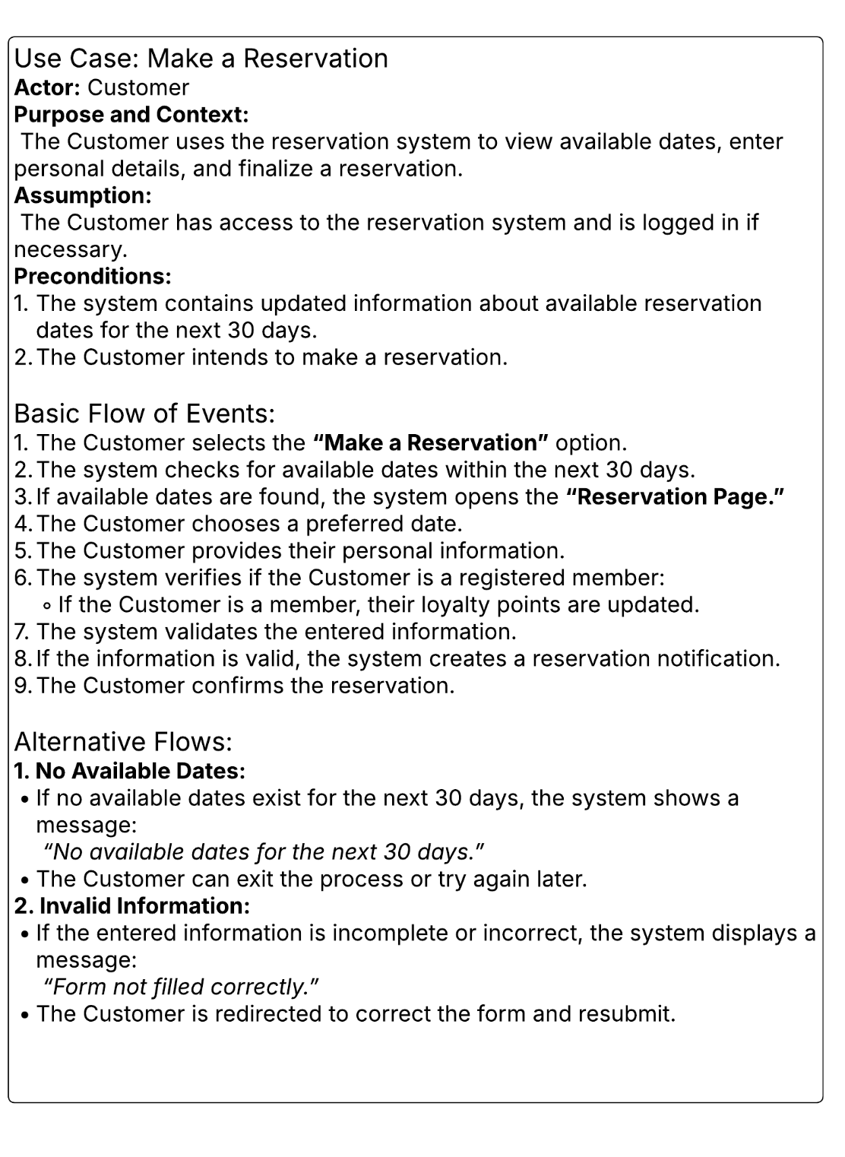

Use Case Scenario :"Add a Dish"
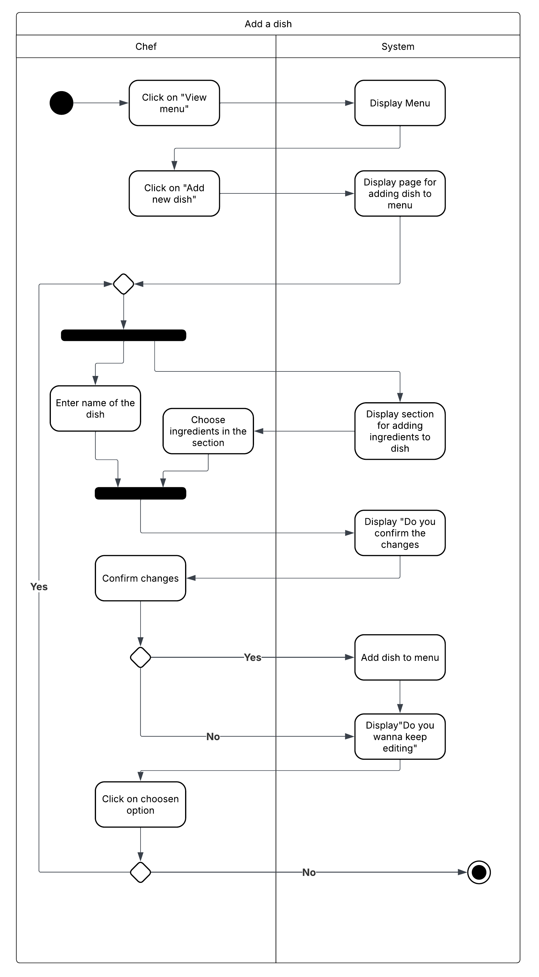

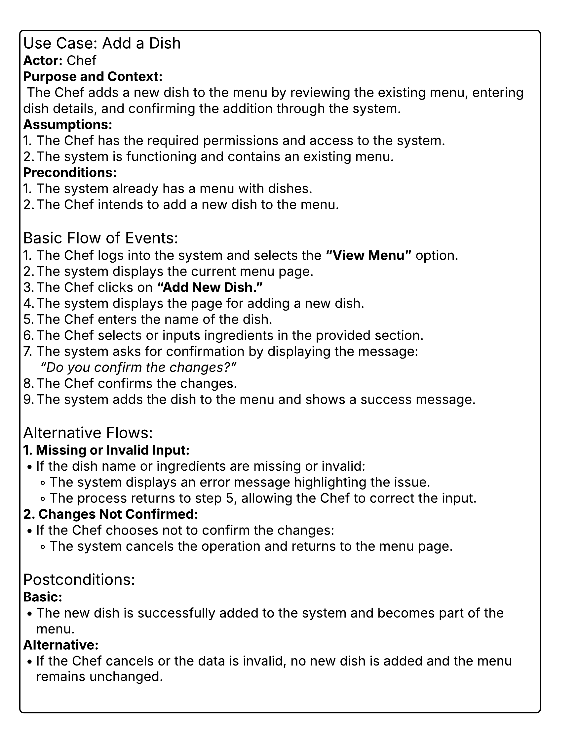

Use Case Scenario : "Assign a Shift"
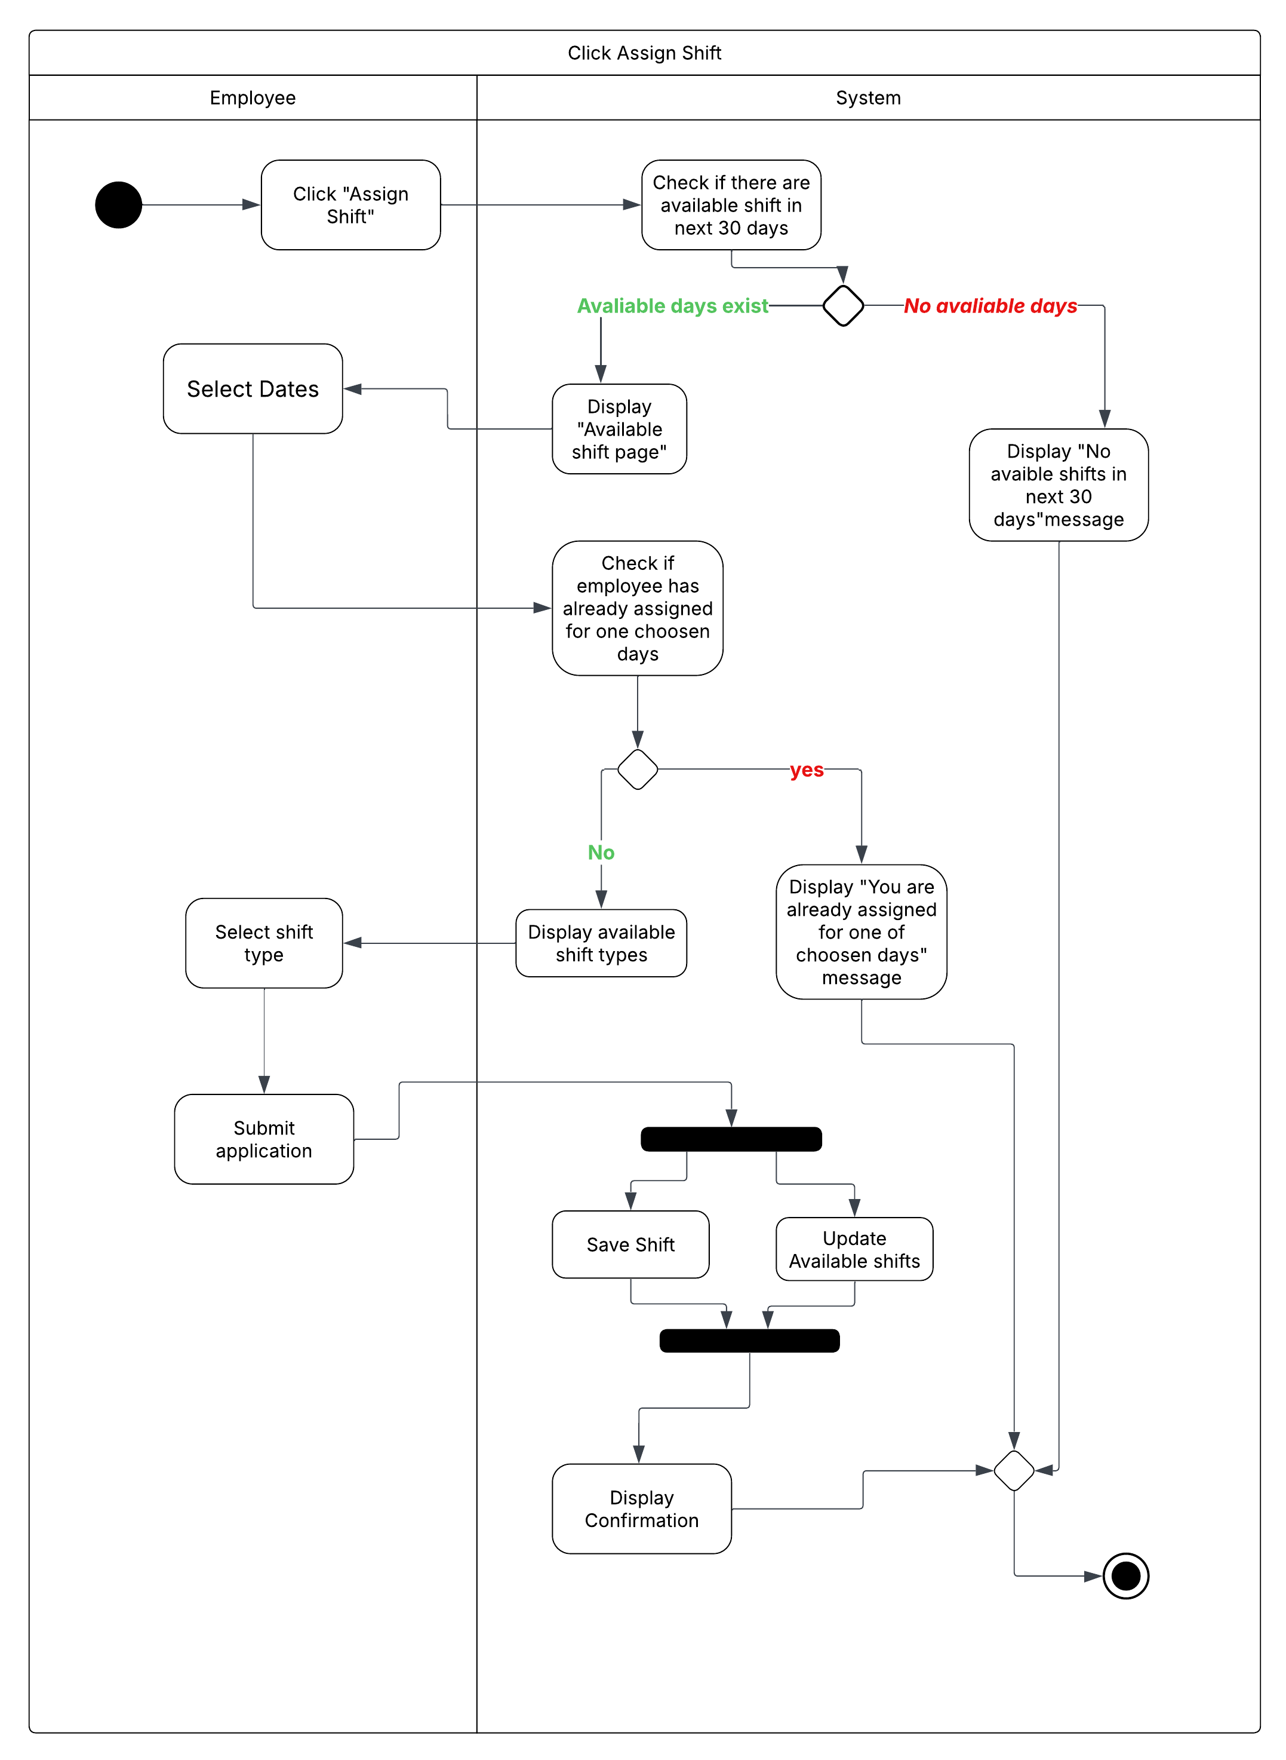

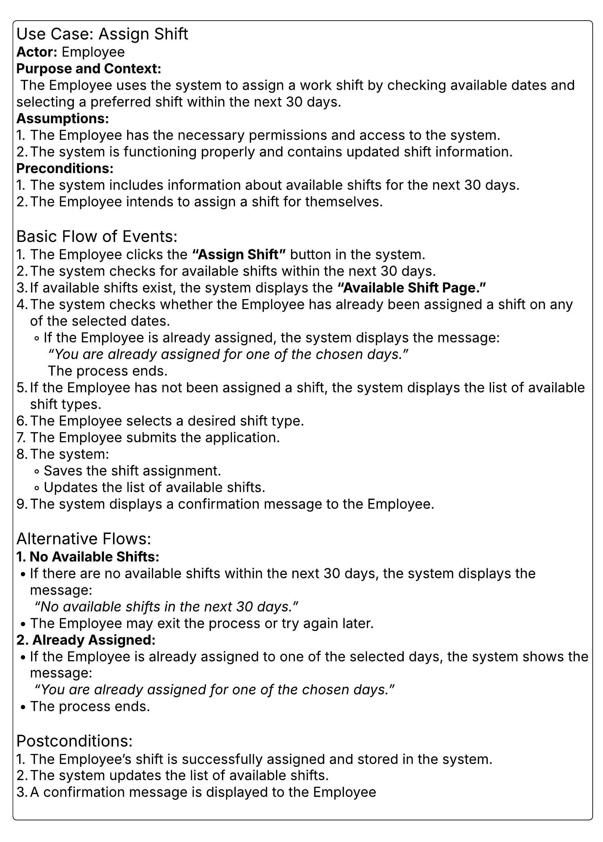

State Diagram
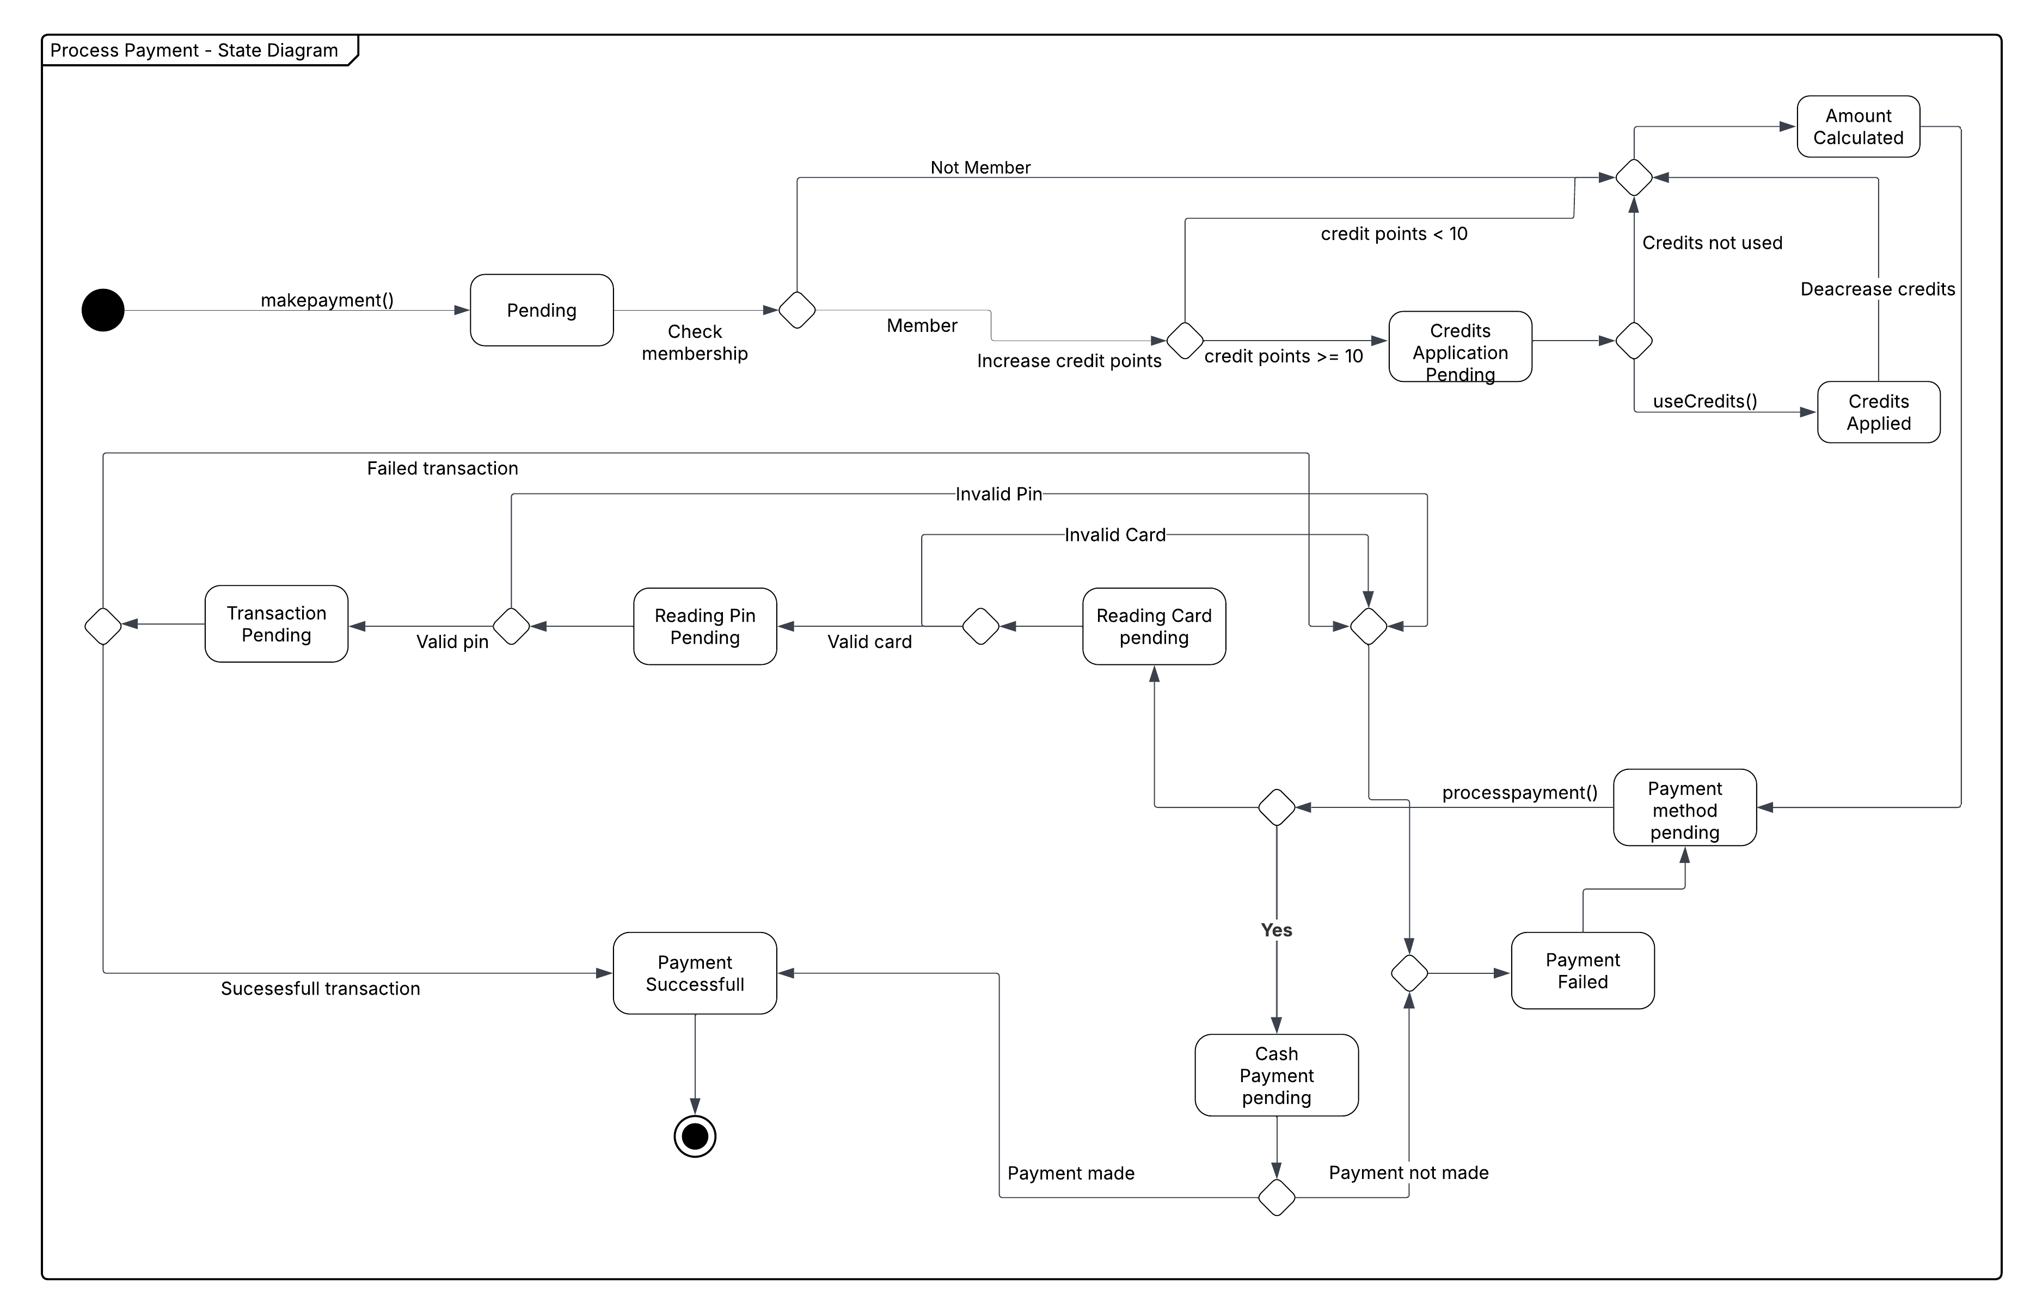

Design diagram

Design Decisions
The class diagram above illustrates the necessary changes to model that are not natively supported in the C# language. The final implementation uses class extent persistence through JSON serialization for storing object instances locally, and the design choices associated with this approach are discussed in the following sections. The changes introduced are highlighted in green. This section will explain the transformation process of certain UML constructs such as attribute types (based on UML notations), tagged values, derived attributes, optional attributes, multi-value attributes, and class attributes.

Polymorphic Serialization
Abstract base classes use System.Text.Json polymorphic attributes for type discrimination:
- Person discriminates Customer and Employee
- Customer discriminates Member and NonMember
- Employee discriminates Manager, Chef, Waiter, and Valet
- EmployeeExperienceProfile discriminates TraineeProfile, ExperiencedProfile, and SpecialistProfile
Each derived type includes a typeDiscriminator string in JSON.

Class Extent Persistence
The Restaurant and Payment classes implement class extent persistence using static collections and JSON serialization.
- Restaurant Class: Static _extent list stores all Restaurant instances Save() serializes the extent to JSON Load() deserializes from JSON and replaces the extent Instances are added to the extent in the constructor
- Payment Class: Static Extent property holds all Payment instances SaveAll() and LoadAll() handle persistence Extent is managed separately from instance creation

Multi-Value Attributes
Multi-value attributes are implemented as private lists with public read-only collection properties:
- Menu.AvailableLanguages (List)
- Dish.Ingredients (List)
- SousChef.SupervisedSections (List)
- LineChef.TasksAssigned (List)
- Customer._reservations (List)
- Table._reservations (List)
- Order._orderDishes (List)
- Waiter._assignedTables (List)
Private fields are marked with [JsonInclude] for serialization. Public properties return IReadOnlyCollection.

Optional Attributes
Optional attributes use nullable types:
- Customer.Email (string?)
- Payment.ProcessedOn (DateTime?)
Nullability indicates optionality.

Derived Attributes
Derived attributes are computed properties without backing fields:
- Order.TotalAmount = sum of OrderDish.TotalPrice
- OrderDish.TotalPrice = Dish.Price * Quantity
These are read-only and computed on access.

Class Attributes
Class-level attributes are static properties:
- Payment.TaxRate (static decimal) with ChangeTaxRate() for modification
Static properties are shared across all instances.

JSON Serialization Configuration
JsonSerialization.GetDefaultOptions() provides:
- WriteIndented = true
- ReferenceHandler = ReferenceHandler.IgnoreCycles
- Custom DateOnlyJsonConverter for DateOnly serialization (format: "yyyy-MM-dd")

Property Validation
Properties with private setters include validation:
- Menu.Name and MenuType check for null/whitespace
- Dish.Name, Cuisine, and Price validate non-empty strings and positive values
- Validation occurs in property setters, not only constructors

Mustafa Mert Atalan s26808
Beril Yavuz s30017
Berkay Bayar s25786
Murside Inci Oldac s30848

