1. I chose the enhancement Number 4 (--ext argument)

2. To run my script, type the command: python scan.py test_root --ext (“extension”)  
So for example, if I want to scan txt files, I would type: python scan.py test_root –ext txt

3. Screenshots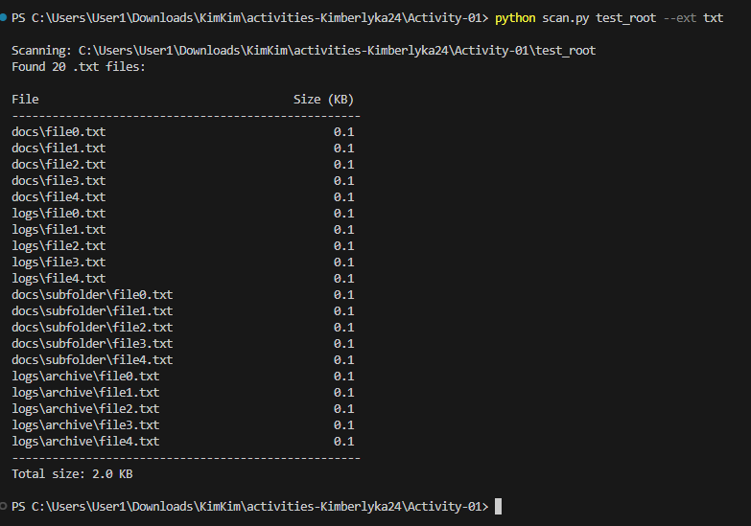

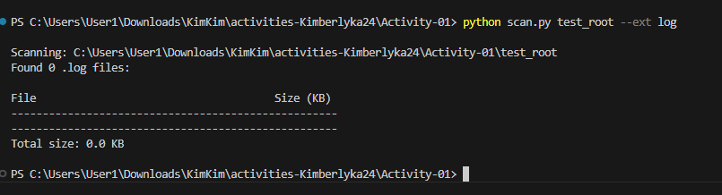

Then I tried putting png file for checking if the code works:

