# Getting HydroServer Lite Source Code (Instructions for Windows)

## Step 1.1 – Install MSysGIT

Go to <http://code.google.com/p/msysgit/>

Go to **Downloads** and select the **Full installer for official Git for Windows 1.8.0**

Download and run the installation file **Git-1.8.0-preview20121022.exe**

Follow the steps in the setup wizard. Keep the default options in all steps.

* In the step **Adjusting your PATH environment** use the default **Use GIT Bash only** option.
* In the step **Configuring the line ending conversions** also use the default **Checkout Windows-style, commit Unix-style endings** option.
* In the last step click **Finish**.

## Step 1.2 – Install TortoiseGIT

Go to <http://code.google.com/p/tortoisegit/wiki/Download>

* Select the download version (for 32-bit OS or for 64-bit OS). If you are unsure you can find out the Operationg system type in My Computer – Properties – System Properties)Download the .msi installation file and run it.
* Follow the steps in the TortoiseGit setup wizard. Keep the default options in all steps.
* In the last step click **Finish**.

## Step 1.3 - Get the source code of Hydroserverlite

In your computer navigate to the folder where you want to have a local copy of the code, for example c:\wamp\

Right-click on the folder in Windows Explorer and select GIT Clone..

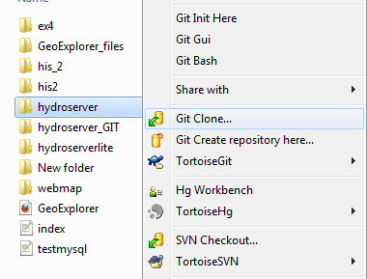

In the URL enter the following address:

**https://git01.codeplex.com/hydroserverlite**

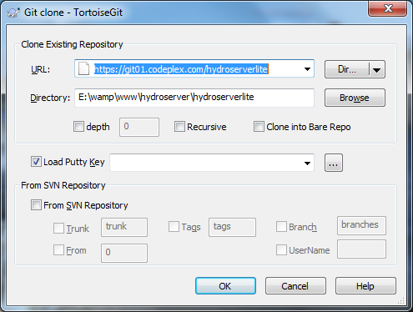

After the clone is complete click close on the progress window. In Windows Explorer the folder and all its files and subfolders are labeled with a green icon:

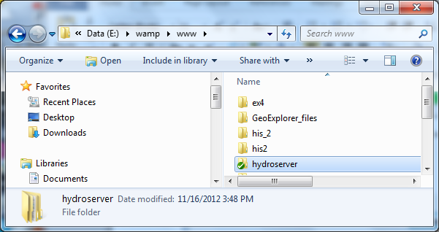

## Step 1.4 – Test Hydroserverlite on a local computer

You can also install wampserver <http://www.wampserver.com/en/>) on your local computer. Wampserver is the apache, php and mysql package for Windows. You can use it to test or modify HydroServer lite offline on a local computer without uploading every change to a remote server

# Part 2 - Contributing source code to hydroserverlite

## Step 2.1 Register on codeplex and ask for code commit privileges

If you don’t have a user account on codeplex.com, go to [www.codeplex.com](http://www.codeplex.com) and select register. Create a new account.

After you created the codeplex user account go to

<http://hydroserverlite.codeplex.com/team/view> and contact the coordinator danames or jirikadlec2 with a request. After the coordinator gives you developer privieges you will see your name under Developers.

## Step 2.2 Remember user name and password

This is an optional step, if you don’t wont to re-type your username and password every time.

In **notepad** create a file called **_netrc** with the following contents:

machine git01.codeplex.com  
login <login>  
password <password>

Instead of <login> write your codeplex user name.

Instead of <password> write your codeplex password

Save the file without the .txt extension to C:\Users\<your-username> Note: Use save as – all types in notepad)

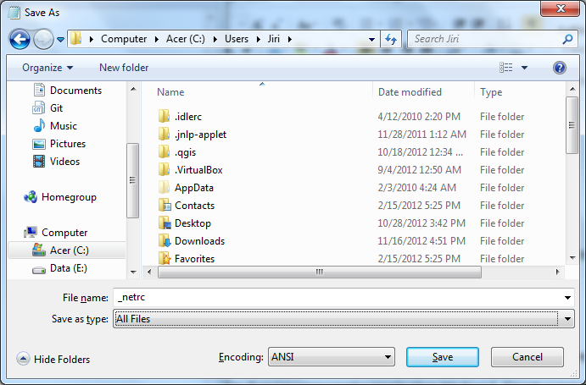

Go to start – all programs – accessories - **command prompt**, type

setx home C:\Users\<your-username>

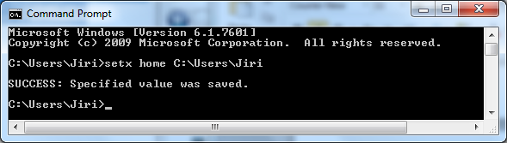

Note: if you’re using something earlier than Windows 7, the setx command may not work for you.  Use set instead and add the home environment variable to Windows using via the Advanced Settings under My Computer.

## Step 2.3 Make a change in the source code – edit existing file

For example, edit the file hydroserver\services\wof_read_db and add a comment:

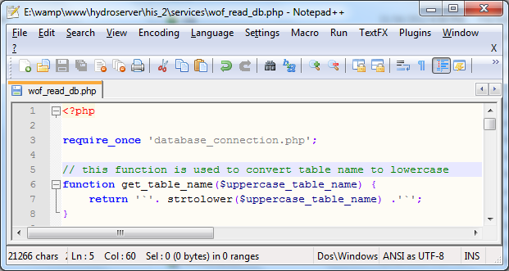

In Windows explorer the file will be marked by a red icon:

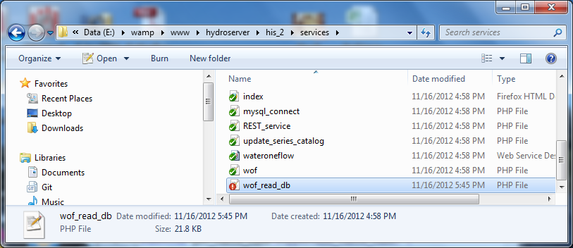

## Step 2.4 Make a change in the source code – add a new file

The new file is marked in Windows Explorer with a question mark (?) icon. You must right-click on the file and select **Tortoise Git – Add.** The icon of the file will change to a plus (+) icon.

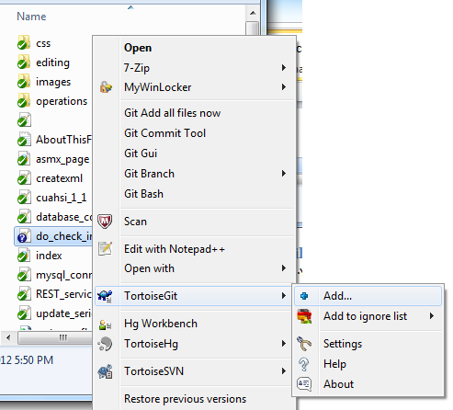

Note: If you created multiple files or folders you can also use the option: **Git Add all files now**.

## Step 2.5 Git Synchronization

After you made changes, right-click on the folder and select **Git Sync…**

The following screen shows.

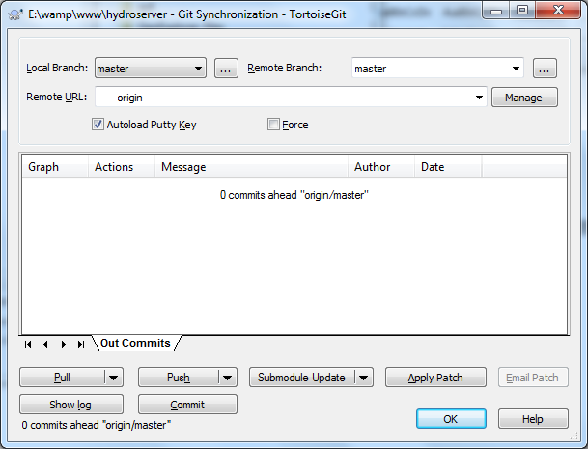

First, click the button **Pull**. This will download any changes made by other developers when you were working on the code. If there are no external changes, you will see a message: all files are up to date.

Second, click the button **Commit**. This will prepare your changes for upload to the codeplex.com server.

(Note: the first time, you will be prompted for a name and email. You should enter your codeplex username)

Next, a new window shows. Enter a summary of your changes and click **OK**.

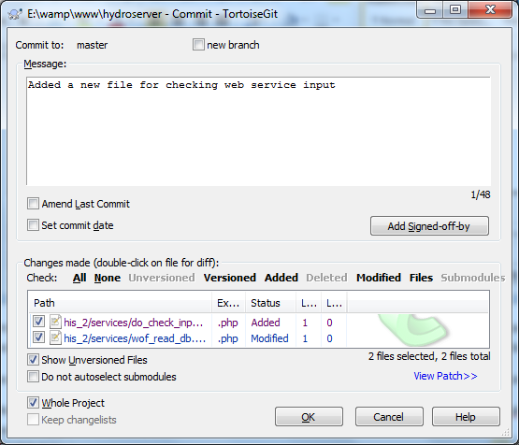

Next, click the **Push** button. A progress window is shown. If successful, a similar message like this is shown:

