Place Your Paper Title Here with Title Capitalization that May Run Multiple Lines
Firstname Q. Lastnameª, Givenname R. S. Surname Jr.^{ab}, and Personwith MULTIWORD LASTNAME^{b}*
ª Provincial University, Department of Chemical Engineering, City, Province, Country
^{b} State College, Engineering Department, City, State, Country
* Corresponding Author: author.email@someuniversity.ca
Abstract
Type your abstract text here. Please limit to 250 words. Uses the style PSE_AbstractText. Lorem ipsum dolor sit amet, consectetur adipiscing elit, sed do eiusmod tempor incididunt ut labore et dolore magna aliqua. Ut enim ad minim veniam, quis nostrud exercitation ullamco laboris nisi ut aliquip ex ea commodo consequat. Duis aute irure dolor in reprehenderit in voluptate velit esse cillum dolore eu fugiat nulla pariatur. Excepteur sint occaecat cupidatat non proident, sunt in culpa qui officia deserunt mollit anim id est laborum.
Keywords: Choose an item., Choose an item., Choose an item., Choose an item., Choose an item. additional keywords separated by commas

this is header 1
This is Header 2
Regular text uses the PSE_Text style. Please do not add spaces between paragraphs. Paragraphs will indent automatically and will hyphenate automatically. Do not add extra paragraph spaces between sections.
This is header 3
Use the PSE_Header styles for all headers. When you do this, do not add extra blank paragraph whitespace between text and headers, the spacing will already be set.
This is header 4
Some text that follows header 4.
Figures and Tables in the text
One Column-Width Figures
The standard column width is 8.5 cm in this template. When inserting a single-column figure in the text, insert the figure in its own paragraph, and change the style of that paragraph to PSE_FigureAndCaption. Insert the figure. On the next line, type the figure caption, and make sure you use the PSE_FigureAndCaption style Place the figure where it best flows with the text.
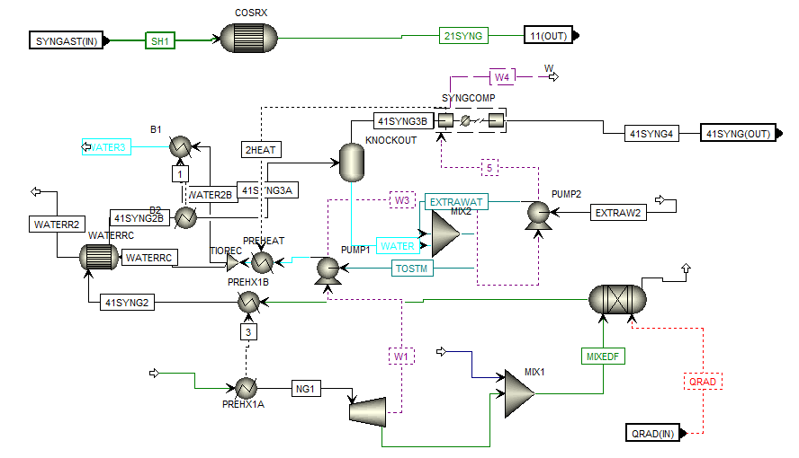
Figure 1. Example 1-column figure with a short caption. Max width is 8.5 cm.
One-Column Tables
Use the Insert | Table feature to insert a table with a single column width, inline in the text. Use PSE_TableCaption for the caption and PSE_TableContent for the table itself. Use the PSE_TableFormat template in the Table Design ribbon to apply standard borders, but feel free to add other rules and lines as needed to best communicate your table. (You will not see PSE_TableFormat in the list of styles, that is found in the Table Design ribbon).
Table 1: Caption for the table. Multi-line table captions will be fully justified. The style is PSE_TableCaption.
Stream | Description | Flow
Feed | A mixture of MeOH, EtOH, & BuOH. | 11.2 kmol/hr
Side Draw | Mostly ethanol | 115.0 kmol/hr
Distillate | Mostly methanol | 21.5 kmol/hr
Bottoms | Mostly butanol | 110 kmol/hr
Two Column (Page-Width) Tables and Figures
The printable page width is 17.5 cm, but images and tables should be limited to 17 cm wide. Use the Insert Text box feature in Microsoft word and use a Simple Text Box (leave the borders around it). Use the same styles that you would use for single column tables and figures (PSE_FigureAndCaption, PSE_TableCaption, and PSE_TableContent). Resize the text box appropriately. To snap the box to the top or bottom of the page, click the text box, go to the Shape Format ribbon. In the Position drop down, choose the icon in the upper left to have the text box snap to the upper left portion of the page. Place the text box on whatever page is most convenient to your message. In fact, the example is located on the next page.
How to CITE REFERENCES IN THE TEXT
Text citations should use numbers in square brackets [1] and placed at the end of the phrase that is most appropriate in the context of the sentence, which may or may not be at the end of the sentences. You can cite ranges of papers [1-5] or sets of papers [3,5,8].
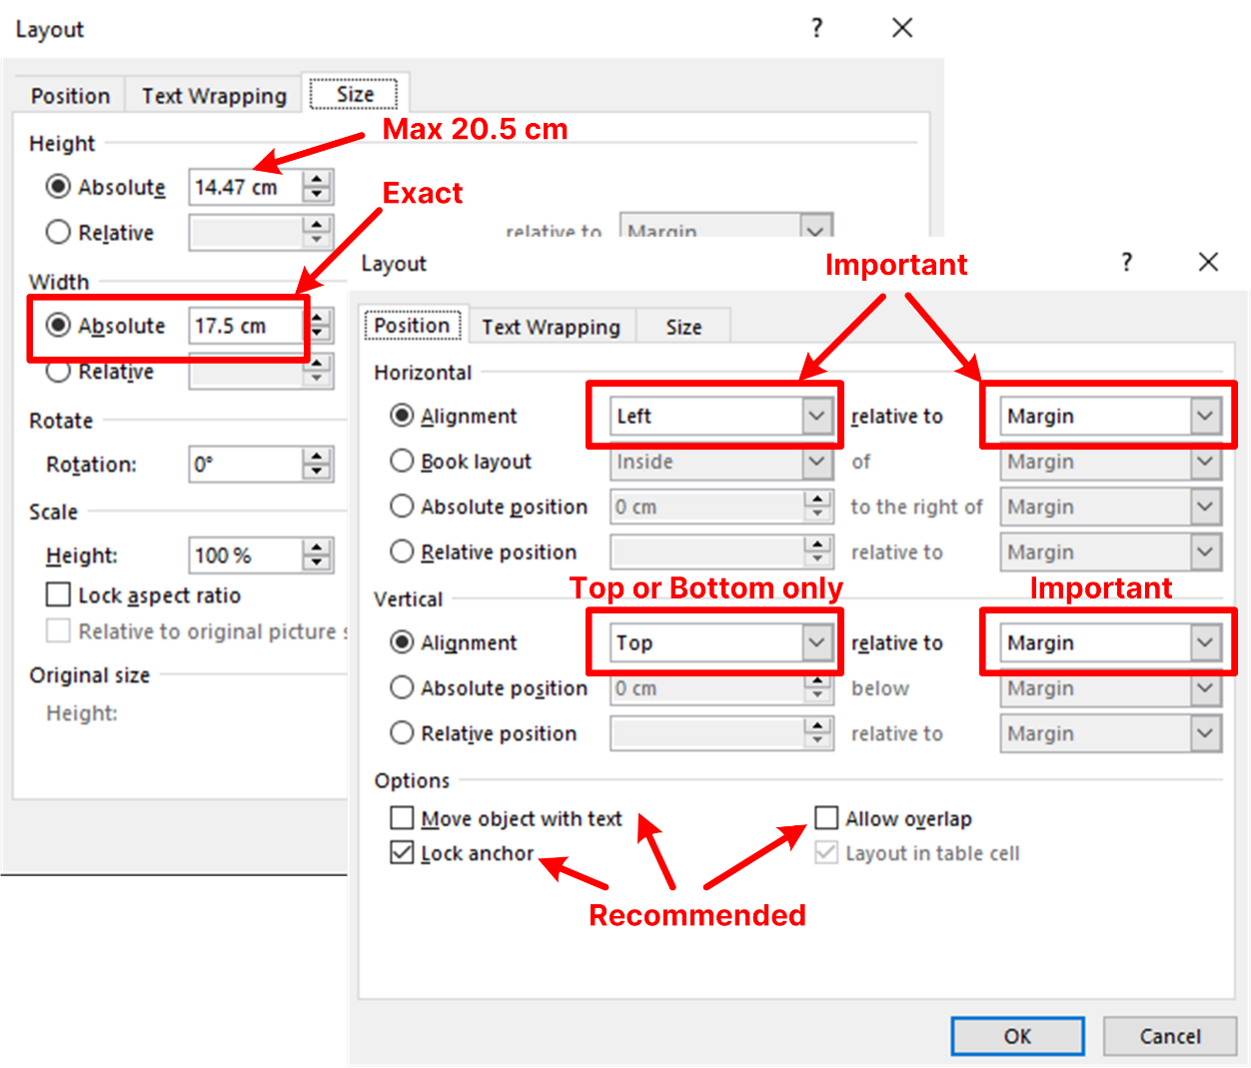
Figure 2: For wide figures and tables, place inside of a text box (just copy-paste this textbox into your paper). You can put multiple figures in one box. The width of the box must be exactly 17.5 cm. The box height should not exceed 20.5 cm. Set the horizontal alignment to Left relative to Margin, and the vertical alginment to either Top or Bottom relative to Margin. This makes sure you don’t place the box in the margins or at the wrong spot. You can adjust these easily by selecting the box (click the box edge border), then in the Ribbon choose Layout | Position | More Layout Options, and adjust the above as needed.
Other Formatting instructions
Equations in the Text
Equations should look like the following. Use the Equation Editor in Microsoft Word (Alt + = or Insert | Equation). Then use PSE_Equation for the style. Add the equation reference numbers in parenthesis after the equation inline, and use tabs until the equation numbers are aligned properly (equation numbers and whitespace should all use PSE_Equation). Do not add additional space above or below equation; the style will handle it.
$f\left(x\right)=μ\int_{0}^{∞}{\frac{1}{x}dx}$ (1)
$f\left(x\right)=αβ\int_{0}^{∞}{\frac{1}{x}dx}+y/x$ (2)
You can use LaTeX format or UnicodeMath format if you prefer. Here is an example of a matrix that was made using LaTeX. To add a LaTeX format equation, hit Alt + = or Insert | Equation to add a new equation, and make sure the Conversions is set to LaTeX in the Editor ribbon (you should only need to do this the first time).
$A=\{\begin{matrix}a & b & c \\ d & e & f \\ g & h & j\end{matrix}\}$ (3)
Code
You can use the style PSE_CodeInline to format computer code inline within the text, such as a function name. For code blocks, use PSE_Code as demonstrated below.
for i in range(NPoints):
T.append(600 + (400) * (i/(NPoints-1)))
P.append( 2 + (50) * (i/(NPoints-1)))

random.shuffle(P)
Language and Spelling
We prefer US English. Other forms are acceptable.
Headers, Footers, and Copyright
Do not make any other modification to the headers, footers, margins, or copyright information after the references.
Definitions, Theorems, and Block Quotes
You can use the PSE_Definition styles and PSE_TheoremTitle styles to create definitions and terms in your text. PSE_Definition also works well as a block quote format.
Theorem 1
Then this text is where your theorem is declared, and you can describe it across multiple lines.
Term Being Defined
This works well for definitions too.
DIGITAL supplementary material
You are encouraged to submit digital supplementary materials to the Living Archive for Process Systems Engineering at http://PSEcommunity.org/LAPSE. You can then refer to your digital materials by using the LAPSE ID in this section. We will hyperlink it to your LAPSE submission automatically. Delete section if not used.
ACKNOWLEDGEMENTS
Please acknowledge your funders in this section, with grant or funding numbers as appropriate. Note that most funding agencies require this.
DELCARATION OF USE OF AI
Describe how generative AI was used in preparing the manuscript. If AI was used in the research methods, describe that in the main paper instead (e.g. methods section). AI is not an author.
author identifiers
Author ORCIDs:
Lastname FQ: 0000-0001-2345-6789
Surname GRS Jr: 0000-0001-2345-6789
Multiword Lastname P: 0000-0001-2345-6789
References
- Author FN, Suffix AB Jr, Roman BC III, Multiple Surname GV. Title of the paper in sentence case. Abbrev J Title 4:32-42 (2020) https://doi.org/10.1234/56789.10
- Inventor FN. Title of the patent in sentence case. US Patent 3,765,134. (2019)
- Author FN, Other SD. Capitalized Title of the Book. Publisher (2021). ISBN 123-4-5678901-2-3
- Author FN, Other CA. Title of the section of the book. In: Capitalized Title of the Edited Book. Ed: Editor QC, Other JC. Publisher (2022)
- Webpage author. http://hyper.link/deep/link.html [accessed Date]
© 2027 by the authors. Licensed to PSEcommunity.org and PSE Press. This is an open access article under the creative commons CC-BY-SA licensing terms. Credit must be given to creator and adaptations must be shared under the same terms. See https://creativecommons.org/licenses/by-sa/4.0/


