# The Ship: Putting it All Together

The ability for the player to customize its ship is one of the new features of *Super Asteroids*. When all of the pieces of the ship are put together, it might look something like this:

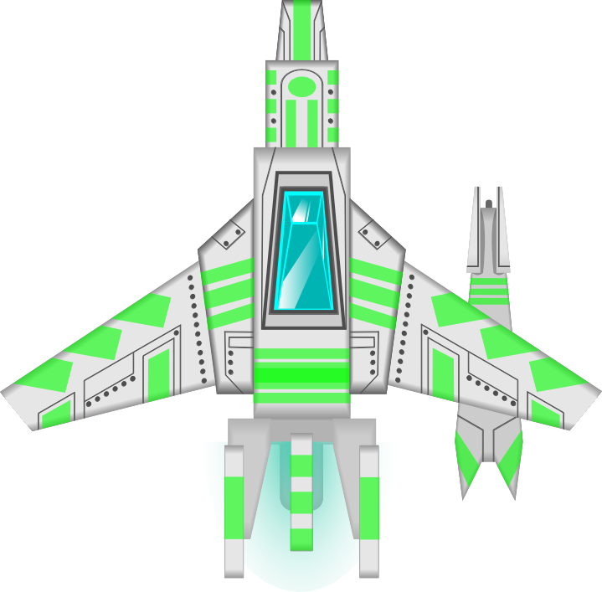

The ship is made up of four parts, the: main body, extra part, cannon, and engine. Each part is stored in its own image file. These parts can be seen below.

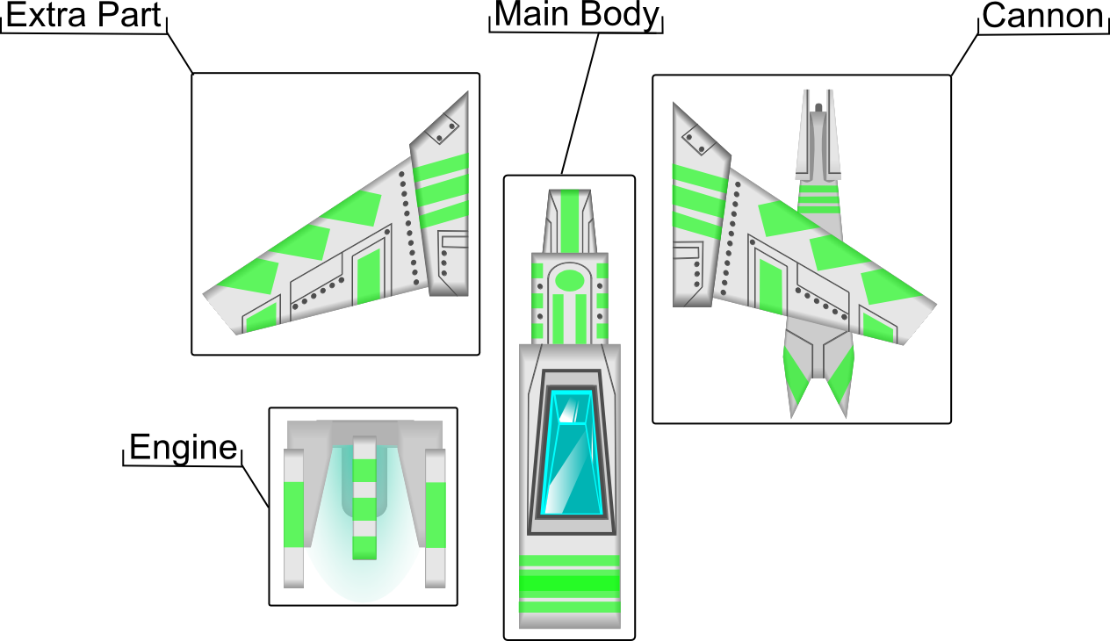

Storing the ship parts in separate image files makes the process of putting the ship together require some specific information about each piece. For example, to attach the cannon to the main body requires two pieces of information: a point on the cannon image and a point on the main body image.

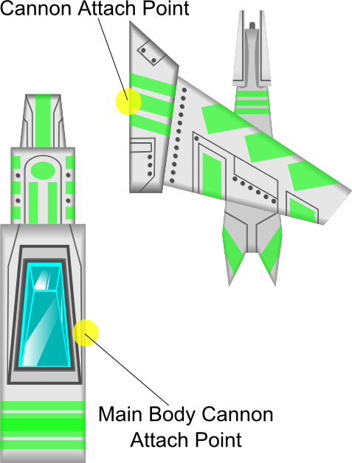

Drawing the cannon attached to the main body simply requires a few offset calculations. Basically, the goal is to draw the two images such that the two attach points overlap. Below is an example of some hypothetical measurements of the images and attach points. Notice the attach points are measured from the top left corner of the image.

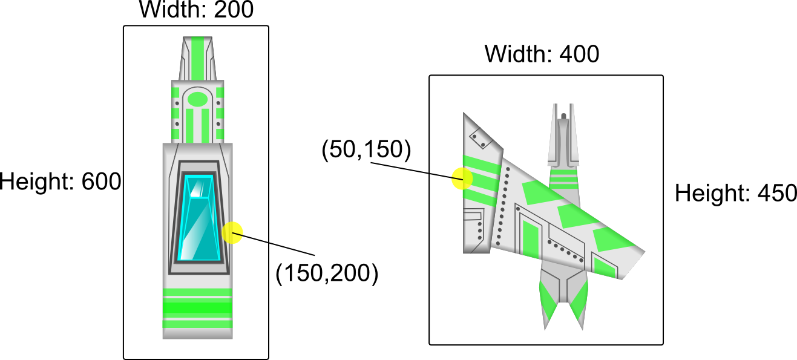

The ship’s position gives us the coordinates for drawing the main body, but where should the cannon be drawn so it is correctly attached to the main body? This is left for you to work through!

Once you figure out the offset calculations for one piece, the same calculation method can be applied to the rest of the pieces. As you can see below, each part has two points associated with it.

