# Introduction

***Logisim Evolution*** is a logic circuit simulator written in Java. The “logisim-evolution.jar” file may be run from any operating system as long as Java is installed on the system (Windows, Mac OSx, Linux, etc.). In most systems you simply need to double-click on the “jar” file. In other systems it is invoked at the command prompt with “java -jar logisim-evolution.jar” command.

Logisim-Evolution should be installed on your computer. Installation can be done by downloading the appropriate installation program. The current version is 3.8.0, and can be found [HERE](https://github.com/logisim-evolution/logisim-evolution/releases):  
  
](https://github.com/logisim-evolution/logisim-evolution/releases)

# Installation

***Logisim Evolution*** will enable the user to get a firm grasp of digital logic circuits from a schematic entry and simulation perspective. Use the following figures as a guide in getting started with ***Logisim Evolution***.

Screenshots in the rest of the document are from a Windows-based installation, but MacOS and Linux are almost identical.

**Note**: running the MacOS version may require a small start-up script to enable all features. If you are installing and running on a Mac, please talk to the instructor about the script to add to launch the program.

After installing and running the program, you should see the initial Logisim Evolution view:

Once you have the ***Logisim Evolution*** window open, follow the steps below to create a simple circuit:

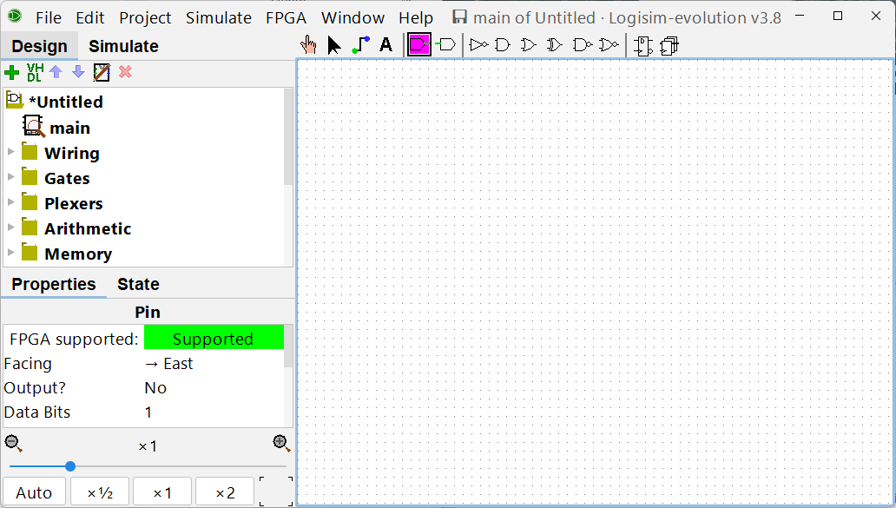

Step 1: Select the “Add Pin” tool  
There is a left-facing and right-facing in the tool-bar

Step 2: Place the pin  
Add a label “A”

Step 3: Repeat and add another input pin “B”  
  
Note that there are many shortcuts to help with editing For example:  
CTRL-C / CTRL-V / CTRL-D /CTRL-Z for copy/paste/duplicate/undo, respectively.

Step 4: Add a 2-input AND gate.  
Use the gate icon on the top bar or find it in the dropdown list of Gates

Step 5: Drag the cursor to place wires between the connecting points on the gate and ports.

Step 6: Add an output pin, label it “Out1”, and connect it to the output of the AND gate

# Simulation of Circuit

With the circuit connected and built, it can be simulated. For now, we will simulate the operation by manually changing the value of the inputs and seeing the output response. Later in the semester, we’ll simulate large circuits with automated stimulus files that both set the inputs, and check the outputs.

Step 7: Put the program in “Simulation” mode, and select the “Poke Finger” icon.  
  
Clicking on the input pin ‘A’ will toggle the logic value between ‘0’ and ‘1’.

Step 8: Modify the input logic values of ‘A’ and ‘B’ with the four combinations and verify that the simulator show the AND output on ‘Out1’

# Finishing

Finally, you can save your design using the Files / Save menu pick.

Before exiting the program, go back to “Design” mode and look around at the various sub-menus with different types of components that can be used to make designs. We’ll learn about and use many of these during the course of the class.

