# Steps:

## **Create (if you haven’t already) a github user.**

Recommended: use your byui.edu email address

## **Accept the tutorial about github as posted in our** [Classroom HERE](https://classroom.github.com/a/0vKikGQI)

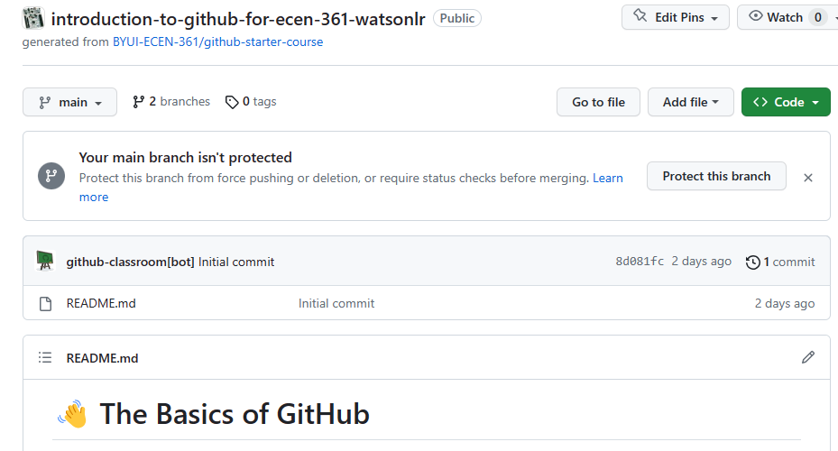Practice cloning the tutorial repo by opening its page in a browser and selecting the green code button. Decide the method to clone – use what you’re familiar with. If this is the first time, recommended: get the [GitHub-Desktop tool](https://desktop.github.com/).

## **Make some modification to the repo and PUSH**

Edit the README.md file somehow, add your name, etc., and then commit and push changes back to GitHub.

## **Verify your changes were pushed back to github.com**

Using a browser, check the contents of the README.md on the website. Note that this is easy to do from Github-Desktop – Just use the button to automatically go to the repository on the web:

# Comments

If you haven’t already, using a revision control system like *GitHub*, will be key to your career. Most all disciplines that have changing, digital content, use these types of systems to track changes, share projects with co-workers, and make complicated workflows from the actions with the repository. Recommended: At the end of this (and others) class, keep your repository for future reference about how you did the labs, as a reference and maybe even part of your digital portfolio.

The *Github-Classroom* variation of *GitHub* creates individual, private repositories for each of the assignments, for each student. The professor will create a base assignment, that the student is to start from, modify, run on his own STM-Nucleo board, and submit.

With *Github-Classroom*, students accept the lab assignment, modify it, run it on their host (PC/MAC), then re-commit it to the repository. The professor and/or T/A’s have read permission to these repositories and can clone, read, and grade them. Work in repositories in a *GitHub-Classroom* cannot be directly shared.

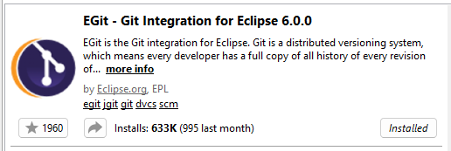Note – Most IDEs like Visual-Studio-Code, Eclipse, and even our STM32CubeIDE allow for direct cloning of a project from GitHub. This allows editing in the IDE, then directly committing and pushing back to the repository. To do this, with STM32CubeIDE, and add-in has to be installed. The solution recommended to install can be done with “Help/Eclipse Marketplace”:

This approach is not required, and all of your commits can be done with an external tool like GitHub-Desktop or even with the command-line, but it may be useful.