(NYSE: FICO)
Fintech/Data Analytics
United States

Key Stats
Market Cap | 24.194B
P/E | 38.6x
Revenue | 1,990.87
Operating Margin | 46.45%
Net Margin | 32.75%
ROA | 36.95%
Beta | 1.15
Recommendation | Hold

Executive Summary
Fair Isaac Corporation (FICO) is the dominant provider of credit scoring and analytics software for the U.S. financial system. With its FICO Score embedded in over 90% of U.S. consumer lending decisions, FICO has operated as a de facto monopoly in consumer credit scoring for decades, supported by deep regulatory entrenchment, high switching costs, and a network effect that makes its scores the standard language of credit risk.
FICO's business model is split into two primary segments: Scores and Software. The Scores segment, which is the higher-margin, usage-based segment, generates revenue each time a lender pulls a credit score. The Software segment provides analytics platforms such as FICO Platform, fraud detection, and decision management tools to banks, insurers, and fintechs globally.
In our initial Round 1 pitch (February 2026), we rated FICO as a BUY based on its defensible moat, consistent earnings growth, and pricing power. However, a significant competitive development in March 2026 has materially altered the risk-reward profile. On March 9, 2026, the credit bureaus cut VantageScore pricing from approximately $4 to $0.99 (a 75% reduction) signaling the potential start of a price war in credit scoring. This event, combined with the FHFA's 2025 authorization of VantageScore 4.0 for GSE mortgage underwriting, meaningfully weakens our confidence in the long-term durability of FICO's pricing moat.
As a result, we are downgrading FICO from BUY to HOLD. While FICO remains a high-quality business with strong fundamentals, the current valuation of ~40x trailing P/E prices in sustained premium pricing that now faces credible competitive pressure. Our blended valuation (DCF 10% / EV/EBITDA 40% / P/E 50%) yields a 1-year target price of $816.16 and a 5-year target of $1,279.16, implying approximately 2% CAGR, insufficient to justify a buy at current levels given the elevated uncertainty.

Company Overview
Fair Isaac Corporation, founded in 1956 and headquartered in Bozeman, Montana, is the pioneer of credit risk analytics. FICO went public in 1987 and has since evolved from a pure-play credit bureau into a diversified analytics technology platform. The company employs approximately 4,800 people worldwide and operates across the Americas, EMEA, and Asia-Pacific regions.
FICO's core competitive advantage is its namesake FICO Score, which has become the universal standard for credit risk assessment in the United States. Lenders, regulators, and consumers have built their entire credit infrastructure around the FICO Score, creating an embedded position that has proven extraordinarily resilient for over 30 years. The company generates revenue through a combination of usage-based scoring fees and recurring software subscriptions. Approximately 60% of revenue comes from the scores segment, but it accounts for approximately 80% of operating income. (the rest is attributed to the software segment)
Recent strategy has been to capitalize on the near monopoly, high margin score business. FICO has worked to innovate new models such as FICO 10T that provide more accurate and advanced scoring. In addition, management has made price hikes a priority to expand revenue and margins. In response to the FHFA allowing VantageScore 4.0 to be used for mortgages sold to Fannie Mae and Freddie Mac, FICO launched their direct licensing program to bypass the original distribution channel through the credit bureaus. Under this new model, FICO scores are offered at $4.95 a score rather than the $10 per score fee through the credit bureaus.

Industry Overview
FICO operates at the intersection of financial services data infrastructure and software analytics. The credit scoring industry is a critical upstream component of the approximately $17 trillion U.S. consumer lending market. Every mortgage, auto loan, credit card approval, and personal loan involves a credit score, making the scoring market structurally non-discretionary and resilient through economic cycles.
The competitive structure of this market is analogous to Visa vs. Discover in payment networks; FICO is universally accepted and trusted at the point of regulated approval, while VantageScore serves as a cheaper alternative used primarily in non-binding, pre-qualification contexts. Despite VantageScore's existence since 2006, it has failed to displace FICO in the markets that matter most: final underwriting decisions for mortgages, prime credit cards, and auto loans.
See the “How FICO Works” diagram in the appendix for description of how FICO interacts with banks, credit bureaus, and consumers.

Porter’s Five Forces Analysis
THREAT OF NEW ENTRANTS – LOW
Regulatory entrenchment, 30+ years of model training data, lender system integration costs
POWER OF BUYERS – LOW-MEDIUM
Fragmented lender base; however, VantageScore now a credible alternative at lower price
POWER OF SUPPLIERS – LOW
Inputs are credit bureau data; FICO has direct data relationships and model independence
THREAT OF SUBSTITUTES – MEDIUM HIGH
VantageScore pricing cut to $0.99 and FHFA approval for GSE mortgages elevates this risk
COMPETITIVE RIVALRY – LOW-MEDIUM
Near-monopoly in scoring; software faces Experian, Equifax, TransUnion, and SAS in analytics
Thesis 1: Defensible Moat: Entrenched Monopoly in Consumer Credit Scoring

FICO's original moat thesis rested on three pillars: (1) regulatory entrenchment, with FICO Scores embedded in Fannie Mae / Freddie Mac underwriting guidelines; (2) lender inertia, as banks and card issuers have deeply integrated FICO into their risk management systems; and (3) consumer brand recognition, with consumers universally aware of their "FICO score."

- 90% share of U.S. consumer lending decisions at pitch date
- GSE mortgage underwriting tied to FICO through decades of regulatory precedent
- High switching costs due to lender system integration and model re-validation requirements
- No viable competitor with comparable penetration in regulated lending
STATUS: PARTIALLY IMPAIRED. The July 2025 FHFA approval of VantageScore 4.0 for GSE mortgage underwriting, followed by the March 2026 VantageScore price cut to $0.99, signals that the moat is narrowing. FICO's pricing power in the scores segment, which commands $9.00 per pull on average versus VantageScore's new $0.99 price, is now exposed to competitive pricing pressure for the first time in a meaningful way.
Thesis 2: Strong Innovation: Direct to Lender & New Algorithms
FICO has invested heavily in product innovation to maintain relevance and expand its addressable market. Key initiatives include:
- FICO Mortgage Direct License Program (October 2025): Allows FICO to sell directly to lenders for GSE-compliant mortgages, bypassing the credit bureau distribution intermediary
- UltraFICO Score: Incorporates bank account data (checking, savings) to expand credit access for thin-file consumers
- FICO Score 10T: Uses trended credit data over 24 months for more predictive assessments of credit trajectory
- BNPL Scoring Algorithms: New models incorporating Buy Now Pay Later payment history, addressing a growing $150B+ credit product category
STATUS: INTACT. FICO's innovation pipeline is a genuine positive. The Mortgage Direct License Program is particularly significant, by bypassing the credit bureau distribution layer, FICO captures economics directly and reduces dependence on bureau pricing negotiations. This was a strategic response to the VantageScore threat and demonstrates management's proactive posture.
Thesis 3: Growing Market: Expanding Credit Market with Limited Competitive Threat
The original thesis assumed that FICO's near-monopoly position would persist through credit market expansion, enabling per-unit revenue growth to compound alongside volume growth. With over $17 trillion in outstanding U.S. household debt, the absolute number of credit decisions made annually is massive and growing.
STATUS: PARTIALLY IMPAIRED. The market growth thesis remains valid. However, the assumption of "limited competitive threat" has been undermined. The competitive threat is no longer theoretical, VantageScore has regulatory approval for GSE mortgages and is now priced at an 89% discount to FICO. While we still believe FICO will retain share in the near term due to lender inertia and re-validation costs, the long-term trajectory of FICO's pricing premium is now uncertain.

Competitive Positioning: 4Ms Analysis
MARKET:
FICO operates in a structurally critical, non-discretionary market. Credit scoring is mission-critical infrastructure, it cannot be eliminated, only disrupted by substitution. The U.S. credit market will continue to grow regardless of the competitive dynamics within scoring, providing a secular tailwind for FICO's volume. However, the market for FICO specifically faces dual risk: volume-based risk from a potential economic slowdown that reduces credit origination activity, and price-based risk from VantageScore's aggressive pricing strategy.
MOAT:
FICO's moat has historically been among the widest in fintech infrastructure. Regulatory entrenchment, 30+ years of lender system integration, and consumer brand recognition have collectively made FICO the default choice. However, the events of 2025-2026 have revealed that the moat is more porous than originally estimated. The FHFA's authorization of VantageScore for GSE mortgages removed a critical regulatory protection. The 75% price cut by VantageScore provides the financial incentive for lenders to re-evaluate. We believe the moat remains wide in the near-to-medium term due to lender inertia, but is narrowing.
MARGIN OF SAFETY:
The March 2026 selloff of approximately 20% has partially reset the valuation. However, at ~40x trailing P/E and ~$1,160 per share, FICO still trades at a significant premium to both its historical average and peers. The Margin of Safety for a HOLD thesis requires confidence that the current earnings base is sustainable, which we have moderate but not high confidence in. We estimate a more compelling entry point in the $700-$850 range, which would represent a more appropriate risk-adjusted setup.
MANAGEMENT:
FICO's management team has demonstrated strategic agility in response to the competitive threat. The Mortgage Direct License Program (announced in October 2025) was a proactive, well-structured response to the VantageScore GSE approval. CEO Will Lansing has consistently emphasized pricing discipline and the superiority of FICO's predictive models over VantageScore alternatives. Management's shareholder return track record is strong, with aggressive share buybacks reducing the float meaningfully over the past five years. We have high regard for management's quality; our concern is with the competitive environment, not the team.

Management Profile
Will Lansing: Chief Executive Officer. CEO since 2012; extensive SaaS and enterprise software background; credited with FICO's transformation from a pure-play bureau to a platform company; shareholder-aligned with meaningful stock compensation
Steve Weber: Chief Financial Officer. Strong financial discipline; focus on margin expansion and capital return; executed aggressive buyback program reducing diluted shares significantly
Stephanie Lerdall: Chief Human Resources Officer. Focused on talent retention in competitive analytics/AI labor market
Mark Scadina: EVP & General Counsel. Manages regulatory and compliance strategy; critical given FICO's exposure to FHFA and CFPB oversight

Financial Overview
Revenue Breakdown:
- Revenue growth: 15.9% in 2025
- International revenue: ~13.0% of total
Expenses Breakdown:
- EBITDA Margin: 48.8% in FY2025
- SG&A: ~26.0% of revenue; R&D: ~9.0% of revenue
Other Key Ratios for Industry:
- FCF: 1,009.6 for 2026, up from 750.6 PY (In Millions)
- Diluted EPS: 24.0% growth in 2025, increasing YOY
- ROA: 36.9% in 2025
The financial profile reflects strong future margins relative to peers (although no competitor is perfectly similar).

Valuation Summary
Our new valuation assumptions imply that FICO will be unable to continue to raise prices as previously assumed. (reasoning discussed in greater detail in the Risks section).
Using a blended valuation approach referenced in the pitch materials, including:
- DCF modeling
  - 10-16% revenue growth
  - 2.5% perpetual growth rate
  - Margins in line with analyst consensus estimates
  - WACC of 11.89% (Bloomberg)
- Peer multiples
  - P/E: 28x
  - EV/EBITDA: 18x
To arrive at the chosen multiples, we looked at peer comps, FICO’s historical average, and qualitative data. With comps trading lower and recent news eroding FICO’s long-term moat, we felt comfortable with the above valuation multiples.
Valuation determines a 5yr price target of ~$1,279.16, implying ~2% annualized returns through FY2030. Currently, we recommend a hold for FICO.

Risks
Key risks identified include:
- Regulatory Risk: In the past, FICO has developed a strong moat being the standard score, especially in mortgages. US regulators like the FHFA have been pushing for more competition and lower pricing. Recently, Vantage Score 4.0 was approved for mortgages sold to Fannie Mae and Freddie Mac last year. This ended FICO’s regulatory enforced monopoly in credits scoring for mortgages. Recently, Sen. Josh Hawley (R-MO) announced an investigation into FICO on price hikes in mortgage credit scores.
- Competition: The main competitor to FICO is VantageScore, a joint venture launched by the three credit bureaus in 2006. The threat has been low until recently. Recent regulatory developments as discussed above as well as price cuts by VantageScore have made VantageScore more competitive. This year, the credit bureaus announced that they will offer VantageScore for $0.99 per score compared to $4.95 for FICO (direct licensing option). This along with the credit bureaus offering VantageScore for free with each FICO score show VantageScore’s push to gain market share. There are additional risks of fintech firms and others using their own models. FICO is unlikely to disappear, but competition limits its pricing power.
- Valuation Risk: As with most information technology companies, FICO trades at a high P/E multiple. (38.6x). This limits the margin of safety and enlarges the downside risk in an environment with higher interest rates.
- Macro and Credit Cycle Exposure: FICO is exposed to lending activity making it susceptible to consumer credit cycles and recessions. If consumer lending activity and home-buying were to decrease significantly, score volume would decrease resulting in adverse effects to FICO’s business.
- Technology Risk: Technology advancements are a long-term risk for FICO’s software and scores segments. Changing technology and use of AI could change the industry and underwriting models. Recent AI advancements have resulted in concerns over the long-term viability of software companies. In addition, if FICO is unable to continue with AI advancements, other newer models could become more prevalent. FICO’s long history of a reliable model has given them a strong moat currently, but risks are real.
With the recent increase in these risks, FICO’s share price has faced significant declines and volatility.

Conclusion & Recommendation
While FICO remains a high-quality business with exceptional margins, a near-monopoly share in its core market, and a growing software segment, the competitive developments of 2025-2026 have meaningfully changed the risk-reward calculus. Our view has shifted from a high-conviction BUY to a cautious HOLD for the following reasons:
- Pricing moat is under attack for the first time in a meaningful, regulatory-supported way
- At ~40x trailing P/E, valuation leaves no room for margin compression or market share loss
- The 5-year target of $1,279.16 implies only ~2% CAGR from current levels, insufficient given the elevated uncertainty
- FICO's innovation initiatives (Direct License, 10T, UltraFICO) partially offset the threat but take time to scale
- We would become more interested if FICO dropped below $700-$850, which would provide a margin of safety
Final Recommendation: HOLD
5-Year Target Price: $1,279.16
Expected CAGR through FY2030: ~2%
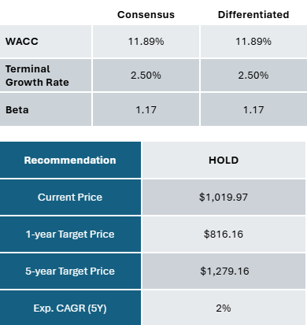
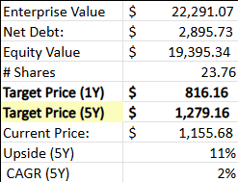

Appendix
Key 10-K Financial Statements:
Consolidated Balance Sheets
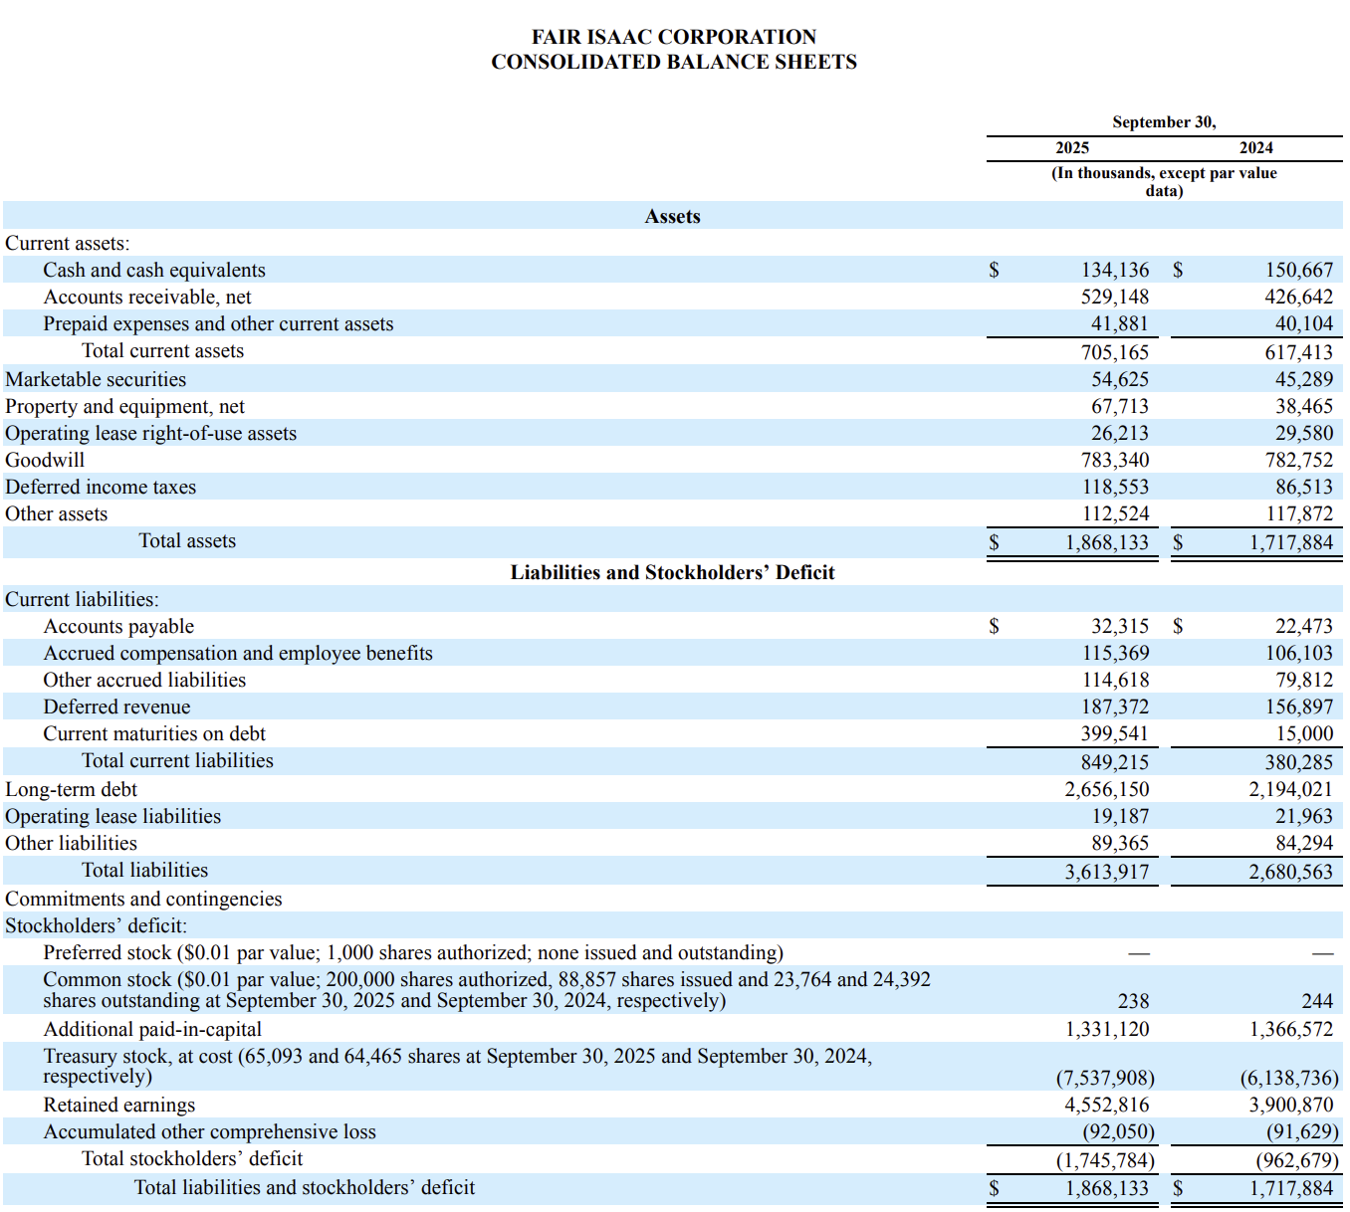
Consolidated Statements of Income and Comprehensive Income 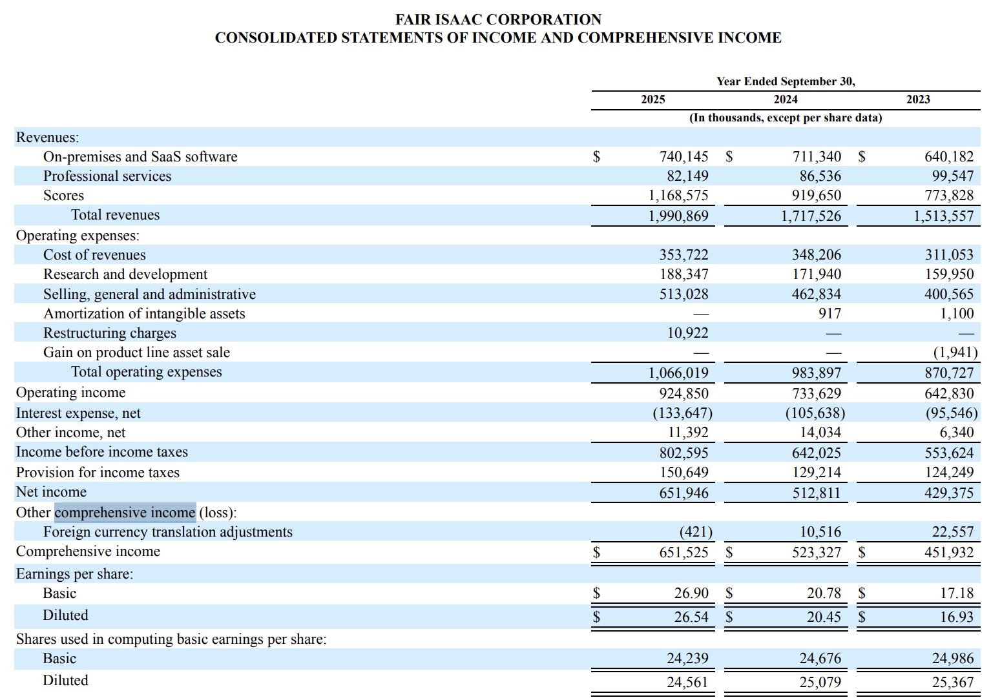
Consolidated Statements of Cash Flows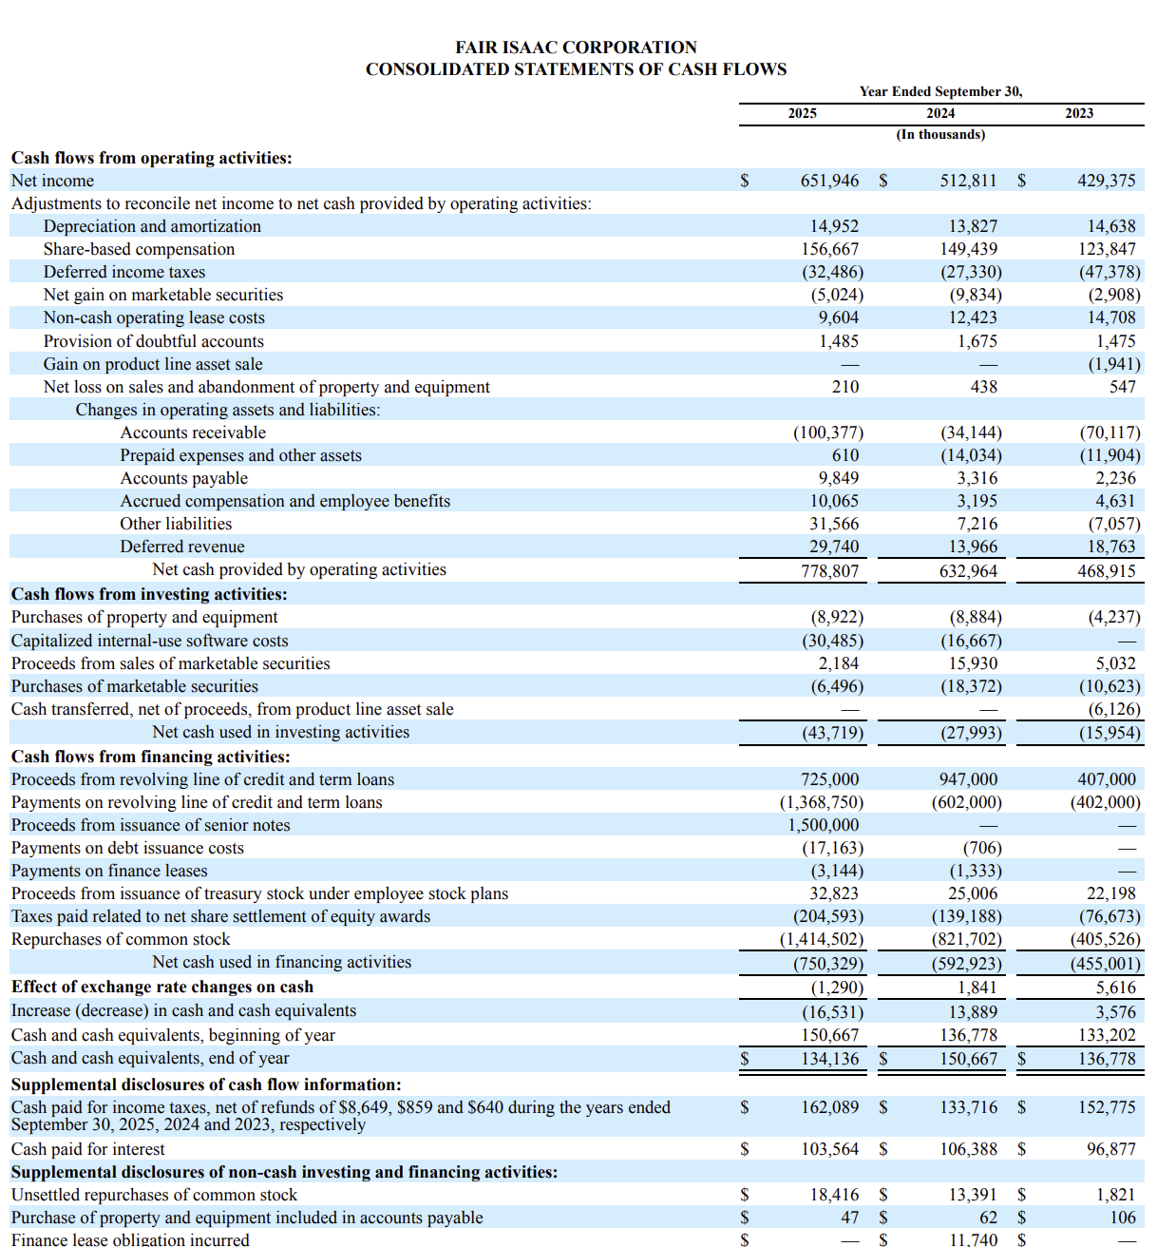

Additional Financial Analysis:
CapIQ Stock Price Graph
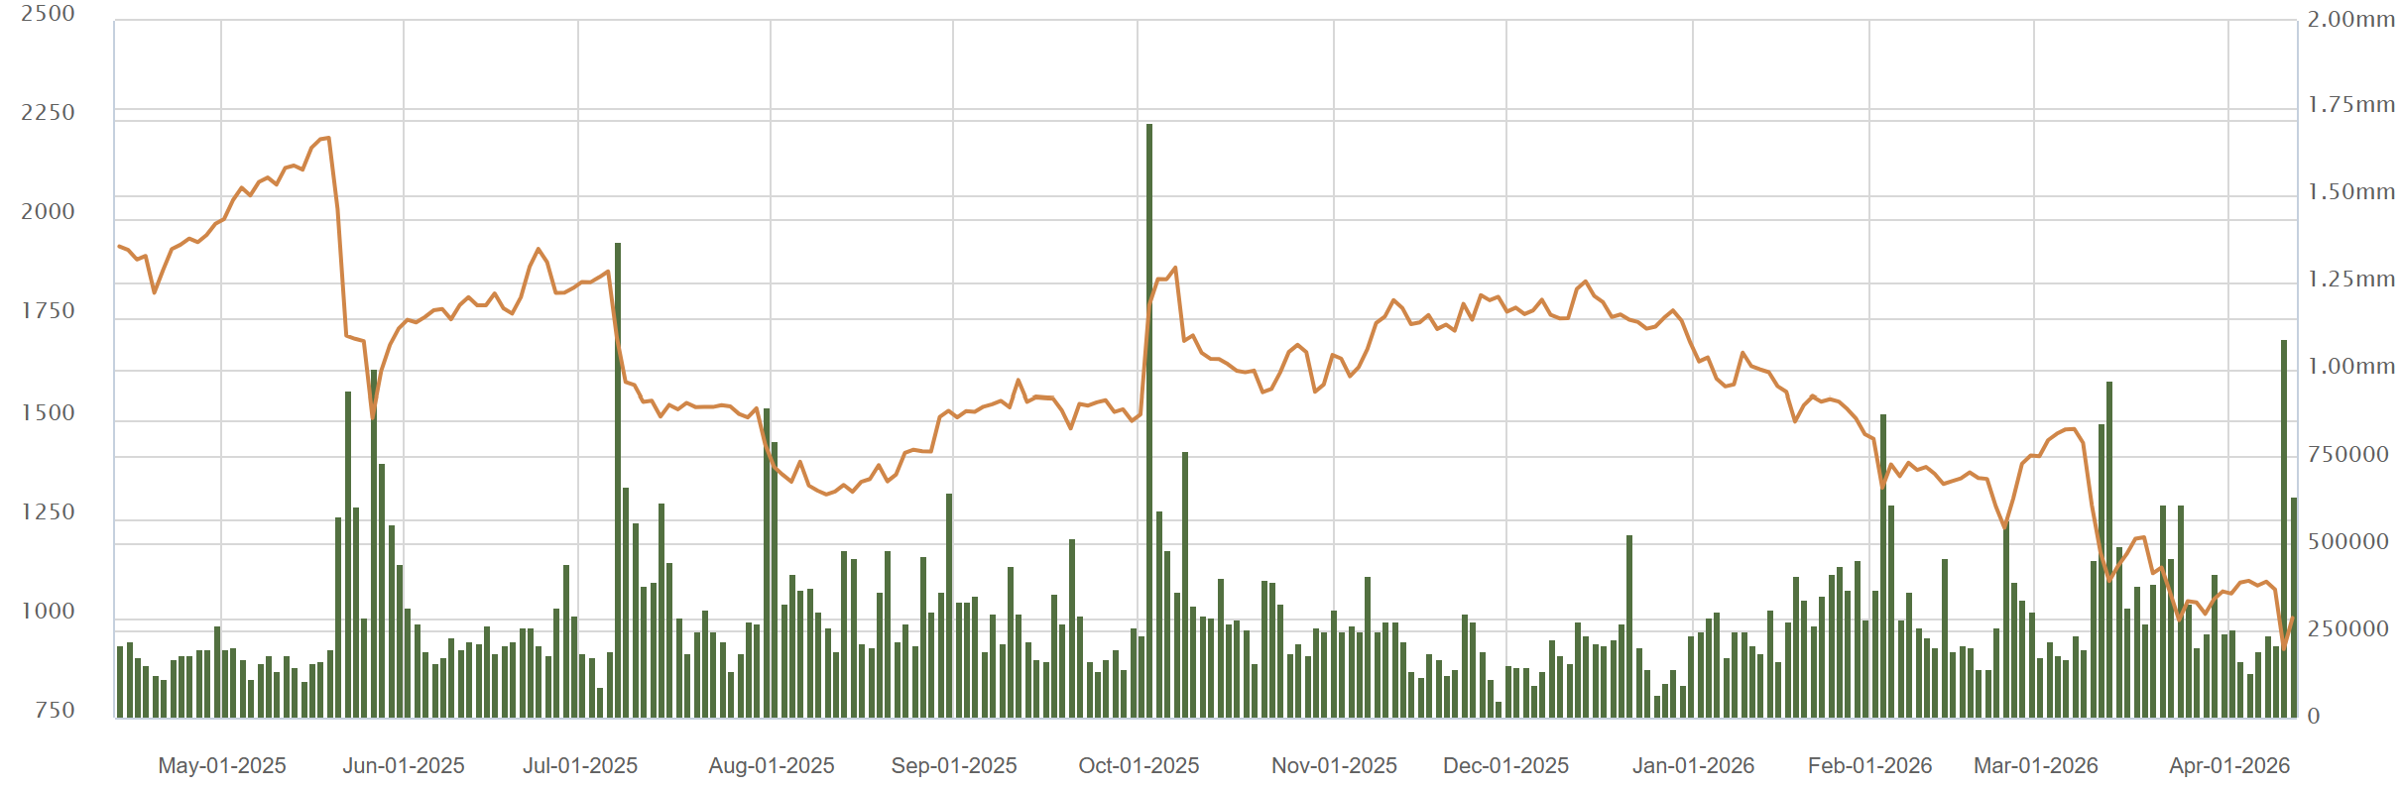
Competitor Metrics Table
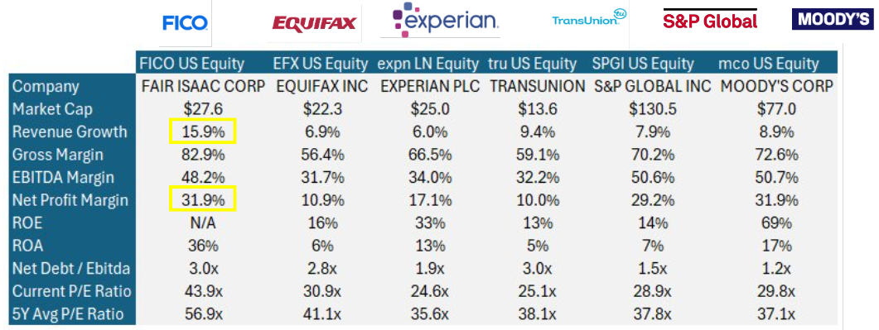

P/E Bands
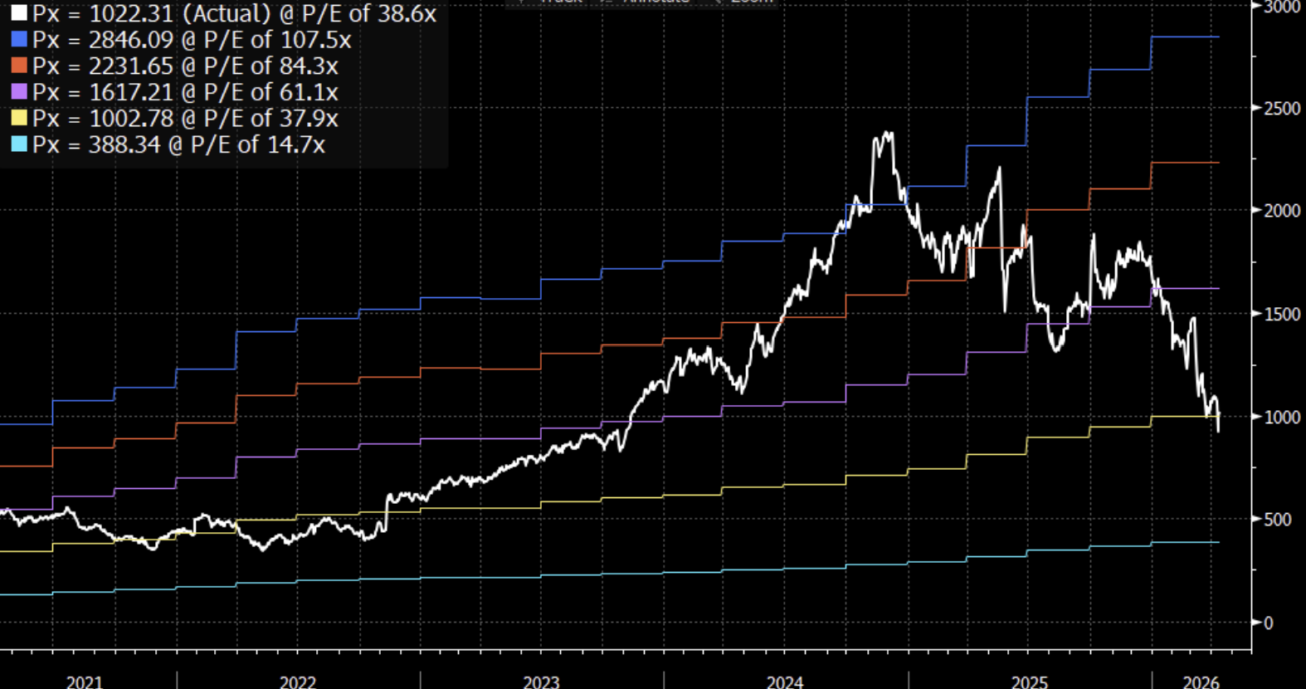
Earnings Estimate Graphs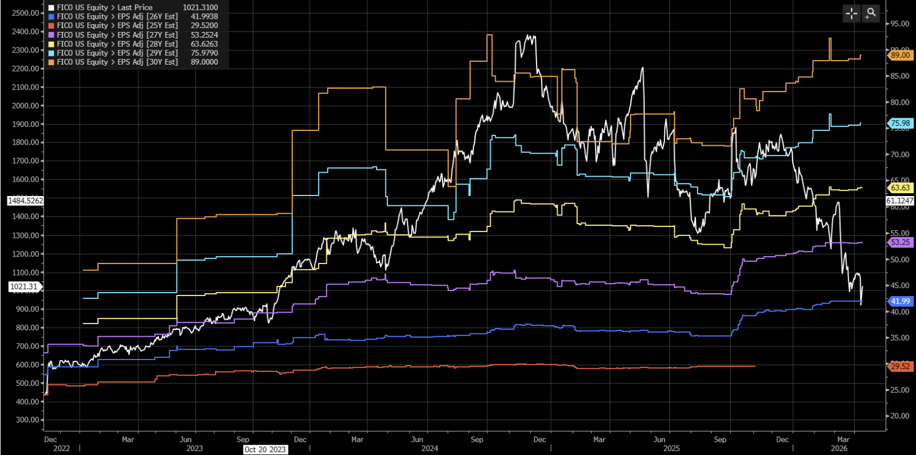

Analyst Recommendations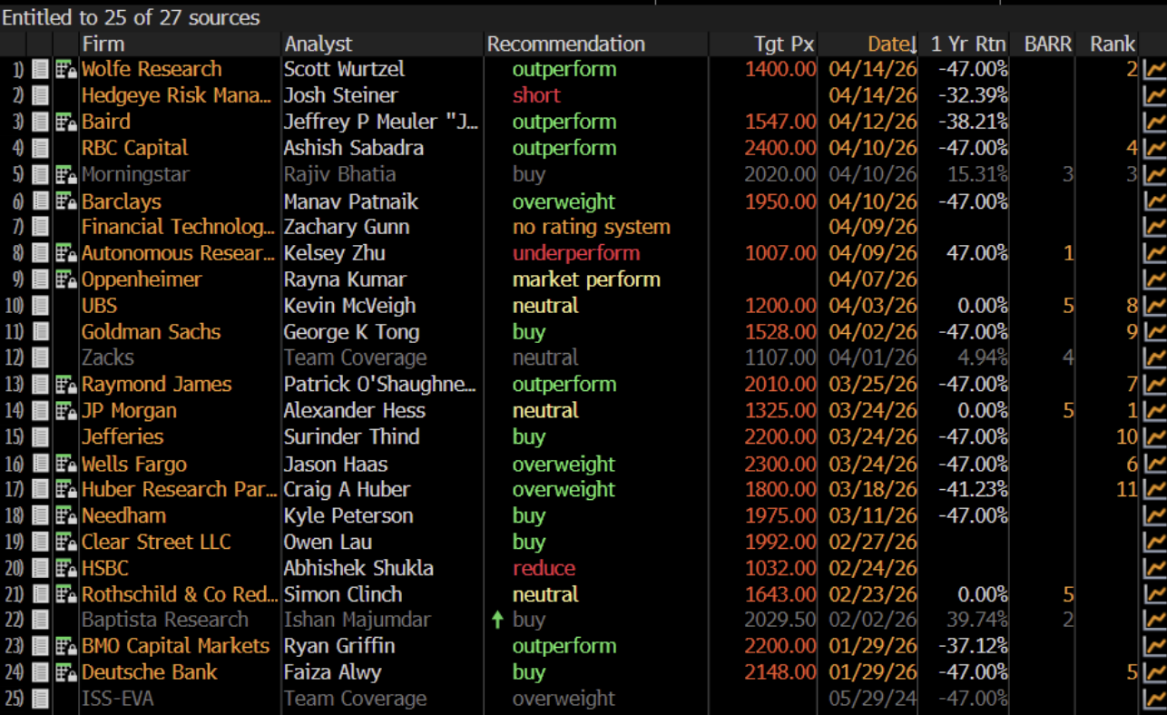

Revenue Analysis:
Revenue by Market

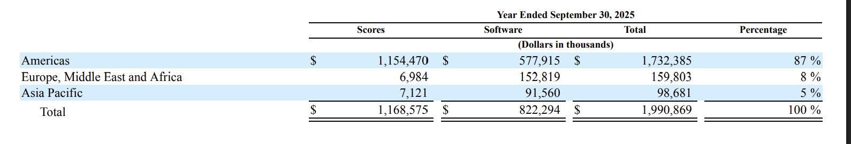

Revenue by Product
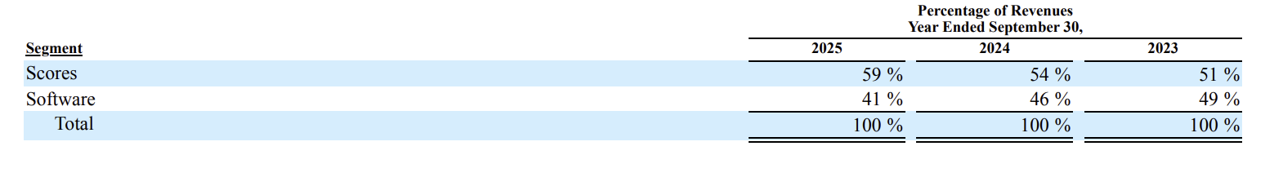
Revenue Growth by Segment
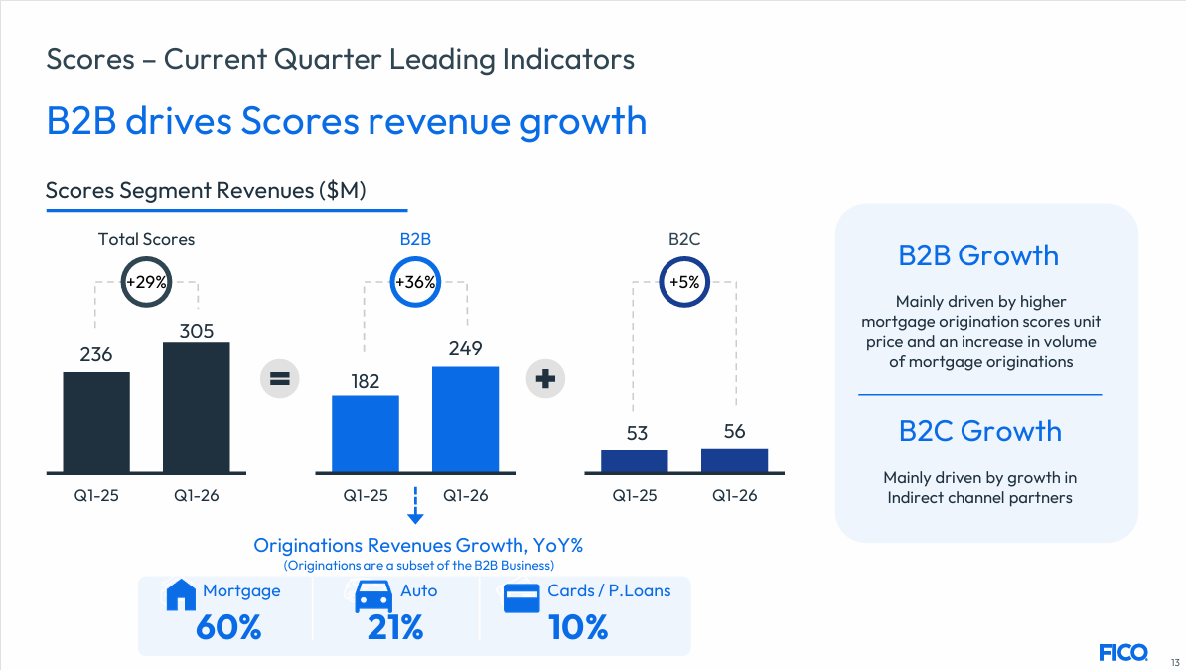
“How FICO Works” Diagram
