Microsoft Corporation (MSFT)
Cloud Computing & Enterprise Software
U.S.
4/17/2026
Report prepared by:
Grant Hill, Caleb Estes, Katherine Nuttall
Recommendation: BUY
Current Price (4/17/26): $388.45
Shares Outstanding: 7.43B
Market Capitalization: $2.77T
P/E (TTM): 23.27
Forward P/E: 28.50
Net Debt to EBITDA: 0.13
1-Year Target Price: $385.43
5-Year Target Price: $597.40
Upside (5Y): 59% / 10% CAGR

Stock Price Graph (Previous 3 Years)
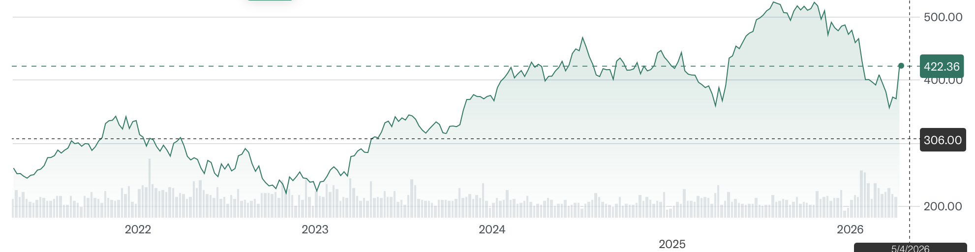

Business Description
Microsoft Corporation (MSFT) is one of the world’s largest technology companies, providing cloud computing, enterprise software, productivity tools, gaming, and professional networking services. Microsoft operates across three primary business segments: Productivity and Business Processes, Intelligent Cloud, and More Personal Computing. Its flagship offerings include the Azure cloud platform, Microsoft 365, LinkedIn, GitHub, Dynamics 365, Xbox, and the Windows operating system. Microsoft serves individuals, small and medium-sized businesses, large enterprises, governments, and educational institutions globally, with a growing emphasis on artificial intelligence integration across its entire product portfolio through its exclusive partnership with OpenAI.

Key Sales Categories
Microsoft operates across three reportable business segments, each generating significant revenue through software subscriptions, cloud services, hardware sales, advertising, and professional services:
- Productivity and Business Processes: Includes Microsoft 365 (commercial and consumer), LinkedIn, and Dynamics 365. This segment contributes approximately 32% of total revenue.
- Intelligent Cloud: Includes Azure, SQL Server, GitHub, and enterprise cloud services — Microsoft’s fastest-growing segment, contributing approximately 43% of total revenue, with Azure growing 39% year-over-year as of Q2 FY2026.
- More Personal Computing: Includes Windows OEM, Xbox, Activision Blizzard gaming, Bing/Edge/Ads, and Surface devices. This segment contributes approximately 25% of total revenue.
Gross margins remain strong across all three segments, with the Intelligent Cloud segment exhibiting particularly high margins due to the scalable nature of cloud infrastructure and software licensing. The percentage revenue contribution from the three segments are as follows:

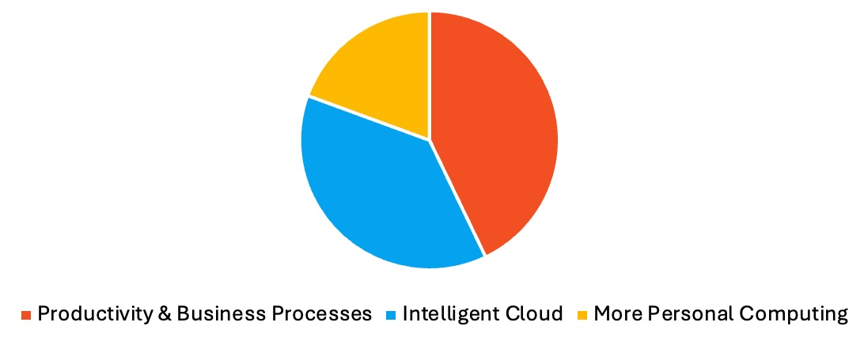

Competitive Market
Microsoft competes across several distinct but overlapping markets. In cloud computing and enterprise software, Azure competes directly with Amazon Web Services (AWS) and Google Cloud Platform (GCP), with Microsoft occupying the second-largest position in global cloud infrastructure. In productivity and collaboration, Microsoft 365 and Teams face competition from Google Workspace and Slack. LinkedIn competes with Meta, Indeed, and ZipRecruiter in professional networking. In gaming, Xbox and Activision Blizzard compete with Sony PlayStation and Nintendo. In operating systems, Windows competes with macOS and ChromeOS. Despite this breadth of competition, Microsoft’s deeply integrated ecosystem and enterprise relationships provide a durable competitive advantage.

Microsoft’s Strategy
Microsoft’s strategy centers on the deep integration of artificial intelligence across its entire product portfolio, leveraging its exclusive partnership with OpenAI and its custom Maia 200 AI chips to differentiate its cloud offerings. The company focuses on accelerating Azure growth through AI-powered services, expanding its commercial remaining performance obligation (CRPO) backlog — which reached $625 billion, a 110% year-over-year increase — and deepening enterprise relationships through bundled solutions that combine productivity, cloud, and AI tools. Microsoft also pursues growth through strategic acquisitions, most notably Activision Blizzard, and by expanding its developer ecosystem through GitHub and Azure-OpenAI services.

Industry Analysis (Porter’s Five Forces)
Threat of New Entrants (Low): Cloud computing and enterprise software require massive capital investment in data centers, R&D, and engineering talent. Microsoft benefits from decades of enterprise relationships, regulatory approvals, and deep ecosystem integration. Competing with Azure or Microsoft 365 at scale is virtually impossible for new entrants without billions in upfront capital and years of customer trust-building.

Bargaining Power of Suppliers (Low to Moderate): Microsoft’s primary inputs include semiconductor chips (especially GPUs from Nvidia), data center infrastructure, and bandwidth. The launch of its proprietary Maia 200 AI chip reduces dependency on Nvidia. Microsoft also holds significant negotiating leverage with suppliers given its massive purchasing scale. The key risk remains semiconductor supply chain constraints and geopolitical factors.

Bargaining Power of Buyers (Moderate): Enterprise customers can negotiate pricing for large-scale Azure contracts or Microsoft 365 licensing agreements. However, Microsoft’s switching costs are exceptionally high — organizations deeply embedded in Azure, Active Directory, Office, and Teams face significant operational disruption if they attempt to migrate. Network effects (particularly with LinkedIn and Teams) further retain users effectively.

Threat of Substitutes (Low to Moderate): Primary substitutes include Google Workspace (vs. Microsoft 365), AWS and GCP (vs. Azure), and open-source solutions. However, the comprehensiveness of Microsoft’s ecosystem, combined with AI-native product integration, makes full substitution difficult. AI agents and Copilot features embedded across Microsoft’s suite reinforce customer retention by delivering increasing value over time.

Industry Rivalry (High): Microsoft faces intense competition from Amazon (AWS), Google (Cloud and Workspace), Apple (consumer ecosystems), Meta (social and advertising), and Oracle (enterprise databases). These competitors invest heavily in innovation and aggressively compete on pricing, performance, and feature sets. However, Microsoft’s breadth of products, AI differentiation, and enterprise trust provide a durable competitive position.

Theses
Strong and Diversified Business Model: Microsoft’s revenue streams are among the most diversified in the technology sector. Unlike pure-play cloud companies or hardware-dependent businesses, Microsoft generates substantial revenue from enterprise subscriptions, gaming, advertising, and professional networking. This diversification provides resilience against sector-specific downturns and ensures consistent free cash flow generation across economic cycles. Azure’s 39% growth rate as of Q2 FY2026 signals that Microsoft’s cloud transition is still in an expansionary phase, while its $625 billion CRPO backlog provides extraordinary revenue visibility. Additionally, the Maia 200 AI chip demonstrates Microsoft’s commitment to reducing infrastructure costs and accelerating AI deployments, which further supports long-term margin expansion.

Market Overreaction to CapEx Spend Creates High-Value Entry Point (~20x P/E): Microsoft’s stock has underperformed following investor concern over its elevated capital expenditure commitments, which reached $37.5 billion in a single earnings period. The market appears to be pricing in uncertainty around CapEx return on investment, pushing the P/E ratio to approximately 23x TTM, well below its five-year average of 32x. However, we believe this reaction is misguided. The CapEx surge is directly tied to Azure infrastructure buildout and AI compute capacity, both of which support the company’s rapidly growing CRPO backlog. History shows that Microsoft’s CapEx cycles consistently lead to accelerated revenue growth 12-18 months later. At current valuations, investors are essentially receiving Microsoft’s AI infrastructure buildout at a discount, making this a compelling entry point for long-term investors.

Strong Competitive Moat Fueled by AI Agents and Integrated Product Line: Microsoft’s competitive moat has never been stronger, driven by the integration of AI agents (Copilot) across its entire product ecosystem. Microsoft 365 Copilot, GitHub Copilot, and Azure AI services create powerful network effects — as more users adopt these tools, productivity gains increase, and the cost of switching to a competitor rises dramatically. Microsoft’s proprietary data from LinkedIn, Office 365, and enterprise Azure workloads provides unique training signals for its AI models, creating a self-reinforcing competitive advantage. The moat scorecard from our analysis shows strong network effects (5/5), high switching costs (4/5), ecosystem depth (4/5), and AI-native integration (4/5): all pointing to a durable, widening competitive position relative to peers.

Valuation
We employed a blended valuation methodology combining a discounted cash flow (DCF) analysis and comparable company analysis to determine a fair value for Microsoft Corporation. Our approach integrates differentiated assumptions around revenue growth, margin trajectory, capital efficiency, and AI-driven upside. We believe our assumptions are well-supported by Microsoft’s CRPO backlog, Azure’s growth trajectory, and its expanding AI monetization.

Discounted Cash Flow Analysis
Our DCF analysis incorporates a revenue growth trajectory beginning at 16.3% in FY2026, modestly declining to approximately 16% by FY2030, driven by sustained Azure expansion, Copilot monetization, and CRPO backlog conversion. We model EBITDA margins expanding from their current 57.74% level toward 60%+ over the projection period, consistent with the operating leverage inherent in Microsoft’s cloud-heavy business model. We applied a WACC of approximately 9.5%, reflecting Microsoft’s AAA-equivalent balance sheet strength, near-zero net debt relative to earnings, and predictable free cash flow generation. Microsoft’s commercial CRPO of $625 billion provides exceptional cash flow visibility, which justifies a lower discount rate relative to peers. This analysis yields an intrinsic equity value of approximately $450 per share.

Comparable Company Analysis
We benchmarked Microsoft against its primary large-cap technology peers across key valuation multiples. Microsoft screens favorably on profitability (36.15% net margin vs. peer average ~24%), capital efficiency (EBITDA margin of 57.74%), and leverage (debt-to-equity of just 0.13x). Its current P/E of 23.27x is notably below its five-year average of 32.42x and below peers like Amazon (28.78x), Apple (32.31x), and Google (27.11x), suggesting significant valuation upside as AI investment cycles play out. The peer benchmarking table below summarizes key financial and valuation metrics:

Company | Mkt Cap | Rev Gr. | Gross Mg. | EBITDA Mg. | Net Mg.
Microsoft | $2.77T | 15% | 68.82% | 57.74% | 36.15%
Google | $3.60T | 15% | 59.65% | 37.28% | 32.81%
Amazon | $2.28T | 12% | 50.29% | 20.33% | 10.83%
Apple | $3.80T | 6% | 46.91% | 34.78% | 26.92%
Meta | $1.45T | 22% | 82% | 50.70% | 30.08%
Oracle | $418B | 8% | 70.51% | 41.55% | 21.68%

Company | ROE | ROA | D/E | P/E (Cur) | P/E 5YR Avg
Microsoft | 29.65% | 16.45% | .13x | 23.27x | 32.42x
Google | 31.83% | 22.20% | .11x | 27.11x | 23.10x
Amazon | 18.89% | 9.49% | .16x | 28.78x | 67.33x
Apple | 151.91% | 31.18% | 1.34x | 32.31x | 29.76x
Meta | 27.83% | 16.52% | .27x | 23.96x | 23.58x
Oracle | 59.34% | 7.39% | 4.41x | 25.73x | 31.59x

We apply a blended multiple in line with the upper end of the peer range given Microsoft’s superior growth profile, AI differentiation, and balance sheet quality. This comparable analysis reinforces our view that Microsoft trades at a discount to intrinsic value at current levels.

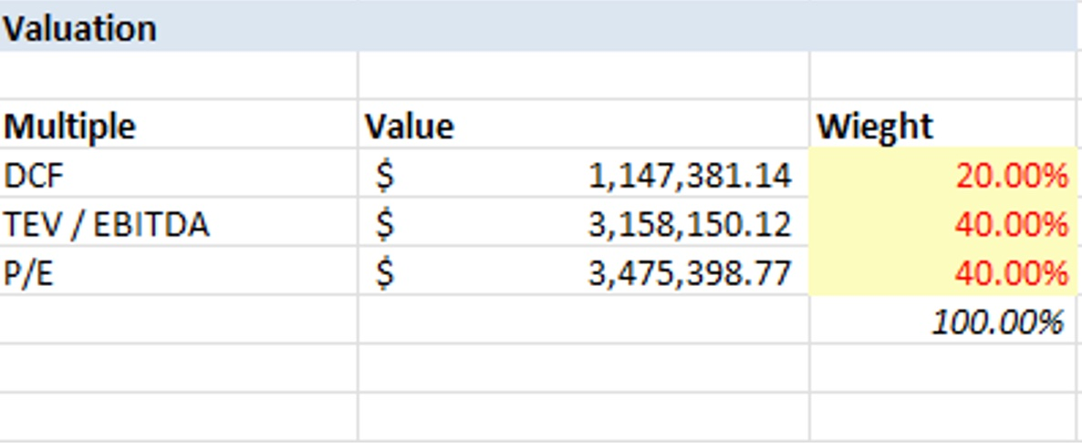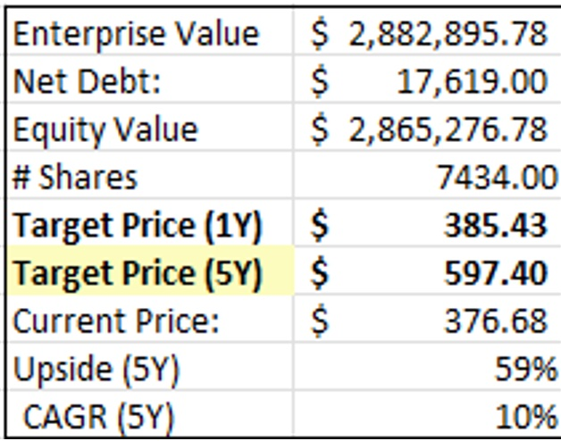

Target Price
Blending our DCF-derived intrinsic value with our market multiples analysis, we arrive at a blended fair value estimate of $385.43 per share for our 1-year target and $597.40 per share for our 5-year target, representing a 59% total upside and a CAGR of approximately 10% over five years from the current price of $376.68. This supports our BUY recommendation and reflects our conviction that Microsoft, while a large-cap holding in most institutional portfolios, remains meaningfully undervalued relative to its AI monetization potential, CRPO-backed revenue visibility, and expanding cloud market share.

Risks & Challenges
We have identified five key risks for Microsoft: (1) CapEx execution risk and ROI uncertainty, (2) macroeconomic and enterprise spending sensitivity, (3) competitive pressure from AWS and Google Cloud, (4) regulatory and antitrust risk, and (5) cybersecurity and data privacy risk.

CapEx Execution Risk and ROI Uncertainty: Microsoft has committed to significant capital expenditure to build out Azure AI infrastructure, including $37.5 billion in a single quarter. While we believe these investments are strategically sound, there is execution risk around the timeline for capacity utilization, ROI realization, and the pace of Copilot monetization. If enterprise customers adopt AI tools more slowly than expected, or if Azure’s capacity buildout outpaces demand, near-term free cash flow conversion could disappoint relative to consensus expectations.

Macroeconomic and Enterprise Spending Sensitivity: Microsoft’s commercial revenue is closely tied to enterprise IT budgets, which are sensitive to macroeconomic conditions. During periods of economic slowdown, companies may delay software upgrades, reduce seat counts for Microsoft 365, or slow Azure cloud migration timelines. While Microsoft 365’s subscription model provides some revenue resilience, enterprise license renewals and Azure consumption are susceptible to budget freezes during downturns.

Competitive Pressure from AWS and Google Cloud: Amazon Web Services remains the dominant cloud provider, and Google Cloud is growing aggressively in AI workloads with its Gemini model family. Microsoft faces the risk that enterprise customers diversify their cloud spend across multiple vendors (multi-cloud strategies), limiting Azure’s ability to capture incremental AI workloads. Additionally, Google Workspace continues to gain traction among SMBs and education institutions, posing a longer-term challenge to Microsoft 365’s market share.

Regulatory and Antitrust Risk: Microsoft’s Activision Blizzard acquisition and its exclusive partnership with OpenAI have attracted regulatory scrutiny in the United States, European Union, and United Kingdom. Regulators are increasingly focused on the concentration of AI capabilities among a small number of large technology companies. Any adverse regulatory ruling — including forced divestiture, limitations on AI partnerships, or new interoperability requirements — could materially impact Microsoft’s competitive strategy and financial results.

Cybersecurity and Data Privacy Risk: As a provider of mission-critical enterprise software and cloud infrastructure, Microsoft is a high-value target for cyberattacks. High-profile security incidents can damage customer trust and lead to increased compliance costs, remediation expenses, and reputational harm. Stricter global data privacy regulations (GDPR, CCPA, and emerging AI governance frameworks) also increase compliance overhead and could constrain certain AI data practices.

Appendix:
Bloomberg Reports
Financial Statements (FY2025)
Revenue Growth vs. Consensus — Differentiated Model (FY2026-FY2030)
AWS vs. Azure Feature Comparison
Microsoft Moat Rating Scorecard

