MTN Group Limited (JSE: MTN SJ)
Telecommunications | Pan-Africa
BYU Silver Fund · April 2026

Company Overview
MTN Group Limited is Africa’s largest mobile network operator and a leading integrated telecommunications provider headquartered in Johannesburg, South Africa, serving over 300 million customers across 16 markets throughout Africa. MTN operates one of the continent's most extensive network infrastructures and has evolved significantly beyond its core voice and data origins.

Under its Ambition 2030 strategic framework, MTN is transforming from a traditional telecom operator into a three-platform digital company centered on Connectivity, Fintech, and Digital Infrastructure. This structural evolution positions MTN to capture outsized value from Africa's rapidly developing digital economy.
MTN's core business lines and platforms include:
- Core Connectivity: Voice, mobile data, Fixed Wireless Access (FWA) broadband, and enterprise services across 16 sovereign markets in sub-Saharan Africa and select Middle Eastern countries.
- MoMo (Mobile Money): Africa's largest mobile financial services platform by subscriber count, offering peer-to-peer payments, micro-lending, microinsurance, savings products, and cross-border remittances.
- Bayobab (Digital Infrastructure): MTN's wholly owned fiber and digital infrastructure subsidiary, operating 127,000+ km of open-access fiber optic network including 24 subsea cable investments and the 2Africa cable.
- Enterprise & Cloud Services: Managed cloud computing, IoT solutions cybersecurity, and unified communications sold to corporations and governments across MTN's footprint.
- Chenosis API Marketplace: A developer-facing platform allowing third-party startups to integrate MTN's payment, identity, and messaging capabilities directly into their applications, monetizing MTN's network infrastructure as a technology stack.

Revenue by Geography
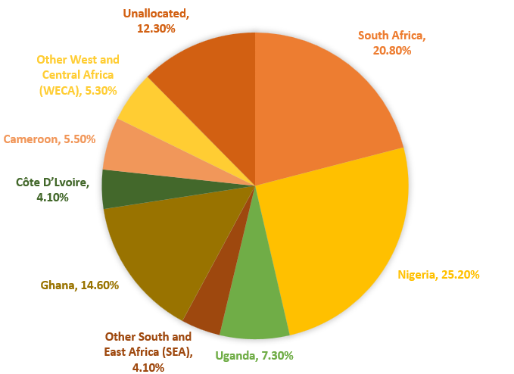
MTN's revenue base is geographically diversified across 16 operating markets within Africa. Nigeria is the single largest market, representing a substantial portion of group service revenue. South Africa is the second-largest contributor. Other key markets include Ghana, Uganda, Cameroon, Côte d'Ivoire, and Zambia. MTN has also simplified its portfolio through the exit of Middle Eastern operations to sharpen focus on the African growth opportunity.

Revenue by Product Segment
MTN's revenue is diversified across its three strategic platform pillars:
- Voice & Data (Connectivity): The core telecom segment, which continues to grow as Africa's mobile internet penetration expands.
- Fintech (MoMo): The fastest-growing and highest-margin segment in transition.
- Digital Infrastructure (Bayobab & Enterprise): MTN's wholly owned fiber and tower infrastructure subsidiary provide backbone connectivity to hyperscalers, enterprises, and governments across Africa.

Investment Thesis
We rate MTN Group a BUY. Our thesis rests on three interlocking pillars that, taken together, make MTN a compelling emerging markets compounder:

Thesis 1: MTN Will Continue to Experience Growth in Its Cellular Data and Fintech Segments
Africa remains the world's most underpenetrated digital market. Mobile internet penetration stands at approximately 28% today versus 60–80% in mature markets, and is projected to reach 37% (518 million users) by 2030. Unlike developed markets where subscriber growth has flattened, MTN holds 136 million existing subscribers who are already on the network but not yet using mobile data, representing a zero-customer-acquisition-cost conversion pipeline of extraordinary scale.

MTN's data revenue is already monetizing this opportunity: data revenue grew +35.4% YTD through Q3 2025, with traffic growth of +26.6% YoY as monetization accelerates faster than subscriber additions. Nigeria alone is projected to be the #1 smartphone market in Sub-Saharan Africa by 2030 with 230 million connections.

Momo is MTN’s most powerful long-term driver. With 57% of Sub-Saharan Africans lacking a bank account, MTN's existing telco relationships and agent network position it as the natural gateway to financial services for hundreds of millions of unbanked consumers. The relevant benchmark is M-Pesa (Safaricom), which followed the same S-curve from basic P2P to advanced financial services and now generates 46.5% ROE. MoMo is at the inflection point of that curve: advanced services grew +39.5% YTD and now represent 33.4% of fintech revenue (up from 25.6% in 2022). The gap between MTN's 14.2% ROE today and Safaricom's mature 46.5% ROE is the opportunity; it is not a question whether it will happen, but when.

We believe that this year will be a powerful year of growth for MoMo if macro-economic conditions remain consistent for Nigeria, Ghana, and South Africa and as MTN continues to gain regulatory traction across Africa. As shown in Exhibits 6 and 7, Data, Digital, and Fintech revenue are expected to grow significantly in Nigeria and Ghana in FY’26 with slight revenue attrition in South Africa when exhibits 4 and 5 are contrasted against one another.

Thesis 2: Vertical Integration Will Improve Gross Margins and Widen Its Moat
MTN's $6.2 billion acquisition of IHS Towers was a strategically important transaction for MTN. Prior to the acquisition, tower lease costs were the single largest line item in MTN's cost structure. Post-acquisition, that cash stays inside MTN. Additionally, competitors now pay MTN to access those 40,000 towers, converting what was an operating expense into a revenue stream. This is a fundamental cost-to-revenue flip that consensus models have not fully priced in.

Bayobab creates a second layer of infrastructure moat. Its 2Africa subsea cable is the world's longest, and its 16,500 km of terrestrial fiber connects 12 landlocked African countries coast to coast. With 41.2% fiber revenue growth in 2025 and positioning as the preferred infrastructure partner for hyperscalers (Microsoft, Google) seeking to deploy AI-enabled data centers in Africa, Bayobab has structural separation potential that could unlock a re-rating to a pure-play infrastructure multiple.

Together, IHS tower ownership and Bayobab fiber create 40,000 towers and 127,000+ km of network infrastructure that simply cannot be replicated by any competitor at any reasonable cost. Airtel Africa, MTN's closest pan-African competitor, deployed materially less capex (R20.8 billion by MTN in H1 2025 alone) and carries 2.16x debt-to-equity versus MTN's 0.86x. The competitive gap is widening.

Thesis 3: MTN Is Well-Positioned to Benefit from African Data Center Growth
Bayobab gives MTN a structural head start in the data center race. Most data center operators must negotiate connectivity to backbone infrastructure; MTN already owns it. This vertical integration means MTN can offer hyperscalers and enterprise clients a bundled colocation-plus-connectivity product that no standalone African data center operator can match.
Demand tailwinds are compounding from multiple directions simultaneously. African governments are enacting data localization laws that force companies to store data within national borders, creating captive demand for in-country facilities. At the same time, global hyperscalers are accelerating African cloud expansion and need local colocation partners with licensed, multi-market presence. MTN, operating across 16 markets, is the only operator positioned to serve that demand at a pan-African scale.
Building data centers in Africa is operationally hard, it requires reliable power, physical security, fiber connectivity, and regulatory relationships in each market. MTN already possesses all of these as byproducts of running a pan-African telecom, making the incremental capex lower than it would be for a greenfield entrant. This creates a durable structural barrier that a standalone data center competitor would struggle to replicate.

Competitive Positioning

Market
MTN operates across 16 markets in a competitive landscape defined by a small number of pan-African operators and several strong regional players. The primary competitors are Airtel Africa, Vodacom Group, Safaricom, Itissalat Al-Maghrib (Maroc Telecom), and Emirates Telecom Group (e&). MTN holds the #1 subscriber position in Nigeria, Ghana, Uganda, and 10 additional markets.
The structural dynamics of African telecoms strongly favor incumbents. Government-issued spectrum licenses and operating rights are finite and non-transferable, creating a legally constrained competitive environment. Capital requirements for tower and fiber infrastructure are prohibitively high for new entrants. MTN's completion of the IHS acquisition and fiber expansion further entrench its infrastructure advantage.

Management
MTN is led by President and CEO Ralph Mupita, who has been guiding the company's strategic transformation toward the Ambition 2030 platform model. Under Mupita's leadership, MTN has accelerated its fintech investments, executed the IHS acquisition, restructured Bayobab as a standalone infrastructure entity, exited the Middle East, and initiated a capital return program including a ~45% dividend increase and ongoing buybacks.

Mupita has publicly committed to shifting MTN's strategic center toward fintech and digital infrastructure, framing the two higher-margin platforms as the primary value-creation levers over the next five years. Management has demonstrated both strategic clarity and execution discipline in navigating the Nigeria FX headwinds without compromising the long-term investment thesis.

Moat
MTN's competitive moat rests on four structural advantages that are difficult for any competitor to replicate or neutralize:
- Pan-African Infrastructure: 127,000+ km of fiber, 40,000 towers post-IHS acquisition, and 30+ years of government-issued spectrum licenses across 16 sovereign markets. The capital required to replicate this physical infrastructure is effectively prohibitive, MTN spent R20.8 billion on capex in H1 2025 alone.
- 300M Subscriber Network Effects: MTN is the only pan-African operator at scale. Network effects compound as more subscribers attract more agents, which attract more merchants, which increase MoMo utility for all users.
- MoMo Financial Ecosystem: $342 billion in annualized transaction value, 63.2 million MAUs, and 1.3 million active cash-in/cash-out agents constitute a financial services network that cannot be quickly replicated. The Mastercard partnership extends MoMo's utility to the global card economy.
- Regulatory Position and Government Relationships 16 non-transferable sovereign operating licenses, deep entrenchment in national data sovereignty infrastructure, and a track record of successfully resolving regulatory disputes (NCC fine, FX controls, pricing reviews) create a durable institutional advantage.

Margin of Safety
MTN's margin of safety is grounded in the combination of an already-large and growing infrastructure moat, a proven fintech platform at the inflection point of its monetization curve, and a valuation that prices the stock as if Nigeria's FX losses are permanent rather than transitional. As our comparable company analysis demonstrates below, MTN trades at a 33% discount to forward P/E peers, 33% discount to P/FCF peers, and PEG ratio of 0.56 relative to a peer average of 1.09, all metrics reflecting a market still assigning excessive weight to one-time accounting losses.
Additionally, MTN's Ambition 2030 strategy creates multiple independent value-creation pathways such that the investment thesis does not depend on any single catalyst. Downside is further protected by the high barriers to competitive entry in each of MTN's core markets.

Risks
Currency and Foreign Exchange Risk:
MTN earns most of its revenue in local African currencies, many of which are subject to significant volatility. The 2024 Naira devaluation (70%+) is the most prominent example. While MTN mitigates FX exposure through currency swaps, forward contracts, and local-currency debt, sudden devaluations can materially compress USD-reported earnings, suppress capital upstreaming from subsidiaries, and create non-cash accounting losses that distort reported financial metrics. Nigeria — MTN's largest market — remains the most significant FX risk concentration.
Nigeria’s risk is a strengthening Rand which sounds paradoxical. As shown in Exhibit 1, USDZAR suggests that the Rand will strengthen from 18.36 to 16.27 in 2026. The profits generated in Naira and Cedi shrink when converted to the group level. Even if MTN Nigeria has a great year, the group’s reported revenue in South Africa could look flat or down due to Rand strength. Exhibit 1 shows a CPI drop towards 14.1% by 2026 for Nigeria. The Central Bank Rate remains at 21% (2026 forecast). Management has aggressively shifted its debt to the Naira, but it appears that the increased oil prices due to the U.S.-Israel war with Iran pose margin erosion which if combined with lower ZAR earnings due to translation adjustment could be a significant headwind for MTN.
As shown in Exhibit 2, Ghana has transitioned from a crisis state (40.3% inflation in 2023 toward a projected stabilization phase. Central Bank rates are forecasted to drop from 18.00% to 13.83% by 2026 and the drop in CPI from 40.3% to 6.7% by 2026 suggests that operating costs (diesel for tower power costs) should normalize, protecting EBITDA margins but could quickly disappear with weak currency relative to Nigeria.
South Africa, provides currency safety for the JSE listing, but the macro data depicts a stagnant environment. Real GDP growth is sluggish at 1.5% for 2026. When combined with 32% unemployment, MTN SA faces a ceiling on average revenue per user growth which is shown between the contrast in Exhibits 4 and 5.
MTN’s focus on Nigeria and Ghana show that management is aware of geo-macro risks impacting its business and currency and it is clear that they are making a strategic choice to continue expansion in Nigeria and Ghana.

Political and Regulatory Risk:
MTN operates across 16 sovereign jurisdictions, each with independent regulatory bodies. Risks include government intervention in telecom pricing, sudden changes in investment or tax policy, requirements to list locally, civil conflict or unrest disrupting operations, and regulatory tightening on financial services (particularly mobile money). MTN mitigates this risk through geographic diversification and its long track record of navigating regulatory disputes, but concentrated adverse action in Nigeria or South Africa would have material group-level impact.

Fintech Execution and Adoption Risk:
MTN's Ambition 2030 thesis depends substantially on MoMo transitioning from basic P2P payments to an advanced financial services platform generating lending spreads, insurance premiums, and recurring service revenue. Risks to this transition include slower-than-expected adoption of advanced services, regulatory tightening on mobile money or micro-lending, fraud and cybersecurity incidents eroding customer trust, and failure to replicate M-Pesa's ROE trajectory. These risks are partially mitigated by the demonstrated +39.5% YTD growth in advanced services and the existing 1.3 million agent network.
Leverage and Debt Risk:
MTN carries a notable debt load (debt-to-equity of approximately 86%), primarily reflecting the capital intensity of its infrastructure. While net debt/EBITDA at approximately 0.3x is manageable and improving, any unexpected deterioration in operating cash flows, driven by FX headwinds, regulatory pricing actions, or a macro slowdown, could constrain the pace of deleveraging. MTN's interest coverage remains sufficient, but the company has less balance sheet flexibility than some peers.

Valuation
Discounted Cash Flow:
Our DCF projects free cash flows over a five-year explicit forecast period (FY2026–FY2030), discounted at a WACC of 11.6%. We model revenue growth accelerating from ~12% to ~14% as MTN executes on its fintech and data monetization strategy. This growth acceleration is not a passive extrapolation of historical rates, it specifically embeds incremental revenue contribution from MoMo's transition to advanced financial services (lending, insurance, and cross-border remittances, which grew +39.5% YTD) and data ARPU uplift as MTN converts its 136 million existing but data-inactive subscribers, the two core drivers described in Thesis 1. As these higher-margin digital and fintech streams scale as a share of the revenue mix, we model EBIT margins expanding to ~35% by the terminal year on operating leverage, with terminal value estimated at a 3.5% perpetuity growth rate reflecting long-term South African GDP and inflation dynamics. Our DCF yields an equity value per share of ZAR 263.02.

Comparable Companies:
We benchmark MTN against five African and emerging-market telecom operators: Airtel Africa, Vodacom, Safaricom, Maroc Telecom, and Turkcell. Applying the peer-group average TEV/EBITDA multiple of 5.7x to MTN's LTM EBITDA implies a value of ZAR 315.94/share, while the average P/E of 16.9x applied to our projected net income implies ZAR 271.10/share. We note that MTN trades at a discount to peer medians on both metrics, which we believe is unwarranted given the company's dominant market position and subscriber growth trajectory. This discount to peer medians on both P/E and P/FCF, noted in our Margin of Safety discussion, is the primary source of the asymmetric return profile embedded in our target price.

Sensitivity
Our base case is sensitive to both the discount rate and terminal growth assumption. At the low end of our WACC range (9%) and a 5% terminal growth rate, our DCF implies ZAR 637.82/share; at the high end (17% WACC, 2% terminal growth), it implies ZAR 117.31/share. We view our base-case assumptions as conservative.

Our blended target price of ZAR 283.35 is derived from equal weighting our DCF estimate (ZAR 263.02), TEV/EBITDA-implied value (ZAR 315.94), and P/E-implied value (ZAR 271.10), resulting in a 1-year implied upside of approximately 42% and a 5-year CAGR of approximately 17%.

Investment Catalysts
The following near-term catalysts are expected to drive a re-rating of MTN's valuation toward intrinsic value:
- MoMo Structural Separation / IPO: Fintech structural separations in Ghana, Uganda, and Nigeria PSB, along with potential minority stake sales at the Mastercard-implied $5.2 billion valuation, would solidify MoMo's embedded value — currently invisible in MTN's consolidated P/E multiple.
- Credit Rating Upgrade: Net debt/EBITDA at 0.3x, strong FCF generation, and the IHS acquisition-driven cost improvement position MTN for a credit rating upgrade that would expand the institutional investor base and reduce the cost of capital.
- Bayobab Scaling and Spin-Off: Continued fiber revenue growth (41.2% in 2025) and a successful IPO or strategic partnership for Bayobab's fiber backbone would unlock infrastructure value at a pure-play multiple well above MTN's current blended telecom multiple.
- Hyperscaler and AI Infrastructure Partnerships: Announced partnerships with Microsoft, Google, or other hyperscalers for AI-enabled data center deployment in South Africa and Nigeria would validate MTN's positioning in Africa's AI infrastructure buildout and attract technology-focused institutional investors.

Financials

Ralph Mupita – President and Chief Executive Officer
Ralph Mupita has served as MTN's President and CEO since 2020. Prior to this role, he served as MTN's Chief Financial Officer from 2017 to 2020. Before joining MTN, Mupita was CEO of Old Mutual Emerging Markets, the emerging markets division of Old Mutual Group. He holds a Bachelor of Science degree in Electrical Engineering from the University of Zimbabwe and an MBA from INSEAD. Under his leadership, MTN has pursued the Ambition 2030 strategic framework, accelerated MoMo monetization, executed the IHS Towers acquisition, and initiated a capital return program including a ~45% dividend increase.
Tsholofelo Molefe – Chief Financial Officer
Tsholofelo Molefe serves as MTN's Chief Financial Officer, responsible for group financial strategy, capital allocation, investor relations, and treasury. She has played a central role in navigating MTN's financial response to the Nigeria FX headwinds, managing the balance sheet through the IHS acquisition, and communicating the group's differentiated earnings recovery trajectory to the investment community.
Serigne Dioum – Group President, Fintech (MoMo)
Serigne Dioum leads MTN's fintech business globally, overseeing the MoMo platform strategy across all operating markets. He has been the primary architect of MoMo's transition from a basic P2P payments service to a full financial ecosystem including micro-lending, microinsurance, remittances, and the Mastercard virtual card partnership. Dioum has positioned MoMo to replicate the M-Pesa monetization S-curve in MTN's markets.
Frédéric Brouhard – Group President, Bayobab
Frédéric Brouhard leads Bayobab, MTN's wholly owned digital infrastructure subsidiary. He oversees the 127,000+ km open-access fiber network, the 2Africa subsea cable system, and MTN's strategy to develop AI-enabled data centers in partnership with hyperscalers including Microsoft and Google. Brouhard is executing the structural separation of Bayobab from MTN's mobile operations to position it for a potential future IPO or strategic partnership at an infrastructure multiple.

Appendix

Exhibit 1:

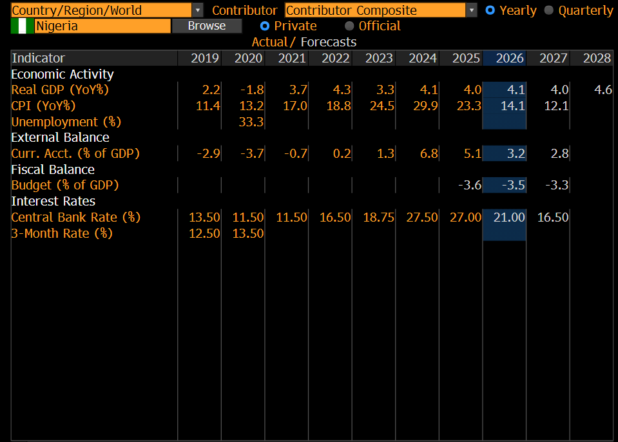

Exhibit 2:

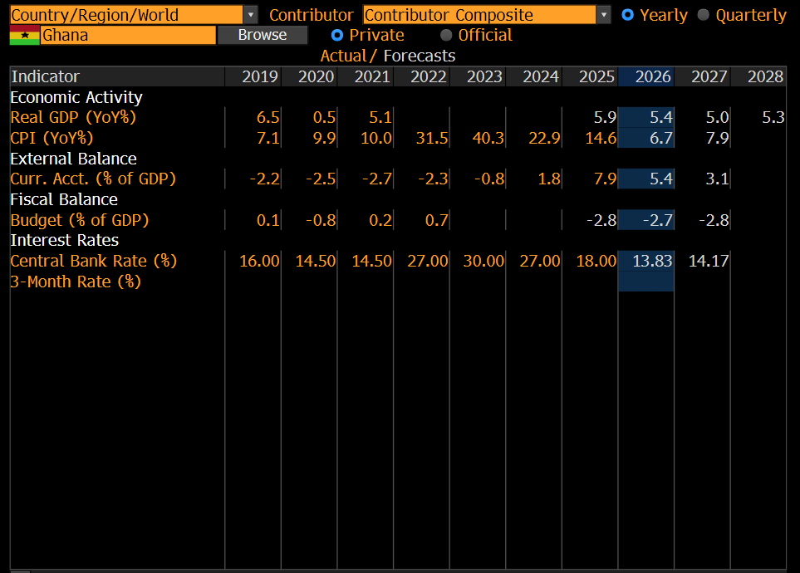

Exhibit 3:

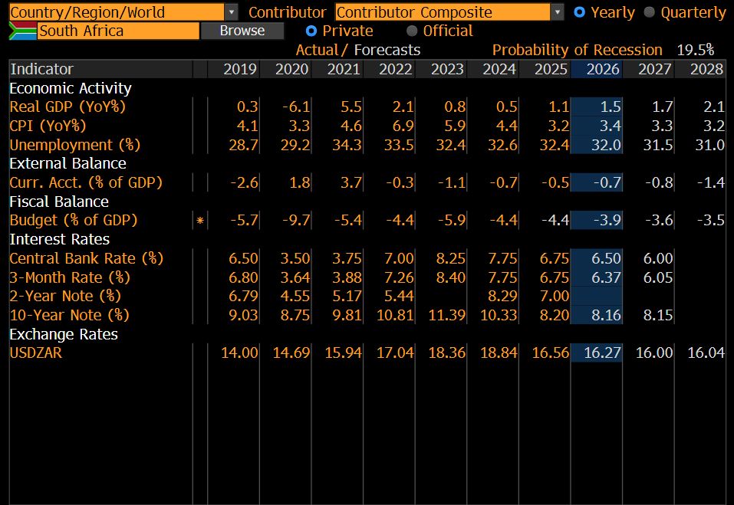

Exhibit 4:

Source: Bloomberg <FA PROD> Function

Exhibit 5

Source: Bloomberg <FA PROD> Function

Exhibit 6

Note: DDF = Data + Digital + Fintech revenue combined. 2026E based on Bloomberg forward estimates. Line chart uses % of each country's own total revenue (not group total).

Exhibit 7

