1. Sequential filters - two-filter convolution produces the same results as convoluting an image twice with single filter(s), but the image size being larger than the filter size makes the computation more efficient.
2. [0 1 1 1 1 1 1 1]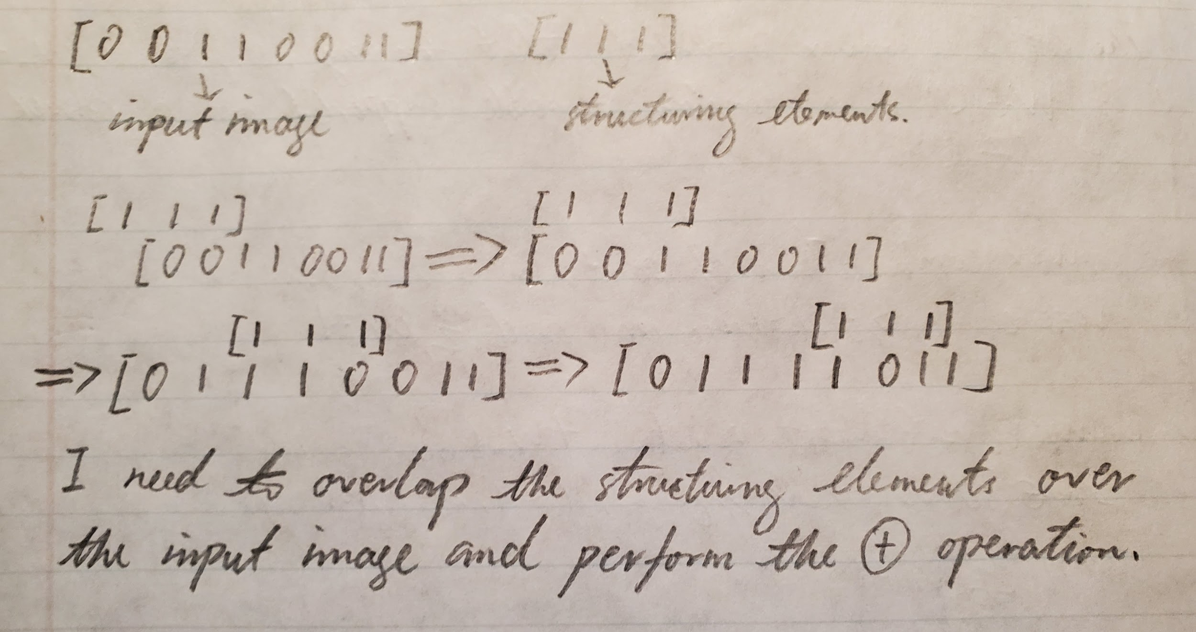
3. 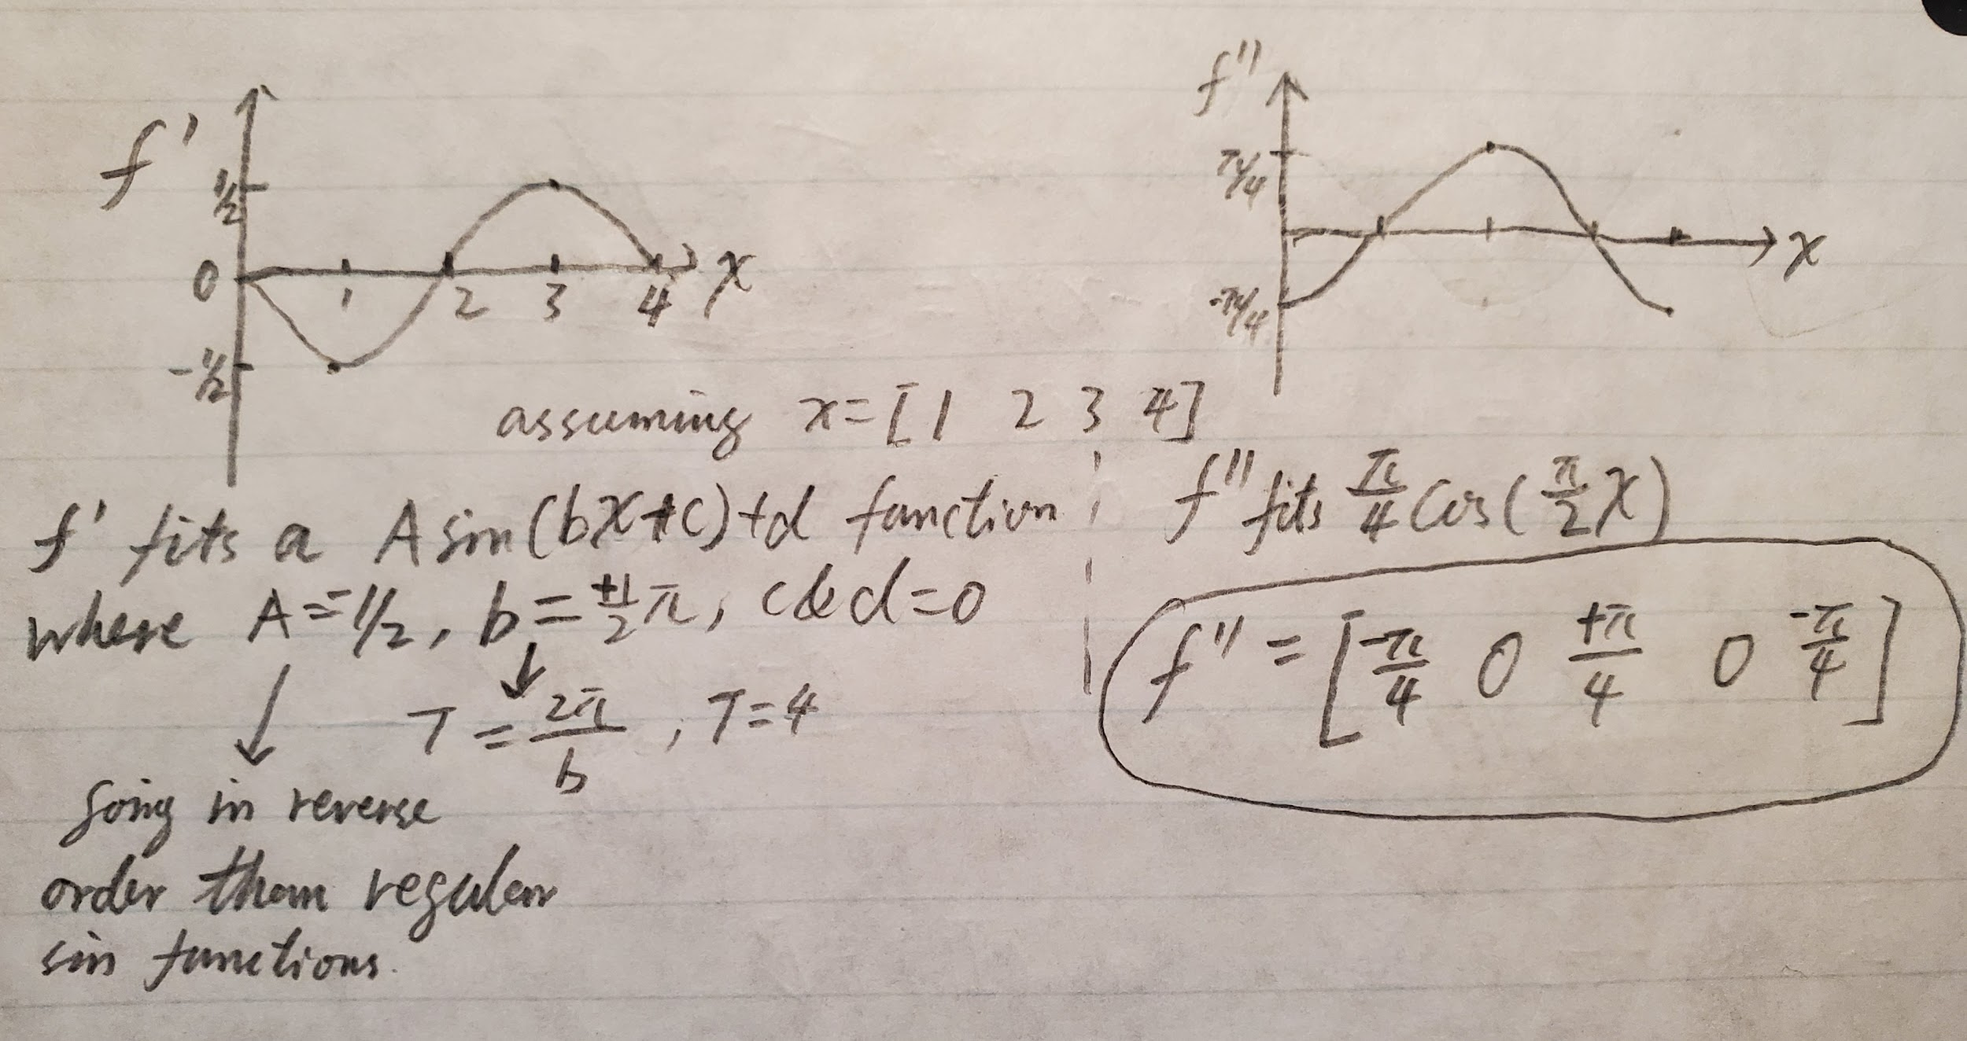
4. One way would be replacing the Gaussian filter with an adaptive filter. Both edges and noises would likely be detected as high frequency signals - a Gaussian filter can smoothen them; however, to increase the accuracy of detections, real edges need to be less smoothened and noises need to be more smoothened. An adaptive filter evaluates the discontinuities among the gray scaled pixel values. More discontinuities would decrease the weight set for the smooth filter at that point and vice versa. Another way would be improving the gradient magnitude and direction calculation. Gradient magnitudes and directions can be planned by edge detection operators, which depending on the operator, the quality of the results may vary.
5. Additive Gaussian Noise - noise power that is uniformly distributed at every band of frequencies. Its resultant is the summation of signal plus noise: . Therefore, the calculation of the resultant signals can be measured as the propagation of the uncertainties of .
6. Assumptions:

* Constant lighting
* Constant orientation
* Constant filming speed
* There exists an exhibit A, which is flawless and can be compared by my result

Steps:

* Extract the image(s) at set time(s) and/or location(s)
* Texture analysis
* Apply filter(s) to the image(s)
* Classification upon the mean absolution responses
* Compare to exhibit A
* Edge analysis
* Apply derivative Gaussian filter
* Record the magnitudes and directions of the gradients
* Apply the hysteresis thresholding: low threshold for continuation and high threshold for starting the edge curves
* Compare to exhibit A via the chamfer distances
* Binary image analysis
* Convert the image(s) to binary (black and white, etc.)
* Clean up the threshold image(s) via the morphological operator
* Find the connected components
* Compare to exhibit A via the connected components

**Programming:**

1. 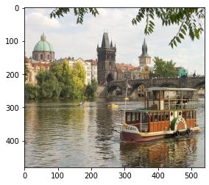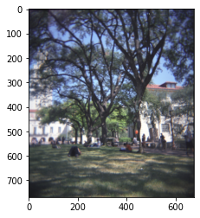
2. 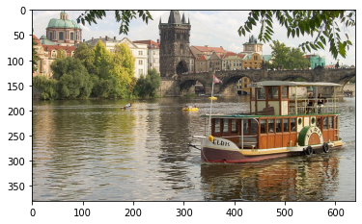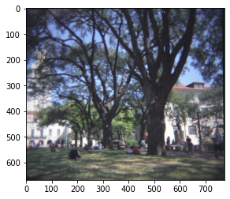
3. 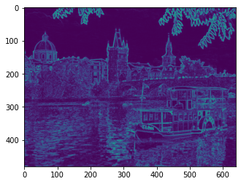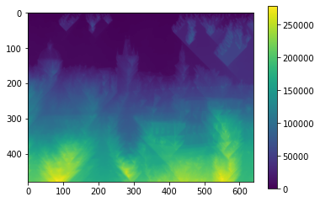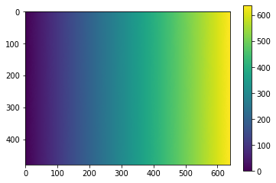The vertical energy map starts from the top going doward choosing the minimum values to display, subject to eight connectedness. The horizontal map is in a similar fashion but starts from left going toward right.
4. 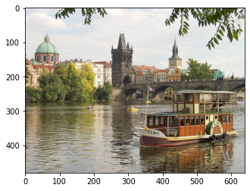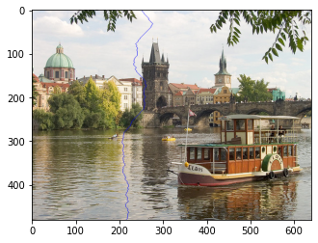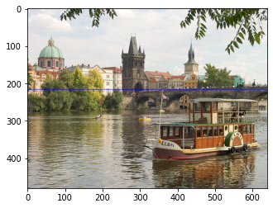The lines are supposed to go through the area on the image which contains the lowest intensities on the horizontal and vertical dimensions.
5. Different filters would display my energy map with different intensities, for example the shades of blue and yellow would be different. 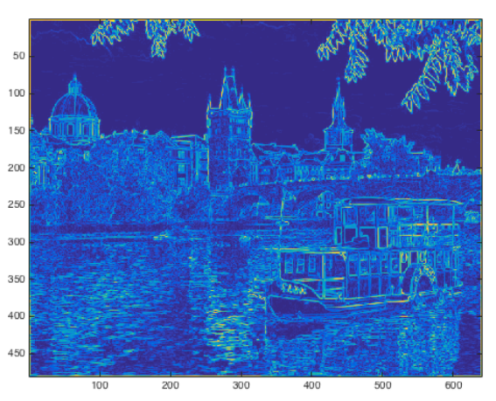
6. 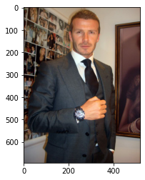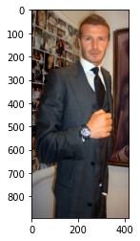

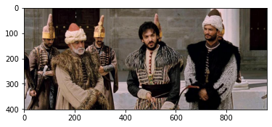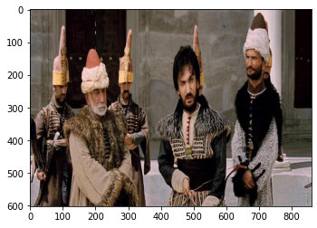The dimensions of the images changed; therefore so did the total number of pixels. However, from a visual perspective no element was deleted from the images. From a quantitative perspective, this is a linear transformation where matrix A is projected onto matrix B.

