**Lab 1**

Use two images for each operation to do the following operations and write down their advantages and disadvantages and explain your results:

1. Test the given pgmreader program use 3x3 average filter and median filter to process images and “lena.pgm” and “noise.pgm” and output the processed image (using pure c++).

**Algorithm:**

Use pseudo code or figure to display the algorithm.

1. **Average Filter**

**AverageFilter(Image *inimage)**

**begin**

tempData= the copy of original 2D matrix of the picture

outImage= the copy of inimage

**for** i=1 to Height-1 **do** //Except the margin

**for** j=1 to Width-1 **do**

tempArr= values of 8 surrounding pixel in 3×3 matrix of tempData[i][j]

average= the average of numbers in the tempArr

tempData[i][j]=average

OneDimData=change the tempData to 1 dimensional array by adding the data one by one

outImage->data= OneDimData

return outImage

1. **Median Filter**

**MedianFilter(Image *inimage)**

**begin**

tempData= the copy of original 2D matrix of the picture

outImage= the copy of inimage

**for** i=1 to Height-1 **do** //Except the margin

**for** j=1 to Width-1 **do**

tempArr= values of 8 surrounding pixel in 3×3 matrix of tempData[i][j]

median= the median of numbers in the tempArr

tempData[i][j]=average

OneDimData=change the tempData to 1 dimensional array by adding the data one by one

outImage->data= OneDimData

return outImage

**Results (compare the results with the original image):**

Paste the result images and the original ones.

1. Lena.png

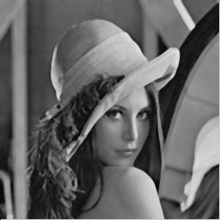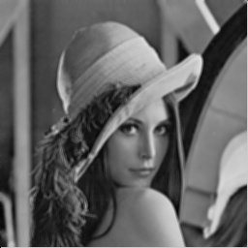

After Median Filter

After Average Filter

Before

1. noise.pgm

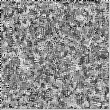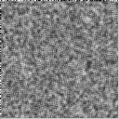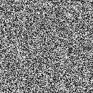

After Median Filter

After Average Filter

Before

**Discussion:**

Write down your discovery about the test.

1. After calling ReadPNMImage() function, the data of the image is stored in a 1D array, we then change it to a 2D array is easier to conduct the following algorithm of 2 filters.
2. If we strictly follow the 3×3 form, the data in the margin cannot have 8 neighbors.
3. The result of the average filter seems dimmer than the result of the median filter.

**Codes:**

You don’t need to paste all the codes. Just show the pieces of code that present the algorithm displayed above.

1. Average Filter

1. Median Filter

