Report
- Abstract:
I analyzed the relationship between duty cycle and inductor current response for four different duty cycles, further dividing each response relationship into two distinct circuit models based on the duty cycle. There are a total of eight cases, and for each case, I compared simulation results from PLECS with manually calculated results, cross-validating them using Bode plots of amplitude and phase angle.

In particular, the 10 dB amplitude offset observed at the last group meeting could not be consistently reproduced, but subsequent modifications and comparisons all met expectations.

The results are as follows:

- Results:
- D1_IL2
- D1>D2
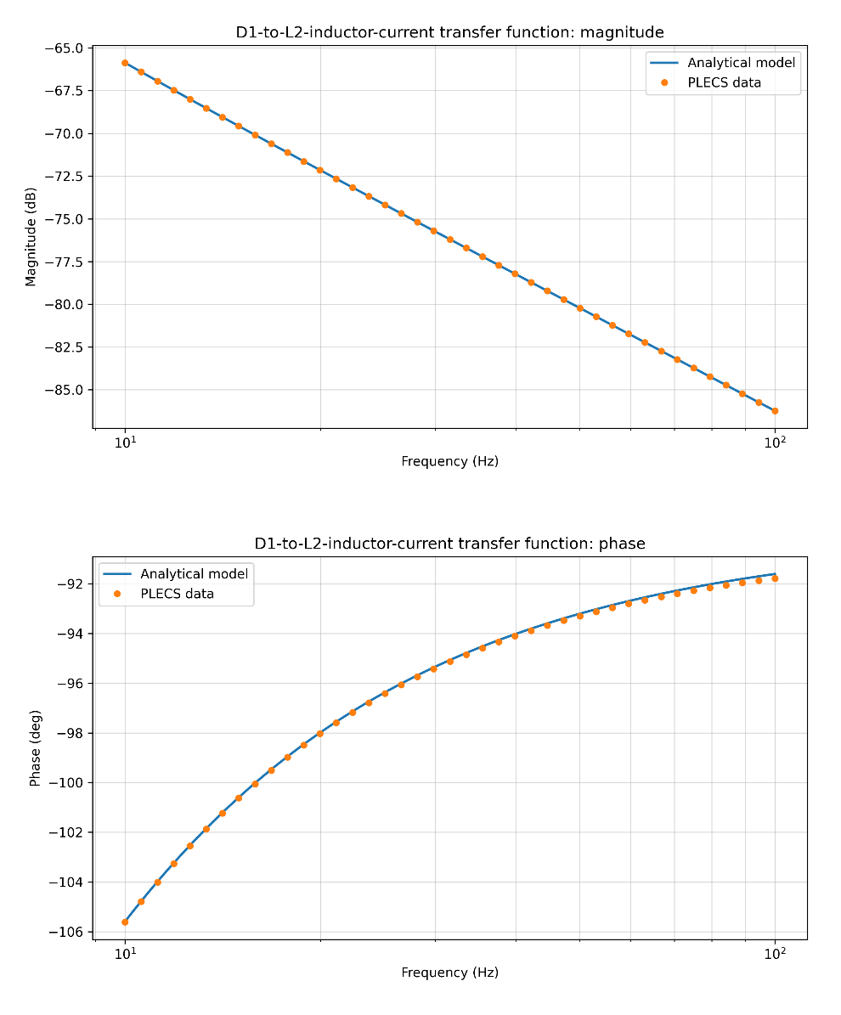
- D2>D1
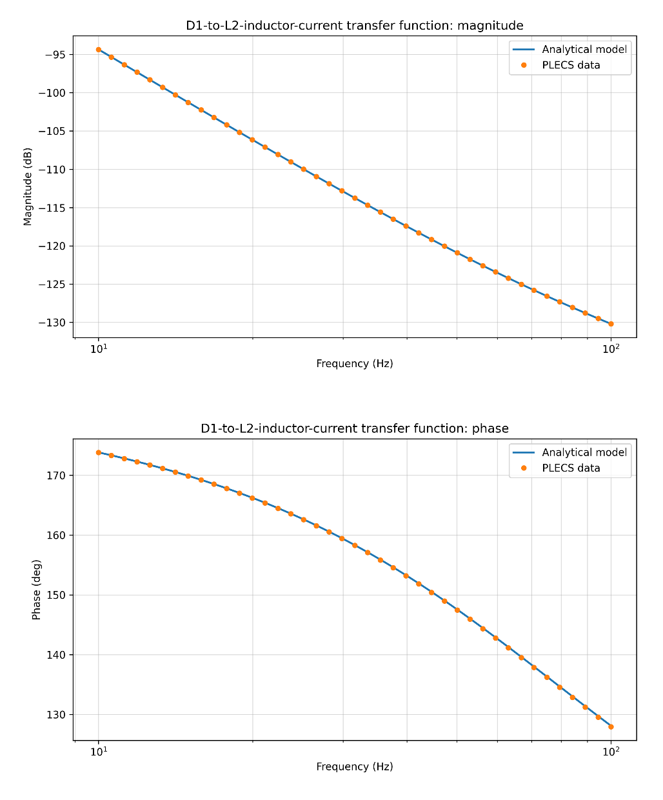

- D2_IL1
- D1>D2
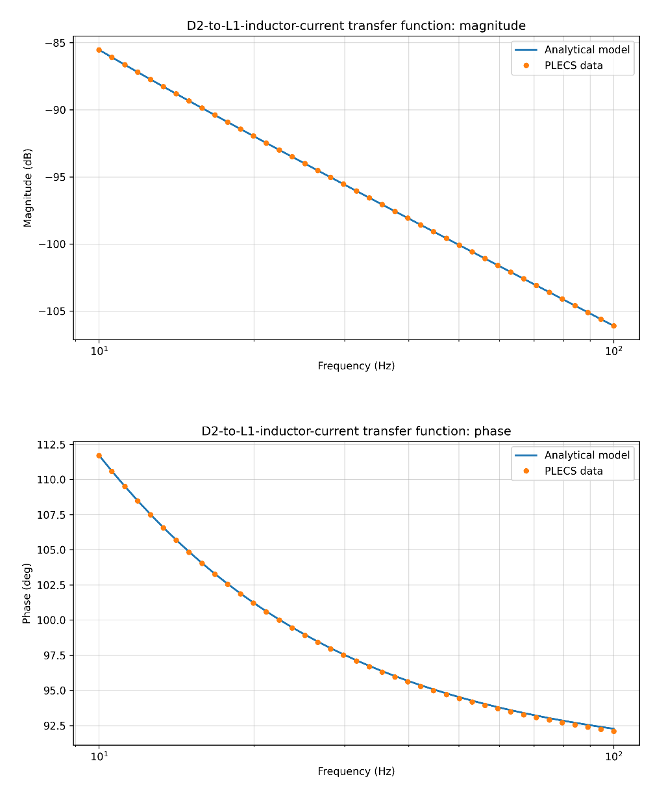
- D2>D1
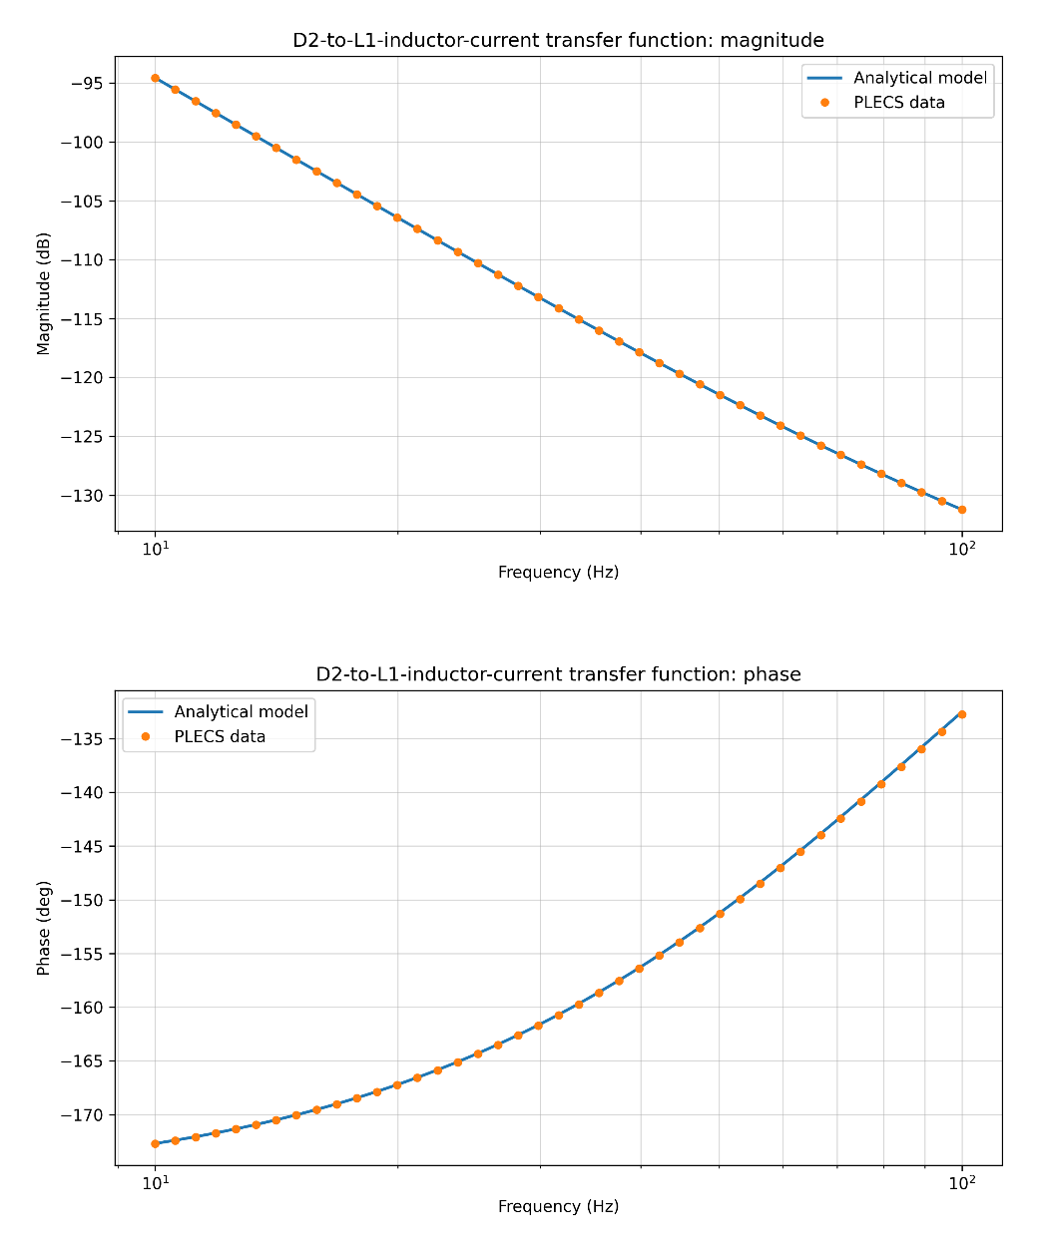

- D1_IL1
- D1>D2
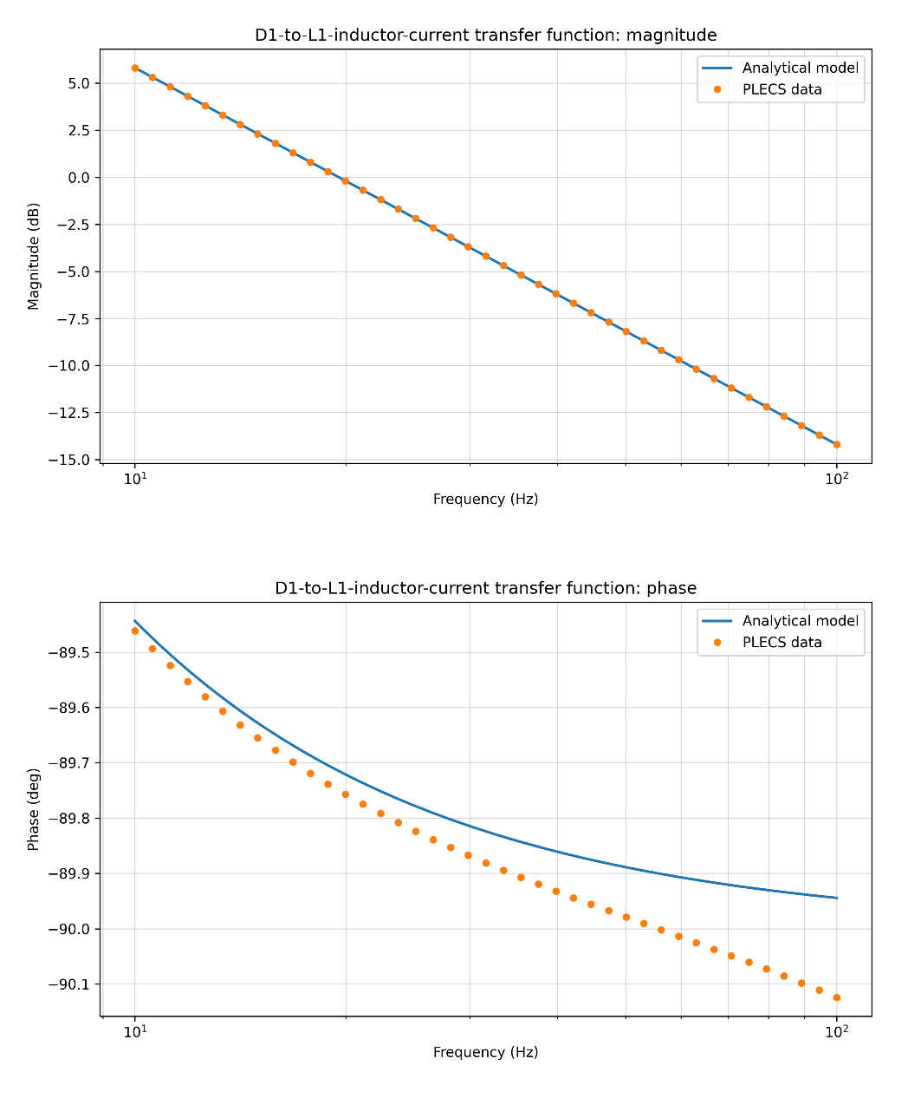
A slight phase angle shift occurs in all cases, the shift error stems from the PLECS sampling strategy, which causes a half-cycle delay in the PWM during simulation. However, the vertical axis of this graph has been magnified, so the error appears more pronounced.

- D2>D1
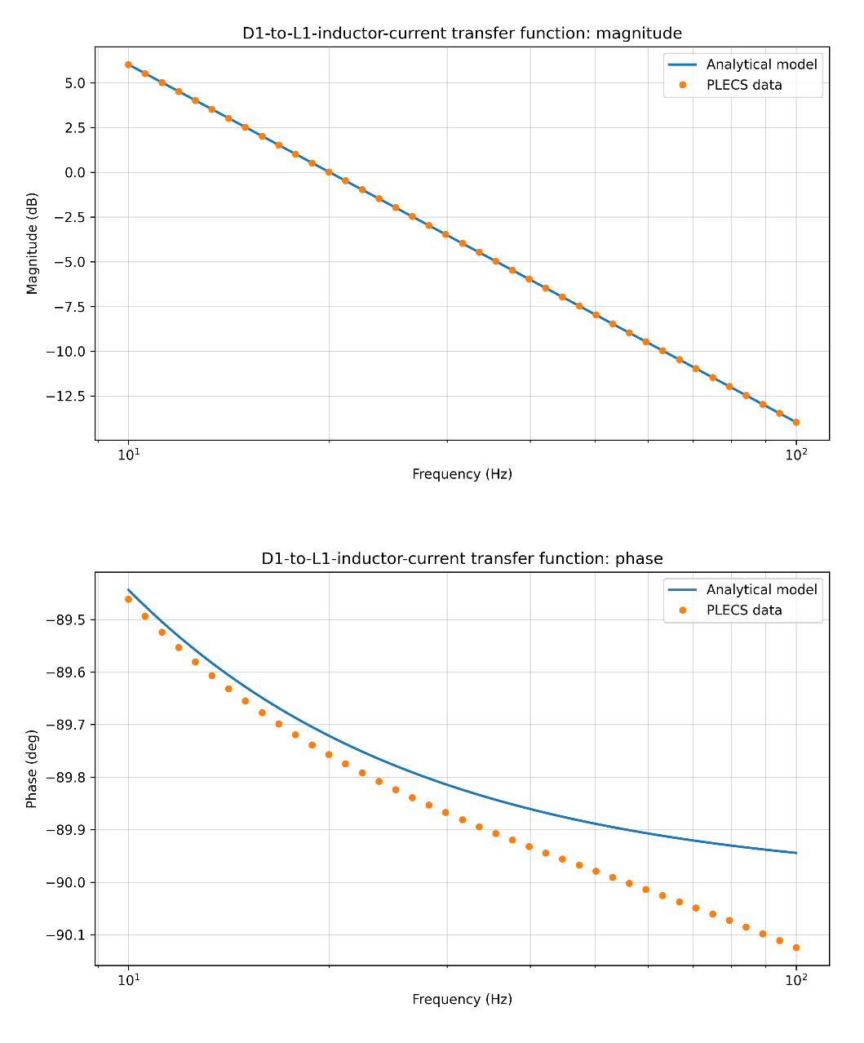
- D2_IL2
- D1>D2
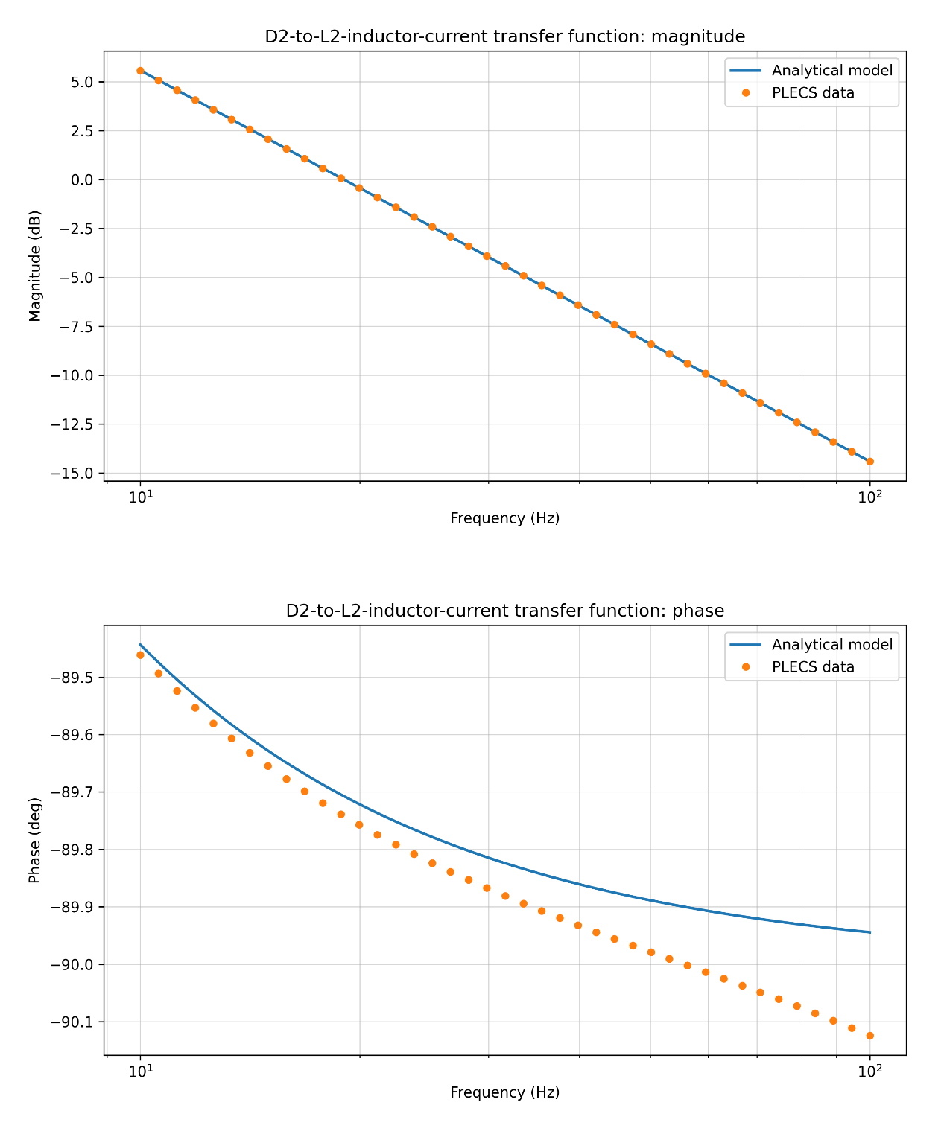
- D2>D1
