ADVENTIST UNIVERSITY OF CENTRAL AFRICA
Faculty of Information Technology
BIG DATA ESSENTIALS
Course Project Report
Customer Behavior Prediction Pipeline
Integrating HDFS, Kafka, PySpark, MLlib, MySQL and Django
GROUP VI
Full Name | Student ID
BYIRINGIRO Elie Yvan | 101219
KINANIRA NTWARI Christian | 101412
NDAYISHIMIYE Patience | 101346

1. Project Overview

1.1 Introduction
This report presents the end-to-end Big Data pipeline built by Group VI for the Big Data Essentials course at the Adventist University of Central Africa (AUCA). The project follows the course guidelines (Dr. Kundan Kumar, May 2026) and implements the Customer Behavior Prediction case study: a complete data engineering and machine learning workflow built from HDFS, Apache Kafka, Apache Spark (PySpark and MLlib), MySQL and a Django web dashboard.
Customer interaction records are generated, stored in HDFS, streamed through Kafka, processed with PySpark, used to train a classification model in MLlib, and the resulting predictions are stored in a relational database and presented on a web dashboard.

1.2 Objectives
- Design and implement a scalable big data pipeline for customer behavior analysis.
- Store and manage the dataset in HDFS (Hadoop Distributed File System).
- Stream the records through Apache Kafka.
- Process and transform the data with Apache Spark (PySpark).
- Train a Spark MLlib model to predict whether a customer will purchase.
- Persist predictions in a MySQL (MariaDB) database.
- Visualize the results on a Django web dashboard.

1.3 Outcome in brief
All components were implemented and run end to end on a single Windows 10 machine: 3,000,000 records were streamed through Kafka and processed in Spark, a Logistic Regression model was trained on 2,400,782 records and evaluated on 599,218, 100,000 predictions were stored in MySQL, and the Django dashboard reads them live from the database. The model itself does not predict better than chance (AUC 0.4993) because the synthetic labels were generated independently of the features; Section 7 explains this and Section 9 describes how it can be improved.

2. Case Study and Dataset

2.1 Case study
Customer behavior prediction is a common e-commerce use case: from how a customer interacts with a site (session length, pages, clicks, cart additions, purchase history) the business estimates whether the customer will buy. The pipeline predicts a binary outcome, will_purchase (1 = purchase, 0 = no purchase), which is a supervised classification problem solved with Logistic Regression from Spark MLlib.

2.2 Dataset description
The dataset is synthetic. It was generated in Python (Faker for identifiers, NumPy for the numeric and categorical columns, seed 42) in six chunks of 500,000 rows and written to one CSV file.
Feature | Type | Description
customer_id | String | Unique UUID identifier for each customer
age | Integer | Customer age (18–69)
session_duration_mins | Double | Duration of the web session in minutes
pages_visited | Integer | Number of pages visited in the session
clicks | Integer | Total clicks during the session
time_on_site_mins | Double | Total time spent on the site in minutes
previous_purchases | Integer | Number of past purchases
cart_additions | Integer | Items added to the cart
device_type | String | mobile, desktop or tablet
browser | String | Chrome, Firefox, Safari or Edge
region | String | North, South, East, West or Central
membership_level | String | none, silver, gold or platinum
discount_applied | Integer | Whether a discount was applied (0/1)
time_since_last_visit_days | Integer | Days since the last visit (0–364)
will_purchase | Integer | Target label: 1 = purchase, 0 = no purchase

Property | Value
Records | 3,000,000
Columns | 15 (1 identifier, 13 features, 1 label)
File size | 291,243,710 bytes (277.8 MiB)
Local path | C:\Users\USER PC\bigdata_project\customer_behavior.csv
HDFS path | /bigdata_project/input/customer_behavior.csv
Label generation | will_purchase was drawn randomly with P(1) = 0.35, independently of the features

3. System Architecture
The pipeline is layered: raw storage, streaming ingestion, stream/batch processing, machine learning, persistence and visualization. Figure 1 shows the flow of data.
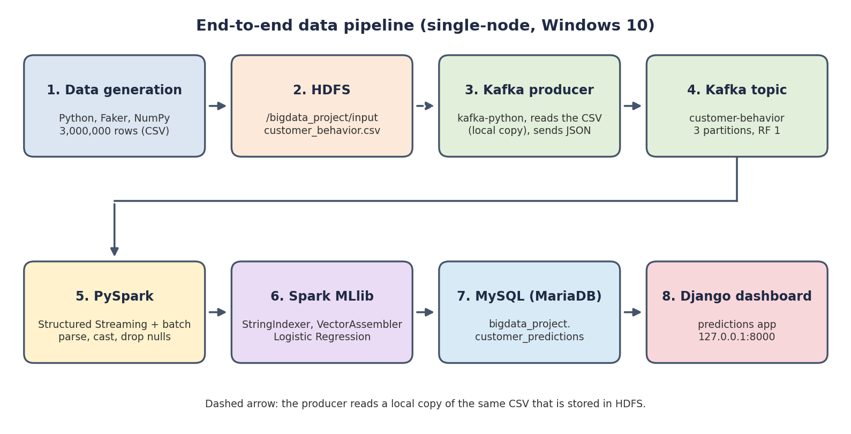
Figure 1: End-to-end architecture of the pipeline
Layer | Component | Role
Storage | HDFS (Hadoop 3.3.6) | Stores the raw CSV dataset (single-node, replication factor 1)
Ingestion | Kafka producer (kafka-python) | Reads the CSV row by row, serializes each row as JSON and sends it to the topic in batches of 1,000
Messaging | Apache Kafka 3.8.0 | Topic customer-behavior, 3 partitions, replication factor 1
Processing | Apache Spark / PySpark 3.5.8 | Reads the topic (Structured Streaming and batch), parses JSON, casts types, drops nulls
Machine learning | Spark MLlib | Feature pipeline and Logistic Regression; produces predictions and probabilities
Persistence | MySQL (MariaDB 10.4.32, XAMPP) | Table customer_predictions in database bigdata_project
Visualization | Django 4.2.30 | Dashboard reading the table through the Django ORM

Data flow.
- The generator writes customer_behavior.csv, which is uploaded to HDFS.
- The Kafka producer reads the CSV and publishes each record to the customer-behavior topic.
- PySpark reads the topic from the earliest offset and converts the JSON messages into typed columns.
- MLlib trains Logistic Regression on 80% of the records and predicts the other 20%.
- Predictions for 100,000 test records are inserted into MySQL.
- The Django dashboard queries MySQL and displays the totals.

4. Technologies and Version Information
Component | Version | Purpose
Windows | 10 (build 19045) | Host operating system, single node
Java JDK | 17.0.10 | Runtime for Hadoop, Kafka and Spark
Python (Anaconda) | 3.12.7 | Notebooks, producer, Django
Apache Hadoop (HDFS) | 3.3.6 | Distributed file storage (NameNode and DataNode on localhost:9000)
Apache Kafka | 3.8.0 (Scala 2.13 build) | Message streaming; uses the bundled Zookeeper 3.8.4
Apache Spark / PySpark | 3.5.8 (Scala 2.12) | Stream and batch processing
Spark MLlib | 3.5.8 (part of Spark) | Machine learning
MariaDB (XAMPP) | 10.4.32 | MySQL-compatible database for results
Django | 4.2.30 (LTS) | Web dashboard
Jupyter Server | 2.14.1 | Notebook environment

5. Dependencies

5.1 Spark packages and jars
The Spark–Kafka connector is loaded at session start through spark.jars.packages; Spark resolves its transitive dependencies (such as the Kafka client library) automatically.
org.apache.spark:spark-sql-kafka-0-10_2.12:3.5.8
The _2.12 suffix is the Scala version of the Spark build (Scala 2.12). Spark is a standalone installation in C:\spark, linked to Anaconda Python with findspark.

5.2 Python packages
Package | Version | Used for
faker | 40.22.0 | UUID customer identifiers
numpy, pandas | Anaconda distribution | Dataset generation
kafka-python | 2.3.2 | Kafka producer
findspark | installed with pip | Locating the Spark installation from Python
mysql-connector-python | 9.7.0 | Inserting predictions into MySQL from the notebook
mysqlclient | 2.3.0 | MySQL driver for Django
Django | 4.2.30 | Dashboard framework (with asgiref 3.12.1, sqlparse 0.6.0)

5.3 Environment, ports and key settings
Item | Value | Notes
HADOOP_HOME | C:\hadoop-3.3.6 | HDFS data directory C:\hadoop-3.3.6\data
Spark home | C:\spark | Local scratch folder bigdata_project\spark-tmp
Kafka home | C:\kafka | log.dirs=C:/kafka/kafka-logs, log.retention.ms=-1
HDFS NameNode | localhost:9000 | Started with start-dfs.cmd
Zookeeper | localhost:2181 | Bundled with Kafka
Kafka broker | localhost:9092 | PLAINTEXT listener
MySQL / MariaDB | localhost:3306 | User root, database bigdata_project
phpMyAdmin | localhost:8080 | Apache from XAMPP
Django | 127.0.0.1:8000 | Development server
Jupyter | localhost:8888 | Notebooks in bigdata_project\scripts

6. Implementation

6.1 Environment
All services run on one Windows 10 machine in single-node mode. They are started in this order: MySQL (XAMPP), HDFS, Zookeeper, Kafka. The notebooks live in bigdata_project\scripts and the Django project in bigdata_project\dashboard. Notebook outputs shown below come from the original run on 10 June 2026 (the Kafka message timestamps confirm this date). The infrastructure screenshots (HDFS, Kafka topic, services, phpMyAdmin, dashboard) were captured on 4 October 2026 after the services were restarted and the HDFS and Kafka issues in Section 8 were resolved.

6.2 Step 1 — Dataset generation and HDFS upload
generate_dataset.ipynb creates the 3,000,000-row CSV (277.8 MiB). The file was then uploaded to HDFS:
hdfs dfs -mkdir -p /bigdata_project/input
hdfs dfs -put "C:\Users\USER PC\bigdata_project\customer_behavior.csv" /bigdata_project/input/
hdfs dfs -ls -h /bigdata_project/input
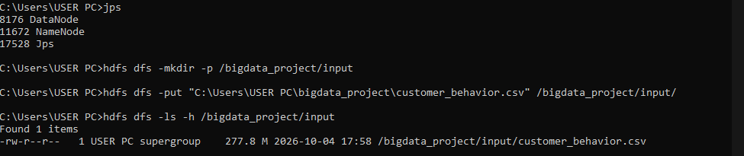
Figure 2: Dataset stored in HDFS (277.8 MB). Upload repeated on 4 October 2026 after the HDFS DataNode was repaired.

6.3 Step 2 — Real-time streaming with Kafka
The topic customer-behavior has 3 partitions and replication factor 1. The producer (kafka_producer.ipynb, cell 1) reads the CSV with csv.DictReader, serializes each row to JSON and sends it to the topic. Every 1,000 records it flushes and pauses for 0.1 s to simulate a stream.
producer = KafkaProducer(bootstrap_servers='localhost:9092',
value_serializer=lambda v: json.dumps(v).encode('utf-8'))
with open(csv_file, 'r') as f:
for row in csv.DictReader(f):
producer.send('customer-behavior', value=row)
count += 1
if count % 1000 == 0:
producer.flush(); time.sleep(0.1)
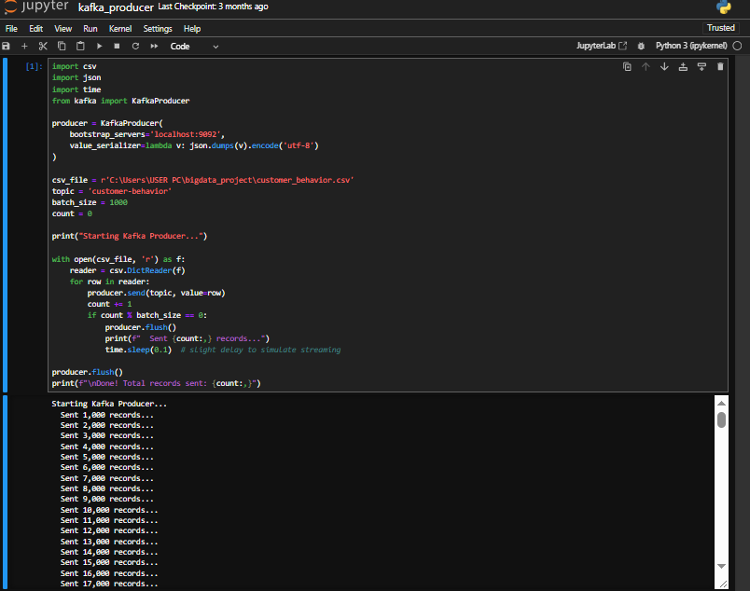
Figure 3: Kafka producer code and progress output (original run)
The end offsets of the three partitions are 1,001,120, 999,938 and 998,942, which add up to 3,000,000 — every record reached the topic. The earliest offsets equal the end offsets because Kafka's default seven-day retention later removed the message contents; the topic is now configured with retention.ms=-1 (see Section 8).
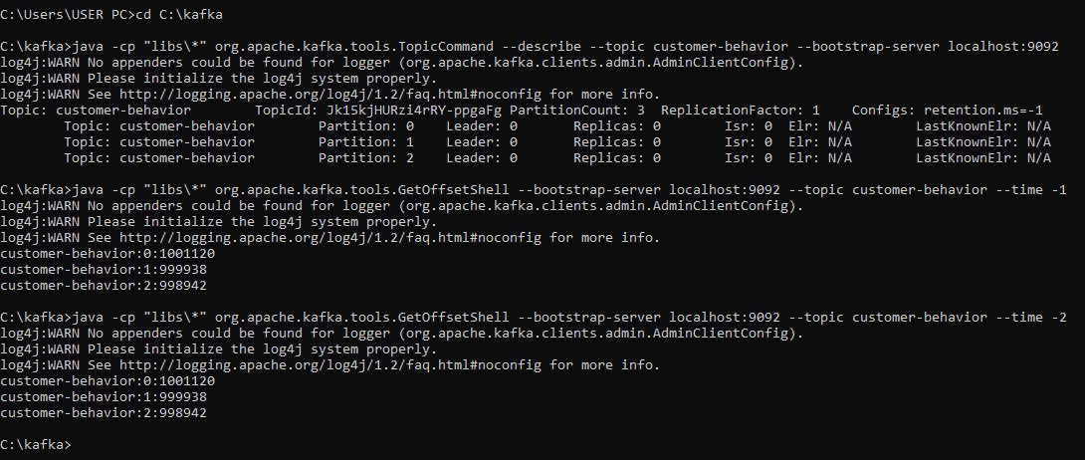
Figure 4: Topic description (3 partitions, replication factor 1) and partition offsets
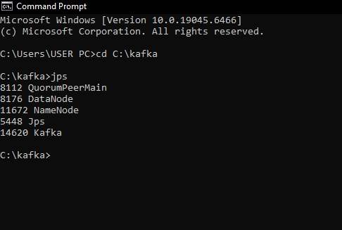
Figure 5: Zookeeper (QuorumPeerMain), Kafka, NameNode and DataNode running together

6.4 Step 3 — Data processing with PySpark
spark_consumer.ipynb creates a Spark session with the Kafka connector and subscribes to the topic with Structured Streaming (readStream, startingOffsets=earliest, 10-second trigger), parsing the JSON value column with from_json and printing the micro-batches to the console. The training notebook reads the same topic in batch mode (spark.read) so that the full set of 3,000,000 records is processed once.
df = (spark.readStream.format("kafka")
.option("kafka.bootstrap.servers", "localhost:9092")
.option("subscribe", "customer-behavior")
.option("startingOffsets", "earliest").load())
parsed = df.select(from_json(col("value").cast("string"), schema)
.alias("data")).select("data.*")
query = (parsed.writeStream.outputMode("append").format("console")
.trigger(processingTime="10 seconds").start())
All fields arrive as strings, so each numeric column is cast to int or double, and rows with nulls are dropped. The record count before and after processing is the same (3,000,000), so no records were lost or rejected.
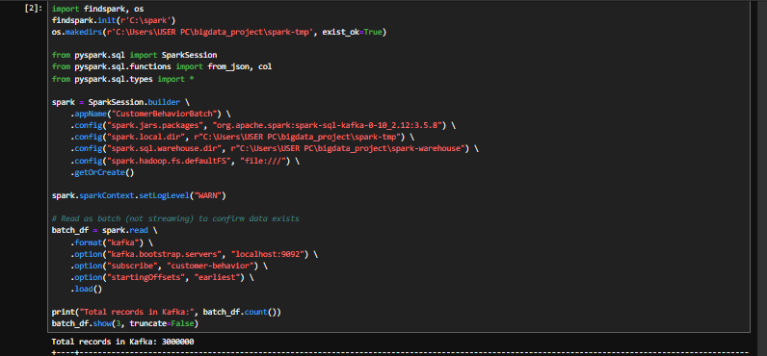
Figure 6: Spark connected to Kafka and counting 3,000,000 records (original run)
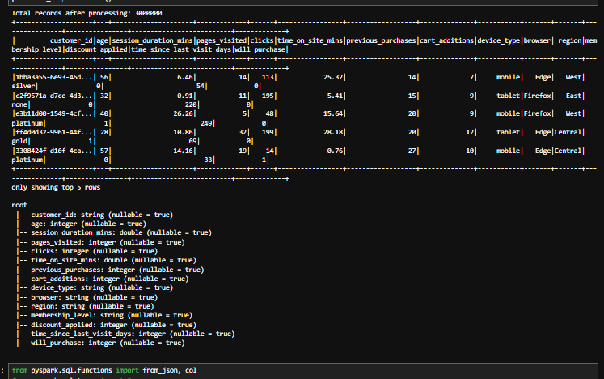
Figure 7: Typed, cleaned DataFrame — 3,000,000 records and final schema

6.5 Step 4 — Prediction modeling with MLlib
A Spark ML Pipeline indexes the four categorical columns, assembles 13 numeric and indexed columns into one feature vector and fits a Logistic Regression model. The data was split 80/20 with seed 42.
Parameter | Value
Algorithm | Logistic Regression (pyspark.ml.classification, default parameters)
Categorical encoding | StringIndexer on device_type, browser, region, membership_level
Features (13) | age, session_duration_mins, pages_visited, clicks, time_on_site_mins, previous_purchases, cart_additions, discount_applied, time_since_last_visit_days, plus the indexed device, browser, region and membership columns
Label | will_purchase
Train / test split | 2,400,782 / 599,218 records (80% / 20%, seed 42)
Evaluation | BinaryClassificationEvaluator (area under ROC)
Result | AUC = 0.4993
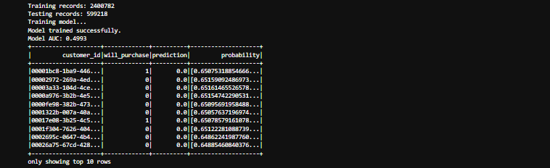
Figure 8: Training and test sizes, AUC, and a sample of predictions (original run)
The predictions table shows probabilities close to 0.65 for class 0 for every row, which is the base rate of non-purchases; the interpretation is in Section 7.

6.6 Step 5 — Storing predictions in MySQL
A table was created in the bigdata_project database and 100,000 test predictions were inserted with mysql-connector-python:
CREATE TABLE customer_predictions (
customer_id VARCHAR(50), will_purchase INT, prediction INT,
probability_no_purchase DOUBLE, probability_purchase DOUBLE );
A single insert of 100,000 rows exceeded MySQL's packet limit, so max_allowed_packet was raised to 64 MB and the rows were inserted in chunks of 5,000.
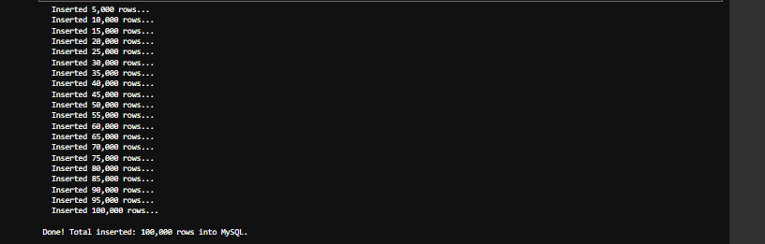
Figure 9: 100,000 rows inserted in chunks of 5,000 (original run)
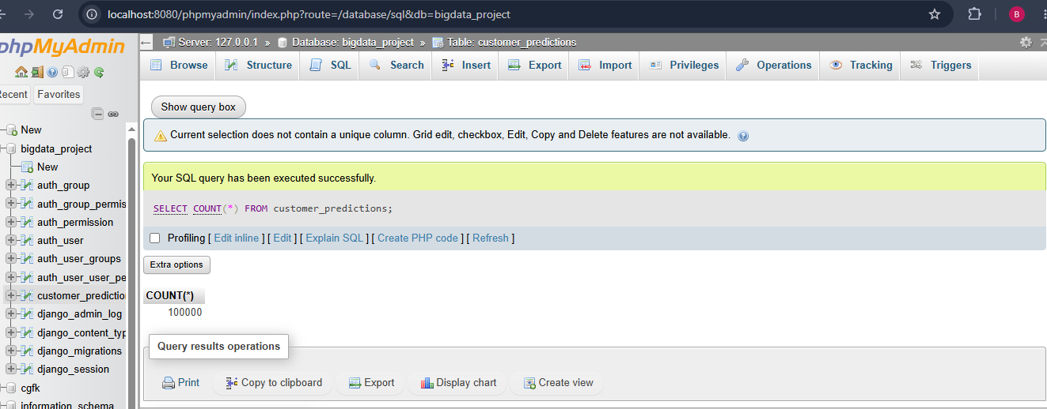
Figure 10: phpMyAdmin — `SELECT COUNT(*) FROM customer_predictions` returns 100000

6.7 Step 6 — Django web dashboard
The Django project dashboard contains the app predictions. An unmanaged model maps to the existing table, so Django reads the data written by Spark without migrating it:
class CustomerPredictions(models.Model):
customer_id = models.CharField(max_length=50, blank=True, null=True)
will_purchase = models.IntegerField(blank=True, null=True)
prediction = models.IntegerField(blank=True, null=True)
probability_no_purchase = models.FloatField(blank=True, null=True)
probability_purchase = models.FloatField(blank=True, null=True)
class Meta:
managed = False
db_table = 'customer_predictions'
The view dashboard() counts total records, predicted purchases and non-purchases, and actual purchases and non-purchases, and passes them to the template, which shows summary cards and a metrics table. It is served at http://127.0.0.1:8000 with:
cd "C:\Users\USER PC\bigdata_project\dashboard"
"C:\ProgramData\anaconda3\python.exe" manage.py runserver
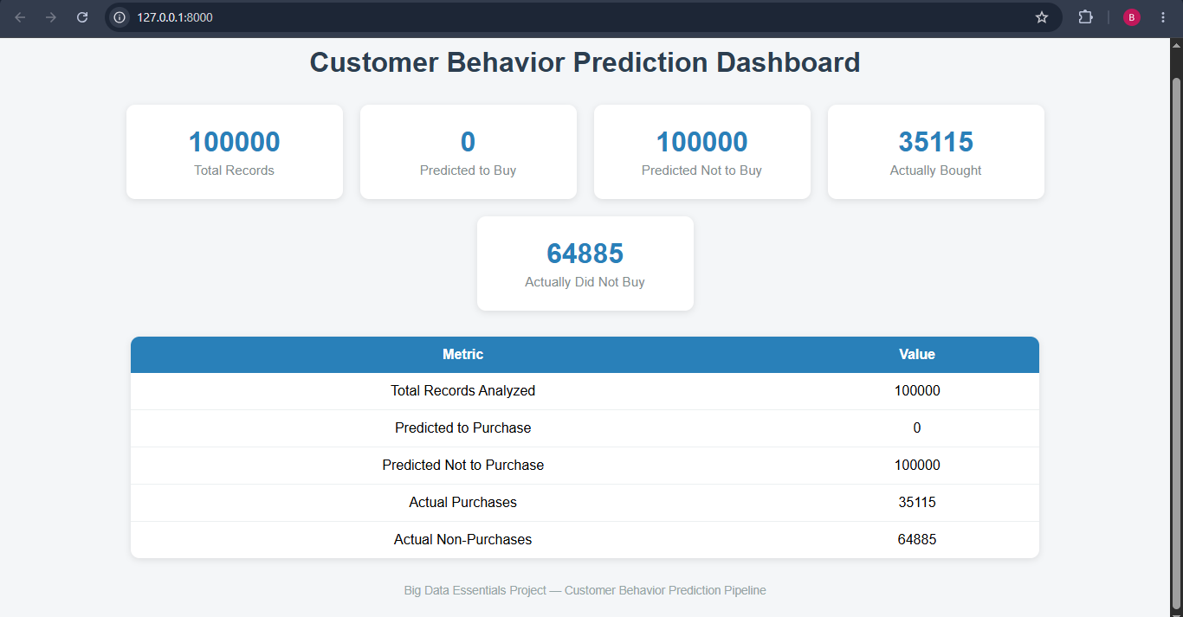
Figure 11: Customer Behavior Prediction Dashboard (Django 4.2.30)

6.8 Step 7 — Testing
Component | Check | Result
HDFS | hdfs dfs -ls -h /bigdata_project/input | File present, 277.8 MB
Kafka | Sum of partition end offsets | 1,001,120 + 999,938 + 998,942 = 3,000,000
Spark | Record count read from Kafka, then after cast and dropna() | 3,000,000 and 3,000,000 (no loss)
MLlib | Train/test split and AUC | 2,400,782 + 599,218 = 3,000,000; AUC 0.4993
MySQL | SELECT COUNT(*) in phpMyAdmin | 100,000 rows
Django | Request to /; dashboard figures versus database | HTTP 200; 35,115 + 64,885 = 100,000
The dashboard is served by Django's development server on the local machine.

7. Findings
Metric | Value
Records read from Kafka | 3,000,000
Records after processing (nulls removed) | 3,000,000 (0 removed)
Training / test records | 2,400,782 / 599,218
Model | Logistic Regression, default parameters
AUC on test data | 0.4993
Predictions stored in MySQL | 100,000
Actual purchases / non-purchases in stored sample | 35,115 (35.1%) / 64,885 (64.9%)
Predicted purchases / non-purchases | 0 / 100,000
Accuracy on stored sample | 64.9%

- The pipeline works at scale. Three million records moved from HDFS storage through Kafka, Spark and MLlib into MySQL and onto the dashboard without any record being lost or rejected.
- The model learned only the base rate. An AUC of 0.4993 is equivalent to random guessing. Every record was predicted as "no purchase", so the accuracy of 64.9% equals the share of non-purchases in the sample (64,885 of 100,000), and the predicted probabilities sit near 0.65 and 0.35.
- This is a property of the data, not of the pipeline. The label will_purchase was generated at random with a 35% purchase rate and no link to the features, so there is no pattern for any algorithm to learn.
- No business conclusion can be drawn from these predictions. The result validates the technical integration; the next step for real insight is data in which behavior and purchases are related (Section 9).

8. Challenges and Solutions
Issue | Cause | Resolution
Spark could not be used from Anaconda Python | Spark is a standalone installation in C:\spark | findspark.init(r"C:\spark") before importing PySpark
Spark scratch files on Windows | Spark needs writable local temp and warehouse folders | Set SPARK_LOCAL_DIRS, spark.local.dir, spark.sql.warehouse.dir and fs.defaultFS=file:///
faker not found in Jupyter | Package installed into a different Python | !{sys.executable} -m pip install faker kafka-python mysql-connector-python
Kafka .bat scripts closed immediately | Windows batch wrappers exited on start | Started Zookeeper and Kafka directly with java -cp "libs\*" ...
MySQL insert failed for 100,000 rows | Packet larger than max_allowed_packet | Raised the limit to 64 MB and inserted in chunks of 5,000
Django 6.0 failed against the database | Django 6.0 does not support MariaDB 10.4 | Used Django 4.2 LTS
python command failed (error 0x80070003) | PATH pointed to a Python 3.14 installation that no longer exists | Called the Anaconda Python by full path and installed Django 4.2.30 and mysqlclient 2.3.0 there
HDFS DataNode would not start; HDFS listing empty | Incompatible clusterIDs between NameNode and DataNode | Renamed C:\hadoop-3.3.6\data\datanode to datanode_old, restarted the DataNode and re-uploaded the CSV
Kafka broker shut down about 30 s after start | Retention cleanup tried to delete expired segments; Windows refused to rename files held open, so Kafka marked the log directory as failed | Set log.retention.ms=-1 in server.properties; the broker has stayed up since
Jupyter crashed on start (permission denied) | Runtime folder under AppData\Roaming\jupyter not writable | Set JUPYTER_RUNTIME_DIR=C:\jupyter_runtime

9. Limitations and Future Work
- Dataset size. The CSV is 277.8 MiB, below the 1 GB suggested in the course guidelines. Generating roughly 11 million rows (or wider records) would reach 1 GB with the same schema.
- Labels without signal. Because will_purchase is random, AUC stays near 0.5. Generating the label from the features (for example from cart additions, previous purchases and discounts), or using a real clickstream dataset, would let the model learn; Random Forest or gradient-boosted trees can then be compared with Logistic Regression.
- Producer source. The producer reads a local copy of the CSV instead of reading from HDFS directly. A producer that reads the file from HDFS (for example through WebHDFS) would match the intended architecture exactly.
- Streaming scope. The Structured Streaming job writes micro-batches to the console; training and the MySQL insert run in batch. A foreachBatch job that scores each micro-batch with a saved model and writes to MySQL would make the predictions truly real-time.
- Stored sample. Only 100,000 of the 599,218 test predictions were stored, and the trained model was not saved to disk.
- Dashboard. It shows totals only, refreshes on page load and runs on the local development server. Charts, auto-refresh and hosting (and AWS RDS in place of local MySQL) are natural extensions.

10. Conclusion
Group VI built and ran a complete big data pipeline — HDFS, Kafka, PySpark, MLlib, MySQL and Django — on a 3,000,000-record customer behavior dataset, and documented each stage with the version of every tool. The integration works end to end and no records were lost between stages. The prediction model has no predictive power because the synthetic labels are unrelated to the features, which is the main limitation; the project therefore demonstrates the engineering side of the workflow rather than a useful purchase predictor. Using feature-dependent or real data, a larger file and a fully streaming scoring job are the clear next steps.

11. References
- Kumar, K. (2026). Big Data Essentials Course Project Guidelines for Students. May 2026.
- Apache Hadoop Documentation. https://hadoop.apache.org/docs/r3.3.6/
- Apache Kafka Documentation. https://kafka.apache.org/documentation/
- Apache Spark MLlib Guide. https://spark.apache.org/docs/3.5.8/ml-guide.html
- Apache Spark Structured Streaming + Kafka Integration Guide. https://spark.apache.org/docs/3.5.8/structured-streaming-kafka-integration.html
- PySpark API Reference. https://spark.apache.org/docs/latest/api/python/
- Django 4.2 Documentation. https://docs.djangoproject.com/en/4.2/
- MySQL Connector/Python Developer Guide. https://dev.mysql.com/doc/connector-python/en/
- Faker Library Documentation. https://faker.readthedocs.io/

Appendix A — Project files
Everything is under C:\Users\USER PC\bigdata_project:
bigdata_project/
customer_behavior.csv (dataset, 3,000,000 rows)
scripts/
generate_dataset.ipynb (dataset generator)
kafka_producer.ipynb (producer, Spark batch, MLlib, MySQL)
spark_consumer.ipynb (Structured Streaming consumer)
dashboard/
manage.py
dashboard/ (settings, urls, wsgi/asgi)
predictions/ (models, views, urls, templates)
spark-tmp/ (Spark scratch files)
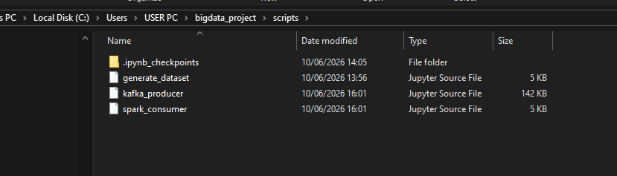
Figure 12: The scripts folder (notebooks)
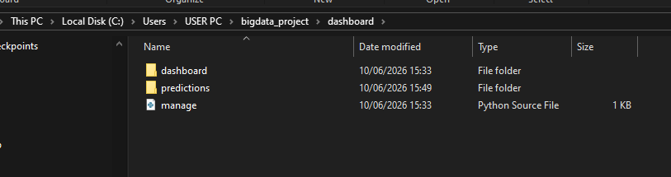
Figure 13: The Django project folder
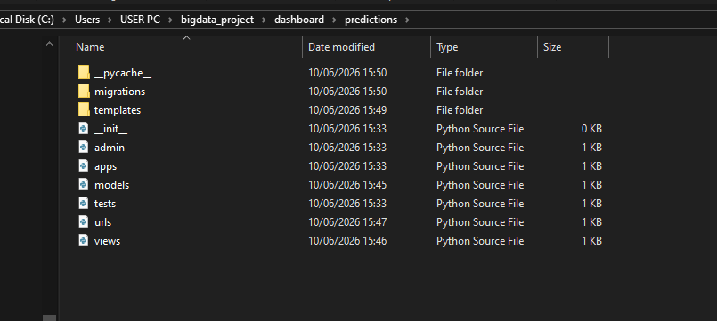
Figure 14: The predictions app

Appendix B — How to run the pipeline
Use separate Command Prompt windows for the long-running services and keep them open.
- Start MySQL (and Apache for phpMyAdmin) in the XAMPP Control Panel.
- Start HDFS: start-dfs.cmd. Check with jps (NameNode and DataNode) and hdfs dfs -ls -h /bigdata_project/input.
- Start Zookeeper: cd C:\kafka then java -cp "libs\*" org.apache.zookeeper.server.quorum.QuorumPeerMain config\zookeeper.properties.
- Start Kafka: cd C:\kafka then java -cp "libs\*" kafka.Kafka config\server.properties.
- Start Jupyter: cd "C:\Users\USER PC\bigdata_project\scripts" then "C:\ProgramData\anaconda3\python.exe" -m jupyter notebook.
- Run generate_dataset.ipynb once (skip if the CSV exists), upload the CSV to HDFS, then run kafka_producer.ipynb from the top: producer, Kafka count, parsing, MLlib training, MySQL insert.
- Start the dashboard: cd "C:\Users\USER PC\bigdata_project\dashboard" then "C:\ProgramData\anaconda3\python.exe" manage.py runserver, and open http://127.0.0.1:8000.
- Shut down in reverse order: stop Kafka (Ctrl+C), then Zookeeper, then stop-dfs.cmd.

