Introduction to JavaScript

Figure Area
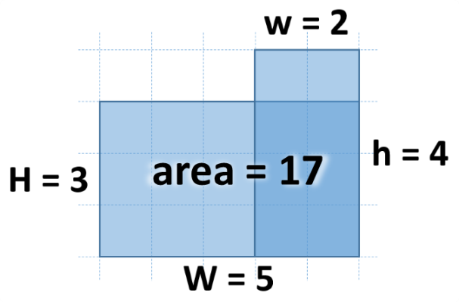
Write a JS function that calculates the area of the figure on the right by given values for w, h, W and H. The lower right corner is always common for the two rectangles.
The input comes as four number parameters w, h, W and H.
The output should be returned as a result of your function.

Examples
Input | Output |  | Input | Output
2, 4, 5, 3 | 17 |  | 13, 2, 5, 8 | 56

Next Day
Write a JS function that calculates the date of the next day by given year, month and day.
The input comes as three number parameters. The first element is the year, the second is the month and the third is the day.
The output should be returned as a result of your function.

Examples
Input | Output
2016, 9, 30 | 2016-10-1

Distance between Points
Write a JS function that calculates the distance between two points by given x and y coordinates. Use objects to store the two points.
The input comes as four number elements in the format x1, y1, x2, y2. Each pair of elements are the coordinates of a point in 2D space.
The output should be returned as a result of your function.

Examples
Input | Output
2, 4, 5, 0 | 5

Input | Output
2.34, 15.66, -13.55, -2.9985 | 24.50778901186315

