Data Types, Expressions, Statements

Distance in 3D
Write a JS function that calculates the distance between the two points in 3D by given coordinates.
The input comes as an array of numbers. The first three elements are the x, y and z coordinates for the first point and the second set of arguments are the coordinates of the other point.
The output should be printed to the console.

Examples
Input | Output
[1, 1, 0, 5, 4, 0] | 5
[3.5, 0, 1, 0, 2, -1] | 4.5

Hints
You can find the horizontal and vertical offset between two points by calculating the difference between their respective coordinates. Use Pythagoras’ theorem to find the distance.

Grads to Degrees
Land surveyors use grads (also known as gon, 400 grads in a full turn) in their documents. Grads are rather unwieldy though, so you need to write a JS function that converts from grads to degrees. In addition, your program needs to constrain the results within the range , so if you arrive at a value like -15°, it needs to be converted to 345° and 420° becomes 60°.
The input comes as single number.
The output should be printed to the console.

Examples
Input | Output |  | Input | Output |  | Input | Output |  | Input | Output
100 | 90 |  | 400 | 0 |  | 850 | 45 |  | -50 | 315

Hints
You can use the remainder (modulo) operator to get a value that is cyclic – it returns the same result for all input values with offset equal to the second parameter. For instance, n % 10 will return 3 with values for n 3, 13, 23, 243, 1003 and so on.

*Rounding
Write a JS function that rounds numbers to specific precision.
The input comes as an array of two numbers. The first value is the number to be rounded and the second is the precision (significant decimal places). If a precision is passed, that is more than 15 it should automatically be reduced to 15.
The output should be printed to the console. Do not print insignificant decimals.

Examples
Input | Output |  | Input | Output
[3.1415926535897932384626433832795, 2] | 3.14 |  | [10.5, 3] | 10.5

Imperial Units
Imperial units are confusing, but still in use in some backwards countries (Myanmar, Liberia and the United States are the only countries still using them). They are so confusing in fact, that native users struggle to convert between them. Write a JS function that converts from inches to feet and inches. There are 12 inches in a foot. See the example for formatting details.
The input comes as a single number.
The output should be printed to the console.

Examples
Input | Output |  | Input | Output |  | Input | Output
36 | 3'-0" |  | 55 | 4'-7" |  | 11 | 0'-11"

Binary to Decimal
Write a JS function that reads an 8-bit binary number and converts it to a decimal.
The input comes as one string element, representing a binary number.
The output should be printed to the console.

Examples
Input | Output |  | Input | Output
00001001 | 9 |  | 11110000 | 240

Assign Properties
Write a JS function that composes an object by given properties. There will be 3 sets of property-value pairs (a total of 6 elements). Assign each value to its respective property of an object and return the object as a result of the function.
The input comes as an array of string elements.
The output should be returned as a value.

Examples
Input
['name', 'Pesho', 'age', '23', 'gender', 'male']
Output
{
name: 'Pesho',
age: '23',
gender: 'male'
}

Input
['ssid', '90127461', 'status', 'admin', 'expires', '600']
Output
{
ssid: '90127461',
status: 'admin',
expires: '600'
}

*Last Month
Write a JS function that receives a date as array of strings containing day, month and year in that order. Your task is to print the last day of previous month (the month BEFORE the given date). Check the examples to better understand the problem.
The input comes as an array of numbers.
The output should be a single number representing the last day of the previous month.

Examples
Input | Output |  | Input | Output
[17, 3, 2002] | 28 |  | [13, 12, 2004] | 30

Conditional Statements and Loops
In this homework, you are supposed to write program logic using expressions, conditions and loops in JavaScript. You will practice working with arithmetic operators, expressions and calculations, using conditional statements (if, if-else, multiple if-else-if-else-… and switch-case) and working with loop statements (like for, while, do-while and for-of) and nested loops, combined with conditional statements and calculations.

Point in Rectangle
Write a JS function that takes as input 6 numbers x, y, xMin, xMax, yMin, yMax and prints whether the point {x, y} is inside the rectangle or outside of it. If the point is at the rectangle border, it is considered inside.
The input comes as array of numbers. Its holds the representations of x, y, xMin, xMax, yMin, yMax. All numbers will in the range [-1 000 000 … 1 000 000]. It is guaranteed that xMin < xMax and yMin < yMax.
The output is a single line holding “inside” or “outside”.

Examples
Input | Output | Figure |  | Input | Output | Figure
8  -1  2  12  -3  3 | inside | 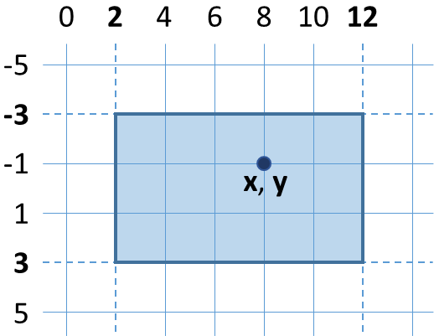 |  | 12.5  -1  2  12  -3  3 | outside | 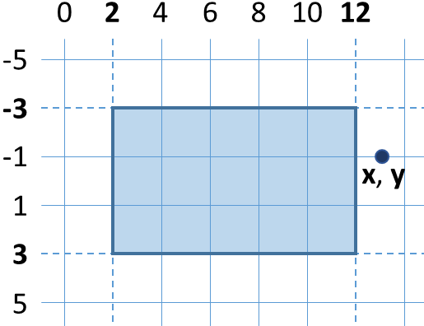

Hints
First write a JS function to read the input numbers x, y, xMin, xMax, yMin and yMax from the array of 6 numbers, passed as input parameter input. The numbers should be taken from the array elements input[0], input[1], … as follows:
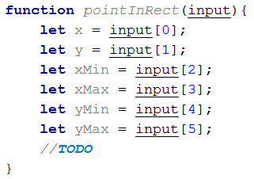
The above code could be significantly shortened by using a JS language feature called “destructuring assignment” like this:
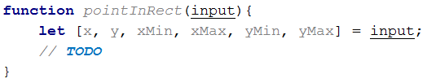
Next, write if-else statement to check whether the point {x, y} is inside the rectangle. A point is inside a rectangle if and only if both of the following conditions are fulfilled:
- its x coordinate is between xMin and xMax
- its y coordinate is between yMin and yMax
The code may look like this:
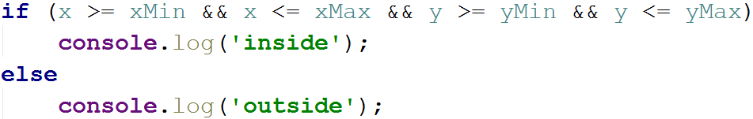
Now test the function locally on your computer. Invoke the above function like this:
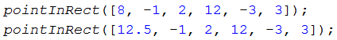
Note that the function takes its input as 6 numbers. You may test your code in your IDE, in the console (with Node.js) or in your Web browser’s JS console.
The screenshot below shows the above function, invoked in Chrome JavaScript Console:
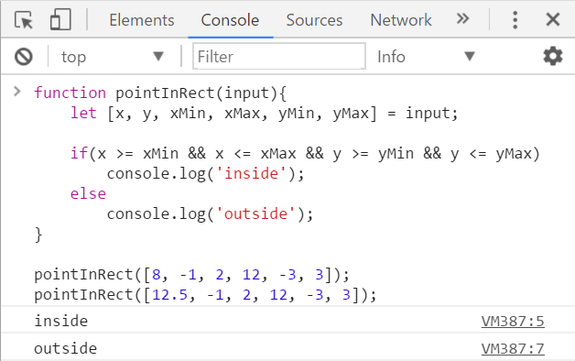
The screenshot below shows the above code in the Node.js REPL console:
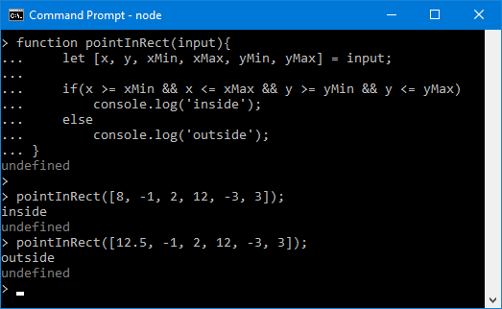

** Monthly Calendar
Note: this problem is for champions only!
Write a JS function calendar([day, month, year]) that returns a monthly calendar as HTML table (like in the examples below) by given day, month and year. Weeks start by “Sun” (Sunday) and end by “Sat” (Saturday).
The input comes as array of 3 numbers:
- day (1 ≤ day ≤ 31)
- month (1 ≤ month ≤ 12)
- year (1900 ≤ year ≤ 2100)
The output should be an HTML table, holding the calendar rows and columns, like in the examples below. Display the weeks as table rows: <tr>…</tr>. Display the days as table cells: <td>…</td>. Display the days of the previous month with CSS class “prev-month”, the days of the next month with CSS class “next-month” and the current day with CSS class “today”. See the examples below.

Examples
Input | 24  12  2012
Output | <table>  <tr><th>Sun</th><th>Mon</th><th>Tue</th><th>Wed</th><th>Thu</th><th>Fri</th><th>Sat</th></tr>  <tr><td class="prev-month">25</td><td class="prev-month">26</td><td class="prev-month">27</td><td class="prev-month">28</td><td class="prev-month">29</td><td class="prev-month">30</td><td>1</td></tr>  <tr><td>2</td><td>3</td><td>4</td><td>5</td><td>6</td><td>7</td><td>8</td></tr>  <tr><td>9</td><td>10</td><td>11</td><td>12</td><td>13</td><td>14</td><td>15</td></tr>  <tr><td>16</td><td>17</td><td>18</td><td>19</td><td>20</td><td>21</td><td>22</td></tr>  <tr><td>23</td><td class="today">24</td><td>25</td><td>26</td><td>27</td><td>28</td><td>29</td></tr>  <tr><td>30</td><td>31</td><td class="next-month">1</td><td class="next-month">2</td><td class="next-month">3</td><td class="next-month">4</td><td class="next-month">5</td></tr>  </table>
Preview | 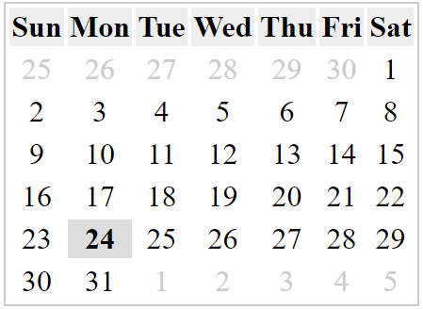

Input | 4  9  2016
Output | <table>  <tr><th>Sun</th><th>Mon</th><th>Tue</th><th>Wed</th><th>Thu</th><th>Fri</th><th>Sat</th></tr>  <tr><td class="prev-month">28</td><td class="prev-month">29</td><td class="prev-month">30</td><td class="prev-month">31</td><td>1</td><td>2</td><td>3</td></tr>  <tr><td class="today">4</td><td>5</td><td>6</td><td>7</td><td>8</td><td>9</td><td>10</td></tr>  <tr><td>11</td><td>12</td><td>13</td><td>14</td><td>15</td><td>16</td><td>17</td></tr>  <tr><td>18</td><td>19</td><td>20</td><td>21</td><td>22</td><td>23</td><td>24</td></tr>  <tr><td>25</td><td>26</td><td>27</td><td>28</td><td>29</td><td>30</td><td class="next-month">1</td></tr>  </table>
Preview | 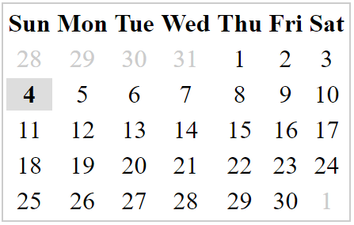

HTML Skeleton
To simplify your work, use the below HTML code and write the missing code in the calendar() function:
calendar.html
<!DOCTYPE html>
<html>
<head>
<title>Monthly Calendar</title>
<style>
.prev-month, .next-month { color: #CCC }
.today { font-weight: bold; background: #DDD; }
.title { background: #AAAAFF; margin: 10px 0; padding:5px }
table { border: 1px solid #CCC;}
td { text-align: center; }
#calendarCode { width: 100%; }
</style>
<script>
function calendar([day, month, year])
{
// TODO: return the HTML text holding the calendar table
}
</script>
</head>
<body>
Day: <input id="day" type="number" value="4" />
Month: <input id="month" type="number" value="9" />
Year: <input id="year" type="number" value="2016" />
<input type="button" value="Show"
onclick="let calendarHTML =
calendar([document.getElementById('day').value,
document.getElementById('month').value,
document.getElementById('year').value]);
document.getElementById('calendar').innerHTML = calendarHTML;
document.getElementById('calendarCode').innerText = calendarHTML" />
<div class="title">Calendar:</div>
<div id="calendar">Calendar will be shown here</div>
<div class="title">HTML:</div>
<textarea rows="12" id="calendarCode"></textarea>
</body>
</html>
Submit in the judge system the JS code of your calendar() function only, without the above HTML code that visualizes the calendar in the Web browser.

Screenshot
This is how your calendar should look in Web browser, when the calendar() function is implemented correctly:
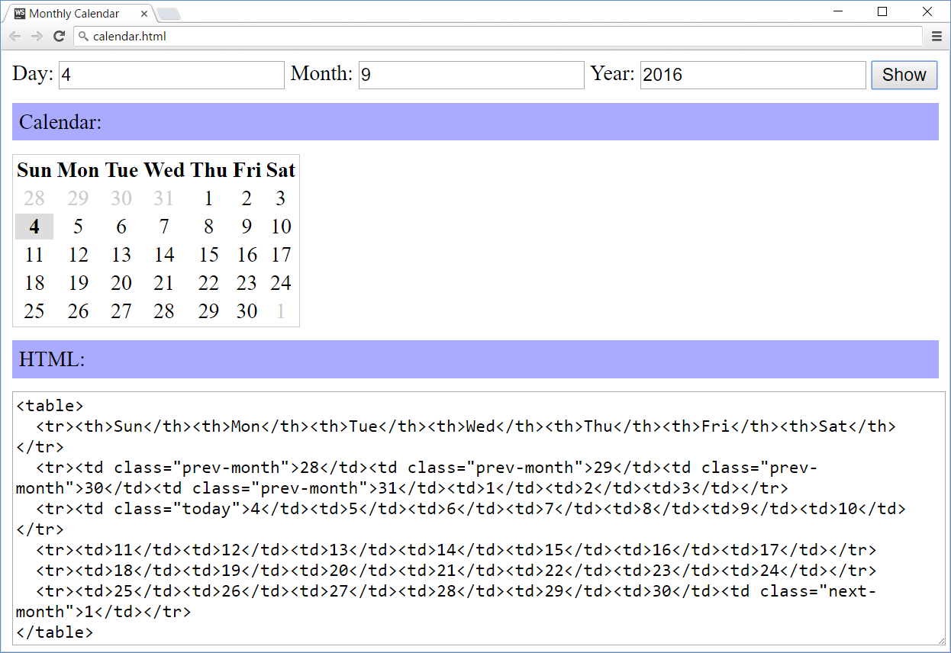

Hints
- Printing a calendar in JS without using an external library is not as simple as the previous problems in this exercise! It may take a few hours or even more to implement it correctly.
- Play with the class Date in JavaScript and make some calculations.
- You may also search in Google, e.g. try “JavaScript calendar code example”.
- Print the calendar table headings + days.
- Print the days from the previous month (if any).
  - Find the day of week for the first day of the input date.
  - If it is not Sunday, days from the previous month exist.
  - Go back a few days in the previous month to find the closest Sunday (first week day).
  - Start from it and print the days until the end of the previous month.
- Print the days from the current month.
  - Print the days, one after another.
  - Create a new table row after the last week day (Saturday).
- Print the days from the next month (if any).
  - Stop when you reach Saturday (the last week day).
- You may start from this code template:
