1. **Go to their website**

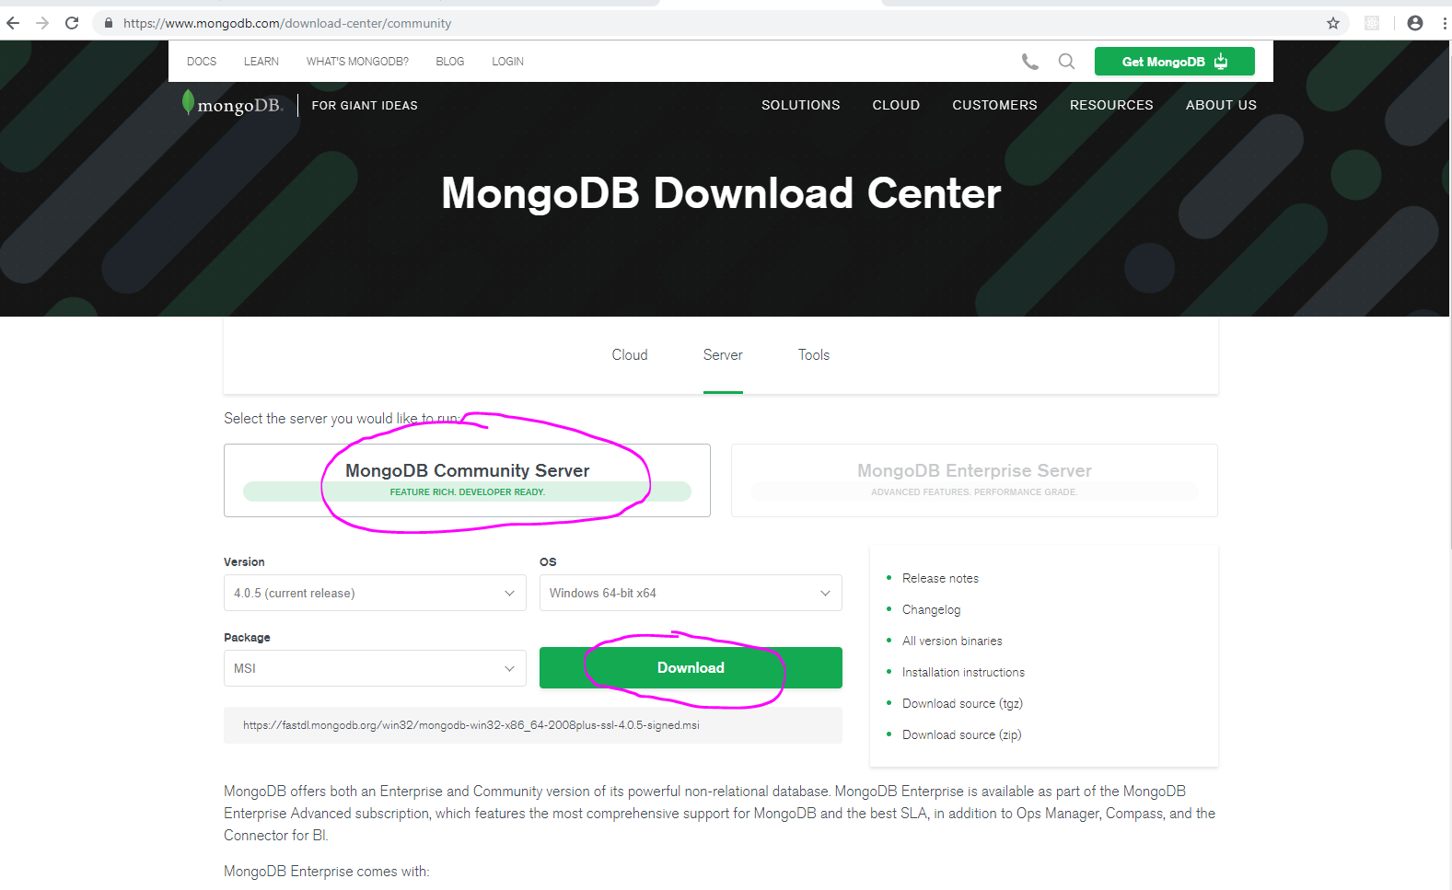

Choose Community Server version and click Download. You will download an .msi file you haven’t chosen another option.

1. **Open the .msi file and install**

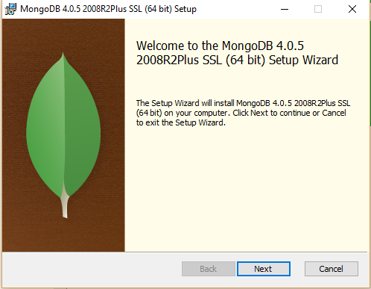

Click Next and then choose the Complete version

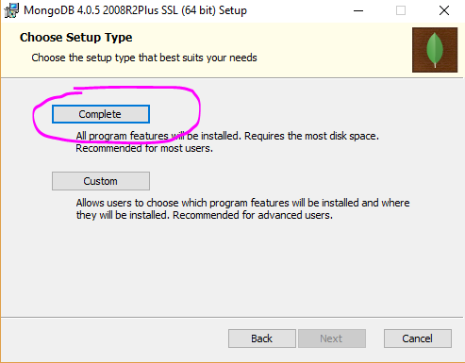

Then click Next again

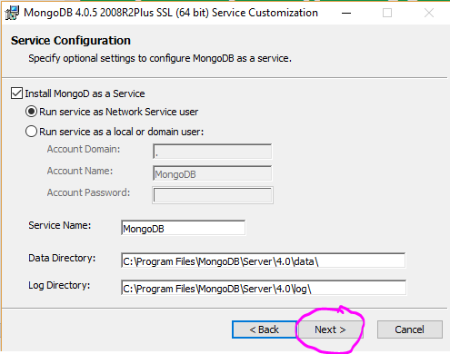

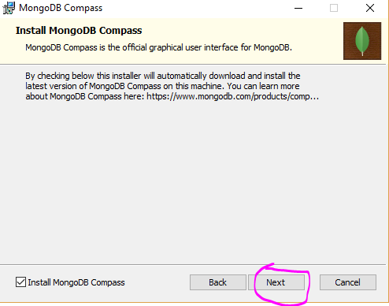

Follow the steps and wait for the whole installation process.

1. **Install drivers for Node JS**

After MongoDB is downloaded and installed we have to also make it work with Node JS. In order to do that from the Command Prompt we have to run the following command npm install mongodb -g if we want to install it globaly in NodeModules folder or we can run npm install mongodb -E to install it only in the current project.

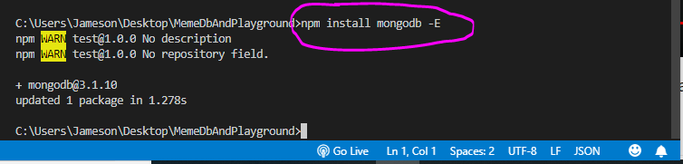

1. **Start your MongoDB**

After we have downloaded and installed MongoDB and then downloaded and installed mnogodb for NodeJS now we also have to run the application. In order to do that open Command Prompt where MongoDB is installed , by default it is C:\Program Files\MongoDB\Server\4.0\bin in the bin folder is the exe file of the database.

Now in the command prompt type mongod --dbpath E:\MongoData the E part of hard disk and folder MongoData are for example, you can specify where your database to be stored on the hard disk

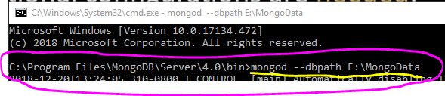

NOTE: You should not close the command prompt window once you run it, just minimize, otherwise database will not work.

NOTE: When specifing in which folder your database you want, for example E:\MongoData that folder have to be already existing, MongoDB will not create it automatically if it doesn’t exist and your database will not work.

1. **Check if all done correct**

To check if everything is working got back to VSCode and in the script with the server press F5 and wait couple of minutes to see if it will load. You should see the following result if everything is fine

