**README file for VBA-Challenge**

**VBA Homework: The VBA of Wall Street**

**Background**

In this homework assignment, I used VBA scripting to analyze real stock market data as well as do some additional challenging analysis.

**Before You Begin**

1. Created a new repository for this project called VBA-challenge. https://github.com/BZNUDS/VBA-challenge

**Did not add this homework to an existing repository**.

1. Added VBA files I use for this assignment.
   1. For the initial assignment see <https://github.com/BZNUDS/VBA-challenge/blob/main/VBA_Challenge_Initial_Assignment_Zdarsky_v1.vbs>
   2. For the Bonus Challenge, see https://github.com/BZNUDS/VBA-challenge/blob/main/VBA_Challenge_Bonus_Zdarsky_v2.vbs
2. These will be the main scripts to run for each analysis.

**Files**

* Multi_Year_Stock_Data - Run your scripts on this data to generate the final homework report.

**Stock Market Analyst**

**Instructions**

* Create a script that will loop through all the stocks for one year and output the following information:
  + The ticker symbol.
  + Yearly change from opening price at the beginning of a given year to the closing price at the end of that year.
  + The percent change from opening price at the beginning of a given year to the closing price at the end of that year.
  + The total stock volume of the stock.
* You should also have conditional formatting that will highlight positive change in green and negative change in red.
* The result should look as follows:

**BONUS**

1. For the Bonus Challenge, see https://github.com/BZNUDS/VBA-challenge/blob/main/VBA_Challenge_Bonus_Zdarsky_v2.vbs

* My solution was able to return the stock with the "Greatest % increase", "Greatest % decrease" and "Greatest total volume". The solution will look as follows:

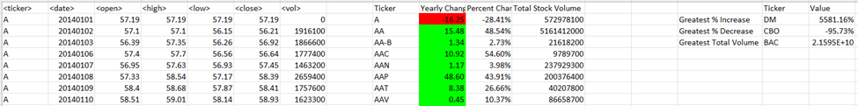

* Make the appropriate adjustments to your VBA script that will allow it to run on every worksheet, i.e., every year, just by running the VBA script once.

**Submission**

* To submit please upload the following to GitHub:
  + A screen shot for each year of your results on the Multi Year Stock Data.
    - VBA-Challenge_Screenshots_for_BONUS_assignment_v2
  + VBA scripts as separate files.
* Ensure you commit regularly to your repository and it contains a README.md file.
  + - VBA-Challenge_BONUS_README_Zdarsky_v2.1
* After everything has been saved, created a shareable link and submitted that to <https://bootcampspot-v2.com/>.