User Manual

1. Introduction

Robots only being able to perform a small number of tasks and frequently breaking down. Additionally, the robots could not carry soup or pour hot water and, importantly, they could not take customer orders.

1. Compile and Run

Extracts and move files under File Folder into Code Folder:

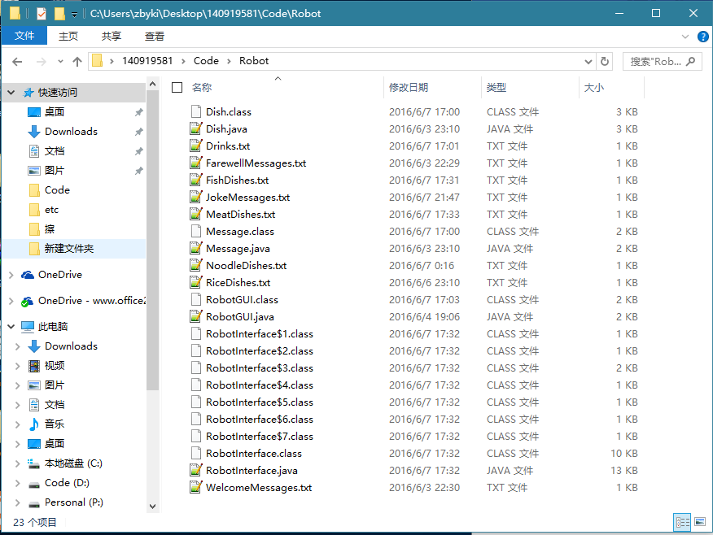

|  |  |  |
| --- | --- | --- |
|  | Compile | Run |
| RobotGUI.java | Javac RobotGUI.java | Java RobotGUI |

1. Operation
   1. When the robot first approaches the customer, a randomly-selected greening is showed on the GUI

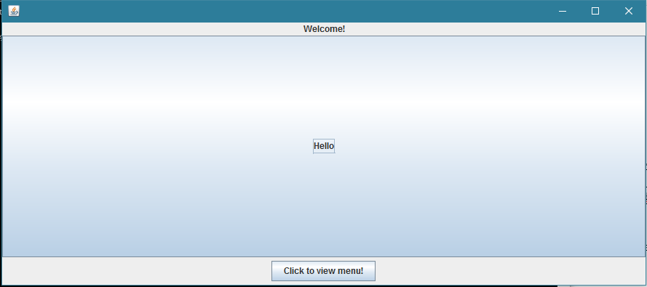

* 1. Click the greeting message. The robot then asks the customer if they wish to order a fish, meet, rice, noodle or drink. Something is interesting, the color in order is random.

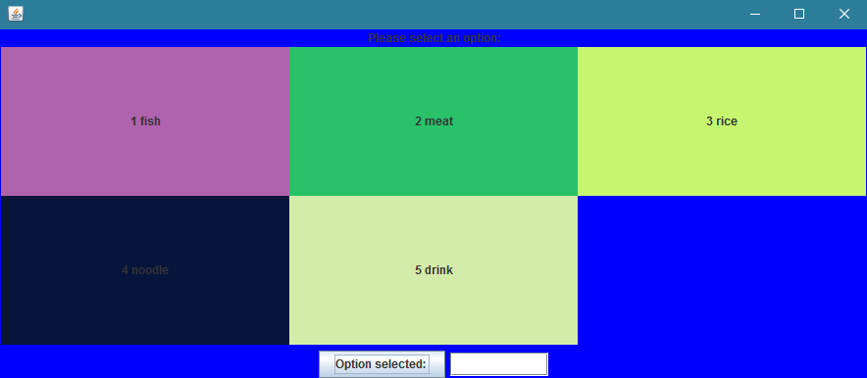

* 1. If the customer enters an incorrect option, the robot returns an error message.

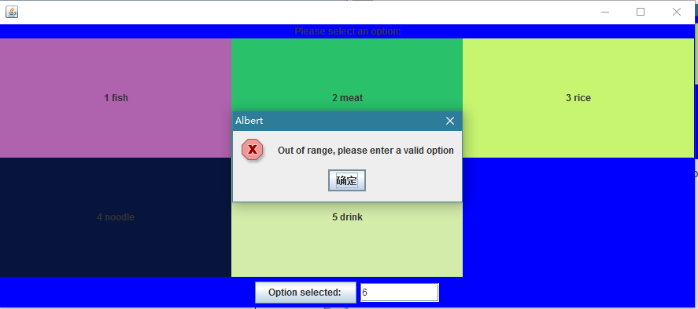

* 1. The robot allows a customer to enter an order of one dish or drink.

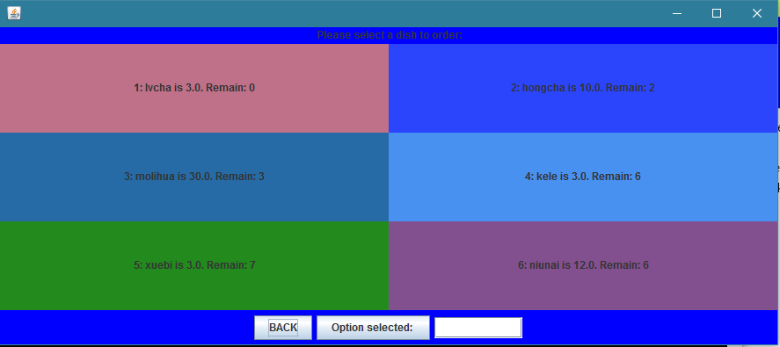

* 1. If the dish or drink selected is not available to order, the robot will recommend alternative dishes (within the same category) or drinks to the customer, until they eventually select one which is available.

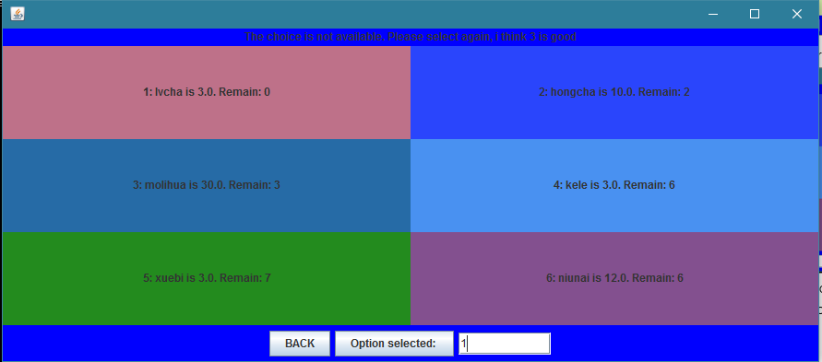

* 1. And you can use “BACK” return to the previous interface.

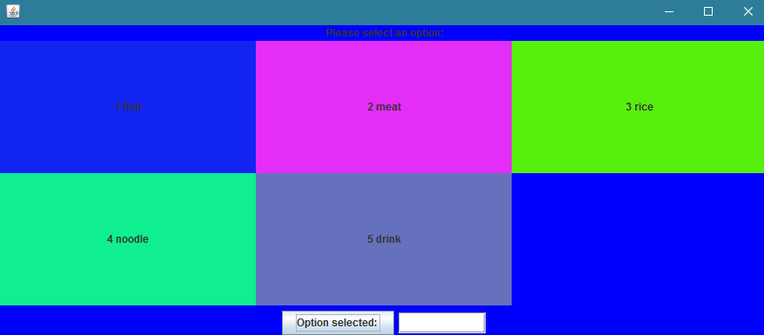

* 1. When the robot brings the dish or the drink to the customer, it should stay with the customer and tell jokers for entertainment; these jokes should be randomly-selected from a set of 4defined by yourselves.

Enter1: The customer can ask the robot to stop telling jokes.

Enter2: The customer can order another dish or drink.

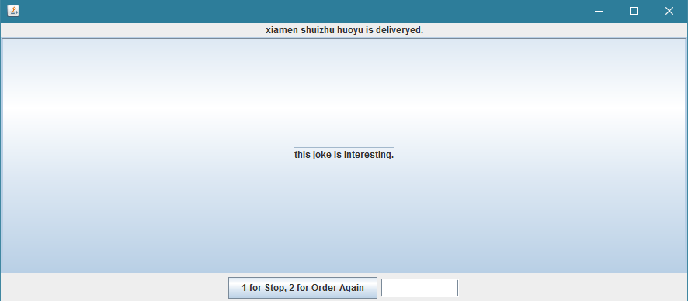

* 1. When the customer decides to leave the restaurant, the robot will display the total price for all dishes and drinks ordered during the visit. 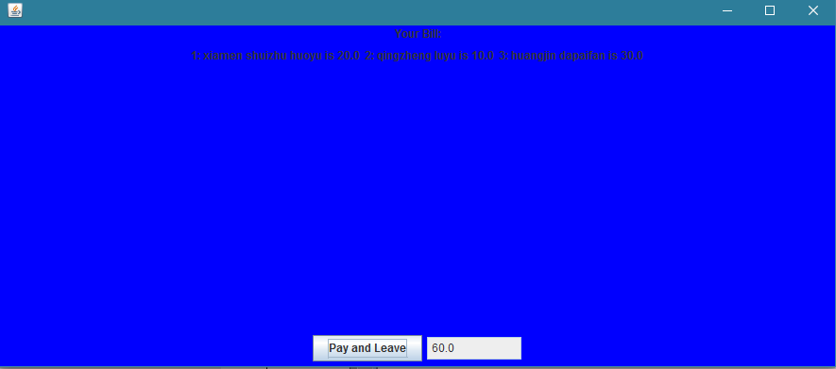
  2. When you stop after 30s activity will go to sleep, or directly back to the start interface. After 30s you can use “wake up” to back to the start interface.

