**BAGRAT PETROSYAN**

IT STUDENT

**CONTACT**

phone number:

+(374)93313363

E m a i l : [bagpetrosyan@gmail.com](mailto:bagpetrosyan@gmail.com)

HOBBIES

* Workout
* Play Chess
* play Guitar

# PROFILE

Hi, I'm 23 years. I study in IT area I know Phyton OOp and basic C++ programming

languages. I am experienced as a technician. I have experience with Arduino IDE and LEGO Mindstorms. I'm interested in Startups. It

was my 2nd year in University. From 2017- 2019 I served in the army. I also participated in "Tumo Summer Champ 2016 "as a student and I did a successful final exam presentation about robotics.

# EDUCATION

2005-2017

High School 2019 - 2023

Information technology - EUA(European university in Armenia), Armenia Yerevan city

# EXPERIENCE

VR game technical supporter 2019-2020

Technician Unit Company | 2021-

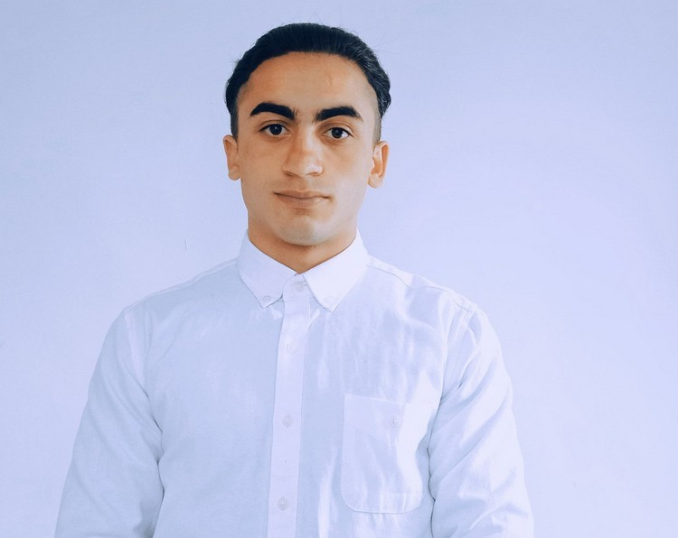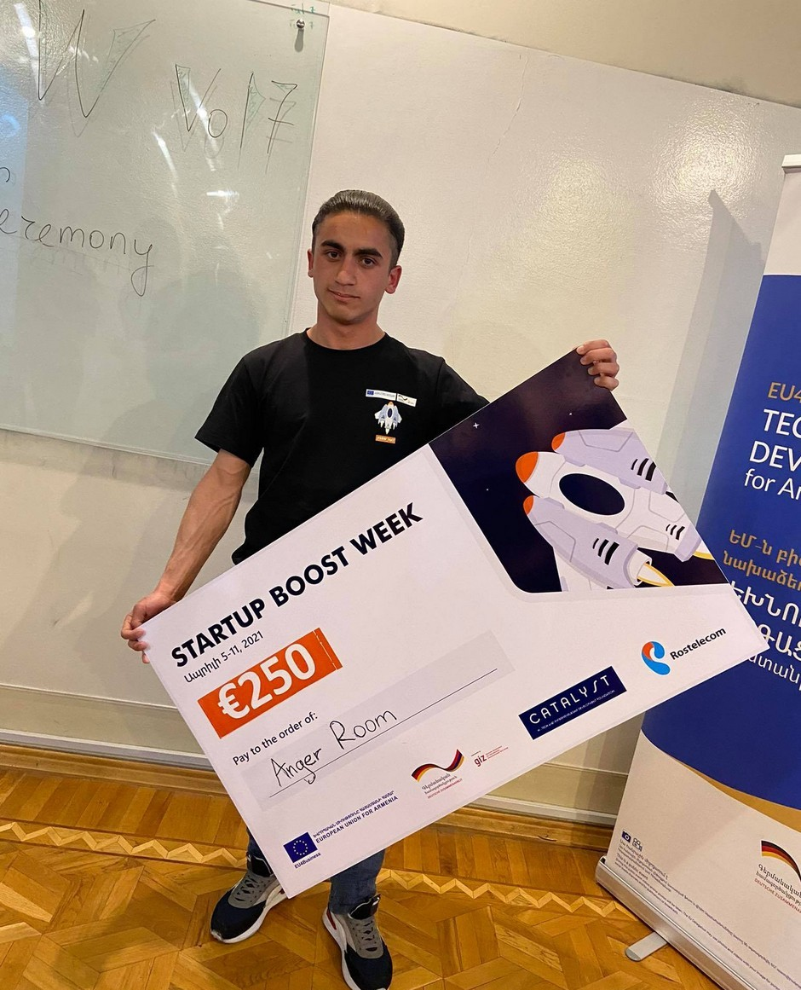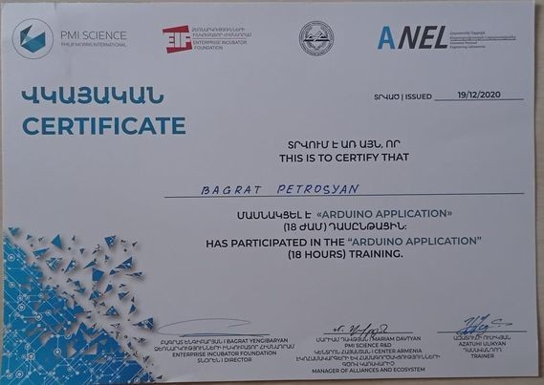

# SKILLS & QUALITIES

Armenian level English level Positive attitude Team Player

# RELATED PICTURES AND CERTIFICATIONS

2021_ winner in startup boost

week competition 2020 _Arduino IDE course certification

TUMO 2016 Camp presentation

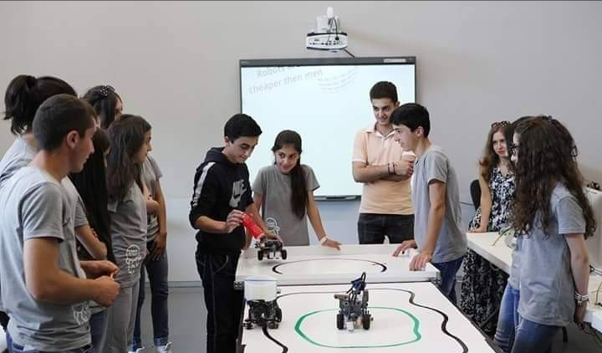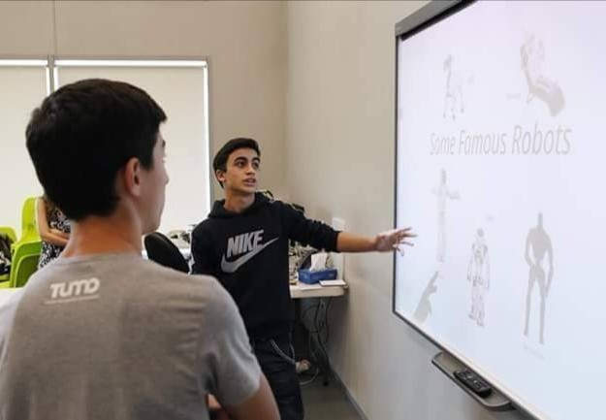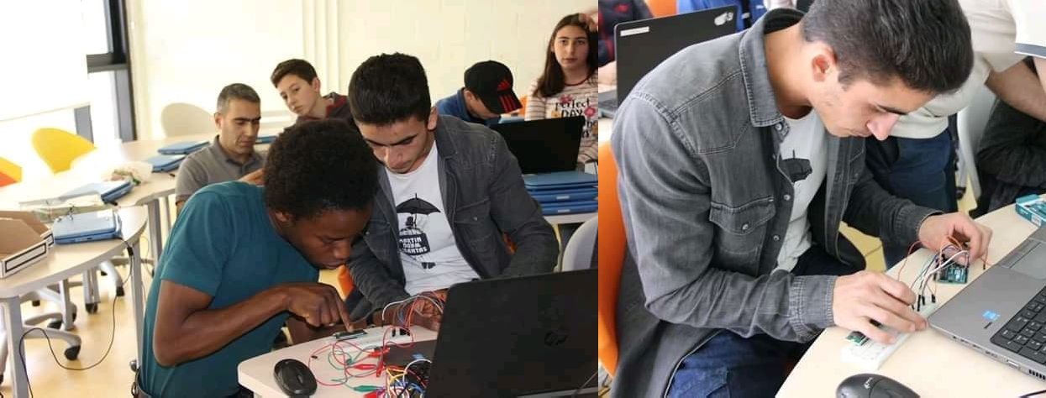

2019 Fab Lab Dilijan maker's day small project with

<<Arduino Uno>>