BAGRAT PETROSYAN
IT STUDENT

CONTACT
phone number:
+(374)93313363
E m a i l : bagpetrosyan@gmail.com

HOBBIES

- Workout
- Play Chess
- play Guitar

PROFILE
Hi, I'm 23 years. I study in IT area I know Phyton OOp and basic C++ programming
languages. I am experienced as a technician. I have experience with Arduino IDE and LEGO Mindstorms. I'm interested in Startups. It
was my 2nd year in University. From 2017- 2019 I served in the army. I also participated in "Tumo Summer Champ 2016 "as a student and I did a successful final exam presentation about robotics.

EDUCATION
2005-2017
High School 2019 - 2023
Information technology - EUA(European university in Armenia), Armenia Yerevan city

EXPERIENCE
VR game technical supporter 2019-2020
Technician Unit Company | 2021-






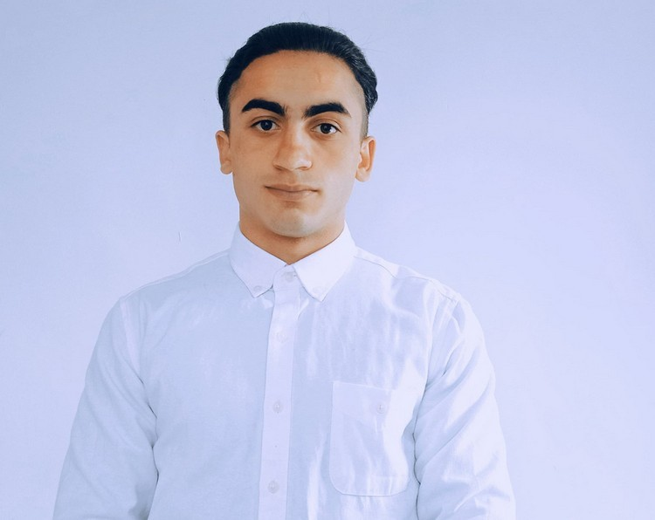
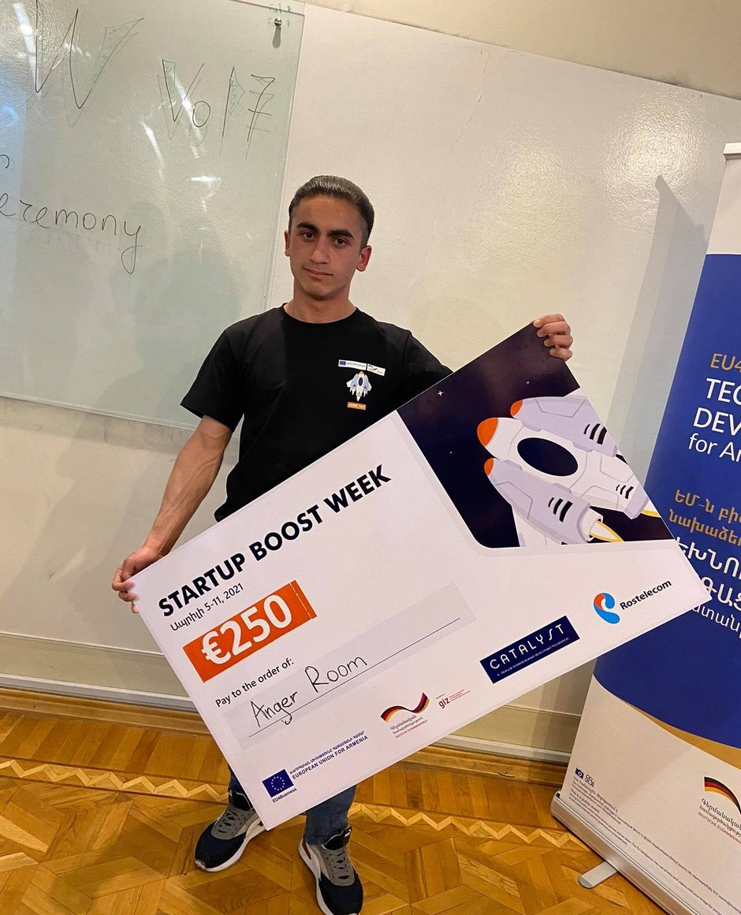
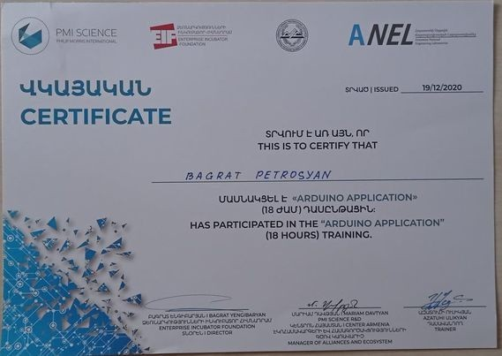

SKILLS & QUALITIES

Armenian level English level Positive attitude Team Player

RELATED PICTURES AND CERTIFICATIONS

2021_ winner in startup boost
week competition 2020 _Arduino IDE course certification

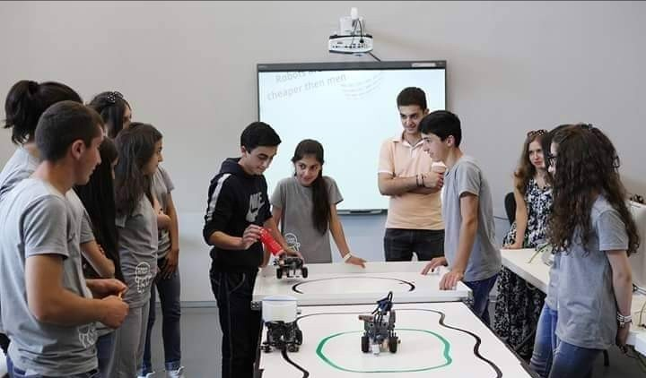
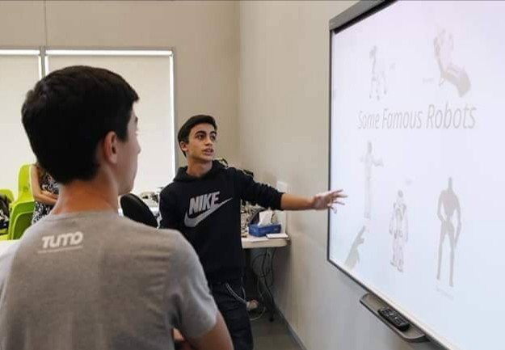
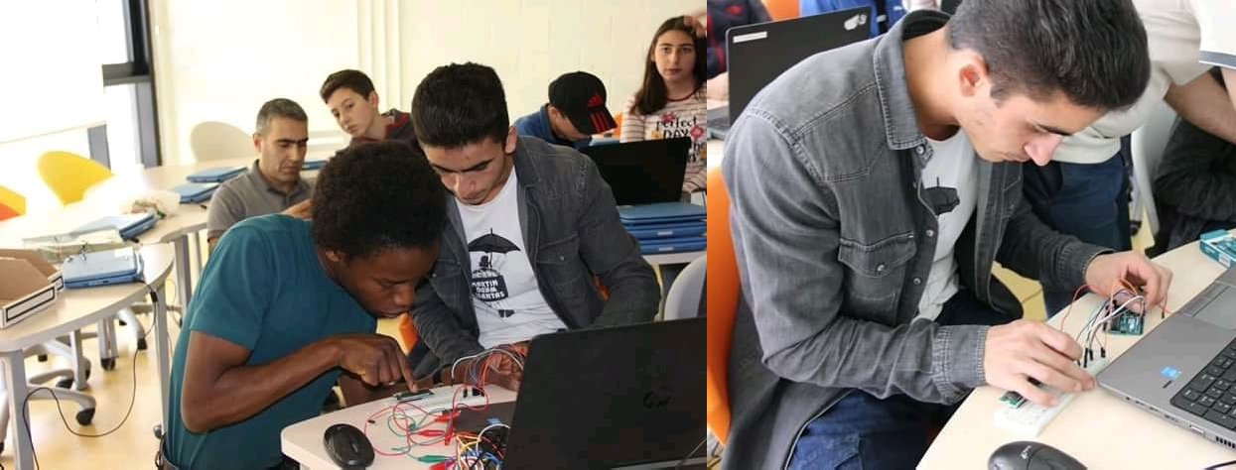
TUMO 2016 Camp presentation

2019 Fab Lab Dilijan maker's day small project with
<<Arduino Uno>>

