**Assignment – Agent based simulation Lab 5**

Lena Walcher

**1. Static modelling**

**1.1.3. Question:** What is a uniform distribution? Why would one use in certain cases a uniform distribution instead of the often used Gaussian distribution?

A uniform distribution is a distribution of data where each value is equally likely within a set range. Different to that is the Gaussian or normal distribution where values are clustered around the mean and more likely the closer they are to the mean value. It makes sense to use uniform distribution if one wants a random value to be drawn which is not representing a normal distributed variable/number. In this case we just want any number to be drawn within the range of -0.5 and 0.5 and we want each possible value to be equally likely so it makes sense to use a uniform distribution.

**1.3.1. Question:** Give two other examples of the use of field-agents in spatial or spatio-temporal simulation.

Field-agents could be animal territories or bodies of water which can change over time or any kind of store like in this example to simulate processes surrounding and including the store.

**1.5. Question:** What is approximately the range of values in the propensity of the foodstores? Compare this with the range in the propensity of the households. What is causing the observed difference?

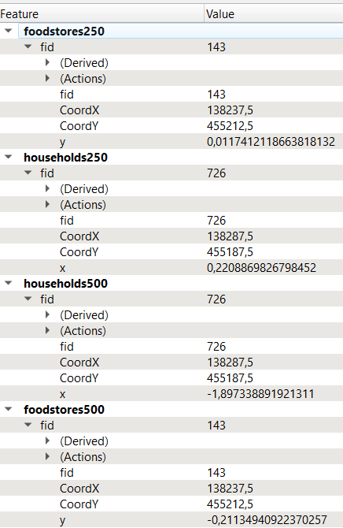The values in food stores (250) for y vary between -0,8698646018711964 and 1,8387347561344405 whereas the values in households for x vary between -1,9990673129166043 and 1,9997333872418768 which is within the boundaries defined in the script for healthy/unhealthy nutrition.

**1.5. Question:** What is the effect of the size of the neighborhood, for instance 250 or 500 m, on the resulting range in propensity values of the food stores? Explain your answer.

When comparing different neighborhood sizes of 500 and 250 and their effects on the propensity of the food store values one can see that the values for y change significantly. The minimum y-values are -0,48142962380970483 for food stores with a 500m neighborhood compared to -0,8698646018711964 with a smaller neighborhood. This shows that the values vary depending on how many households are included which is dependent on the radius around and therefore the area around the food stores. In this example the values got worse referring to a neighborhood considered less healthy on average with more households included.

**2. Spatio-temporal modelling**

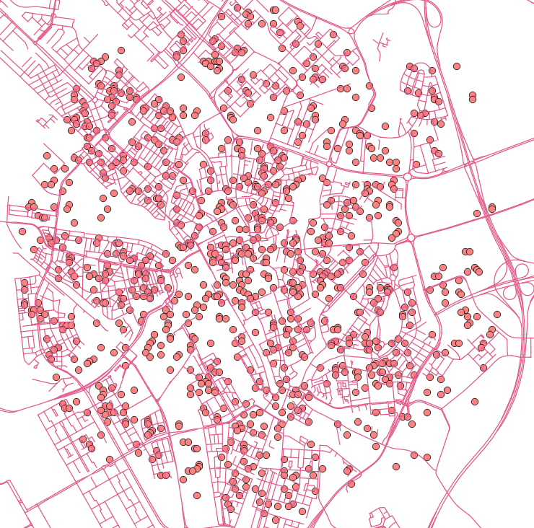**2.1. Question:** How does the value of the propensity change over time? What are the values at the last time step?

The value of the propensity changes as it gets closer to the default propensity which in this case was zero. So with a default propensity of the households being 0 the more time steps we run the closer we will get to the stable state.

It therefore makes sense that all values in the layer of the 12th and last time step are categorized in the range of -0.23 and 0.17 as 0, the default is included in this range.

**2.2. Question:** What is the highest value of the household propensity in the area at the end of the model run? Does it correspond with what you would expect from the value of the differential equation plot in equations.pdf, centre row, right plot?

The highest value for x in the households model with the 12th timestamp and therefore end of the model run is 1.77. The total effect of the food stores and the household effects in the differential equation shows the household propensities on the x-axis. The contribution to the rate of change was 1.19. The generated food store propensity effect of 0 or 0.2 was now added. The curve is therefore higher than it would be if the food stores had no effect. It therefore does correspond with what we would have expected by looking at the differential equation.

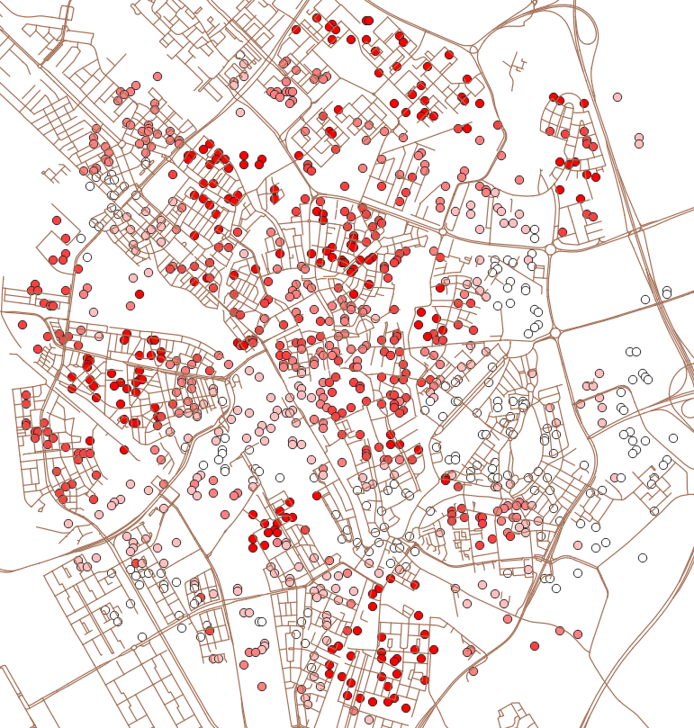**2.3. Question:** What is the spatial pattern in the household propensities at the start, halfway, and at the end of the run? Explain the mechanisms that determine the spatial pattern and how it changes over time.

At the start of the run at timepoint 1 one can see that there is still very scattered and spread out within the boundaries of -2 and 2. So as the food stores adjust the products they offer to the products a household consumes the values will get closer to the initial propensities of the model.

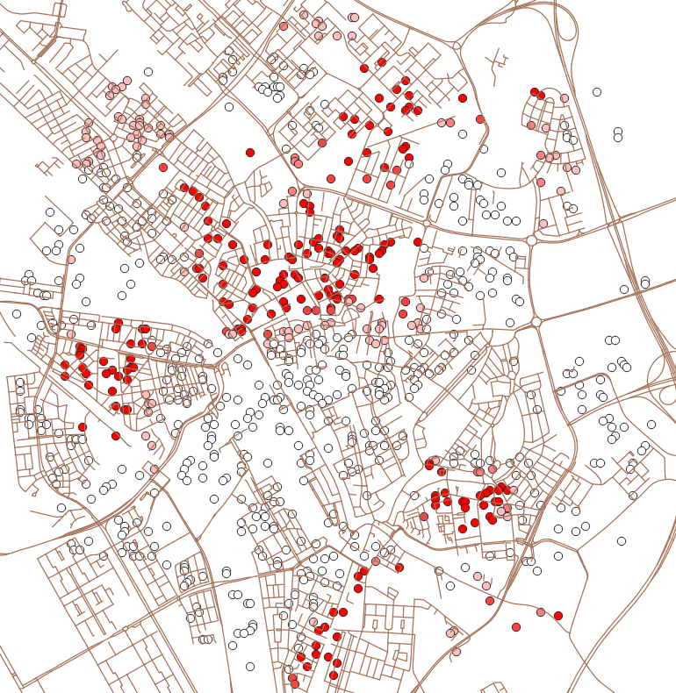At the halfway point and 6th timepoint one can already see that there is not as much variation within the boundaries. As the change of the food store propensities in the surroundings of the household now change over time, y is affected by it on every time step which shows that the values are moving towards the stable equilibria and the colors of the households representing the y value are now either closer to white or dark red.

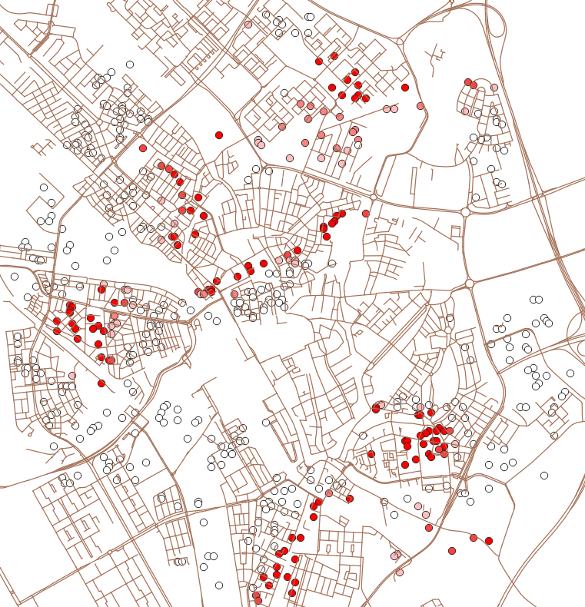

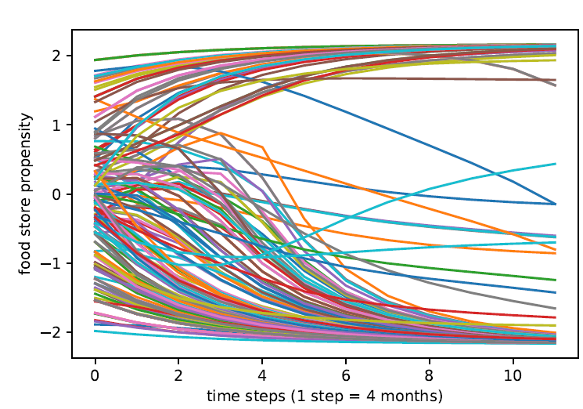In the last time point at the end of the run one can see that the extremes have formed. As the rate of change now changes with the propensity of the households and is not a fixed rate anymore, the change gets more obvious the further we go. The two stable equilibria can be seen as the values have now boiled down. The propensity of the households closes down on the propensity of the surrounding food stores. So that food stores changing their products offered and households changing consumption due to offered foods have adapted to each other to a point where the values are getting more and more stable. Over time the values therefore

The development of foodstores_y over the time steps shows the spread out at the time step 0 and moving closer to the stable equilibria of -2 and 2 with every time step. As the food store properties and household properties are updates as a function of their surroundings with every step. The values on the map that were neither dark red nor white are here represented as the lines that are still in the middle of the plot and have not moved further to the initial propensities of the households yet.