**The process we follow to process the signal (recorded file), includes the following steps:**

1. Since the recorded received signal contains silence, we remove the silence segments of the recorded file, to obtain a file that contains the tone only.

|  |
| --- |
| **Before Removing Silence** |
| Figure_1 |
| **After Removing Silence**  Notice that the reflections and echo cause the sound duration to be longer than the transmitted tone duration that is = 1000ms |
| Figure_2 |

1. We write the sound .wav file into array (samples)
2. To get (filtered\_samples), we apply BPF that passes frequencies within a certain range [smallest frequency, largest frequency] contained in the transmitted tone.
3. We obtain the magnitude spectrum of the (filtered\_samples), and we write the resultant magnitude values into a spectrum .csv file.

|  |
| --- |
| **Before Filtering** |
| Figure_3-1Figure_3 |
| **After Filtering** |
| Figure_4Figure_4 |

**Points to Discuss**

1. Apply the process of key extraction over each single transmitted tone, or concatenate the probes as in [1]. (In the paper [1], Alice and Bob exchange probe packets periodically and use these probe packets to measure the RSS values over the time domain) i.e. each party concatenate the probes that it received and apply key extraction on the resultant time series.
2. Apply quantization over chunks of the concatenated time series.
3. When dealing with time series, the magnitude values were spread over all the x-axis and hence it was making sense to quantize chunks, while in the case of the spectrum (specially in the linear scale rather than the dB), the magnitude values are negligible except in the range of the tone frequencies.

Maybe the quantization over chunks can make sense only if

* we will take the spectrum in dB,
* **or** if we apply the process of key extraction over the range of the tone frequencies. I.e, only in the part



* **or** if we concatenate the tones magnitude spectrum in the tone frequency range only (don’t know, imagining something like this)

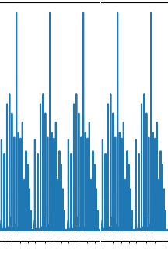

**Note:** In our case, we are taking spectrum, so will it help to concatenate the time series correspond to the consecutive tones (recordings of many consecutive tones in the same experiment), and then get the corresponding spectrum (the idea is only to increase number of points)

1. Premnath, S. N., S. Jana, J. Croft, P. L. Gowda, M. Clark, S. K. Kasera, N. Patwari, and S. V. Krishnamurthy, 2013 May, “Secret key extraction from wireless signal strength in real environments,” IEEE Transactions on Mobile Computing 12, 917– 930