

**Air Conditioning Project**

**Team Members:**

|  |
| --- |
| Alaa Ibrahim |
| Bassel Yasser |
| Sharpel Malek |
| Sherif Khadr |

Contents

INTRODUCTION 1

High Level Design 1

**01)** **Layered Architecture** 1

**02)** **Modules Description** 2

**03)** **Drivers’ Documentation** 3

Low Level Design 12

Figure 1: Project Layered Architecture 2

# INTRODUCTION

# High Level Design

## **Layered Architecture**

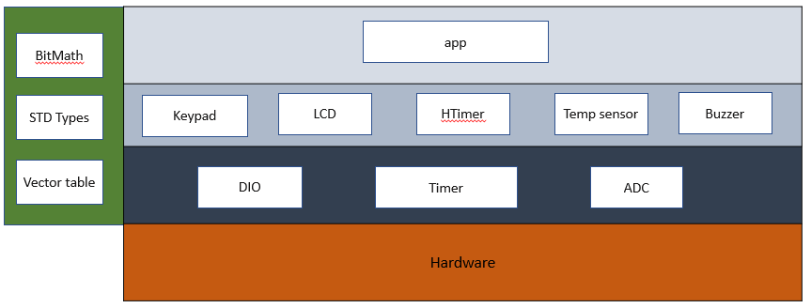

Figure : Project Layered Architecture

## **Modules Description**

**MCAL Layer:**

* **DIO:** For controlling GPIO pins
* **Timer:** Provides an interface with timer 0 low-level capabilities.
* **ADC:** Provides interface to control and read from ADC peripheral.

**HAL Layer:**

* **Keypad:** Deal witha set of buttons arranged in a block. The 3 x 3 matrix keypad usually is used as input in a project
* **LCD:** Use for display data
* **Temp Sensor:** Provides functions to get readings from temperature sensor.
* **Buzzer:** Simple module to control a buzzer.
* **HTimer:** Provides high-level functions using the lower level timer 0 module capabilities.

**Service Layer:**

* **STD_Types:** Contains all the standard types used by all the layers.
* **BIT_Math:** Provides bit-wise operations.
* **Vect_table:** Contains all interrupt vectors and provides macros for dealing with general interrupt.

**Application Layer:**

Contains the main logic of the project.

## **Drivers’ Documentation**

**MCAL Layer:**

* **DIO:**

/*

* AUTHOR : Bassel Yasser

* Function : DIO_s8SETPinDir

* Description : Set Pin Direction

* Arguments :

* - enPinCopy {DIO_PINA_0...., DIO_PIND_7}

* - enPortDir {INPUT , OUTPUT}

* Return : Sint8_t

*/

Sint8_t **DIO_s8SETPinDir** (enu_pin enPinCopy, enu_dir enPortDir)

/*

* AUTHOR : Bassel Yasser

* Function : DIO_s8SETPinVal

* Description : Set Pin Value

* Arguments :

* - enPinCopy {DIO_PINA_0...., DIO_PIND_7}

* - enPortDir {HIGH , LOW}

* Return : Sint8_t

*/

Sint8_t **DIO_s8SETPinVal** (enu_pin enPinCopy, enu_val enPortVal)

/*

* AUTHOR : Bassel Yasser

* Function : DIO_s8GETPinVal

* Description : Set Pin Value

* Arguments :

* - enPinCopy {DIO_PINA_0...., DIO_PIND_7}

* - pu8Val address of variable that u want to save value on it

* Return : Sint8_t

*/

Sint8_t **DIO_s8GETPinVal** (enu_pin enPinCopy, Uint8_t* pu8Val)

* **Timer:**

/**

* \brief Initialize the timer with given mode

* \param u8_a_Mode

* \return en_TIMErrorState_t

*/

en_TIMErrorState_t TIM0_voidInit(en_TIMMode_t u8_a_Mode);

/**

* \brief Start the timer clock after prescaling it with given value

* \param u8_a_prescaler

* \return en_TIMErrorState_t

*/

en_TIMErrorState_t TIM0_Start(en_TIM_CLK_SELECT_t u8_a_prescaler);

/**

* \brief Function to stop timer 0

* \return void

*/

void TIM0_Stop();

/**

* \brief Set the timer to start from a certain value

* \param u8_a_FlagValue The value to start the timer from

* \return void

*/

void TIM0_SetValue(Uchar8_t u8_a_startValue);

/**

* \brief Function to get the value of the overflow flag of timer 0

* \param u8_a_FlagValue reference to a variable to store flag value *

* \return en_TIMErrorState_t

*/

en_TIMErrorState_t TIM0_GetOVF(Uchar8_t* u8_a_FlagValue);

/**

* \brief Function to clear timer 0 overflow flag

* \return void

*/

void TIM0_ClearOVF(void);

/**

* \brief Function to get the timer state (running/stopped)

* \param u8_a_State reference to a variable to store timer state

* \return en_TIMErrorState_t

*/

en_TIMErrorState_t TIM0_GetState(en_TIMState_t* u8_a_State);

/**

* \brief Function to set a function to call when the timer0

* Overflow Interrupt is triggered

* \param pv_a_CallbackFn reference to the function to call

* \return en_TIMErrorState_t

*/

* ADC

/* Struct Contain all adc information to config it */

typedef struct

{

void(*interruptHandler)(void);

EN_ADC_REFERENCE_SELECTION_BITS_t referenceSource;

EN_ADC_ADJUST_RESULT_t resultAdjust;

EN_ADC_PRESCALER_SELECTION_t prescalerDivision;

EN_ADC_EVENT_TRIGGER_SOUREC_t triggerSource;

}ST_ADC_CFG_t;

/**

* \brief : This Function Use To Init The Adc It Set Bits For Prescaler , Refrence Source , event trigger resource and Adjust Resualt

*

* \param : const ST_ADC_CFG_t *_adc

*

* \return : Std_ReturnType

*/

Std_ReturnType ADC_Init(const ST_ADC_CFG_t *_adc)

/**

* \brief : This Function Use To Disable The ADC

*

* \param : const ST_ADC_CFG_t *_adc

*

* \return : Std_ReturnType

*/

Std_ReturnType ADC_Deinit(const ST_ADC_CFG_t *_adc)

/**

* \brief : This Function Is Used To Select ADC Channel

*

* \param : const ST_ADC_CFG_t *_adc

* \param : EN_ADC_CHANNEL_SELECTION_t _channel

*

* \return : Std_ReturnType

*/

Std_ReturnType ADC_SetChannel(const ST_ADC_CFG_t *_adc , EN_ADC_CHANNEL_SELECTION_t _channel)

/**

* \brief : This Function Use To Start Conversion

*

* \param : const ST_ADC_CFG_t *_adc

*

* \return : Std_ReturnType

*/

Std_ReturnType ADC_StartConversion(const ST_ADC_CFG_t *_adc)

/**

* \brief : This Function Use To Polling On The ADC Flag To Return The Conversion Resualt

*

* \param : const ST_ADC_CFG_t *_adc

* \param : Uint16_t *_ConversionResult

*

* \return : Std_ReturnType

*/

Std_ReturnType ADC_GetConversionResult(const ST_ADC_CFG_t *_adc , Uint16_t *_ConversionResult)

/**

* \brief : This Function Use To Make All Operation Of The Adc

*

* \param : const ST_ADC_CFG_t *_adc

* \param : EN_ADC_CHANNEL_SELECTION_t _channel

* \param : Uint16_t *_ConversionResult

*

* \return Std_ReturnType

*/

Std_ReturnType ADC_Conversion(const ST_ADC_CFG_t *_adc , Uint16_t *_ConversionResult , EN_ADC_CHANNEL_SELECTION_t _channel)

**HAL Layer:**

* **Keypad:**

// Macros

#define R1 DIO_PINC_2

#define R2 DIO_PINC_3

#define R3 DIO_PINC_4

#define C1 DIO_PINC_5

#define C2 DIO_PINC_6

#define C3 DIO_PINC_7

// user defined datatypes

typedef enum EN_KEYPAD_BTNS

{

KEY_INCREAMENT=0,

KEY_DECREAMENT,

KEY_SET,

KEY_ADJUST,

KEY_RESET,

KEY_6,

KEY_7,

KEY_8,

KEY_9,

KEY_NOTHING

}EN_KEYPAD_BTNS;

// functions prototypes

/*************************************************************************************************************

*

Name : KEYPAD_init()

Description : This Function Initializes keypad pins (Rows are outputs & Columns are inputs).

ARGS : void

return : void

************************************************************************************************************/

void KEYPAD_init(void);

/*************************************************************************************************************

*

Name : KEYPAD_GetButton

Description : This Function loops over other three functions (Checks (R1,R2,R3)).

ARGS : void

return : the pressed key or Nothing pressed

************************************************************************************************************/

EN_KEYPAD_BTNS KEYPAD_GetButton(void);

/*************************************************************************************************************

*

Name : KEYPAD_checkR1 , KEYPAD_checkR2, KEYPAD_checkR3

Description : functions are checking the entire row if it pressed or not.

ARGS : void

return : the pressed key or Nothing pressed

************************************************************************************************************/

EN_KEYPAD_BTNS KEYPAD_checkR1(void);

EN_KEYPAD_BTNS KEYPAD_checkR2(void);

EN_KEYPAD_BTNS KEYPAD_checkR3(void);

* **HTimer:**

/**

* \brief Generate Synchronous delay (busy waiting)*

* \param Copy_delayTime Desired delay

* \param Copy_timeUnit Time units (Seconds, mSeconds, uSeconds)

*

* \return en_HTIMErrorState_t

*/

en_HTIMErrorState_t TIM0_SyncDelay(Uint32_t u32_a_delay, en_timeUnits_t u8_a_timeUnit);

/**

* \brief Generates delay asynchronously

* \param u32_a_delay desired delay

* \param u8_a_timeUnit delay time units

* \param Copy_pvCallbackFn function to call when delay is complete

*

* \return en_TIMErrorState_t

*/

en_HTIMErrorState_t TIM0_AsyncDelay(Uint32_t u32_a_delay, en_timeUnits_t u8_a_timeUnit, void (*Copy_pvCallbackFn)(void));

/**

* \brief Function to end a delay asynchronously

* To Stop Async Delay: No Restrictions

* To Stop Sync Delay: should only be called in an ISR/Callback function

*

* \return void

*/

void TIM0_AsyncEndDelay();

* **HLCD:**

/*

* function : HLCD_vidInit

* description : func to set LCD initialization

* input param : void

* return : void

* */

**void** **HLCD_vidInit**(**void**)

/*

* function : HLCD_vidWritecmd

* description : func to configure some commands on lcd

* input param :

* u8commandCopy --> take lcd cmd instructions from instruction table <https://components101.com/sites/default/files/component_datasheet/16x2%20LCD%20Datasheet.pdf>

* return : void

* */

**void** **HLCD_vidWritecmd**(Uint8_t u8commandCopy)

/*

* function : HLCD_vidWriteChar

* description : func to write char on lcd

* input param : u8CharCopy -> take ascii code of char or char address on CGROM

* return : void

* */

**void** **HLCD_vidWriteChar**(Uint8_t u8CharCopy)

/*

* function : HLCD_ClrDisplay

* description : func to clear anything on lcd

* input param : void

* return : void

* */

**void** **HLCD_ClrDisplay**(**void**)

/*

* function : HLCD_gotoXY

* description : func to determine position which char print at this position on lcd ### NOTE : (2rows x 16coloms)

* input param :

* row -> take row number 0 or 1

* pos -> take colom number from 0 ~ 16

* return : void

* */

**void** **HLCD_gotoXY**(Uint8_t row, Uint8_t pos)

/*

* function : HLCD_WriteString

* description : func to write string on lcd

* input param : str --> which take string as argument

* return : void

* */

**void** **HLCD_WriteString**(Uint8_t* str)

/*

* function : HLCD_WriteInt

* description : func to write integer number on lcd

* input param : number --> which take number as argument

* return : void

* */

**void** **HLCD_WriteInt**(Uint32_t number)

/*

* function : HLCD_vidCreatCustomChar

* description : func to store new patterm on CGRAM

* input param :

* pu8custom -> take pointer to array which having LCD Custom Character Generated data ### take only 8 characters

* u8Location -> determine location on CGRAM [0 ~ 8]

* return : void

* */

**void** **HLCD_vidCreatCustomChar**(Uint8_t* pu8custom, Uint8_t u8Location)

* **Buzzer**

/**

* \brief Initialize buzzer pin as output

* \param pst_a_buzzer reference to buzzer

* \return void

*/

void BUZ_Init(st_Buzzer_t* pst_a_buzzer);

/**

* \brief Turn the buzzer on/off

* \param pst_a_buzzer reference to buzzer

* \param u16_a_state BUZ_ON (or) BUZ_OFF

* \return en_BuzzerErrorState_t

*/

en_BuzzerErrorState_t BUZ_SetState(st_Buzzer_t* pst_a_buzzer, en_BuzzerState_t en_a_state);

* **Temperature Sensor**

/**

* \brief Function to initialize the sensor port/pin

* \param pst_a_sensor reference to sensor info

* \return void

*/

void TSENSOR_Init(st_TempSensor_t* pst_a_sensor);

/**

* \brief Function to get the current sensor reading

* \param pst_a_Sensor reference to sensor info

* \param f32_a_Value reference to variable to store Analog value

*

* \return en_SensorError_t

*/

en_SensorError_t TSENSOR_ReadValue(st_TempSensor_t *pst_a_Sensor, float32_t *f32_a_Value);

**Application Layer:**

/**

* \brief Initialize all modules and execute welcome routine

*

* \param

*

* \return void

*/

void APP_Init(void);

/**

* \brief Application main logic

*

* \param

*

* \return void

*/

void APP_Start(void);

/**

* \brief Initialize temperature adjustment process

*

* \param

*

* \return void

*/

static void APP_adjustInit(void);

/**

* \brief timeout callback function

*

* \return void

*/

void timeout(void);

# Low Level Design

**MCAL Layer:**

* **DIO:**

Sint8_t **DIO_s8SETPinDir** (enu_pin enPinCopy, enu_dir enPortDir)

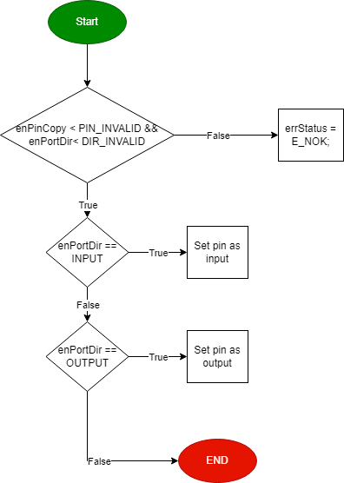

Sint8_t **DIO_s8SETPinVal** (enu_pin enPinCopy, enu_val enPortVal)

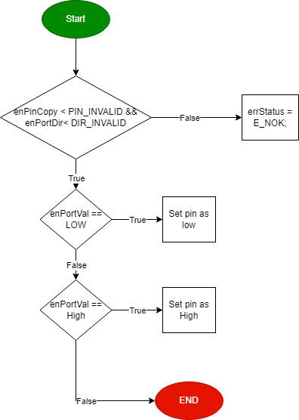

Sint8_t **DIO_s8GETPinVal** (enu_pin enPinCopy, Uint8_t* pu8Val)

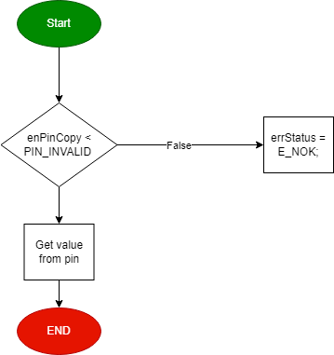

* **Timer:**

**TIM0_Init**

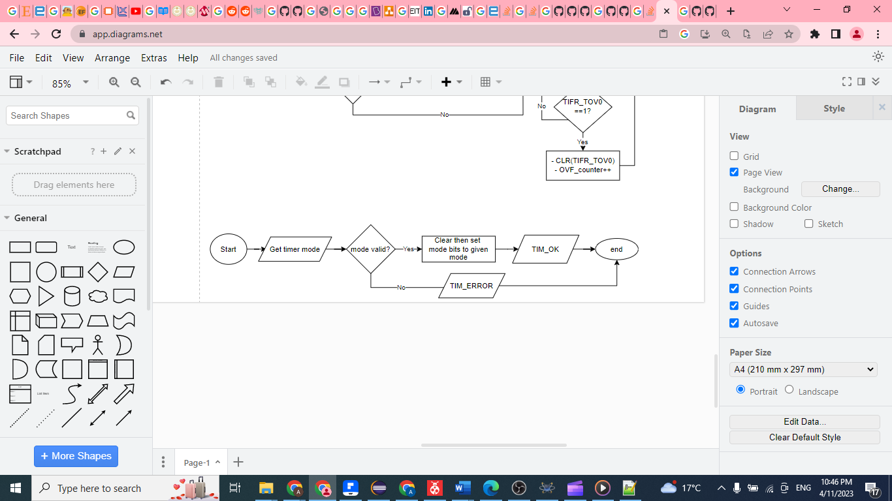

**TIM0_Start**

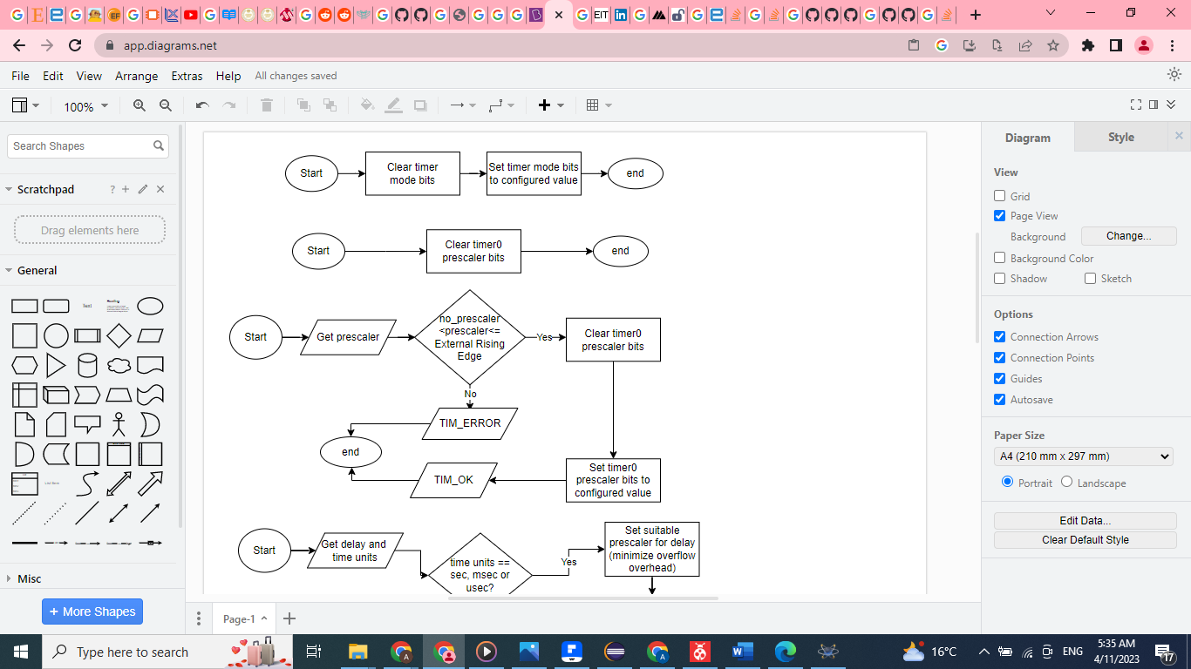

**TIM0_Stop**



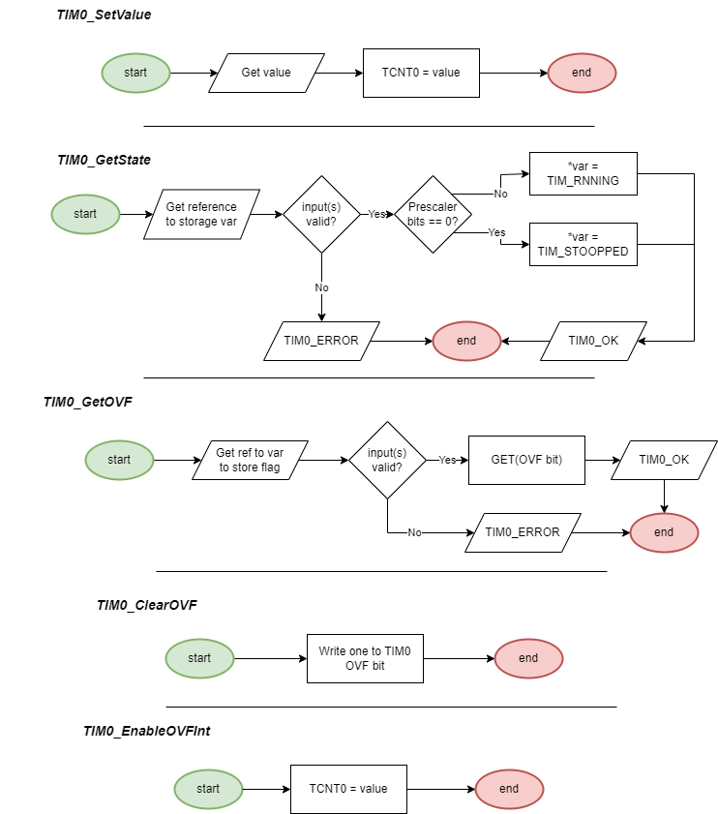

* **ADC**
* ADC_Init

* **ADC_Deinit**

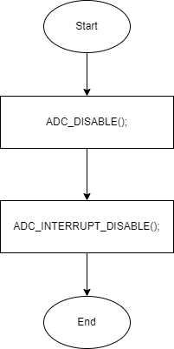

* **ADC_SetChannel**

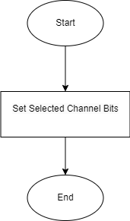

* **ADC_StartConversion**

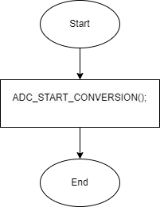

* **ADC_GetConversionResult**

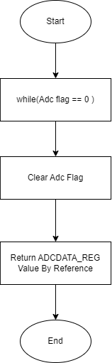

* **ADC_Conversion**

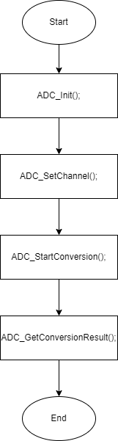

**HAL Layer:**

* **Timer0**

**HTIM0_SyncDelay**

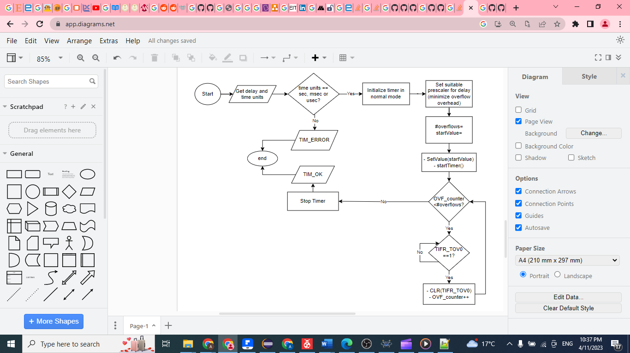

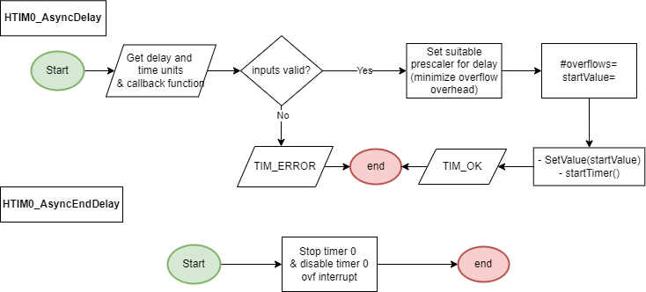

* **LCD:**

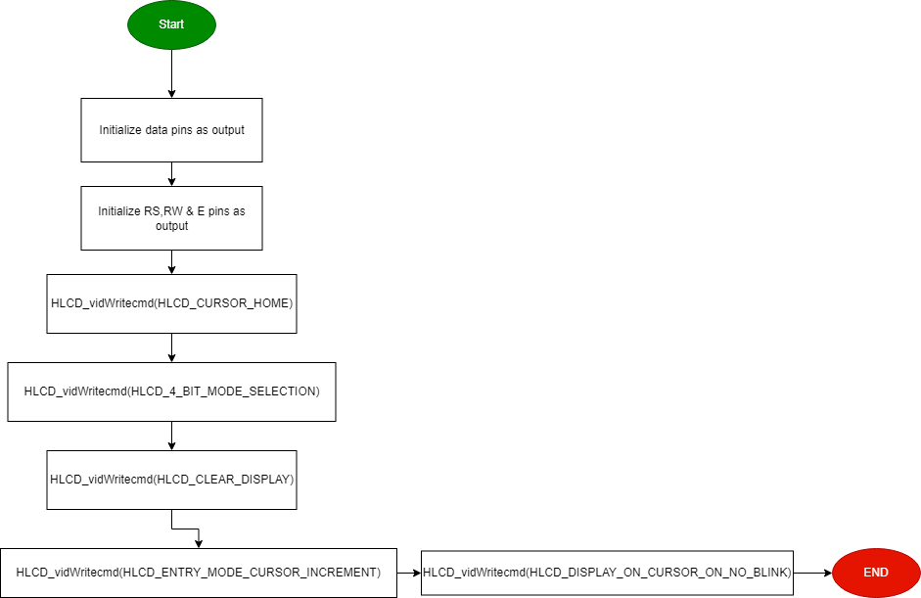**void** **HLCD_vidInit**(**void**)

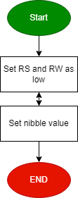**void** **HLCD_vidWritecmd**(Uint8_t u8commandCopy)

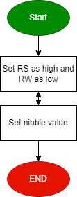

**void** **HLCD_vidWriteChar**(Uint8_t u8CharCopy)

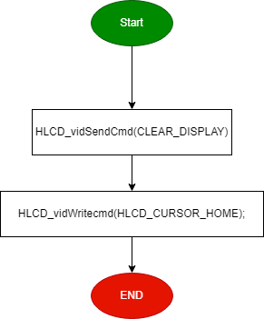**void** **HLCD_ClrDisplay**(**void**)

**void** **HLCD_gotoXY**(Uint8_t row, Uint8_t pos)

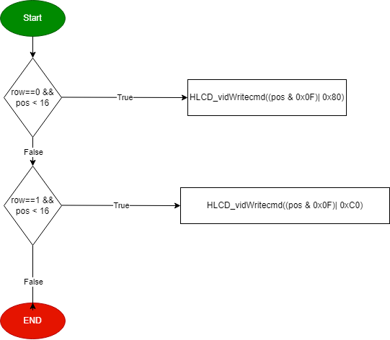

**void** **HLCD_WriteString**(Uint8_t* str)

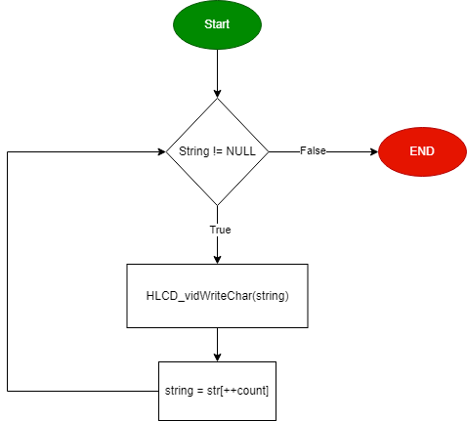

**void** **HLCD_WriteInt**(Uint32_t number)

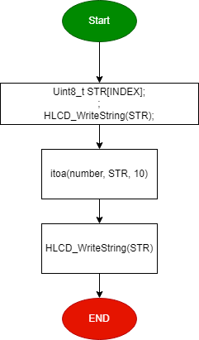

**void** **HLCD_vidCreatCustomChar**(Uint8_t* pu8custom, Uint8_t u8Location)

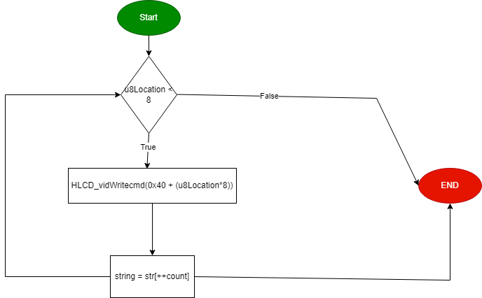

* **Keypad :**

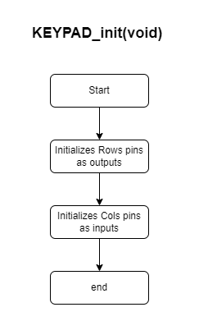

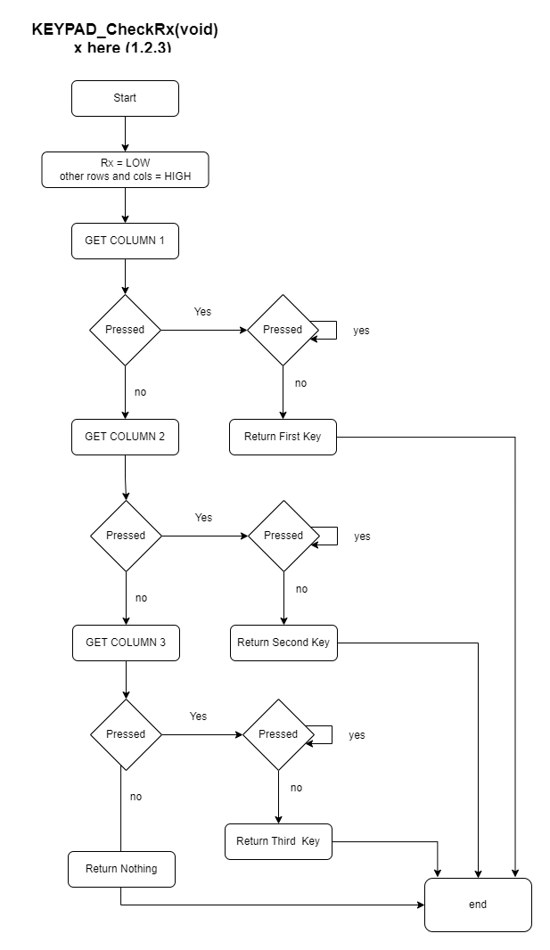

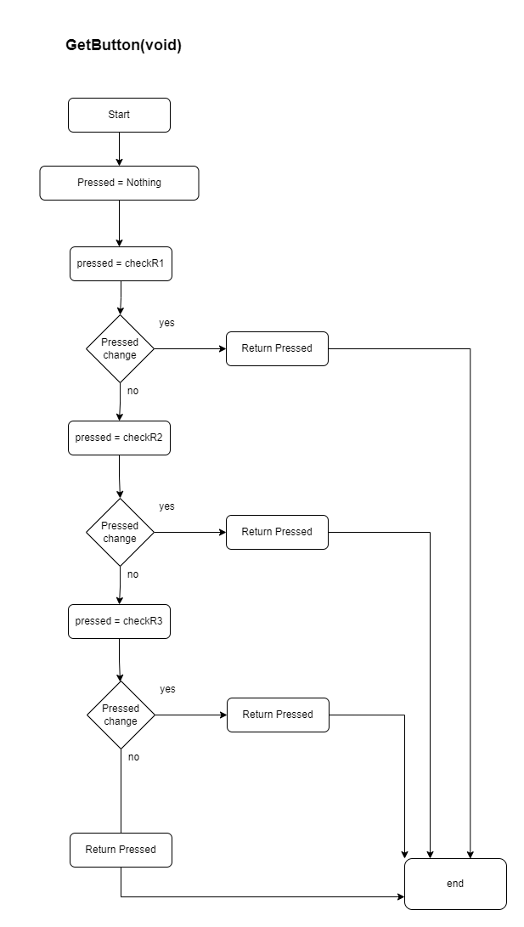

* **Buzzer**

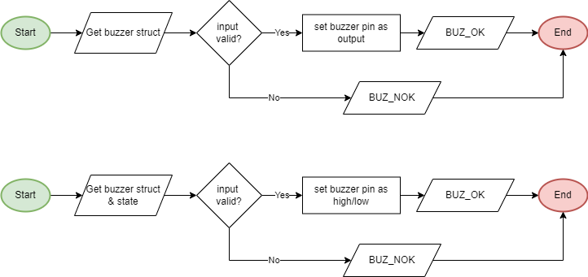

**BUZ_SetState**

**BUZ_Init**

* 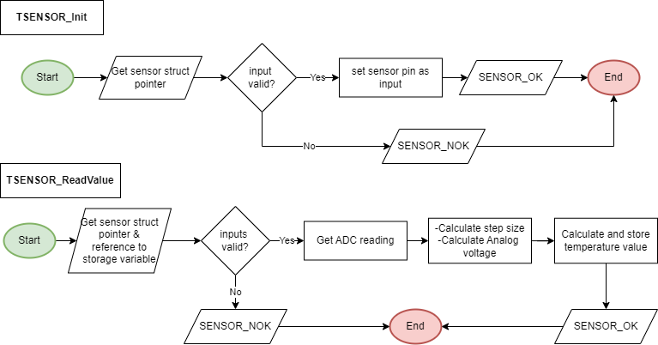**Temperature Sensor**

**Application Layer:**

