

**Simple ATM Machine**

**Team Members:**

|  |
| --- |
| Alaa Ibrahim |
| Bassel Yasser |
| Sharpel Malek |
| Sherif Khadr |

Contents

INTRODUCTION 1

High Level Design 1

**01)** **Layered Architecture** 1

**02)** **Modules Description** 2

**03)** **Drivers’ Documentation** 3

**MCAL Layer** 3

• **DIO** 3

• **Timer 0** 4

• **EXTINT:** 5

• **I2C:** 6

• **UART:** 8

• **SPI:** 9

**HAL Layer:** 10

• **Keypad** 10

• **HTimer:** 11

• **HLCD** 12

• **Buzzer** 13

• **Button** 13

• **HEXT_INT** 14

• **HSPI** 14

• **EEPROM:** 15

**Card_Database Layer (CARD MCU)** 17

**ATM_MODULE Layer (ATM MCU)** 18

• **ATM:** 18

• **Database_check:** 19

**Application Layer:** 20

• **Card MCU** 20

• **ATM MCU** 20

Low Level Design 21

**MCAL Layer:** 21

• **DIO** 21

• **Timer:** 24

• **EXTINT:** 26

• **UART:** 29

• **SPI:** 33

• **I2C:** 34

**HAL Layer** 38

• **HTimer0** 38

• **HSPI** 39

• **LCD** 40

• **Keypad** 47

• **Buzzer** 50

• **HEXTINT:** 51

• **Button:** 52

• **EEPROM** 53

**Card_Database Layer (CARD MCU)** 58

• **Database_check:** 62

• **ATM Module** 66

**Application Layer:** 71

• **Card App** 71

• **ATM App** 71

Figure 1 ATM MCU Layered Architecture 1

Figure 2 Card MCU Layered Architecture 1

Figure 3 DIO_s8SETPinDir Flow Chart 21

Figure 4 DIO_s8SETPinVal Flow chart 22

Figure 5 DIO_s8GETPinVal Flow Chart 23

Figure 6 TIM0_Init Flow Chart 24

Figure 7 TIM0_Start Flow Chart 24

Figure 8 TIM0_Stop Flow Chart 24

Figure 9 TIM0 remaining Flow Charts 25

Figure 10 EXTINT: Set_Global_Interrupt 26

Figure 11 EXTINT_Init flow chart 27

Figure 12 EXTINT_CALLBACK flow chart 28

Figure 13 USART_init flow chart 29

Figure 14 USART_receiveData flow chart 30

Figure 15 USART_sendData flow chart 30

Figure 16 USART_sendString flow chart 31

Figure 17 USART_receiveString flow chart 32

Figure 18 Flow charts of SPI APIs 33

Figure 19 i2c_init_master flow chart 34

Figure 20 i2c_start flow chart 34

Figure 21 i2c_repeated_start flow chart 35

Figure 22 i2c_send_slave_address_with_write_req flow chart 35

Figure 23 i2c_send_slave_address_with_read_req flow chart 36

Figure 24 i2c_write_byte flow chart 36

Figure 25 i2c_read_byte flow chart 37

Figure 26 i2c_stop flow chart 37

Figure 27 HTIM0_SyncDelay Flow Chart 38

Figure 28 HTIM0_AsyncDelay and EndDelay 38

Figure 29 Flow charts of HSPI APIs 39

Figure 30 HLCD_vidInit Flow Chart 40

Figure 31 HLCD_vidWritecmd Flow Chart 41

Figure 32 HLCD_vidWriteChar Flow Chart 41

Figure 33 HLCD_ClrDisplay Flow Chart 42

Figure 34 HLCD_gotoXY Flow Chart 43

Figure 35 HLCD_WriteString Flow Chart 44

Figure 36 HLCD_WriteInt Flow Chart 45

Figure 37 HLCD_vidCreatCustomChar Flow Chart 46

Figure 38 HLCD_DisplayFloat flow chart 46

Figure 39 KEYPAD_Init Flow Chart 47

Figure 40 KEYPAD_CheckRx Flow Chart 48

Figure 41 GetButton Flow Chart 49

Figure 42 Buzzer Init & SetState Flow Charts 50

Figure 43 H_EXTINT_create flow chart 51

Figure 44 HButton_Init flow chart 52

Figure 45 HButton_ExtIntInit flow chart 52

Figure 46 HButton_getPinVal flow chart 52

Figure 47 eeprom_init flow chart 53

Figure 48 eeprom_write_byte flow chart 54

Figure 49 eeprom_read_byte flow chart 55

Figure 50 eeprom_write_string flow chart 56

Figure 51 eeprom_read_string flow chart 57

Figure 52 APP_terminalPinGet flow chart 58

Figure 53 APP_terminalPanGet flow chart 59

Figure 54 CARD_PinMatch flow chart 59

Figure 55 SaveCardData flow chart 60

Figure 56 ReadCardData flow chart 61

Figure 57 isValidPanAccount flow chart 62

Figure 58 isRunningAccount flow chart 63

Figure 59 isValidAccountAmount flow chart 63

Figure 60 isBelowMaxDailyAmount flow chart 64

Figure 61 DATABASE_checking flow chart 65

Figure 62 Get_pin flow chart 66

Figure 63 get_amount_left flow chart 67

Figure 64 PIN_checkPinMatching flow chart 68

Figure 65 deinitAtm flow chart 69

Figure 66 ATM_GetCardData & ATM_ApprovedCard flow charts 70

Figure 67 Card App state machine 71

Figure 68 ATM App state machine 71

# INTRODUCTION

# High Level Design

## **Layered Architecture**

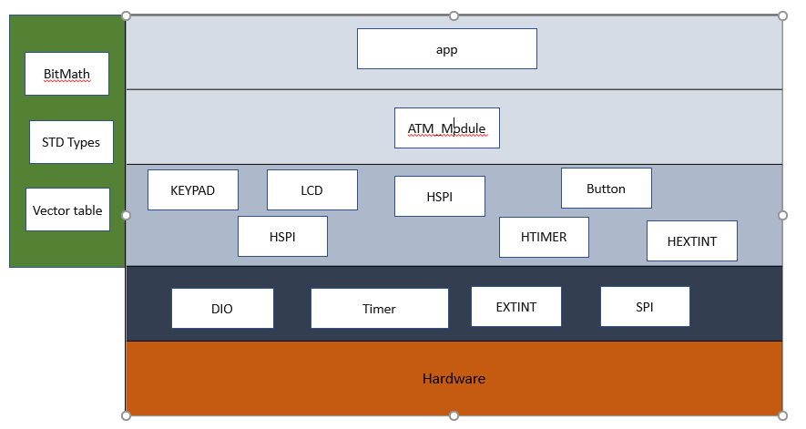

**ATM MACHINE:**

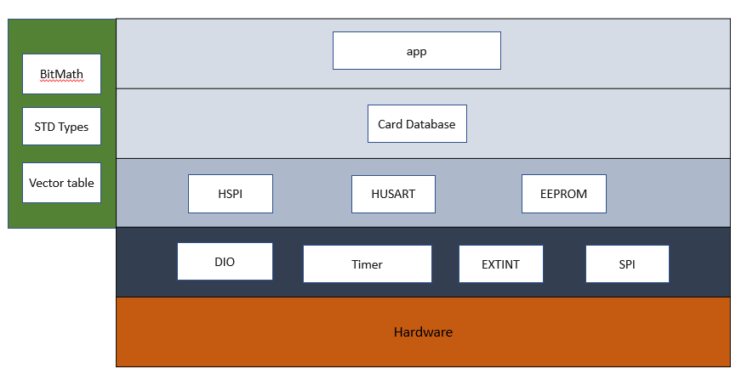**CARD MCU**

Figure ATM MCU Layered Architecture

Figure Card MCU Layered Architecture

## **Modules Description**

**MCAL Layer:**

* **DIO:** For controlling GPIO pins
* **Timer:** Provides an interface with timer 0 low-level capabilities.
* **EXTINT:** it controls three external hardware interrupts on pins PD2, PD3, and PB2 which are referred to as INT0, INT1, and INT2 respectively
* **USART:** Enables MCU to communicate using serial protocols.
* **SPI:** Provides interface with SPI’s low-level functionalities.
* **I2C:** Handles the i2c address oriented, multi-master, multi-slave communication.

**HAL Layer:**

* **Keypad:** Deal witha set of buttons arranged in a block. The 3 x 3 matrix keypad usually is used as input in a project
* **LCD:** Use for display data
* **Buzzer:** Simple module to control a buzzer.
* **HTimer:** Provides high-level functions using the lower-level timer 0 module capabilities.
* **H_EXT_INT:** Provides middle ware layer between app and external interrupt in MCAL.
* **HUSART:** Provides middle ware layer between app and UART in MCAL.
* **HSPI:** Provides high-level functionalities for using SPI communication.
* **EEPROM:** Enables MCU to interface with external EEPROM using i2c.
* **Button:** Interface with button to get its state (Enter/Zero).

**Service Layer:**

* **STD_Types:** Contains all the standard types used by all the layers.
* **BIT_Math:** Provides bit-wise operations.
* **Vect_table:** Contains all interrupt vectors and provides macros for dealing with general interrupt.

**Application Layer:**

Contains the main logic of the project.

## **Drivers’ Documentation**

### **MCAL Layer**

#### **DIO**

/*

* AUTHOR : Bassel Yasser

* Function : DIO_s8SETPinDir

* Description : Set Pin Direction

* Arguments :

* - enPinCopy {DIO_PINA_0...., DIO_PIND_7}

* - enPortDir {INPUT , OUTPUT}

* Return : Sint8_t

*/

Sint8_t **DIO_s8SETPinDir** (enu_pin enPinCopy, enu_dir enPortDir)

/*

* AUTHOR : Bassel Yasser

* Function : DIO_s8SETPinVal

* Description : Set Pin Value

* Arguments :

* - enPinCopy {DIO_PINA_0...., DIO_PIND_7}

* - enPortDir {HIGH , LOW}

* Return : Sint8_t

*/

Sint8_t **DIO_s8SETPinVal** (enu_pin enPinCopy, enu_val enPortVal)

/*

* AUTHOR : Bassel Yasser

* Function : DIO_s8GETPinVal

* Description : Set Pin Value

* Arguments :

* - enPinCopy {DIO_PINA_0...., DIO_PIND_7}

* - pu8Val address of variable that u want to save value on it

* Return : Sint8_t

*/

Sint8_t **DIO_s8GETPinVal** (enu_pin enPinCopy, Uint8_t* pu8Val)

#### **Timer 0**

/**

* \brief Initialize the timer with given mode

* \param u8_a_Mode

* \return en_TIMErrorState_t

*/

en_TIMErrorState_t TIM0_voidInit(en_TIMMode_t u8_a_Mode);

/**

* \brief Start the timer clock after prescaling it with given value

* \param u8_a_prescaler

* \return en_TIMErrorState_t

*/

en_TIMErrorState_t TIM0_Start(en_TIM_CLK_SELECT_t u8_a_prescaler);

/**

* \brief Function to stop timer 0

* \return void

*/

void TIM0_Stop();

/**

* \brief Set the timer to start from a certain value

* \param u8_a_FlagValue The value to start the timer from

* \return void

*/

void TIM0_SetValue(Uchar8_t u8_a_startValue);

/**

* \brief Function to get the value of the overflow flag of timer 0

* \param u8_a_FlagValue reference to a variable to store flag value *

* \return en_TIMErrorState_t

*/

en_TIMErrorState_t TIM0_GetOVF(Uchar8_t* u8_a_FlagValue);

/**

* \brief Function to clear timer 0 overflow flag

* \return void

*/

void TIM0_ClearOVF(void);

/**

* \brief Function to get the timer state (running/stopped)

* \param u8_a_State reference to a variable to store timer state

* \return en_TIMErrorState_t

*/

en_TIMErrorState_t TIM0_GetState(en_TIMState_t* u8_a_State);

/**

* \brief Function to set a function to call when the timer0

* Overflow Interrupt is triggered

* \param pv_a_CallbackFn reference to the function to call

* \return en_TIMErrorState_t

*/

#### **EXTINT:**

// EXT_INT TYPEDEFS

typedef enum EN_EXTINT_ERROR {

EXTINT_OK=0,

EXTINT_NOT_OK

}EN_EXTINT_ERROR;

typedef enum EN_Sence_Control {

LOW_LEVEL=0,

FALLING_EDGE,

RISING_EDGE,

ANY_LOGICAL_CHANGE

}EN_Sence_Control;

typedef enum EN_EXINT_NUMBER{

EXTINT0=0,

EXTINT1,

EXTINT2,

}EN_EXINT_NUMBER;

typedef enum EN_GLOBAL_INT{

DISABLE=0,

ENABLE

}EN_GLOBAL_INT;

// EXT_INT prototypes

/*

Description : This function initializes the GLOBAL_INTERRUPT

ARGS : takes the state ( ENABLE OR DISABLE )

return : return EXTINT_OK if the PIN initializes correctly, EXTINT_NOT_OK otherwise

*/

EN_EXTINT_ERROR SET_GLOBAL_INTERRUPT(EN_GLOBAL_INT state);

/*

Description : This function initializes the external interrupt number and it's detecting type

ARGS : takes the EXINT_NUMBER( INT0,INT1 OR INT2) and sense control.

return : return EXTINT_OK if the EXINT_NUMBER initializes correctly, EXTINT_NOT_OK otherwise

*/

EN_EXTINT_ERROR EXTINT_init(EN_EXINT_NUMBER INTx ,EN_Sence_Control INTxSense);

/*

Description : This function takes the external interrupt number and initialize call back function.

ARGS : takes the EXINT_NUMBER( INT0,INT1 OR INT2) and pointer to the function we want to execute.

return : return EXTINT_OK if the EXINT_NUMBER initializes correctly, EXTINT_NOT_OK otherwise

*/

EN_EXTINT_ERROR EXTINT_CallBack(EN_EXINT_NUMBER INTx,void(*ptrfunc)(void));

#### **I2C:**

/***********************************************************************************/

/* 01- i2c_init_master() */

/* ----------------------------------------------------------------------------------

* @func : I2C master Initialization

* @in : void

* @out : void

************************************************************************************/

**void** **i2c_init_master**(**void**);

/***********************************************************************************/

/* 02- i2c_init_slaver() */

/* ----------------------------------------------------------------------------------

* @func : I2C slave Initialization

* @in : void

* @out : void

************************************************************************************/

**void** **i2c_init_slave** (**void**);

/***********************************************************************************/

/* 03- i2c_start() */

/* ----------------------------------------------------------------------------------

* @func : Send start condition

* @in : void

* @out : void

************************************************************************************/

**void** **i2c_start**(**void**);

/***********************************************************************************/

/* 04- i2c_repeated_start() */

/* ----------------------------------------------------------------------------------

* @func : Send repeated start condition

* @in : void

* @out : void

************************************************************************************/

**void** **i2c_repeated_start**(**void**);

/***********************************************************************************/

/* 05- i2c_send_slave_address_with_write_req() */

/* ----------------------------------------------------------------------------------

* @func : send write request from master to slave

* @in[1] : slave_address

* - Slave address that you want to write on it

* @out : void

************************************************************************************/

**void** **i2c_send_slave_address_with_write_req**(Uint8_t slave_address);

/***********************************************************************************/

/* 06- i2c_send_slave_address_with_read_req() */

/* ----------------------------------------------------------------------------------

* @func : send read request from master to slave

* @in[1] : slave_address

* - Slave address that you want to read from it

* @out : void

************************************************************************************/

**void** **i2c_send_slave_address_with_read_req**(Uint8_t slave_address);

/***********************************************************************************/

/* 07- i2c_write_byte() */

/* ----------------------------------------------------------------------------------

* @func : Write data to slave

* @in[1] : byte

* - write data that u need to send

* @out : void

************************************************************************************/

**void** **i2c_write_byte**(Uint8_t byte);

/***********************************************************************************/

/* 08- i2c_read_byte() */

/* ----------------------------------------------------------------------------------

* @func : read data from slave

* @in : void

* @out : returned data

************************************************************************************/

Uint8_t **i2c_read_byte**(**void**);

/***********************************************************************************/

/* 09- i2c_stop() */

/* ----------------------------------------------------------------------------------

* @func : Send Stop condition

* @in : void

* @out : void

************************************************************************************/

**void** **i2c_stop(void**);

#### **UART:**

typedef enum EN_USART_ERROR{

USART_OK=0,

USART_NOT_OK

}EN_USART_ERROR;

/*

Name : USART_init

Description : This function initializes USART Module with selected options in USART.cfg file.

Args : Void (all options defined as macros).

return : Std_ReturnType (E_OK) if Module initializes Correctly, (E_NOT_OK) otherwise.

*/

EN_USART_ERROR USART_init(void);

/*

Name : USART_sendData

Description : This function Send Data To Receiver (we can change size of data from USART.cfg file) we select 8 bits data size.

Args : take one argument (data to be sent) must be same size as the size we select in Initialization function.

return : Std_ReturnType (E_OK) if module sent data Correctly, (E_NOT_OK) otherwise.

*/

EN_USART_ERROR USART_sendData(Uchar8_t data);

/*

Name : USART_receiveData

Description : This function Receive Data from sender (we can change size of data from USART.cfg file) we select 8 bits data size.

Args : void

return : data received. must be same size as the size we select in Initialization function.

*/

Uchar8_t USART_receiveData(void);

/*

Name : USART_sendSTRING

Description : This function send array of data To Receiver. (we can change size of data from USART.cfg file) we select 8 bits data size.

Args : pointer to the array of data to be sent

return : void

*/

void USART_sendSTRING(Uchar8_t * str);

/*

Name : USART_receiveSTRING

Description : This function receive data from sender and store it in array.

Args : pointer to the array to store data received in it and size of data.

return : void

*/

void USART_receiveSTRING(Uchar8_t * str,Uchar8_t size);

#### **SPI:**

/**

* (Author: Alaa Hisham)

* \brief Initialize the MCU as the Master

* in SPI communication

* \return void

*/

void SPI_MasterInit(void);

/**

* (Author: Alaa Hisham)

* \brief Initialize the MCU as a slave

* in SPI communication

*

* \return void

*/

void SPI_SlaveInit(void);

/**

* (Author: Alaa Hisham)

* \brief Sets the value of the SPI data register

* \param u8_a_data: Desired value

* \return void

*/

void SPI_SetValue(Uchar8_t u8_a_data);

/**

* (Author: Alaa Hisham)

* \brief Exchange a letter with selected slave

* \param u8_a_character: Character to send

* \param pu8_a_receivedChar: Pointer to character to store received value

* \return en_SPI_ErrorState_t

*/

en_SPI_ErrorState_t SPI_TranscieveChar(Uchar8_t u8_a_character, Uchar8_t* pu8_a_receivedChar);

/**

* (Author: Alaa Hisham)

* \brief Exchange a letter with selected slave

* \param u8_a_character: Character to send

* \param pu8_a_receivedChar: Pointer to character to store received value

* \return en_SPI_ErrorState_t

*/

en_SPI_ErrorState_t SPI_SlaveTranscieve(Uchar8_t u8_a_character, Uchar8_t* pu8_a_receivedChar);

/**

* (Author: Alaa Hisham)

* \brief Set a notification function for the SPI Interrupt

* \param pv_a_CallbackFn: reference to the function to callback

* when the SPI Interrupt is triggered

* \return en_SPI_ErrorState_t

*/

en_SPI_ErrorState_t SPI_SetCallback(void (*pv_a_CallbackFn)(void));

### **HAL Layer:**

#### **Keypad**

// Macros

#define R1 DIO_PINC_2

#define R2 DIO_PINC_3

#define R3 DIO_PINC_4

#define C1 DIO_PINC_5

#define C2 DIO_PINC_6

#define C3 DIO_PINC_7

// user defined datatypes

typedef enum EN_KEYPAD_BTNS

{

KEY_1=0,

KEY_2,

KEY_3,

KEY_4T,

KEY_5,

KEY_6,

KEY_7,

KEY_8,

KEY_9,

KEY_NOTHING

}EN_KEYPAD_BTNS;

// functions prototypes

/*************************************************************************************

Name : KEYPAD_init()

Description : This Function Initializes keypad pins (Rows are outputs & Columns are inputs).

ARGS : void

return : void

************************************************************************************************************/

void KEYPAD_init(void);

/*************************************************************************************************************

*

Name : KEYPAD_GetButton

Description : This Function loops over other three functions (Checks (R1,R2,R3)).

ARGS : void

return : the pressed key or Nothing pressed

************************************************************************************************************/

EN_KEYPAD_BTNS KEYPAD_GetButton(void);

/*************************************************************************************************************

*

Name : KEYPAD_checkR1 , KEYPAD_checkR2, KEYPAD_checkR3

Description : functions are checking the entire row if it pressed or not.

ARGS : void

return : the pressed key or Nothing pressed

************************************************************************************************************/

EN_KEYPAD_BTNS KEYPAD_checkR1(void);

EN_KEYPAD_BTNS KEYPAD_checkR2(void);

EN_KEYPAD_BTNS KEYPAD_checkR3(void);

#### **HTimer:**

/**

* \brief Generate Synchronous delay (busy waiting)*

* \param Copy_delayTime Desired delay

* \param Copy_timeUnit Time units (Seconds, mSeconds, uSeconds)

*

* \return en_HTIMErrorState_t

*/

en_HTIMErrorState_t TIM0_SyncDelay(Uint32_t u32_a_delay, en_timeUnits_t u8_a_timeUnit);

/**

* \brief Generates delay asynchronously

* \param u32_a_delay desired delay

* \param u8_a_timeUnit delay time units

* \param Copy_pvCallbackFn function to call when delay is complete

*

* \return en_TIMErrorState_t

*/

en_HTIMErrorState_t TIM0_AsyncDelay(Uint32_t u32_a_delay, en_timeUnits_t u8_a_timeUnit, void (*Copy_pvCallbackFn)(void));

/**

* \brief Function to end a delay asynchronously

* To Stop Async Delay: No Restrictions

* To Stop Sync Delay: should only be called in an ISR/Callback function

*

* \return void

*/

void TIM0_AsyncEndDelay();

#### **HLCD**

/*

* function : HLCD_vidInit

* description : func to set LCD initialization

* input param : void

* return : void

* */

**void** **HLCD_vidInit**(**void**)

/*

* function : HLCD_vidWritecmd

* description : func to configure some commands on lcd

* input param :

* u8commandCopy --> take lcd cmd instructions from instruction table <https://components101.com/sites/default/files/component_datasheet/16x2%20LCD%20Datasheet.pdf>

* return : void

* */

**void** **HLCD_vidWritecmd**(Uint8_t u8commandCopy)

/*

* function : HLCD_vidWriteChar

* description : func to write char on lcd

* input param : u8CharCopy -> take ascii code of char or char address on CGROM

* return : void

* */

**void** **HLCD_vidWriteChar**(Uint8_t u8CharCopy)

/*

* function : HLCD_ClrDisplay

* description : func to clear anything on lcd

* input param : void

* return : void

* */

**void** **HLCD_ClrDisplay**(**void**)

/*

* function : HLCD_gotoXY

* description : func to determine position which char print at this position on lcd ### NOTE : (2rows x 16coloms)

* input param :

* row -> take row number 0 or 1

* pos -> take colom number from 0 ~ 16

* return : void

* */

**void** **HLCD_gotoXY**(Uint8_t row, Uint8_t pos)

/*

* function : HLCD_WriteString

* description : func to write string on lcd

* input param : str --> which take string as argument

* return : void

* */

**void** **HLCD_WriteString**(Uint8_t* str)

/*

* function : HLCD_WriteInt

* description : func to write integer number on lcd

* input param : number --> which take number as argument

* return : void

* */

**void** **HLCD_WriteInt**(Uint32_t number)

/*

* function : HLCD_vidCreatCustomChar

* description : func to store new patterm on CGRAM

* input param :

* pu8custom -> take pointer to array which having LCD Custom Character Generated data ### take only 8 characters

* u8Location -> determine location on CGRAM [0 ~ 8]

* return : void

* */

**void** **HLCD_vidCreatCustomChar**(Uint8_t* pu8custom, Uint8_t u8Location)

/**

* (Author: Alaa Hisham)

* \brief Display floating point number on LCD

*

* \param f32_a_number: number to display

* \return void

*/

void HLCD_DisplayFloat(float32_t f32_a_number);

#### **Buzzer**

/**

* \brief Initialize buzzer pin as output

* \param pst_a_buzzer reference to buzzer

* \return void

*/

void BUZ_Init(st_Buzzer_t* pst_a_buzzer);

/**

* \brief Turn the buzzer on/off

* \param pst_a_buzzer reference to buzzer

* \param u16_a_state BUZ_ON (or) BUZ_OFF

* \return en_BuzzerErrorState_t

*/

en_BuzzerErrorState_t BUZ_SetState(st_Buzzer_t* pst_a_buzzer, en_BuzzerState_t en_a_state);

#### **Button**

/*

* AUTHOR : Bassel Yasser Mahmoud

* FUNCTION : HButton_Init

* DESCRIPTION : Initialize specified pin as input and pull up

* RETURN : enu_buttonError_t {BUTTON_NOK, BUTTON_OK}

*/

enu_buttonError_t **HButton_Init**(enu_pin en_pinx);

/*

* AUTHOR : Bassel Yasser Mahmoud

* FUNCTION : HButton_ExtIntInit

* DESCRIPTION : Initialize specified as pull up for external interrupt

* RETURN : enu_buttonError_t {BUTTON_NOK, BUTTON_OK}

*/

enu_buttonError_t **HButton_ExtIntInit**(enu_pin en_pinx);

/*

* AUTHOR : Bassel Yasser Mahmoud

* FUNCTION : HButton_getPinVal

* DESCRIPTION : Get pin status if it is high or low

* RETURN : enu_buttonError_t {BUTTON_NOK, BUTTON_OK}

*/

enu_buttonError_t **HButton_getPinVal**(enu_pin en_pinx, Uint8_t* pu8_refVal );

*

Description : This function initializes the external interrupt number and it's detecting type and initialize call back function.

ARGS : takes the EXINT_NUMBER( INT0,INT1 OR INT2) and sense control and and pointer to the function we want to execute when interrupt occurs.

return : return EXTINT_OK if the EXINT_NUMBER initializes correctly, EXTINT_NOT_OK otherwise

*/

EN_EXTINT_ERROR H_EXTINT_create(EN_EXINT_NUMBER INTx ,EN_Sence_Control INTxSense,void(*ptrfunc)(void));

#### **HEXT_INT**

*

Description : This function initializes the external interrupt number and it's detecting type and initialize call back function.

ARGS : takes the EXINT_NUMBER( INT0,INT1 OR INT2) and sense control and and pointer to the function we want to execute when interrupt occurs.

return : return EXTINT_OK if the EXINT_NUMBER initializes correctly, EXTINT_NOT_OK otherwise

*/

EN_EXTINT_ERROR H_EXTINT_create(EN_EXINT_NUMBER INTx ,EN_Sence_Control INTxSense,void(*ptrfunc)(void));

#### **HSPI**

/**

* (Author: Alaa Hisham)

* \brief Initialize the MCU as the Master in SPI communication

* \return void

*/

void HSPI_MasterInit(void);

/**

* (Author: Alaa Hisham)

* \brief Initialize the MCU as a slave in SPI communication

* \return void

*/

void HSPI_SlaveInit(void);

/**

* (Author: Alaa Hisham)

* \brief Function to send a single character

* \param u8_a_character character to send

* \return void

*/

void HSPI_SendChar(Uchar8_t u8_a_character);

/**

* \brief Receive data in the given buffer

*

* \param pu8_a_data: reference to buffer to store received data

* \param u8_a_DataSize: Size (length) of data to receive

*

* \return void

*/

void HSPI_ReceiveData(Uchar8_t *pu8_a_data, Uchar8_t u8_a_DataSize);

/**

* \brief Send given data byte by byte to selected slave

* and receive data in exchange into given array

* \param pu8_a_TxDataArr: Reference to array of data to be transmitted

* \param pu8_a_RxDataArr: Reference to array to store received data

* \param u8_a_DataLen: Length of data to exchange (in bytes)

* (Must be less than or equal SPI_BUFFER_SIZE)

*

* \return en_HSPI_ErrorState_t

*/

en_HSPI_ErrorState_t HSPI_ExchangeData(Uchar8_t* pu8_a_TxDataArr, Uchar8_t* pu8_a_RxDataArr, Uchar8_t u8_a_DataLen);

/**

* (Author: Alaa Hisham)

* \brief Request to send data to the master

* \param u8_a_data: data to send

* \return void

*/

void HSPI_SlaveRequest(Uchar8_t* pu8_a_dataPtr, Uchar8_t u8_a_DataSize);

#### **EEPROM:**

/** AUTHOR : Sherif Ashraf Khadr

* \brief : This Function Just Call To Initialize I2C as Master

*

* \param : Void

*

* \return void

*/

void eeprom_init(void)

/** AUTHOR : Sherif Ashraf Khadr

* \brief : This Function Call To Make The Sequence Of I2C Frame To Write Byte On A Device

*

* \param : Uint16_t address : This Is Device Address

* : Uchar8_t data : This Is Data That Will Be Write

*

* \return void

*/

void eeprom_write_byte(Uint16_t address, Uchar8_t data)

/** AUTHOR : Sherif Ashraf Khadr

* \brief : This Function Call To Make The Sequence Of I2C Frame To Read Byte On A Device

*

* \param : Uint16_t address : This Is Device Address

*

* \return Uchar8_t : Function Will Return Uchar8_t Contain The Data

*/

Uchar8_t eeprom_read_byte(Uint16_t address)

/** AUTHOR : Sherif Ashraf Khadr

* \brief : This Function Call When You Need To Write A String In The EEPROM

*

* \param : Uint16_t address : This Is Device Address

* : Uchar8_t *str : This Pointer Will Store The Address Of The Array Of The Chars

* \return Void

*/

void eeprom_write_string(Uint16_t Copy_u8Address, const Uchar8_t* str)

/** AUTHOR : Sherif Ashraf Khadr

* \brief : This Function Call When You Need To Read A String From The EEPROM

*

* \param : Uint16_t address : This Is Device Address

* : Uchar8_t *str : This Pointer Will Store The Address Of The Array Of The Chars That Will Return String In It

* \return Void

*/

void eeprom_read_string(Uint16_t Copy_u8Address, Uchar8_t* str)

### **Card_Database Layer (CARD MCU)**

/*

* AUTHOR : Bassel Yasser Mahmoud

* FUNCTION : APP_terminalPinGet

* DESCRIPTION : Get pin from User within terminal and doing some validation

* RETURN : en_terminalPinGetStatus_t {PINGET_NOK or PINGET_OK}

*/

en_terminalPinGetStatus_t **APP_terminalPinGet**(Uchar8_t* arr);

/*

* AUTHOR : Sharpel

* FUNCTION : APP_terminalPanGet

* DESCRIPTION : Get pan from User within terminal and doing some validation

* RETURN : en_terminalPanGetStatus_t {PANGET_NOK or PANGET_OK}

*/

en_terminalPanGetStatus_t **APP_terminalPanGet**(Uchar8_t* arr);

/*

* FUNCTION : SaveCardData

* DESCRIPTION : Saving PAN and PIN in EEPROM

* RETURN : EN_TerminalDataState {DATA_SAVED, DATA_NSAVED, DATA_READ, DATA_NREAD}

*/

EN_TerminalDataState **SaveCardData**(Uchar8_t *CardPan,Uchar8_t *CardPin);

/*

* FUNCTION : ReadCardData

* DESCRIPTION : Reading PAN and PIN from EEPROM

* RETURN : EN_TerminalDataState {DATA_SAVED, DATA_NSAVED, DATA_READ, DATA_NREAD}

*/

EN_TerminalDataState **ReadCardData**(Uchar8_t *CardPan,Uchar8_t *CardPin);

/*

* FUNCTION : CARD_MatchPINs

* DESCRIPTION : Validate if PIN no and Confirmed PIN no is Matched or not

* RETURN : en_CardPinMatchError_t { PIN_Match_NOK, PIN_Match_OK}

*/

en_CardPinMatchError_t **CARD_MatchPINs**();

### **ATM_MODULE Layer (ATM MCU)**

#### **ATM:**

/**

* \brief Displays welcome routine

*

* \return void

*/

void Welcome(void);

/**

* (Author: Sherif Ashraf)

* \brief Check if the pin user enters is the same as the cardholder's pin

* \param pinFromAtm : reference to pin entered by user

* \param pinFromServer: reference to pin received from card

* \return EN_PinState

*/

EN_PinState PIN_checkPinMatching(Uchar8_t *pinFromAtm,Uchar8_t *pinFromServer);

/*

* AUTHOR : Sharpel

* FUNCTION : Get_pin

* DESCRIPTION : get pin from user (on the atm )

* ARGS : pointer to array (the size of array must be 5 or more) to store entered pin by user

* RETURN : PIN_OK if user enters 4 numbers , PIN_NOT_OK otherwise

*/

EN_PinState Get_pin(Uchar8_t *enteredpin);

/**

* (Author: Sherif Ashraf)

* \brief Locks the system and sound the buzzer

* \param pst_a_buzzer: reference to the buzzer

* \return en_BuzzerErrorState_t

*/

en_BuzzerErrorState_t deinitAtm(st_Buzzer_t* pst_a_buzzer);

/**

* (Author: Alaa Hisham)

* \brief Get the card pan and pin

* \param pu8_a_pan: reference to buffer to receive pan from card

* \param pu8_a_pin: reference to buffer to receive pin from card

* \return EN_PinState

*/

EN_PinState ATM_GetCardData(Uchar8_t *pu8_a_pan, Uchar8_t *pu8_a_pin);

/*

* AUTHOR : Sharpel

* FUNCTION : get_amount_left

* DESCRIPTION : get amount from user ( on the atm )

* ARGS : pointer to array (the size of array must be 8 or more and equal "0000.00" initial value) to store entered pin by user

* RETURN : void

*/

void get_amount_left (Uchar8_t * amount);

/*

* AUTHOR : Bassel Yasser

* FUNCTION : EXTINT_FUNC

* DESCRIPTION : when timer 2 ISR is fire it changes the state of (Enter or Zero)

* ARGS : void

* RETURN : void

*/

void EXTINT_FUNC(void);

/**

* (Author: Alaa Hisham)

* \brief Carries out the routine for approved card

* \param f32_a_NewBalance: the balance to display after transaction

* \return void

*/

void ATM_ApprovedCard(float32_t f32_a_NewBalance);

#### **Database_check:**

/*

* FUNCTION : isValidPanAccount

* DESCRIPTION : Check If PAN No. Valid or not

* RETURN : EN_dataError_t {APPROVED ,FRAUD_CARD,CARD_STOLEN,EXCEED_MAX_DAILY_AMOUNT,INSUFFICIENT_FUND, DATA_ERROR}

*/

EN_dataError_t **isValidPanAccount**(Uchar8_t * pan);

/*

* FUNCTION : isRunningAccount

* DESCRIPTION : Checking if card stolen or not

* RETURN : EN_dataError_t {APPROVED ,FRAUD_CARD,CARD_STOLEN,EXCEED_MAX_DAILY_AMOUNT,INSUFFICIENT_FUND, DATA_ERROR}

*/

EN_dataError_t **isRunningAccount**(Uchar8_t * pan);

/*

* FUNCTION : isValidAccountAmount

* DESCRIPTION : Checking if there is INSUFFICIENT_FUND or not

* RETURN : EN_dataError_t {APPROVED ,FRAUD_CARD,CARD_STOLEN,EXCEED_MAX_DAILY_AMOUNT,INSUFFICIENT_FUND, DATA_ERROR}

*/

EN_dataError_t **isValidAccountAmount**(Uchar8_t * pan,Uchar8_t * amount,float32_t *newAmount);

/*

* FUNCTION : isBelowMaxDailyAmount

* DESCRIPTION : Checking if transfered money is below limited daily amount or not

* RETURN : EN_dataError_t {APPROVED ,FRAUD_CARD,CARD_STOLEN,EXCEED_MAX_DAILY_AMOUNT,INSUFFICIENT_FUND, DATA_ERROR}

*/

EN_dataError_t **isBelowMaxDailyAmount**(Uchar8_t * amount);

/*

* FUNCTION : DATABASE_checking

* DESCRIPTION : Card Database checking

* RETURN : EN_dataError_t {APPROVED ,FRAUD_CARD,CARD_STOLEN,EXCEED_MAX_DAILY_AMOUNT,INSUFFICIENT_FUND, DATA_ERROR}

*/

EN_dataError_t **DATABASE_checking** (Uchar8_t * pan,Uchar8_t * amount,float32_t *newAmount);

### **Application Layer:**

#### **Card MCU**

/**

* \brief Initializations of all used peripherals

* \return void

*/

void APP_Init(void);

/**

* \brief The main logic of the Card

* \return void

*/

void APP_Start(void);

#### **ATM MCU**

/**

* \brief Initializations of all used peripherals

* \return void

*/

void APP_Init(void);

/**

* \brief The main logic of the ATM

* \return void

*/

void APP_Start(void);

# Low Level Design

### **MCAL Layer:**

#### **DIO**

Sint8_t **DIO_s8SETPinDir** (enu_pin enPinCopy, enu_dir enPortDir)

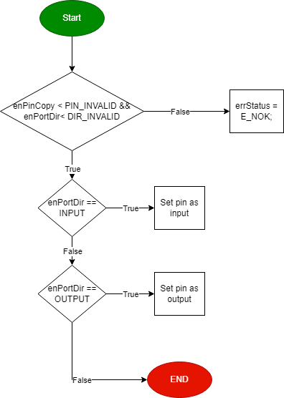

Figure DIO_s8SETPinDir Flow Chart

Sint8_t **DIO_s8SETPinVal** (enu_pin enPinCopy, enu_val enPortVal)

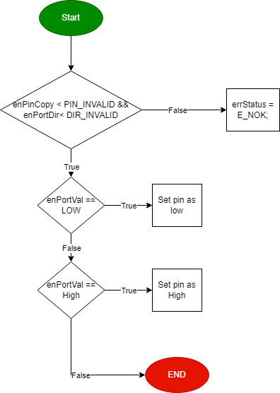

Figure DIO_s8SETPinVal Flow chart

Sint8_t **DIO_s8GETPinVal** (enu_pin enPinCopy, Uint8_t* pu8Val)

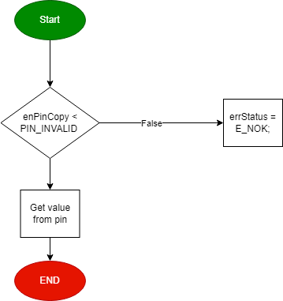

Figure DIO_s8GETPinVal Flow Chart

#### **Timer:**

**TIM0_Init**

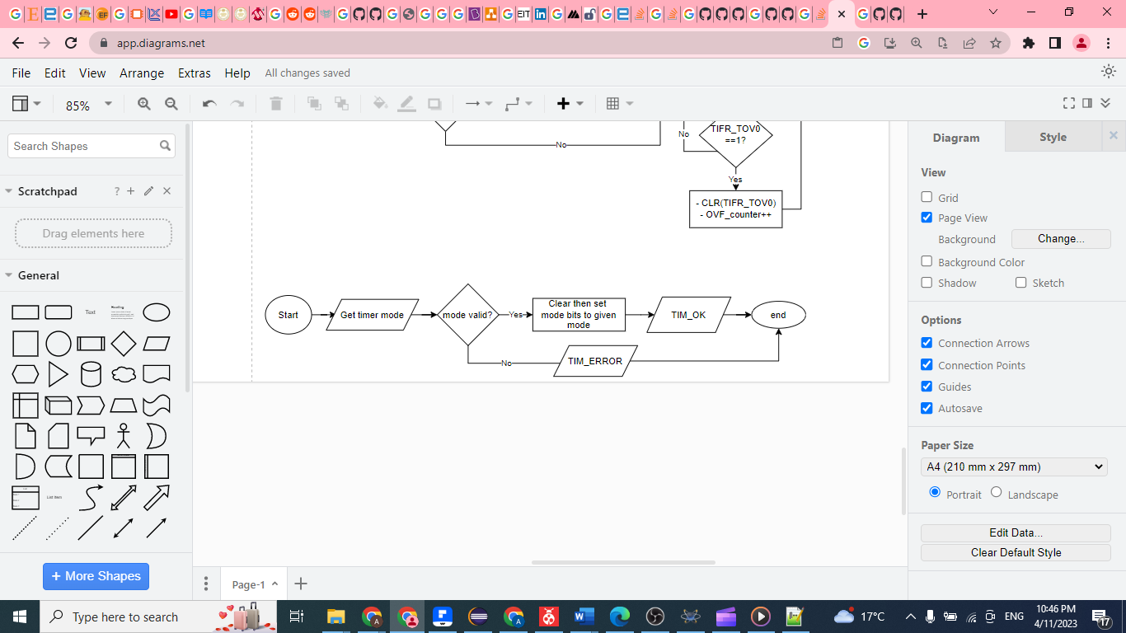

Figure TIM0_Init Flow Chart

**TIM0_Start**

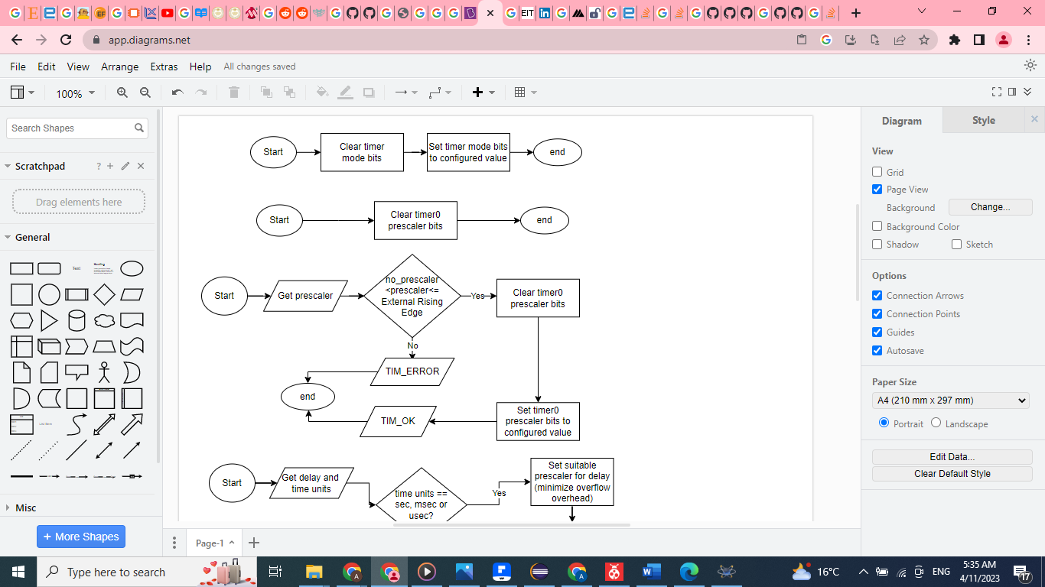

Figure TIM0_Start Flow Chart

**TIM0_Stop**



Figure TIM0_Stop Flow Chart

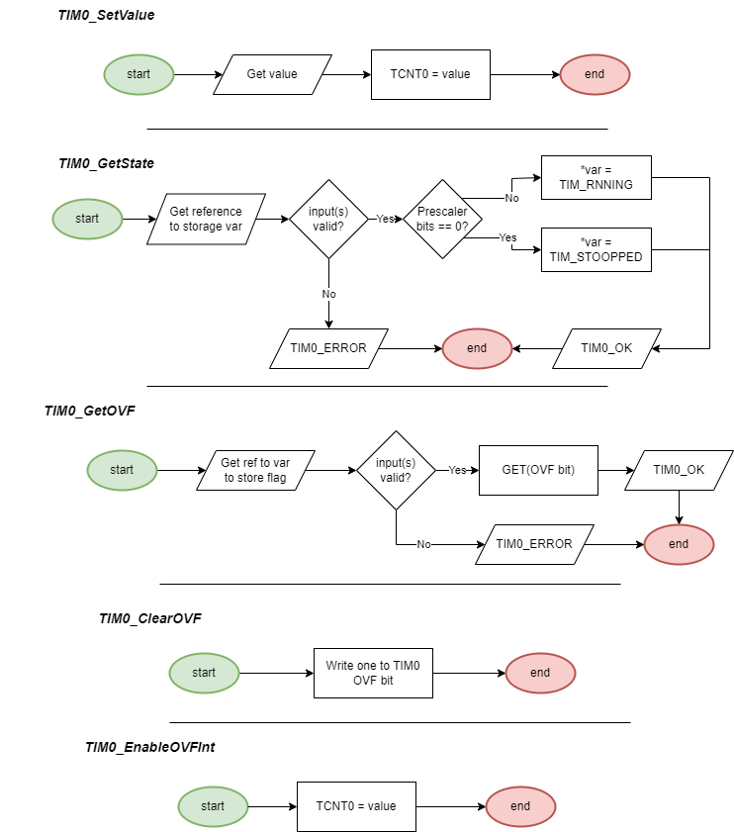

Figure TIM0 remaining Flow Charts

#### **EXTINT:**

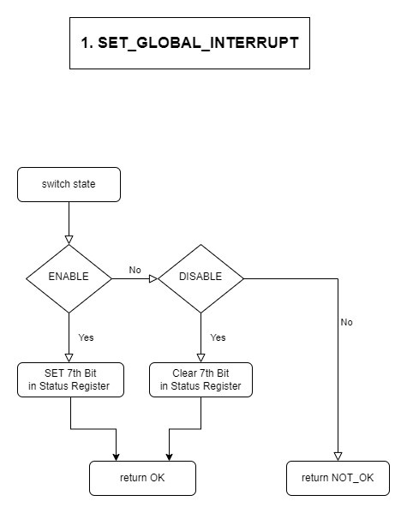

Figure EXTINT: Set_Global_Interrupt

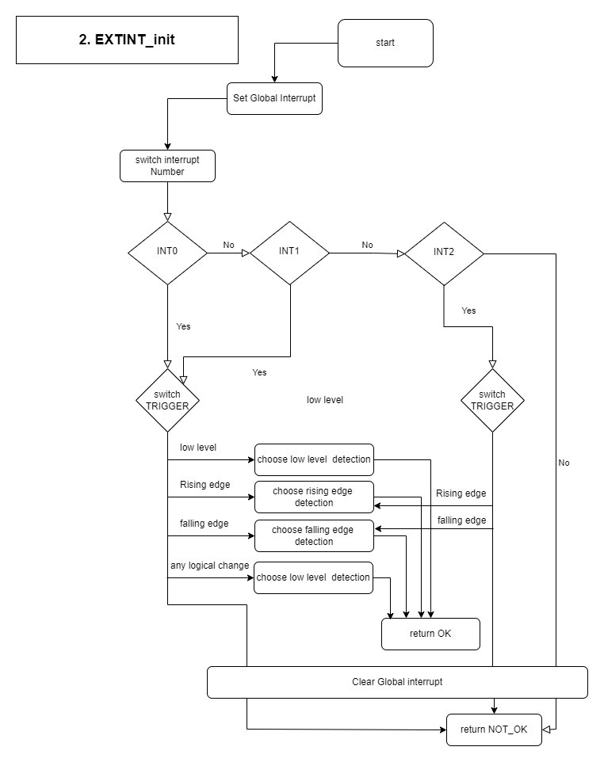 Figure 11 EXTINT_Init flow chart

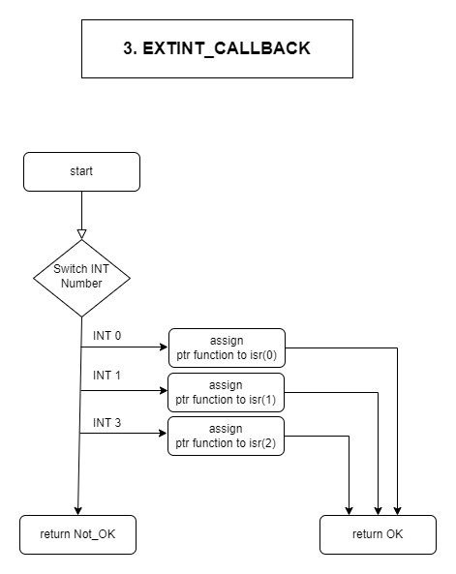

Figure EXTINT_CALLBACK flow chart

#### **UART:**

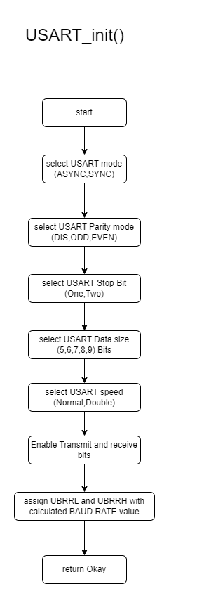

Figure USART_init flow chart

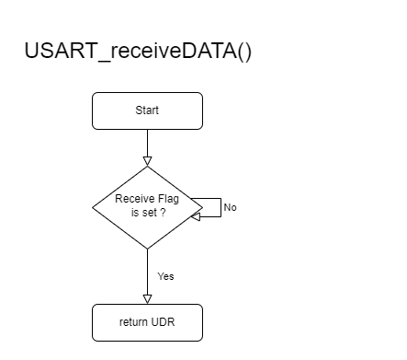

Figure USART_receiveData flow chart

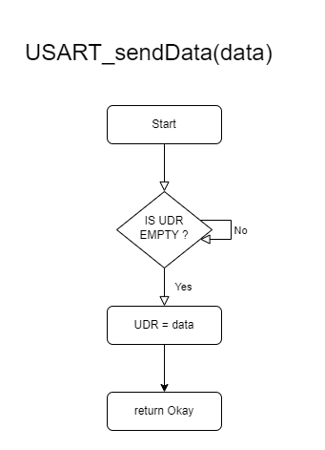

Figure USART_sendData flow chart

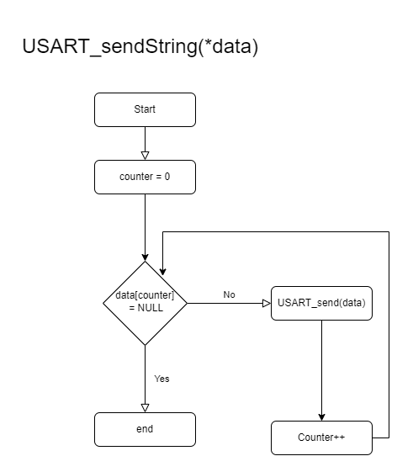

Figure USART_sendString flow chart

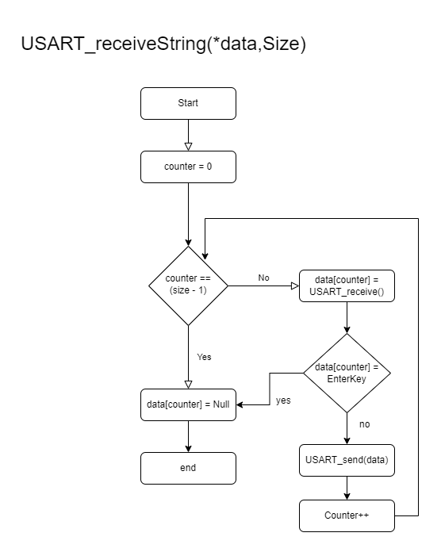

Figure USART_receiveString flow chart

#### **SPI:**

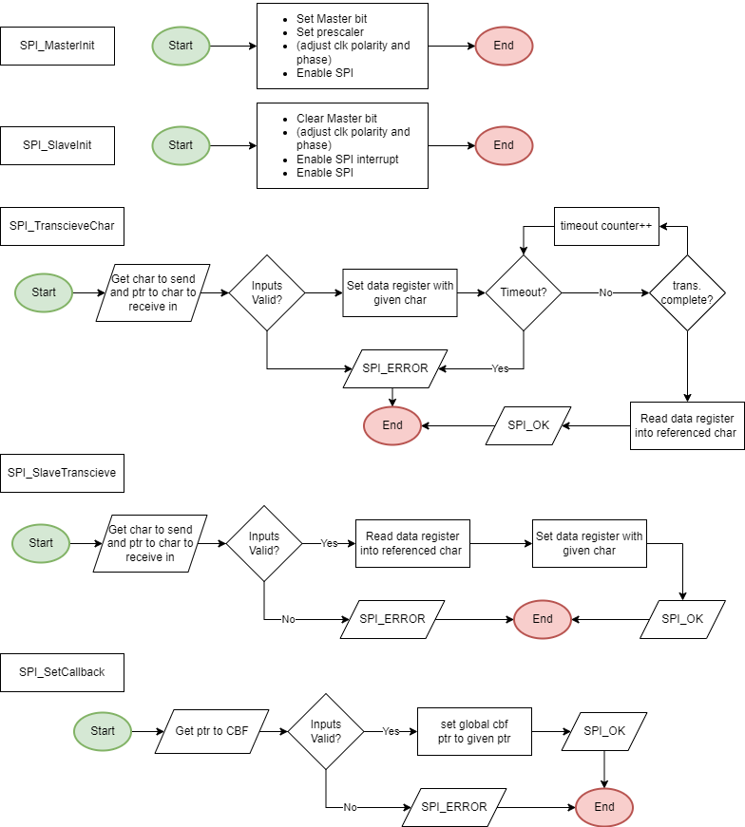

Figure Flow charts of SPI APIs

#### **I2C:**

**void** **i2c_init_master**(**void**);

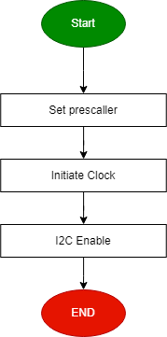

Figure i2c_init_master flow chart

**void** **i2c_start**(**void**);

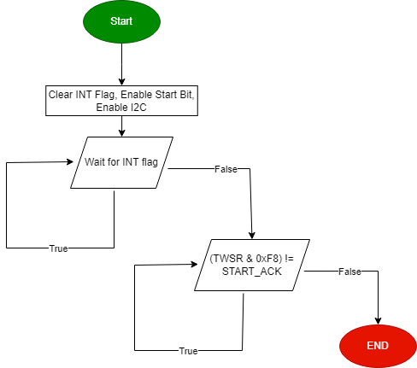

Figure i2c_start flow chart

**void** **i2c_repeated_start**(**void**);

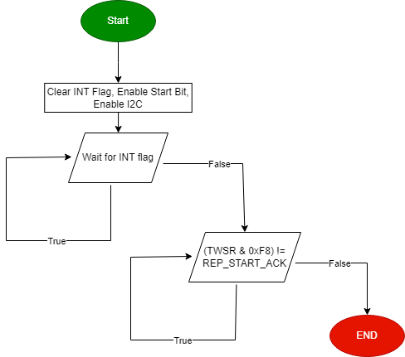

Figure i2c_repeated_start flow chart

**void** **i2c_send_slave_address_with_write_req**(Uint8_t slave_address);

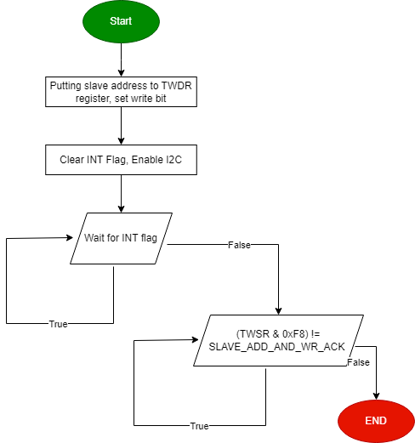

Figure i2c_send_slave_address_with_write_req flow chart

**void** **i2c_send_slave_address_with_read_req**(Uint8_t slave_address);

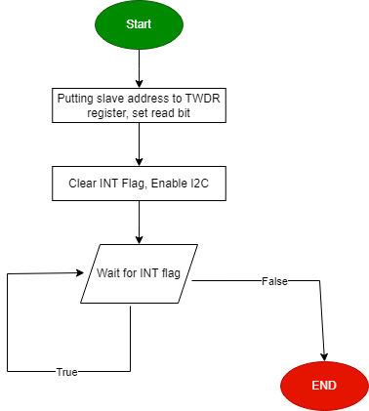

Figure i2c_send_slave_address_with_read_req flow chart

**void** **i2c_write_byte**(Uint8_t byte);

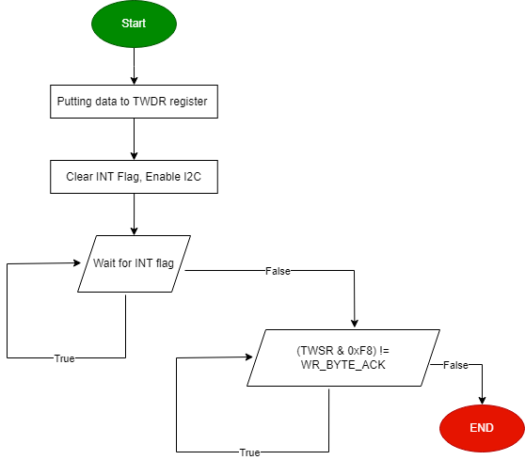

Figure i2c_write_byte flow chart

Uint8_t **i2c_read_byte**(**void**);

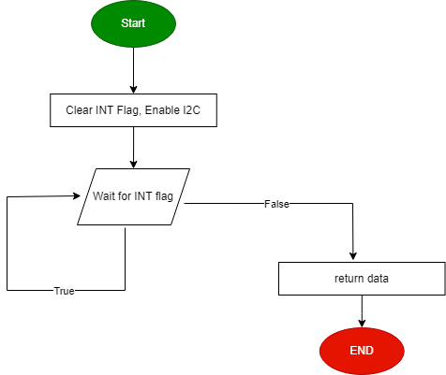

Figure i2c_read_byte flow chart

**void** **i2c_stop**(**void**);

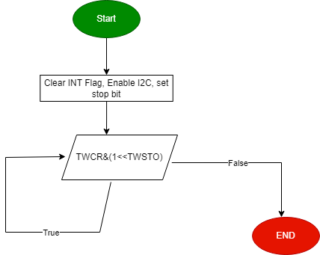

Figure i2c_stop flow chart

### **HAL Layer**

#### **HTimer0**

**HTIM0_SyncDelay**

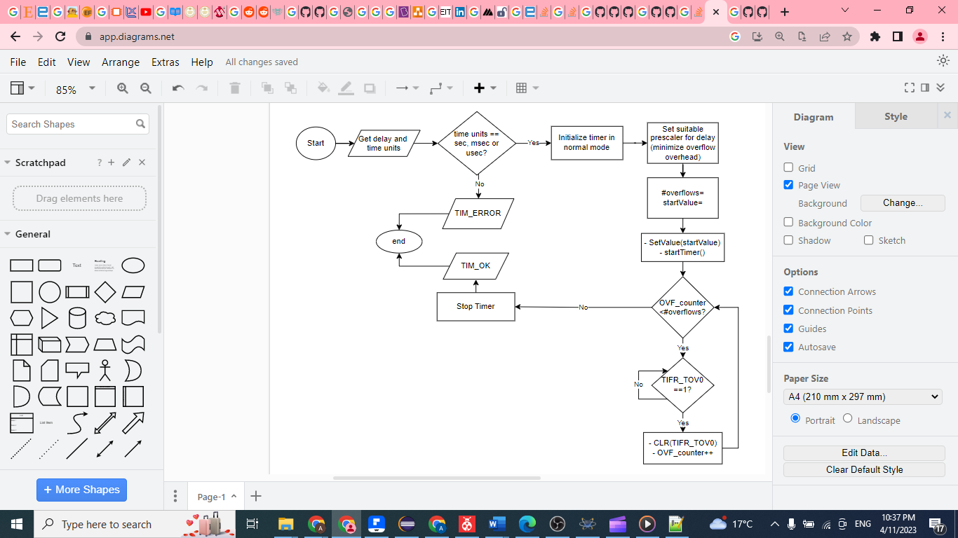

Figure HTIM0_SyncDelay Flow Chart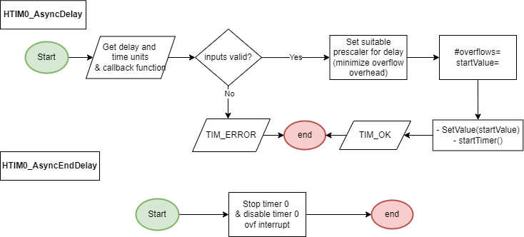

Figure HTIM0_AsyncDelay and EndDelay

#### **HSPI**

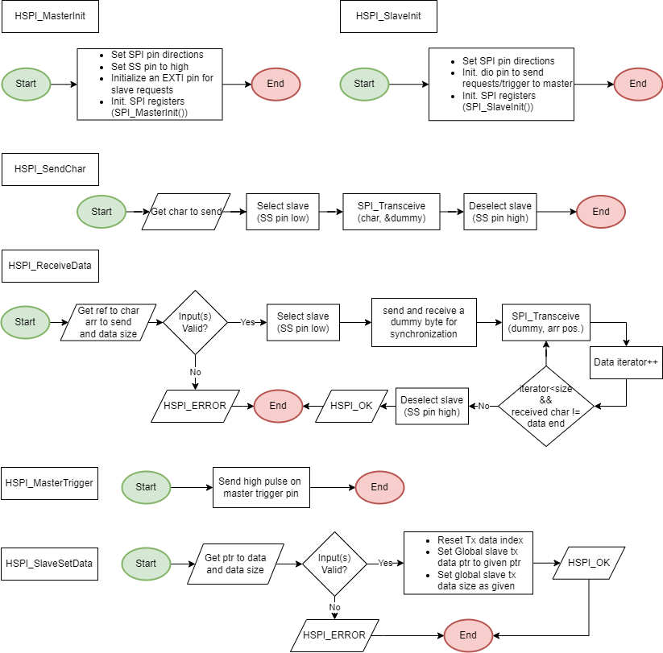

Figure Flow charts of HSPI APIs

#### **LCD**

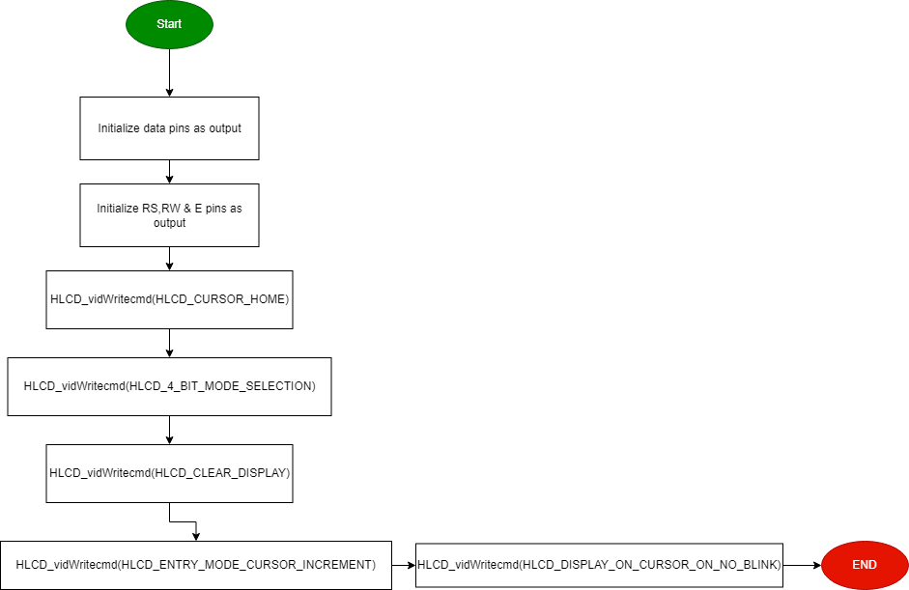**void** **HLCD_vidInit**(**void**)

Figure HLCD_vidInit Flow Chart

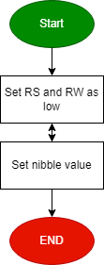**void** **HLCD_vidWritecmd**(Uint8_t u8commandCopy)

Figure HLCD_vidWritecmd Flow Chart

**void** **HLCD_vidWriteChar**(Uint8_t u8CharCopy)

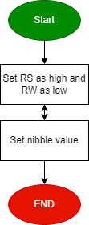

Figure HLCD_vidWriteChar Flow Chart

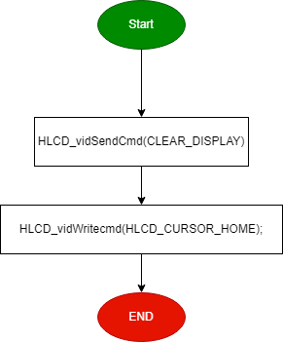**void** **HLCD_ClrDisplay**(**void**)

Figure HLCD_ClrDisplay Flow Chart

**void** **HLCD_gotoXY**(Uint8_t row, Uint8_t pos)

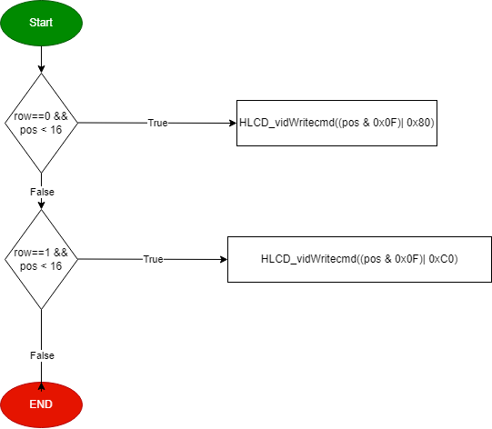

Figure HLCD_gotoXY Flow Chart

**void** **HLCD_WriteString**(Uint8_t* str)

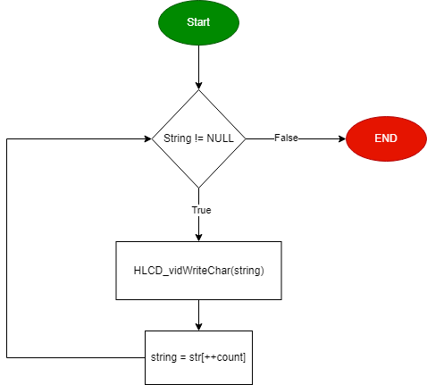

Figure HLCD_WriteString Flow Chart

**void** **HLCD_WriteInt**(Uint32_t number)

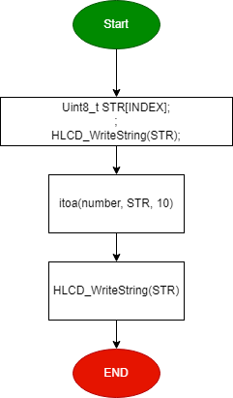

Figure HLCD_WriteInt Flow Chart

**void** **HLCD_vidCreatCustomChar**(Uint8_t* pu8custom, Uint8_t u8Location)

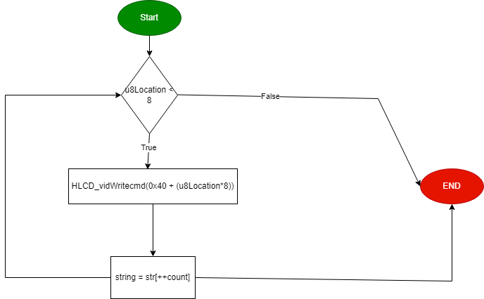

Figure HLCD_vidCreatCustomChar Flow Chart

void HLCD_DisplayFloat(float32_t f32_a_number);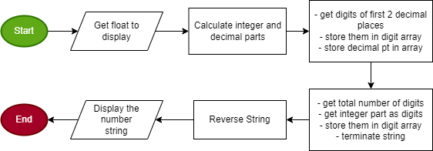

Figure HLCD_DisplayFloat flow chart

#### **Keypad**

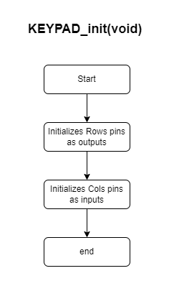

Figure KEYPAD_Init Flow Chart

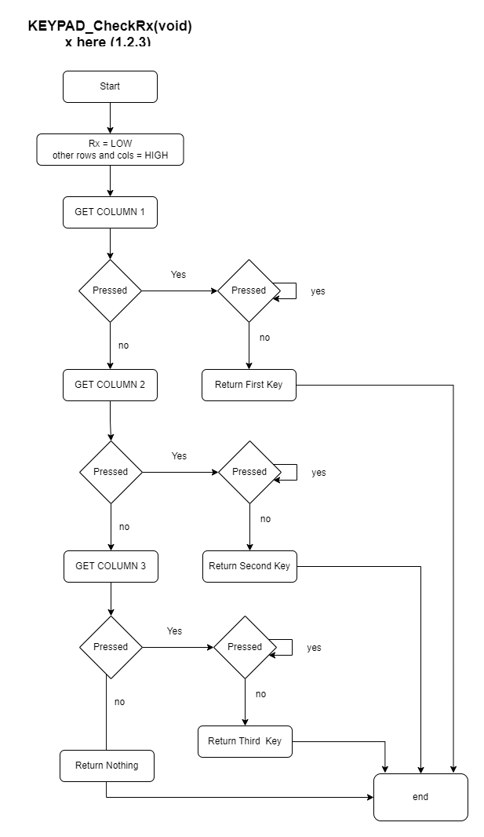

Figure KEYPAD_CheckRx Flow Chart

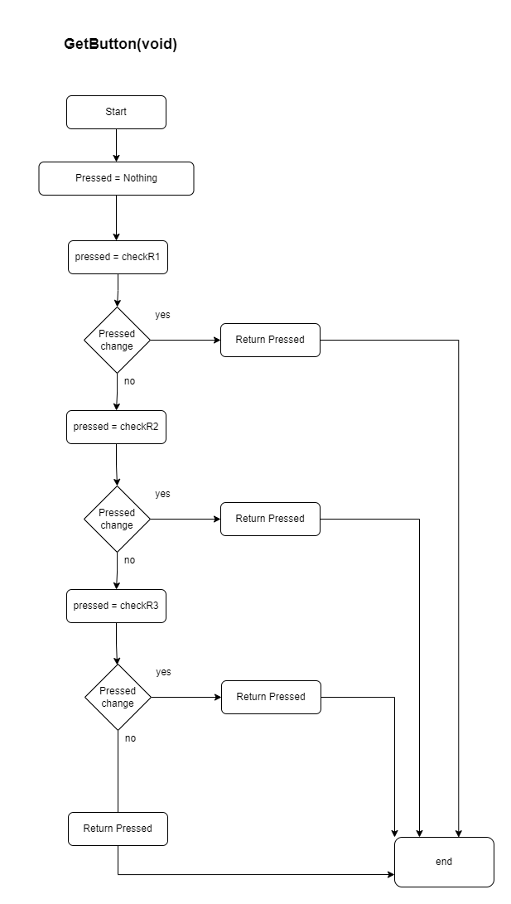

Figure GetButton Flow Chart

#### **Buzzer**

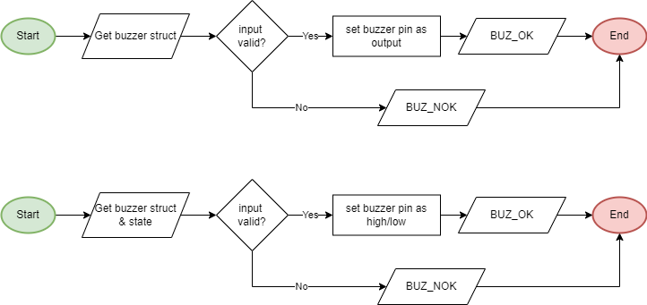

**BUZ_SetState**

Figure Buzzer Init & SetState Flow Charts

**BUZ_Init**

#### **HEXTINT:**

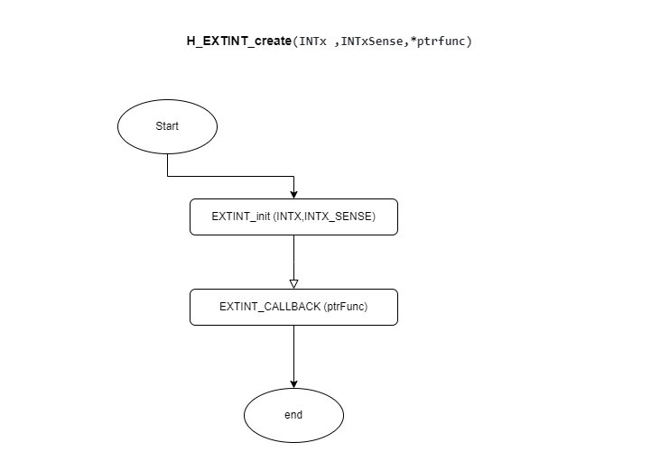

Figure H_EXTINT_create flow chart

#### **Button:**

enu_buttonError_t **HButton_Init**(enu_pin); enu_buttonError_t **HButton_ExtIntInit**(enu_pin);

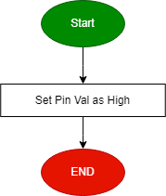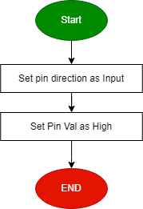 Figure 44 HButton_Init flow chart

Figure 5 HButton_ExtIntInit flow chart

enu_buttonError_t **HButton_getPinVal**(enu_pin en_pinx, Uint8_t* pu8_refVal );

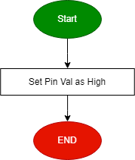

Figure HButton_getPinVal flow chart

#### **EEPROM**

void eeprom_init(void)

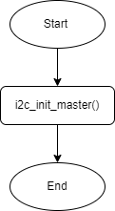

Figure eeprom_init flow chart

void eeprom_write_byte(Uint16_t address, Uchar8_t data)

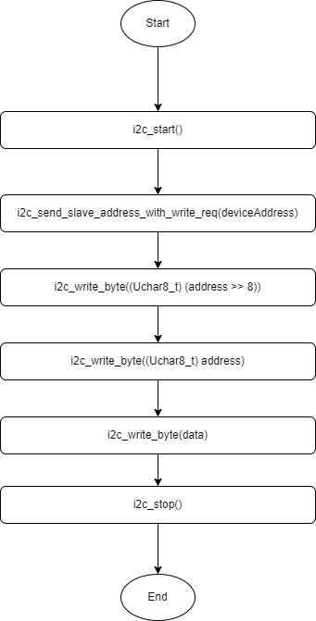

Figure eeprom_write_byte flow chart

Uchar8_t eeprom_read_byte(Uint16_t address)

Figure eeprom_read_byte flow chart

void eeprom_write_string(Uint16_t Copy_u8Address, const Uchar8_t* str)

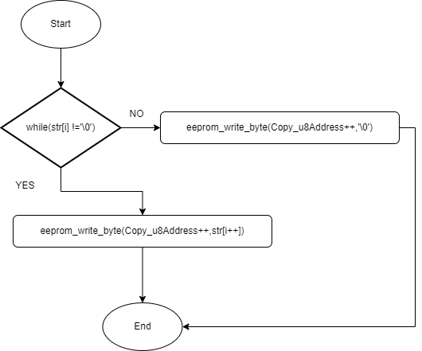

Figure eeprom_write_string flow chart

void eeprom_read_string(Uint16_t Copy_u8Address, Uchar8_t* str)

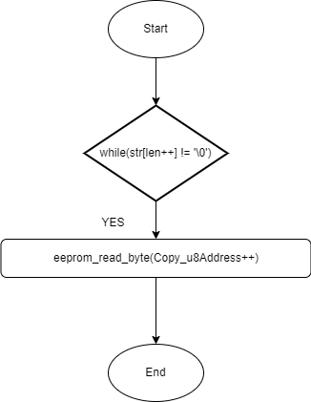

Figure eeprom_read_string flow chart

### **Card_Database Layer (CARD MCU)**

en_terminalPinGetStatus_t **APP_terminalPinGet**(Uchar8_t* arr);

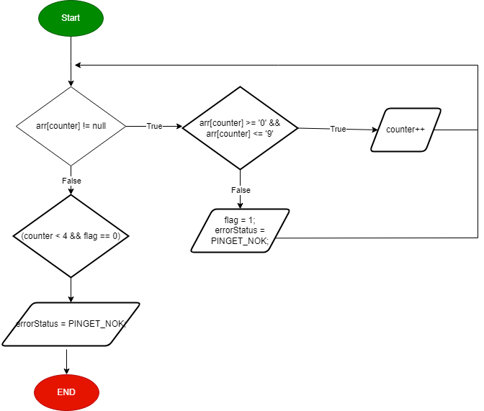

Figure APP_terminalPinGet flow chart

en_terminalPanGetStatus_t **APP_terminalPanGet**(Uchar8_t* arr);

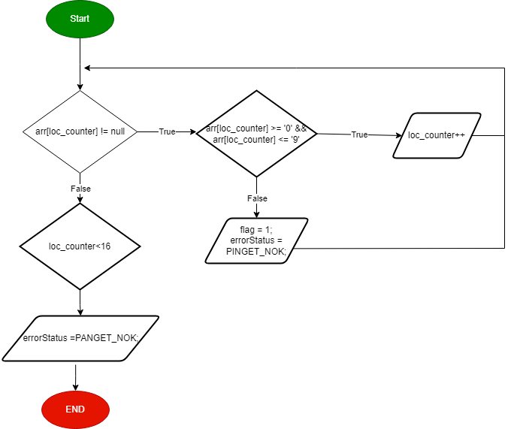

Figure APP_terminalPanGet flow chart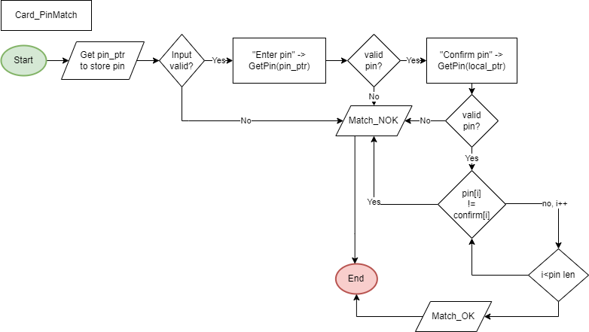

Figure CARD_PinMatch flow chart

SaveCardData

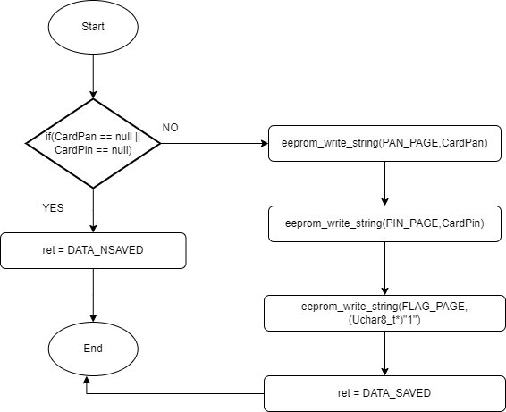

Figure SaveCardData flow chart

ReadCardData

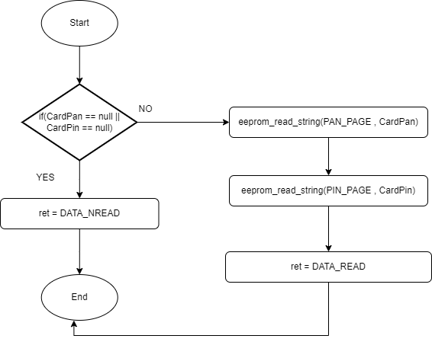

Figure ReadCardData flow chart

#### **Database_check:**

EN_dataError_t **isValidPanAccount**(Uchar8_t * pan);

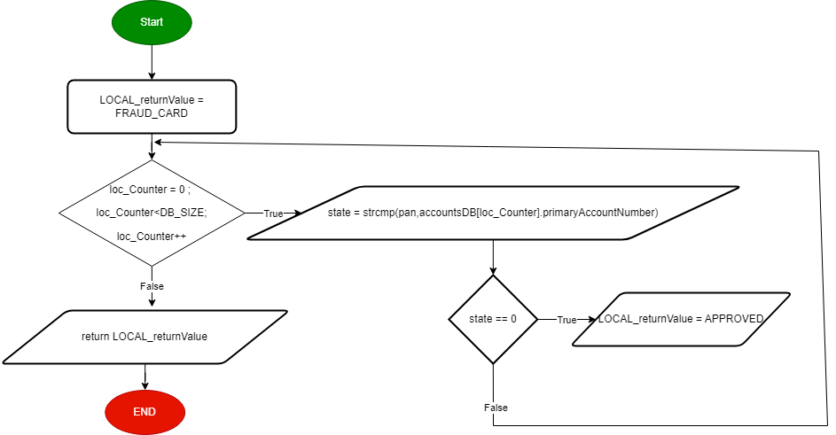

Figure isValidPanAccount flow chart

EN_dataError_t **isRunningAccount**(Uchar8_t * pan);

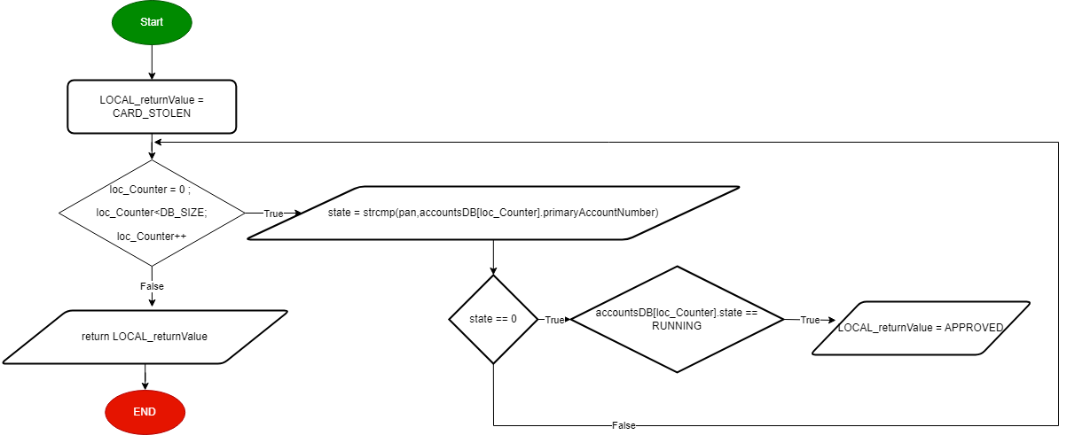

Figure isRunningAccount flow chart

EN_dataError_t **isValidAccountAmount**(Uchar8_t *pan,Uchar8_t *amount,float32_t *newAmount);

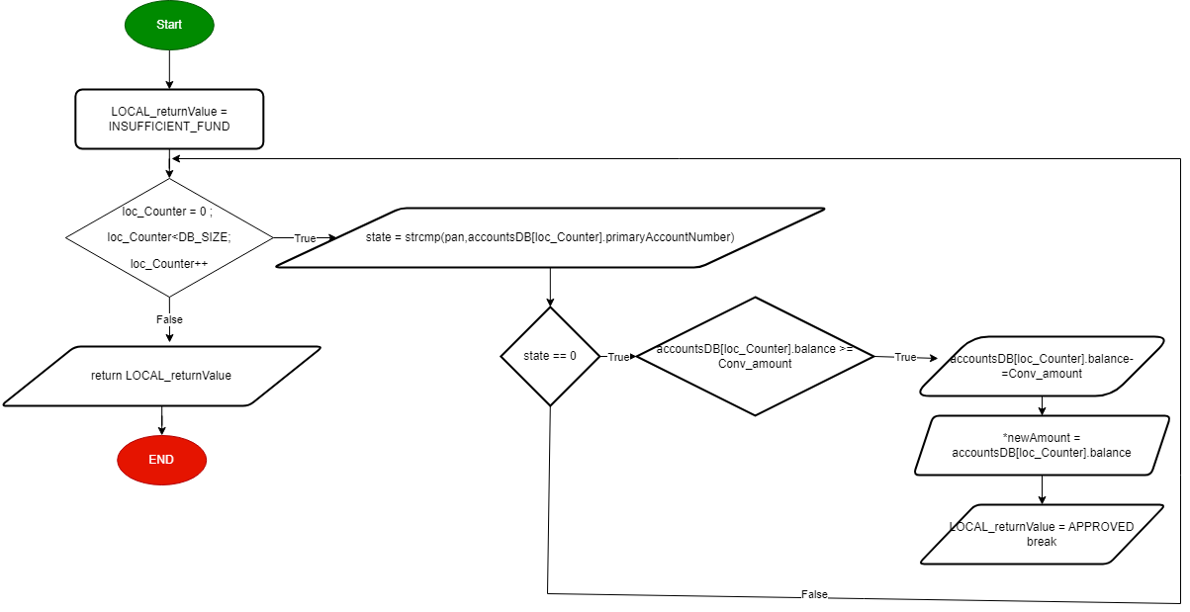

Figure isValidAccountAmount flow chart

EN_dataError_t **isBelowMaxDailyAmount**(Uchar8_t * amount);

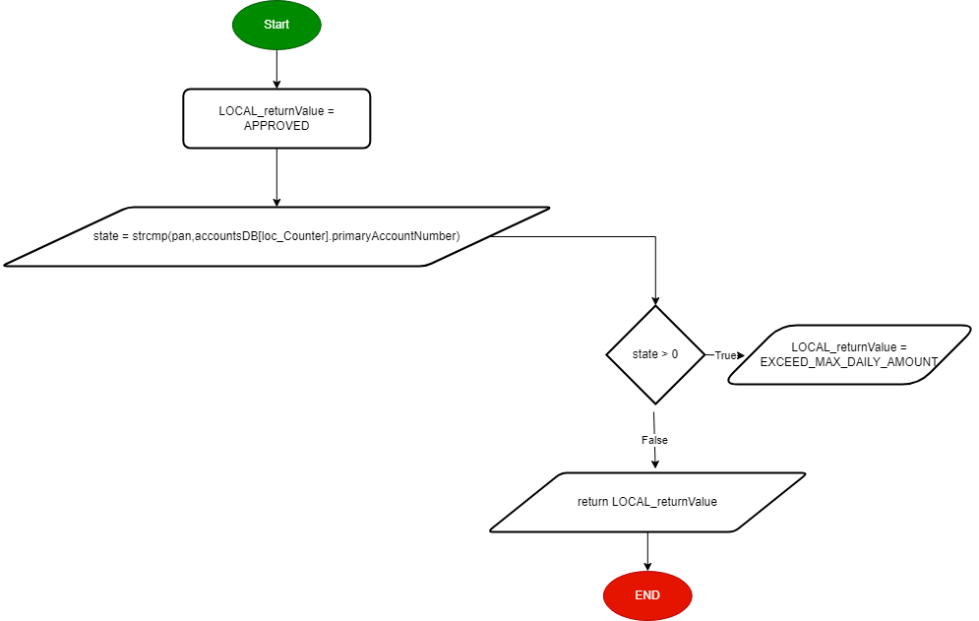

Figure isBelowMaxDailyAmount flow chart

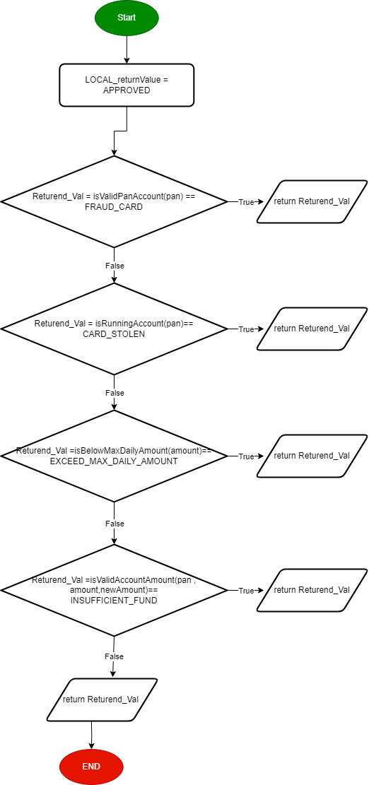EN_dataError_t **DATABASE_checking** (Uchar8_t * pan,Uchar8_t * amount,float32_t *newAmount);

Figure DATABASE_checking flow chart

#### **ATM Module**

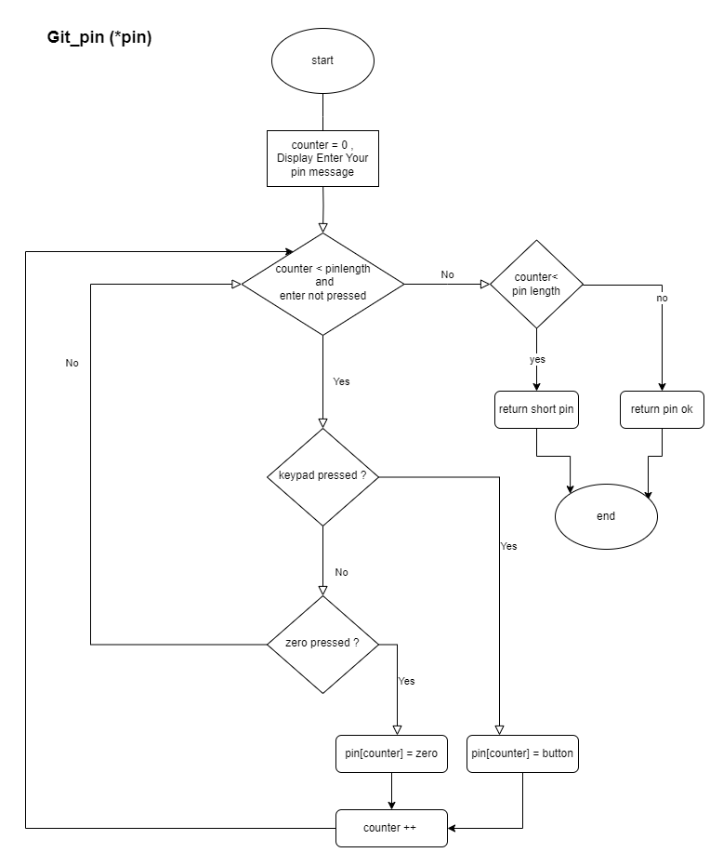

Figure Get_pin flow chart

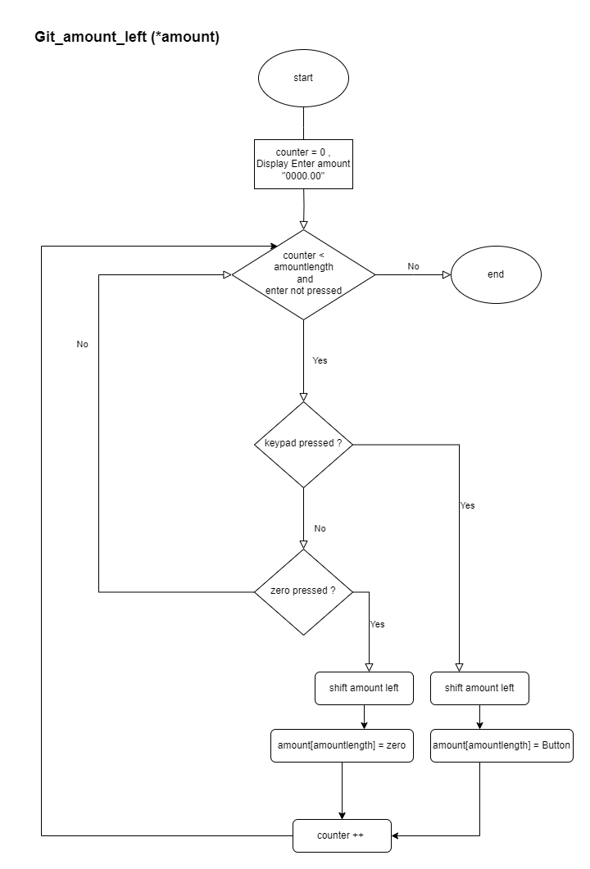

Figure 63 get_amount_left flow chart

PIN_checkPinMatching

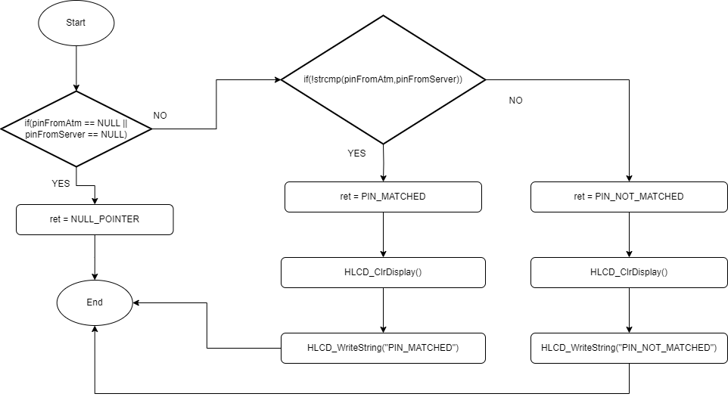

Figure PIN_checkPinMatching flow chart

deinitAtm

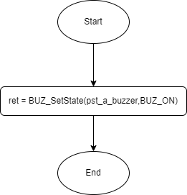

Figure deinitAtm flow chart

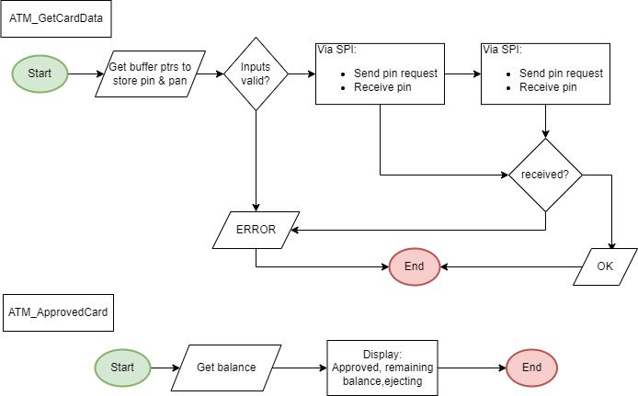

Figure ATM_GetCardData & ATM_ApprovedCard flow charts

### **Application Layer:**

### **Card App**

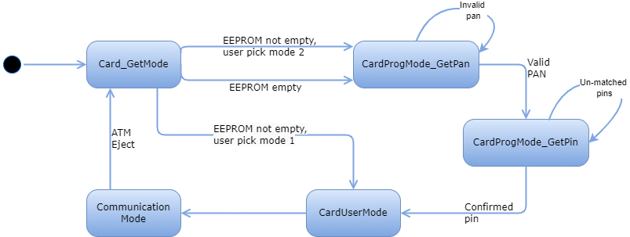

Figure Card App state machine

### **ATM App**

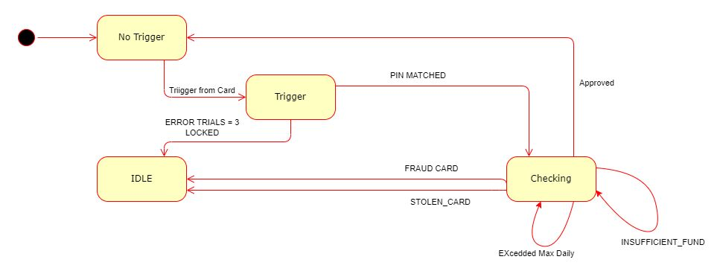

Figure ATM App state machine

