* Introduction
  + The Kyiv tourism app is a mobile application designed to provide tourists with information about the city of Kyiv, including its transport, food, living options, and attractions. Users can navigate through different activities to find the information they need, such as description, website, and map directions.
* Brainstorming and plan of design.
  + The app's design is based on a user-friendly interface with easy navigation to provide users with a seamless experience. The main activity contains shortcuts to the other activities, while each activity has its own set of features and functionalities. The design also incorporates a map view to display the locations, allowing users to find their way around the city easily.
* Project schedule
  + The brief for the project was received on February 21, 2023. The schedule for the project is as follows:
    - Week 1: Plan the app, design its user interface, and develop the main activity and transport activity.
    - Week 2: Develop the food activity, living activity, and attractions activity.
    - Week 3: Integrate map functionality, test the app, and fix any bugs.
    - Week 4: Finalize the app, conduct thorough testing, and submit it for review.
* Project plan
  + The app will be supported by software updates and newer versions. Updates will be released periodically to fix any bugs and add new features to enhance the user experience. To install the app user need to download APK file from <https://github.com/BaTa4Ka/Kyiv-Tourism> .
* Planned development lifecycle.
  + The minimum SDK for the app will be Android 10.0 (9) to ensure compatibility with at least 68% Android devices. The app will be available for Android devices. The app will be deployed to users worldwide.
  + The app's user interface will be designed to be intuitive and user-friendly. The interface will be optimized for different screen sizes to ensure that it looks and functions well on both phones and tablets. The app will be deployed to users as a free download, and there will be no in-app purchases.
* Screenshots of your GUI Design

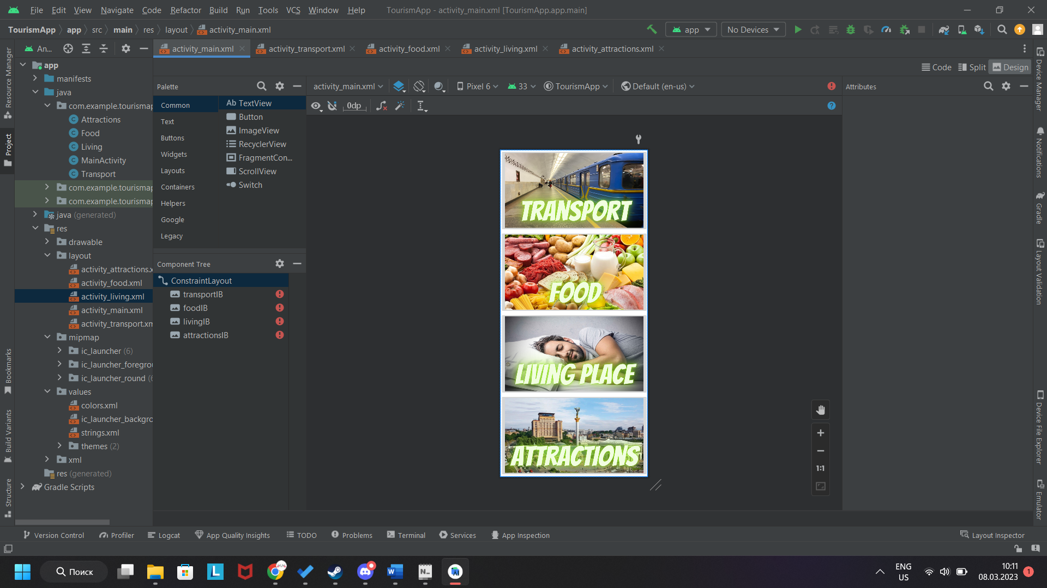 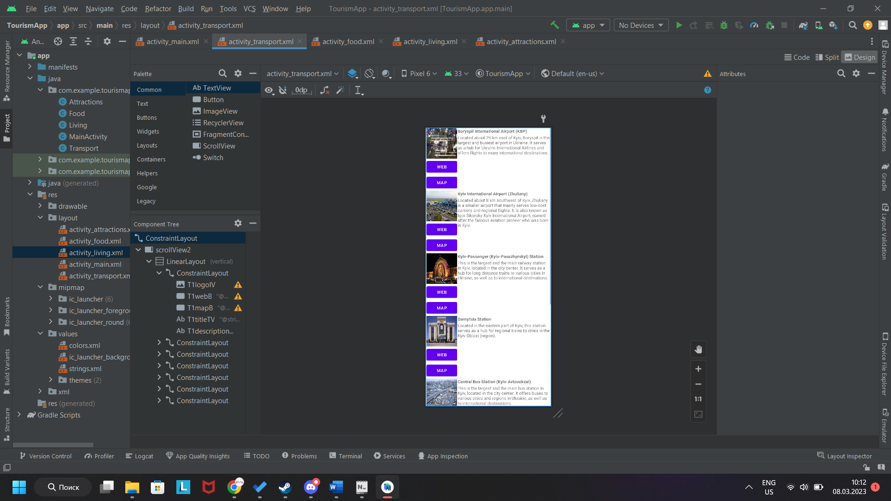 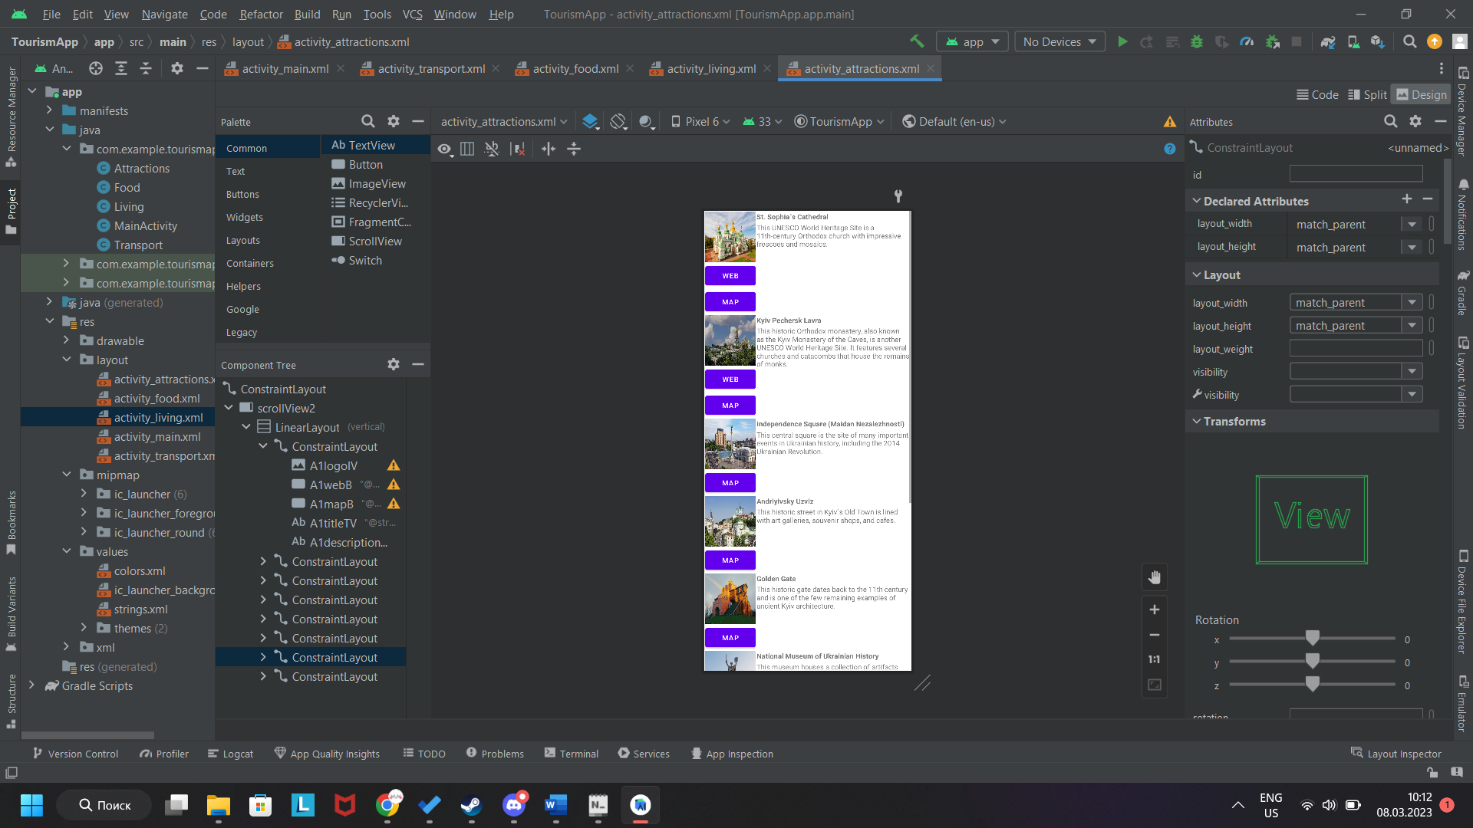

* Code snippets

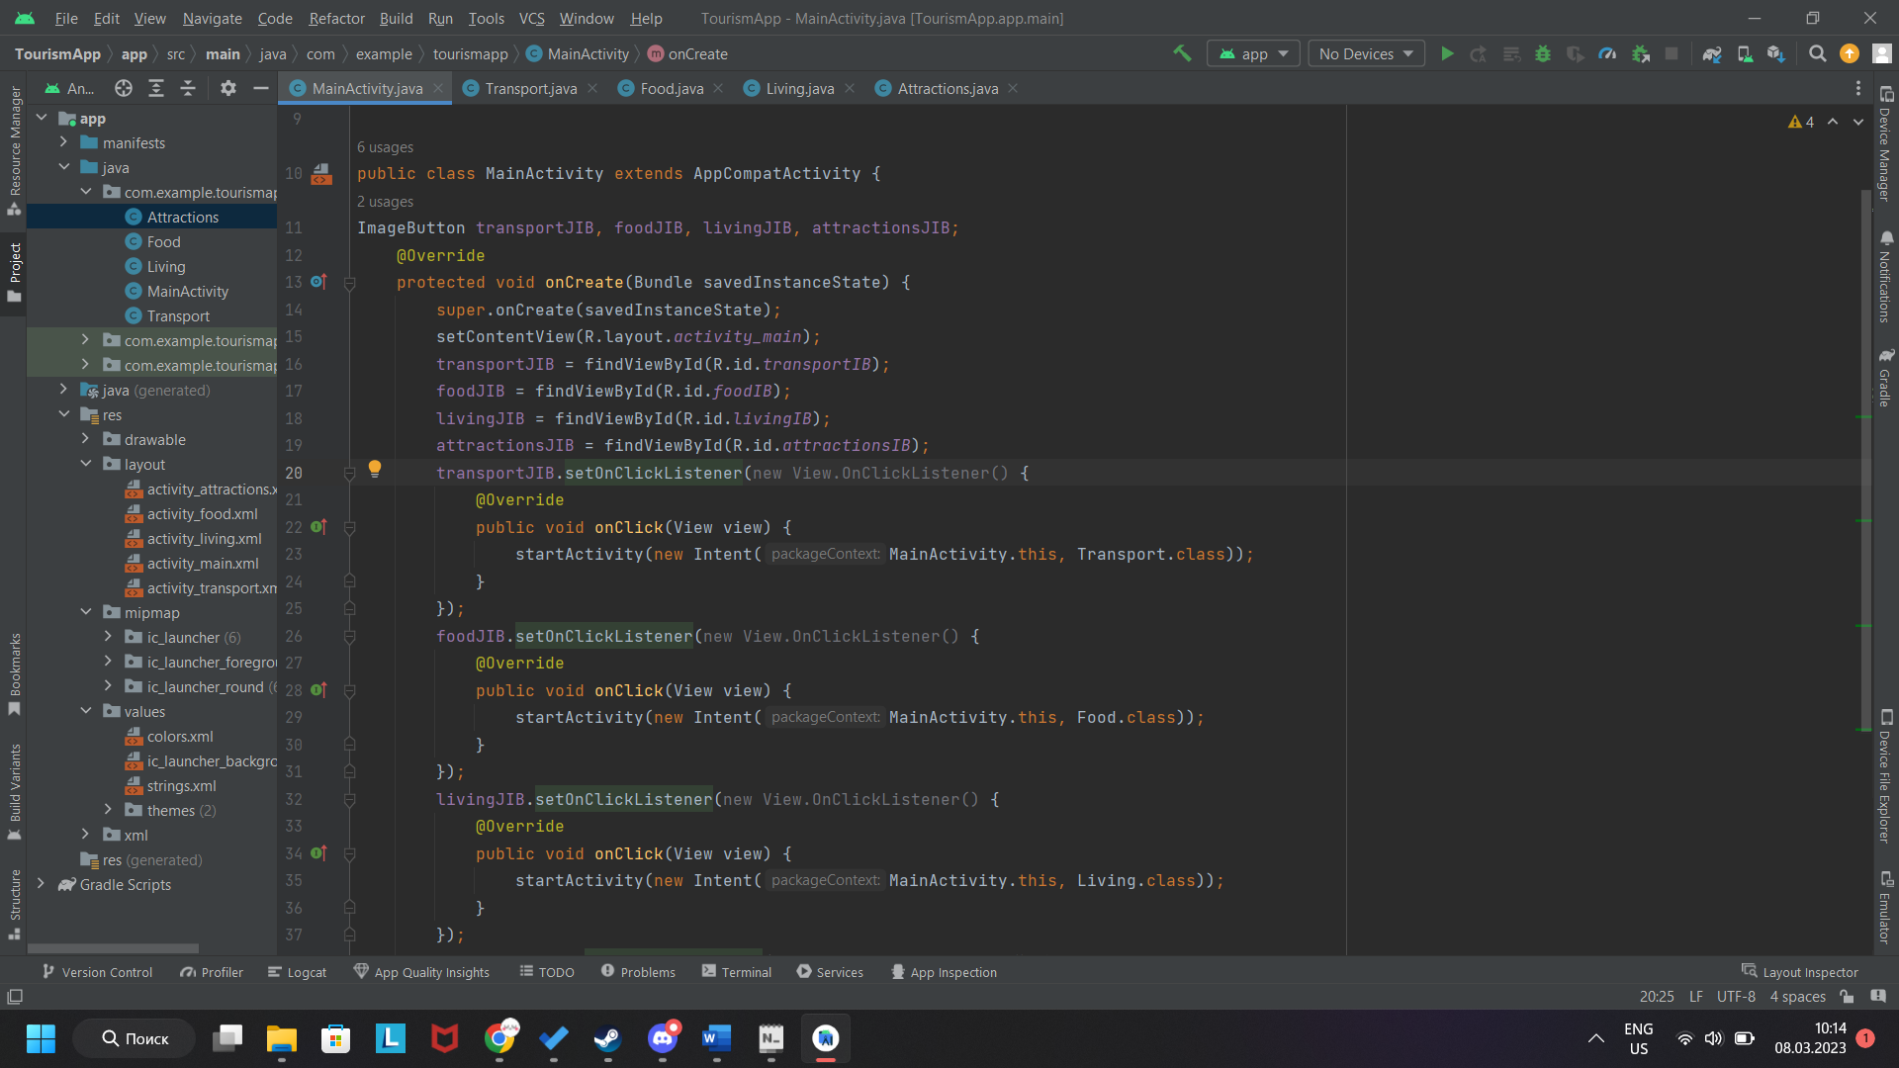

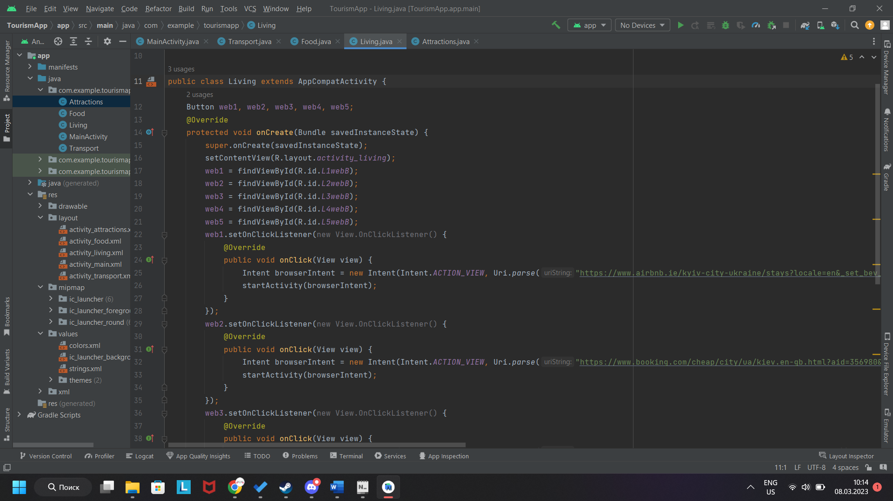

* Testing report
  + The app functions as intended and is reliable. Testing has been done on various devices, including phones and tablets, and no major bugs or issues have been found.
* App review
  + The app is effective in terms of design, and it does what it sets out to do by providing users with information about Kyiv's tourism. The app could be developed further in the future to add more features, such as augmented reality or a virtual tour of the city. Overall, the app is a useful tool for tourists visiting Kyiv.