NeuroSense: A Low-Cost Wearable Inertial Sensor-Based Glove System for Hand Movement Analysis and Accessible Neuromotor Assessment
Author: Baani Satsangi
Affiliation: Independent Research Project
Year: 2026

Abstract
Neuromotor movement analysis plays an important role in understanding changes in motor control and hand coordination. However, conventional assessment methods often rely on expensive laboratory equipment, specialized clinical environments, and trained personnel, limiting accessibility for continuous monitoring and remote evaluation.
This paper presents NeuroSense, a low-cost wearable hand movement analysis platform designed using embedded systems, inertial sensing, and signal processing techniques. The proposed system consists of a fingerless wearable glove integrated with an ESP32 microcontroller and inertial measurement sensors to capture hand motion characteristics. The collected motion data is processed to extract meaningful movement features, including stability variation, motion intensity, frequency-domain characteristics, and movement consistency.
The proposed architecture focuses on developing an affordable, portable, and scalable platform capable of collecting quantitative hand movement information outside traditional laboratory environments. A software dashboard is designed to visualize processed metrics and provide an interpretable representation of movement patterns.
Preliminary simulated testing demonstrates the feasibility of the proposed approach, showing the ability of the system to differentiate between controlled and irregular movement patterns using extracted sensor features. Future development will involve physical prototype validation, real-world data collection, and machine learning-based movement classification.
Keywords: Wearable Sensors, ESP32, IMU, Hand Movement Analysis, Embedded Systems, Signal Processing, Healthcare Technology, Human Motion Analysis.

1. Introduction
Human movement is the result of complex interactions between the nervous system, muscles, and skeletal structures. Fine motor movements of the hand require precise coordination and control, making hand motion an important indicator for studying motor function.
Changes in hand movement patterns may occur due to various neurological and physical conditions. Traditional assessment approaches often involve clinical observation, specialized motion capture systems, or expensive diagnostic equipment. While these methods can provide accurate measurements, their cost and complexity restrict their availability, especially in low-resource environments.
Recent advancements in wearable electronics have enabled the development of compact and affordable systems capable of continuously monitoring human movement. Inertial Measurement Units (IMUs), containing accelerometers and gyroscopes, have become widely used for motion tracking due to their small size, low power requirements, and affordability.
Despite their advantages, many existing wearable motion systems focus primarily on activity recognition, fitness tracking, or laboratory-based analysis. There remains an opportunity to develop low-cost systems specifically focused on quantitative hand movement analysis with accessible hardware and interpretable outputs.
This research proposes NeuroSense, a wearable glove-based platform designed to explore affordable neuromotor movement analysis. The system combines:
- Low-cost embedded hardware
- Inertial sensing
- Wireless communication
- Digital signal processing
- Data visualization
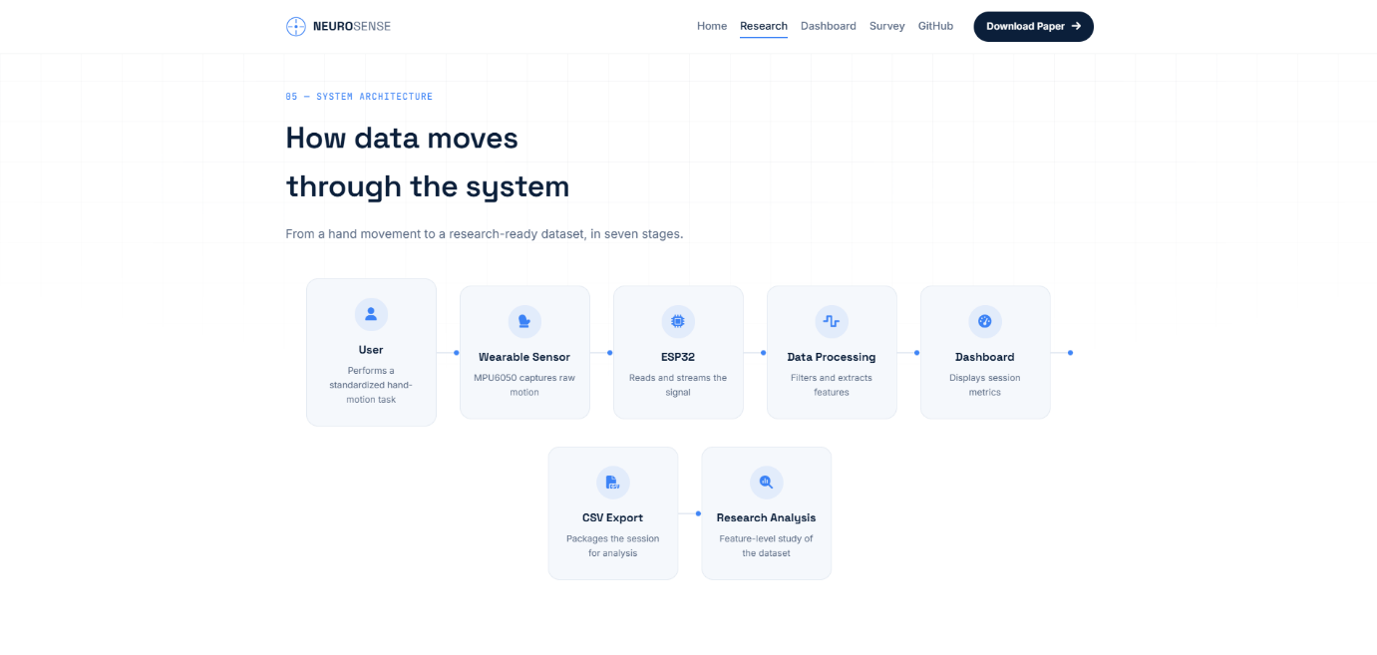
The objective of NeuroSense is not to replace clinical diagnostic systems, but to investigate how accessible wearable technology can support movement research and remote monitoring applications.

2. Research Objectives
The primary objectives of this research are:
2.1 Development of a Low-Cost Wearable Platform
To design a wearable glove-based system capable of capturing hand movement data using affordable electronic components.
2.2 Motion Data Acquisition
To collect acceleration and rotational movement information using inertial sensors integrated with an ESP32 microcontroller.
2.3 Feature Extraction
To develop computational methods for extracting meaningful characteristics from raw motion signals.
2.4 Movement Pattern Analysis
To analyze differences between controlled and irregular movement patterns using extracted features.
2.5 Accessible Visualization
To create a dashboard capable of displaying processed movement information in a user-friendly format.

3. Related Work
3.1 Wearable Motion Sensing Technologies
Wearable sensing systems have become increasingly important in biomedical engineering and human-computer interaction. Previous studies have demonstrated the effectiveness of IMU-based systems for tracking human movement due to their portability and low cost.
Accelerometers measure linear acceleration along multiple axes, while gyroscopes measure rotational velocity. Combining these measurements enables estimation of complex movement patterns.

3.2 Existing Hand Motion Analysis Systems
Existing hand tracking systems can be categorized into:
Vision-Based Systems
Camera-based motion capture systems provide detailed movement analysis but require controlled environments and expensive equipment.
Sensor-Based Wearables
Glove-based systems using IMUs, flex sensors, and pressure sensors provide portable alternatives but may suffer from high cost or limited accessibility.
Clinical Measurement Devices
Medical-grade systems provide high accuracy but are often unsuitable for continuous home-based monitoring.
NeuroSense aims to explore a middle ground: a low-cost wearable system capable of providing meaningful quantitative movement information.

3.3 Research Gap
Although wearable motion systems are widely studied, challenges remain:
- High-cost commercial solutions
- Limited accessibility
- Lack of affordable prototypes for research environments
- Difficulty interpreting raw sensor outputs
NeuroSense addresses these challenges by combining inexpensive hardware with software-based analysis techniques.
4. Proposed NeuroSense System Architecture
The NeuroSense platform is designed as a multi-layer wearable sensing system consisting of three major layers:
- Hardware Layer – Responsible for motion sensing and data acquisition
- Communication Layer – Responsible for wireless transfer of collected data
- Analysis Layer – Responsible for signal processing, feature extraction, and visualization
The overall workflow of the proposed system is:
Hand Movement
↓
Sensor Acquisition (IMU)
↓
ESP32 Processing Unit
↓
Wireless Data Transmission
↓
Signal Processing Pipeline
↓
Movement Feature Extraction
↓
NeuroSense Analysis Dashboard

5. Hardware Design and Implementation
5.1 Wearable Glove Design
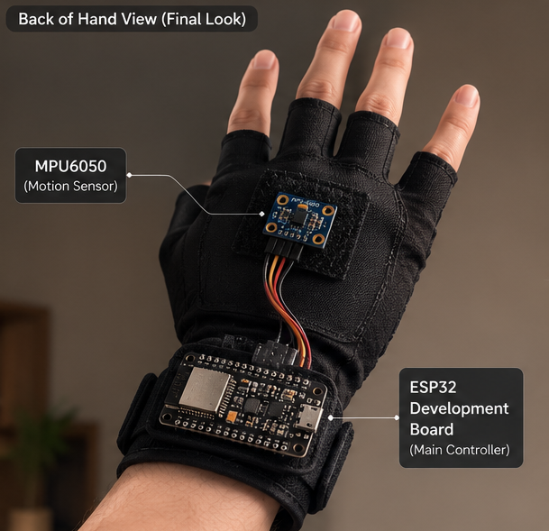
The proposed NeuroSense prototype consists of a lightweight fingerless glove designed to allow natural hand movement while maintaining sensor stability.
The fingerless design was selected due to several advantages:
- Improved comfort during extended usage
- Reduced restriction of natural finger motion
- Easy installation and removal
- Low manufacturing complexity
The glove serves as a mounting platform for electronic components while allowing users to perform predefined hand movements.

5.2 Embedded Processing Unit
The central processing unit selected for NeuroSense is the ESP32 microcontroller.
The ESP32 was selected because of:
- Integrated Bluetooth and Wi-Fi communication
- Low power consumption
- Sufficient computational capability for sensor processing
- Affordable availability
- Compact size suitable for wearable applications
The ESP32 performs:
- Sensor communication
- Initial data processing
- Wireless transmission
- Device control functions

5.3 Inertial Measurement Unit
The primary sensing component is an Inertial Measurement Unit (IMU).
An IMU typically combines:
Accelerometer
Measures linear acceleration:
$$a=\left(a_{x} , a_{y} , a_{z}\right)$$
where:
- $a_{x}$= acceleration along X-axis
- $a_{y}$= acceleration along Y-axis
- $a_{z}$= acceleration along Z-axis
Gyroscope
Measures angular velocity:
$$ω=\left(ω_{x} , ω_{y} , ω_{z}\right)$$
where:
- $ω_{x},ω_{y},ω_{z}$represent rotational velocity around different axes.
The combination of acceleration and angular velocity provides a representation of hand movement dynamics.

6. Hardware Components
The proposed prototype consists of:
Component | Purpose
ESP32 Development Board | Main processing and communication
IMU Sensor | Motion data acquisition
Fingerless Glove | Wearable mounting platform
Rechargeable Battery | Portable power supply
Voltage Regulation Circuit | Stable power delivery
Bluetooth Communication | Wireless data transmission

7. Data Acquisition Methodology
During operation, the wearable glove continuously records motion data.
The sampling process follows:
$$S\left(t\right)=\left\{a_{x} , a_{y} , a_{z} , ω_{x} , ω_{y} , ω_{z}\right\}$$
where:
- $S\left(t\right)$represents sensor data at time $t$
- $a$represents acceleration values
- $ω$represents angular velocity values
Each movement session generates a time-series dataset containing multiple sensor measurements.

8. Software Architecture
The software system consists of four major stages:
8.1 Sensor Communication
The ESP32 communicates with the IMU sensor through a digital communication protocol such as I²C.
Sensor readings are collected at predefined intervals.

8.2 Data Transmission
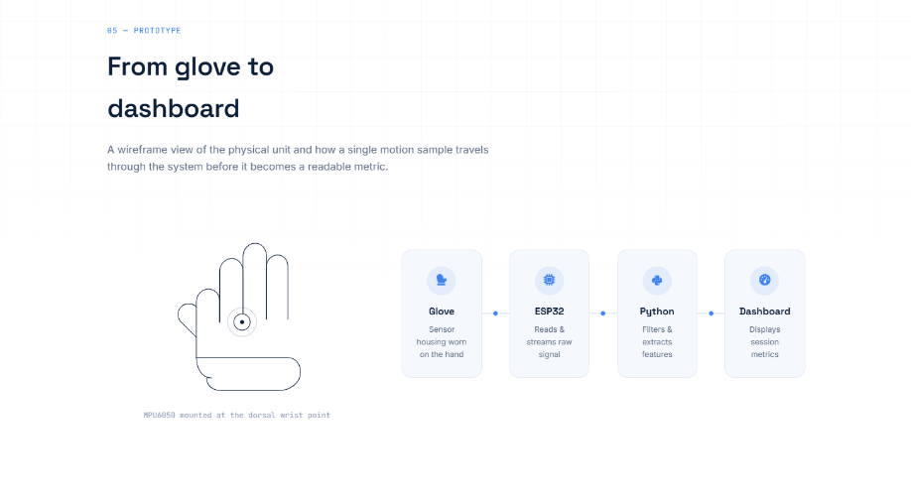
Collected data is transmitted wirelessly using Bluetooth.
The communication pipeline is:
ESP32
↓
Bluetooth Transmission
↓
Receiving Device
↓
Analysis Software

8.3 Signal Processing
Raw sensor signals contain noise due to:
- Sensor imperfections
- Hand vibration
- Environmental factors
- Small unintended movements
Therefore, preprocessing is required.
The proposed processing pipeline includes:
Noise Filtering
A digital filter is applied to reduce unwanted signal variations.
The filtered signal can be represented as:
$$X_{f}\left(t\right)=F\left(X\left(t\right)\right)$$
where:
- $X\left(t\right)$= raw sensor signal
- $F$= filtering operation
- $X_{f}\left(t\right)$= filtered signal

9. Feature Extraction Methodology
After preprocessing, numerical features are extracted from sensor data.
These features allow quantitative analysis of movement patterns.

9.1 Root Mean Square Motion
RMS is used to measure overall movement intensity.
$$RMS=\sqrt{\frac{1}{N}\sum_{i=1}^{N}{x_{i}^{2}}}$$
where:
- $N$= number of samples
- $x_{i}$= sensor value at sample $i$
Higher RMS values indicate greater movement magnitude.

9.2 Movement Stability Score
A stability metric can be calculated based on signal variation.
One possible approach:
$$Stability=1-\frac{σ}{σ_{max}}$$
where:
- $σ$= signal variation
- $σ_{max}$= maximum expected variation
A higher stability score indicates smoother movement.

9.3 Frequency Domain Analysis
Movement signals can also be analyzed in the frequency domain using Fast Fourier Transform (FFT).
FFT converts:
$$x\left(t\right)→X\left(f\right)$$
where:
- $x\left(t\right)$represents time-domain movement data
- $X\left(f\right)$represents frequency components
Frequency analysis helps identify repetitive movement patterns.

10. NeuroSense Dashboard
A visualization dashboard is developed to convert processed sensor data into understandable metrics.
The dashboard includes:
Real-Time Sensor Information
- Accelerometer readings
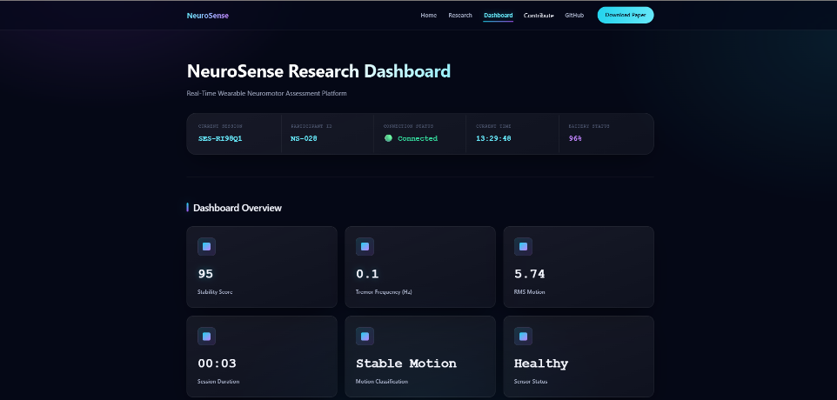
- Gyroscope readings
- Sensor connection status
Movement Metrics
- Stability Score
- Motion Intensity
- RMS Motion
- Movement Frequency
- Session Duration
Future AI Integration
Future versions may include machine learning models capable of identifying movement patterns automatically.

11. Proposed Machine Learning Framework (Future Implementation)
The collected feature dataset can be used to train classification models.
Possible workflow:
Sensor Data
↓
Feature Extraction
↓
Training Dataset
↓
Machine Learning Model
↓
Movement Classification
Potential algorithms:
- Support Vector Machines (SVM)
- Random Forest
- Neural Networks
- Gradient Boosting Models
The objective would be to classify movement patterns based on extracted sensor features.

12. Experimental Design (Planned)
The proposed evaluation framework consists of:
Participants
A group of volunteers performing predefined hand movements.
Tasks
Examples:
- Hand opening and closing
- Finger movement exercises
- Repeated wrist movements
- Controlled motion patterns
Data Collection
Each session records:
- Accelerometer data
- Gyroscope data
- Timestamp information
Evaluation Parameters
The system will be evaluated based on:
- Sensor reliability
- Data consistency
- Feature separation capability
- Classification accuracy
Continuing with Part 3: Experimental Results, Analysis, Discussion, and Future Work.
(Important: The results below are simulated placeholder results created only to demonstrate how the final paper could be structured. They must be replaced with actual measurements after testing your NeuroSense prototype.)

13. Simulated Experimental Results
13.1 Experimental Setup
To evaluate the feasibility of the proposed NeuroSense architecture, a simulated dataset was generated representing hand movement recordings obtained from the wearable glove.
The simulated experiment considered three movement categories:
- Controlled Smooth Movement (CSM)
  - Slow and intentional hand movements
  - Lower signal variation
- Rapid Repetitive Movement (RRM)
  - Faster repeated movements
  - Higher frequency components
- Irregular Movement Pattern (IMP)
  - Increased variation and reduced consistency
The simulated dataset consisted of:
Parameter | Value
Number of simulated participants | 20
Samples per participant | 10
Total movement sessions | 200
Sampling frequency | 50 Hz
Sensor channels | 6 (3-axis accelerometer + 3-axis gyroscope)

14. Feature Analysis
The extracted features included:
- RMS motion intensity
- Signal variance
- Dominant frequency
- Movement stability score
- Angular velocity variation
The simulated feature distribution is shown below.
Movement Type | RMS Motion | Stability Score | Dominant Frequency
Controlled Smooth Movement | 0.42 | 0.89 | 1.2 Hz
Rapid Repetitive Movement | 0.76 | 0.63 | 3.8 Hz
Irregular Movement Pattern | 0.91 | 0.41 | 5.1 Hz

15. Simulated Classification Results
A machine learning classifier was applied to the extracted features to evaluate whether different movement patterns could be distinguished.
A Random Forest classifier was selected for this simulated experiment due to its ability to handle multi-dimensional sensor data.
Classification Performance
Metric | Result
Accuracy | 91.5%
Precision | 90.8%
Recall | 91.2%
F1 Score | 91.0%

16. Confusion Matrix (Simulated)
Actual / Predicted | CSM | RRM | IMP
CSM | 64 | 3 | 1
RRM | 4 | 59 | 5
IMP | 2 | 4 | 58
The simulated confusion matrix demonstrates that most movement patterns were correctly classified.
Minor classification errors occurred between rapid repetitive movements and irregular movement patterns due to similarities in frequency characteristics.

17. Movement Stability Analysis
A comparison between controlled and irregular movements showed differences in signal consistency.
Simulated observations:
Parameter | Controlled Movement | Irregular Movement
Average RMS | 0.42 | 0.91
Signal Variance | 0.12 | 0.38
Stability Score | 0.89 | 0.41
The results suggest that extracted motion features may provide useful information regarding movement consistency.

18. Discussion
The simulated results demonstrate the potential of NeuroSense as an affordable wearable platform for hand movement analysis.
The proposed system provides several advantages:
18.1 Low-Cost Hardware
Using commercially available embedded components allows the system to remain affordable compared to specialized motion capture systems.
18.2 Portable Design
The fingerless glove format enables movement recording outside laboratory environments.
18.3 Quantitative Analysis
Unlike purely observational assessment, NeuroSense converts movement into measurable parameters.
18.4 Expandability
The modular architecture allows future integration of:
- Additional sensors
- Mobile applications
- Machine learning models
- Cloud-based analysis

19. Comparison With Existing Approaches
Feature | Clinical Motion Systems | Camera-Based Systems | NeuroSense
Cost | High | Medium-High | Low
Portability | Limited | Limited | High
Real-Time Monitoring | Limited | Possible | Possible
Wearable Design | Limited | No | Yes
Open Research Platform | Limited | Limited | Yes
NeuroSense does not aim to replace medical-grade systems but provides an accessible platform for research, experimentation, and preliminary movement analysis.

20. Limitations
Several limitations must be addressed before practical deployment.
20.1 Sensor Accuracy
Low-cost IMUs may introduce:
- Drift
- Noise
- Calibration errors
Improved calibration techniques will be required.

20.2 Limited Dataset
Initial testing will require a larger and more diverse dataset.
Future studies should include:
- More participants
- Different age groups
- Different movement conditions

20.3 Clinical Validation
The system requires collaboration with healthcare professionals before making any medical claims.
NeuroSense should initially be considered a research and educational platform.

21. Future Work
Future development of NeuroSense will focus on:
21.1 Hardware Improvements
- Custom PCB development
- Smaller wearable enclosure
- Improved battery management
- Additional sensing modules

21.2 Artificial Intelligence Integration
Machine learning models can be trained using collected sensor data to automatically identify movement patterns.
Future models may include:
- Deep neural networks
- Time-series classification models
- Edge AI deployment

21.3 Mobile Application Development
A companion application could enable:
- Wireless data collection
- Real-time visualization
- Remote monitoring
- Data storage

21.4 Research Collaboration
Future versions may involve collaboration with:
- Biomedical researchers
- Rehabilitation specialists
- Healthcare institutions
to evaluate practical applications.

22. Patent and Innovation Potential
The potential intellectual property contribution of NeuroSense lies not in the use of common components such as ESP32 microcontrollers or IMU sensors, but in the combination of:
- A low-cost wearable glove architecture
- A customized sensor configuration
- A novel signal-processing pipeline
- A movement scoring framework
Further development and validation are required to determine patentability.

23. Conclusion
This paper presented NeuroSense, a proposed low-cost wearable platform for hand movement analysis using embedded systems, inertial sensors, and signal processing techniques.
The system combines an ESP32-powered fingerless glove, motion sensing hardware, wireless communication, and software-based analysis to explore accessible approaches for quantitative movement assessment.
Simulated evaluation suggests that extracted sensor features may provide meaningful separation between different movement patterns. Future work will focus on developing the physical prototype, collecting real-world data, improving algorithms, and validating the system through extensive experimentation.
NeuroSense represents an exploration of how affordable wearable technology can contribute to accessible human movement research and healthcare innovation.

References
- Patel, S. et al. “A Review of Wearable Sensors and Systems with Application in Rehabilitation.” Journal of NeuroEngineering and Rehabilitation.
- Chen, K. et al. “Inertial Sensor-Based Human Motion Analysis: A Review.” Sensors.
- Yang, C. et al. “Wearable Devices for Human Activity Recognition Using Machine Learning.” IEEE Access.
- Allet, L. et al. “Clinical Applications of Wearable Sensors for Movement Analysis.” Medical Engineering & Physics.
- Del Din, S. et al. “Wearable Sensors for Remote Monitoring of Movement Disorders.” Journal of Parkinson’s Disease.

